**Project Implementation tasks**

**Task 1:**

=====================================================================================

Move file from windows Desktop/Shared to Cloudera Desktop/Shared using Shared folder

**Step1: -**

Create directory project_input_data

*hadoop fs -mkdir project_input_data*

**Step2:-**

Remove header from card_transactions.csv file before transferring to HDFS

*sed -i '1d'  Desktop/Shared/card_transactions.csv*

**Step3: -**

Moving file from cloudera local to newly created HDFS folder project_input_data

*hadoop fs -put Desktop/card_transactions.csv project_input_data*

**Step4: -**

Verifying the record count of the card_transactions file loaded into HDFS

hadoop fs -cat project_input_data/card_transactions.csv | wc -l



**Task 2:**

=====================================================================================

**Step1: -**

Login to mysql

*mysql -u root -p*

Creating database bigdataproject and using same

*create database bigdataproject;*

*use bigdataproject;*



**Step2: -**

Creating table card_transactions in MySQL based on the card_transactions.csv file structure.

*create table card_transactions (*

*card_id bigint,*

*member_id bigint,*

*amount int,*

*postcode int,*

*pos_id bigint,*

*transcation_dt varchar(255),*

*status varchar(50)*

*);*

*show tables;*

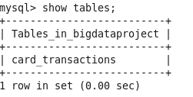

*Describe card_transactions;*

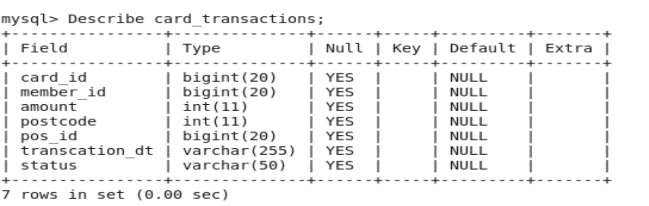

**Task 3:**

=====================================================================================

**Step1: -**

Doing sqoop export of card_transactions data using password encryption from HDFS to MYSQL

*hadoop credential create mysql.bigdataproject.password -provider jceks://hdfs/user/cloudera/mysql.dbpassword.jceks*

*sqoop export *

*-Dhadoop.security.credential.provider.path=jceks://hdfs/user/cloudera/mysql.dbpassword.jceks *

*--connect jdbc:mysql://quickstart.cloudera:3306/bigdataproject *

*--username root *

*--password-alias mysql.bigdataproject.password *

*--table card_transactions *

*--export-dir project_input_data/card_transactions.csv *

*--fields-terminated-by ','*

*select count(*) from bigdataproject.card_transactions;*

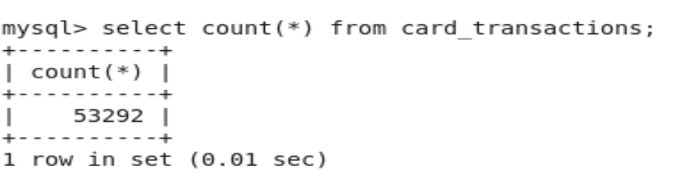

**Step2: -**

Attached production ready parameterized Sqoop export Shell Script(password encrypted) from HDFS to MYSQL card_transactions table



**Step3: -**

Providing permission and execution command for sqoop import shell script

*chmod +x sqoop_export_card_transactions.sh*

Shell execution command:-

*./sqoop_export_card_transactions.sh quickstart.cloudera:3306 bigdataproject root card_transactions*

**Step4: -**

Deleting the file from HDFS

hadoop fs -rm /project_input_data/card_transactions.csv



**Task 4:**

=====================================================================================

**Step1: -**

Enter to Hive Beeline Terminal

*beeline -u jdbc:hive2://*

Create database in Hive

*create database bigdataproject;*

*use database bigdataproject;*

Create hive external table- member_score

*create external table if not exists member_score*

*(*

*member_id string,*

*score float*

*)*

*row format delimited fields terminated by ','*

*stored as textfile*

*location '/project_input_data/member_score/';*

**Step2: -**

Create hive external table- member_details

*create external table if not exists member_details*

*(*

*card_id bigint,*

*member_id bigint,*

*member_joining_dt timestamp ,*

*card_purchase_dt timestamp ,*

*country string,*

*city string,*

*score float*

*)*

*row format delimited fields terminated by ','*

*stored as textfile*

*location '/project_input_data/member_details/';*

Describe member_score;

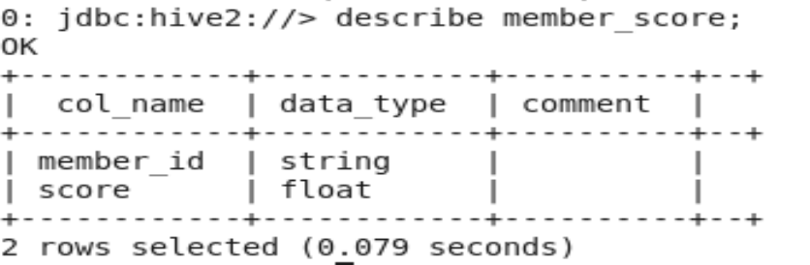

Describe member_details;

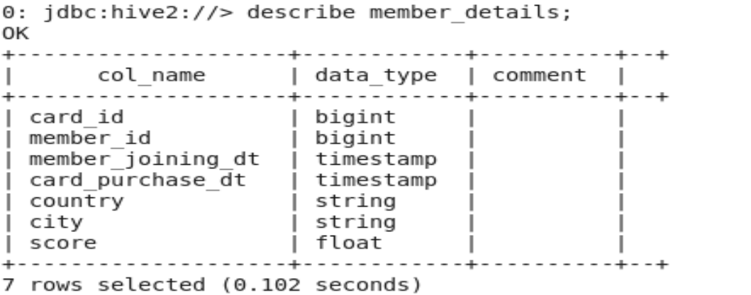

**Step3: -**

Enabling bucketing:-

SET HIVE.ENFORCE.BUCKETING=TRUE;

Create hive bucketed table- member_score with 4 Buckets on column:- member_id since query/join with this table is based on card_id

*create table if not exists member_score_bucketed*

*(*

*member_id string,*

*score float*

*)*

*CLUSTERED BY (member_id) into 4 buckets;*

**Step4: -**

Create hive bucketed table- member_details with 4 Buckets on column:- card_id since query/join with this table is based on card_id

*create table if not exists member_details_bucketed*

*(*

*card_id bigint,*

*member_id bigint,*

*member_joining_dt timestamp ,*

*card_purchase_dt timestamp ,*

*country string,*

*city string,*

*score float*

*)*

*CLUSTERED BY (card_id) into 4 buckets;*

**Step5: -**

Loading bucketed tables member_score_bucketed and member_details_bucketed from external tables

*insert into table member_score_bucketed*

*select * from member_score;*

*insert into table member_details_bucketed*

*select * from member_details;*

**Task 5:**

=====================================================================================

**Step1:-** Creating Hive-HBase table table card_transactions with 8 buckets on column:-card_id since query/join with this table is based on card_id.

*create table card_transactions*

*(*

*card_id bigint,*

*member_id bigint,*

*amount float,*

*postcode int,*

*pos_id bigint,*

*transcation_dt string,* **--timestamp**

*status string*

*)*

*CLUSTERED by (card_id) into 8 buckets*

*STORED BY 'org.apache.hadoop.hive.hbase.HBaseStorageHandler'*

*WITH SERDEPROPERTIES("hbase.columns.mapping"=":key,trans_data:member_id,trans_data:amount, trans_data:postcode,trans_data:pos_id,trans_data:transaction_dt,trans_data:Status")*

*TBLPROPERTIES ("hbase.table.name" = "card_transactions");*

Describing card_transactions table from hive

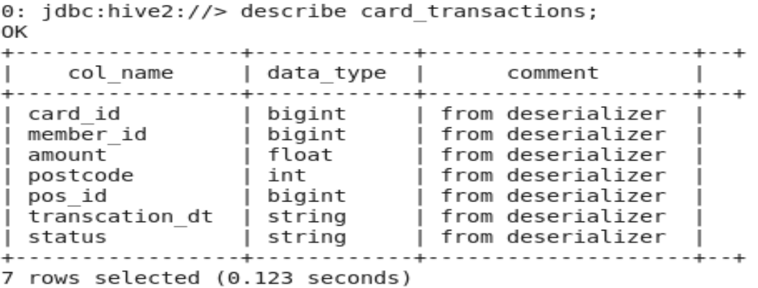

Describing card_transactions table from HBase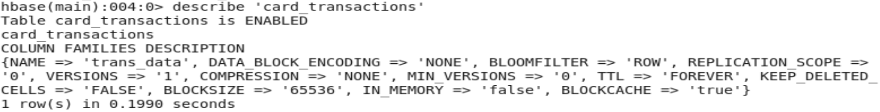

**Task 6:**

=====================================================================================

**Step1:-** Creating Hive-HBase table table card_lookup with 8 buckets on column:-card_id since query/join with this table is based on card_id.

*create table card_lookup*

*(*

*card_id bigint ,*

*ucl float ,*

*score float,*

*last_txn_time string,* **--timestamp**

*last_txn_zip string*

*)*

*CLUSTERED by (card_id) into 8 buckets*

*STORED BY 'org.apache.hadoop.hive.hbase.HBaseStorageHandler'*

*WITH SERDEPROPERTIES("hbase.columns.mapping"=":key,lkp_data:ucl,lkp_data:score, lkp_data:last_txn_time,lkp_data:last_txn_zip")*

*TBLPROPERTIES ("hbase.table.name" = "card_lookup");*

Describing card_ lookup table from hive

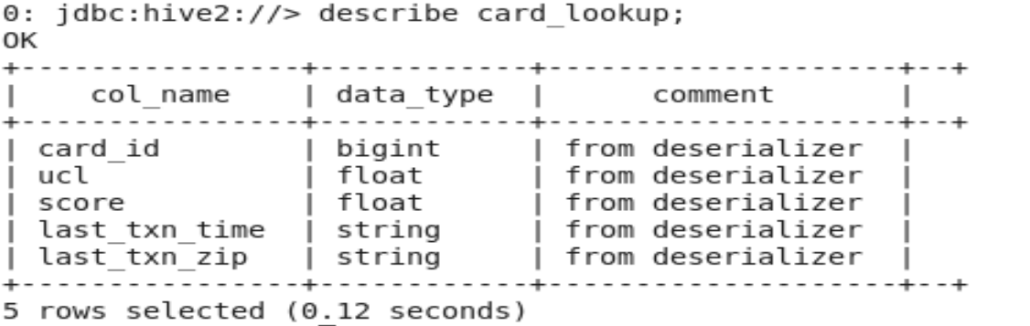

Describing card_transactions table from HBase

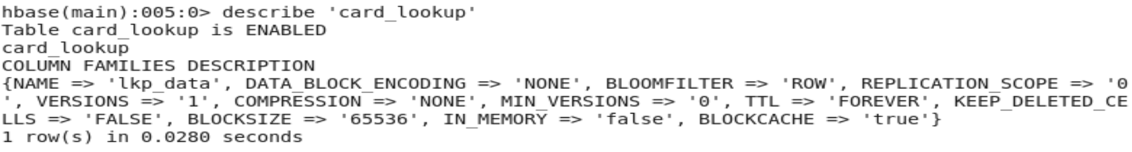

**Task 7:**

=====================================================================================

**Step1: -**

Doing sqoop import of member_score data using password encryption from Amazon RDS to HDFS

*hadoop credential create amazonrds.bigdataproject.password -provider jceks://hdfs/user/cloudera/amazonrds.dbpassword.jceks*

*sqoop import *

*-Dhadoop.security.credential.provider.path=jceks://hdfs/user/cloudera/amazonrds.dbpassword.jceks *

*--connect jdbc:mysql://database-2.cl4c0rtglkdz.ap-south-1.rds.amazonaws.com/BankingPrj *

*--username admin *

*--password-alias amazonrds.bigdataproject.password *

*--table member_score *

*--warehouse-dir /project_input_data*

select count(*) from bigdataproject.member_score;

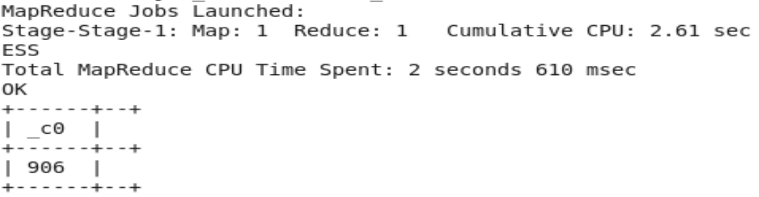

**Step2: -**

Production ready parameterized Sqoop import Shell Script(password encrypted) for Amazon RDS member_score table



**Step3: -**

Providing permission and execution command for sqoop import shell script

*chmod +x sqoop_import_member_score.sh*

Shell execution command:-

*./sqoop_import_member_score.sh database-2.cl4c0rtglkdz.ap-south-1.rds.amazonaws.com BankingPrj admin member_score*

**Task 8:**

=====================================================================================

**Step1: -**

Doing sqoop import of member_details data using password encryption from Amazon RDS to HDFS

We can reuse the password encryption file created for member_score table for member_details too

*sqoop import *

*-Dhadoop.security.credential.provider.path=jceks://hdfs/user/cloudera/amazonrds.dbpassword.jceks *

*--connect jdbc:mysql://database-2.cl4c0rtglkdz.ap-south-1.rds.amazonaws.com/BankingPrj *

*--username admin *

*--password-alias amazonrds.bigdataproject.password *

*--table member_details *

*--warehouse-dir /project_input_data*

select count(*) from bigdataproject.member_details;

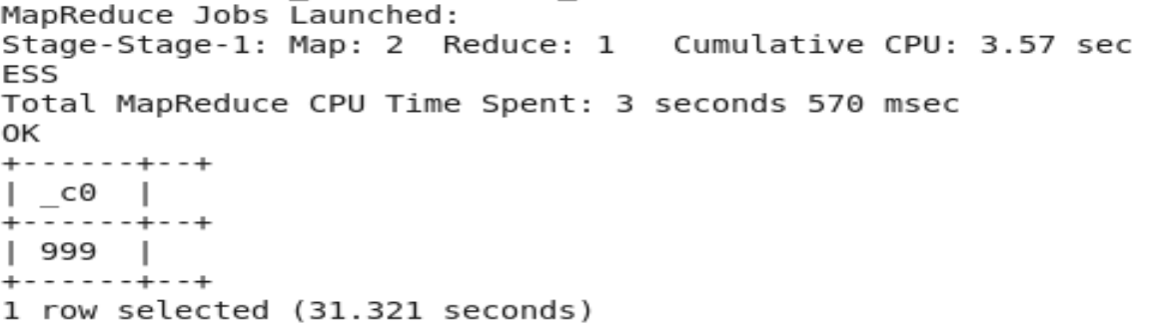

**Step2: -**

Production ready parameterized Sqoop import Shell Script(password encrypted) for Amazon RDS member_details table



**Step3: -**

Providing permission and execution command for sqoop import shell script

*chmod +x sqoop_import_member_details.sh*

Shell execution command:-

*./sqoop_import_member_score.sh database-2.cl4c0rtglkdz.ap-south-1.rds.amazonaws.com BankingPrj admin member_details*

**Task 9:**

=====================================================================================

**Step1: -**

Doing sqoop import of card_transactions data using password encryption from MYSQL to HDFS

*sqoop import *

*-Dhadoop.security.credential.provider.path=jceks://hdfs/user/cloudera/mysql.dbpassword.jceks *

*--connect jdbc:mysql://quickstart.cloudera:3306/bigdataproject *

*--username root *

*--password-alias mysql.bigdataproject.password *

*--table card_transactions *

*--split-by card_id *

*--warehouse-dir /project_input_data*

*hadoop fs -ls /project_input_data/card_transactions*

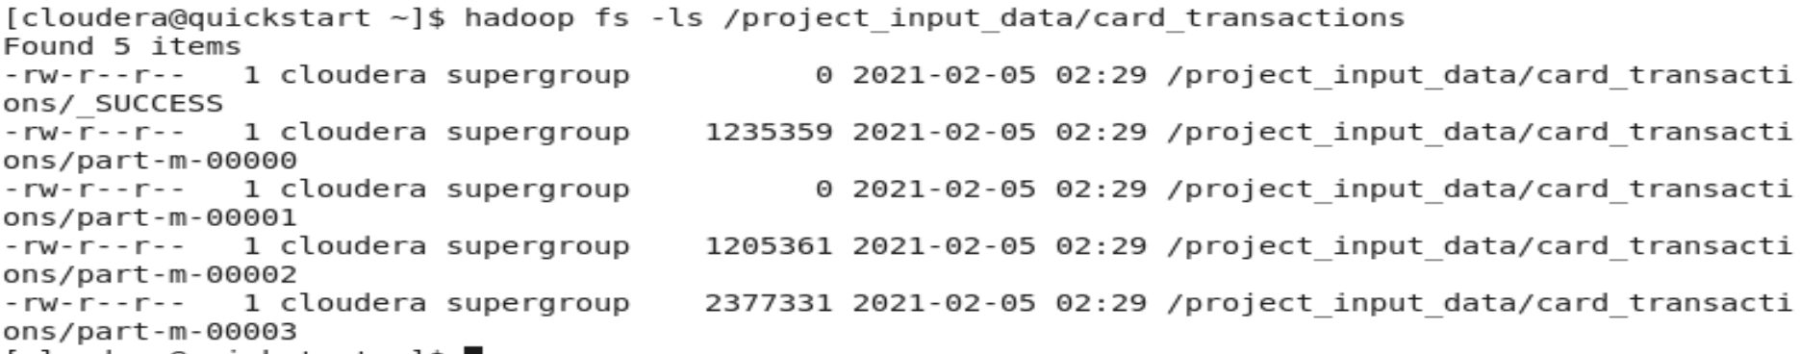

-------------------------------------------------------------------------------------

*sqoop import *

*-Dhadoop.security.credential.provider.path=jceks://hdfs/user/cloudera/mysql.dbpassword.jceks *

*--connect jdbc:mysql://quickstart.cloudera:3306/bigdataproject *

*--username root *

*--password-alias mysql.bigdataproject.password *

--query "select card_id,member_id,amount,postcode,pos_id, STR_TO_DATE(transcation_dt,'%d-%m-%Y %H:%i:%s') as transcation_dt,status from card_transactions WHERE \$CONDITIONS " \

*--split-by card_id *

--hcatalog-database bigdataproject \

--hcatalog-table card_transactions ;

*-------------------------------------------------------------------------------------*

**Step2: -**

Production ready parameterized Sqoop import Shell Script(password encrypted) for MYSQL card_transactions table



**Step3: -**

Providing permission and execution command for sqoop import shell script

*chmod +x sqoop_import_card_txns.sh*

Shell execution command:-

*./sqoop_import_card_txns.sh quickstart.cloudera:3306 bigdataproject root card_transactions*

**Task 14:**

=====================================================================================

Access the hive tables using apache spark and calculate the UCL.

import org.apache.spark.sql.{Row, SaveMode, SparkSession}

import org.apache.log4j.Logger

import org.apache.log4j.Level

import org.apache.spark.SparkConf

object HiveTest extends App{

**//set logging level to error**

Logger.getLogger("org").setLevel(Level.ERROR)

**// create spark config object**

val sparkConf= new SparkConf()

sparkConf.setAppName("Credit_Card_Fraud_Detection")

sparkConf.setMaster("local[2]")

sparkConf.set("hive.metastore.uris", "thrift://localhost:9083")

**// use spark config object to create spark session**

val spark = SparkSession

.builder()

.config(sparkConf)

.enableHiveSupport() **//spark integration with hive**

.getOrCreate()

import spark.implicits._

import spark.sql

**// start writing the hive queries**

val df_ucl=sql("""

with cte_rownum as

(

select card_id,amount,

row_number() over(partition by card_id order by transcation_dt desc) rownum

from card_transactions

)

select card_id,

avg(amount)+ 3* max(std) as UCL ,

avg(amount) as Avg_amount ,

max(std) as Std_deviation from

(

select

card_id,amount,

STDDEV (amount) over(partition by card_id order by (select 1) desc) std

from cte_rownum

where rownum<=10

)a

group by card_id

""" )

val df=df_ucl.select("card_id", "UCL")

df.show

}

