Which City has the best Nightlife?

Las Vegas?

Miami?

NY?

Table of Contents

• Introduction 2

• Data 3

Data: Part 1 4

.1 Nightlife Categories as per Foursquare API 4

.2 NY Nightlife Categories 5

.3 Miami Nightlife Categories 6

.4 Vegas Nightlife Categories 7

.5 Convert datatypes 11

Data: Part II 12

.6 Hot Encoding 13

.7 Normalize the data 14

.8 Final dataset 14

• Methodology 15

• Analysis 16

• Result & Discussion 23

• Conclusion 23

# Introduction

Millions of people love to travel and explore new places all over the world.

Before they plan their trip. Most of the tourists will try to look for the best places to stay, dine, party, etc.

We all know **Las Vegas**, **New York City**, and **Miami** are the most attractive tourist destinations among others in the USA. Each place is unique and known for its attraction.

**The entertainment capital of the world** LAS VEGAS is known for its gambling, shopping, fine dining, entertainment, and nightlife. The major attraction in Las Vegas are the casinos and the hotels and each casino have its nightclubs.

**The city that never sleeps** NEW YORK is known for many Broadway theaters, cinemas, and electronic billboards and nightlife. It has one of the world's most famous bars, music clubs, and night clubs.

**Miami** South Beach is home to some of the most beautiful beaches and outstanding nightclubs in the country.  The city attracts the second-highest number of foreign tourists of any city in the United States, after New York City.

Let us help a tourist who is a Night Owl (Nightlife Lover) and curious to know which city has the best **Nightlife** among these three cities?

# Data

To address this, we must know the definition of Nightlife and what categories come under this Nightlife. For this project, we will be considering the below factors(features).

* Venue Ratings
* Venue Prices
* Venue Likes
* Venue Tips

We will be narrowing our search for within 5 miles radius from the center of the City.

Following data sources will be needed to extract/generate the required data:

* Cities Lat and Long values will be obtained using Google Maps API reverse geocoding.
* Venues and its details will be obtained using Foursquare API.

**Note:** We will be evaluating our results with *Top 10 values* from each nightlife category for each city. We also restrict our data collection for up to 50 records for each category.

Collection of the required data in done two parts:

* First part: we collect the basic venue information like name, id, address, category etc.
* Second part: we collect further venue details like ratings, tips, likes, price range etc.

Once we collect the data in two parts. We merge the second part to the first part of the data. So that we can see all information together I,e venue name, id, rating, tips, counts, category and price range etc.

## Data: Part 1

### Nightlife Categories as per Foursquare API

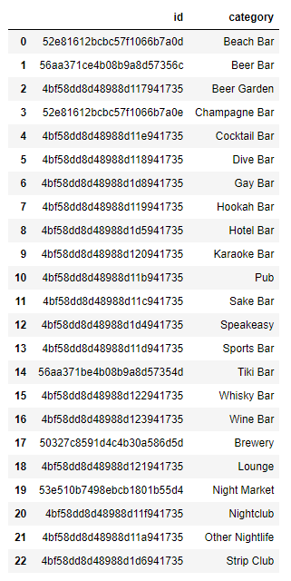

### NY Nightlife Categories

Beach Bar

Beer Bar

Beer Garden

Champagne Bar

Cocktail Bar

Dive Bar

Gay Bar

Hookah Bar

Hotel Bar

Karaoke Bar

Pub

Sake Bar

Speakeasy

Sports Bar

Tiki Bar

Whisky Bar

Wine Bar

Brewery

Lounge

Night Market

Nightclub

Other Nightlife

Strip Club

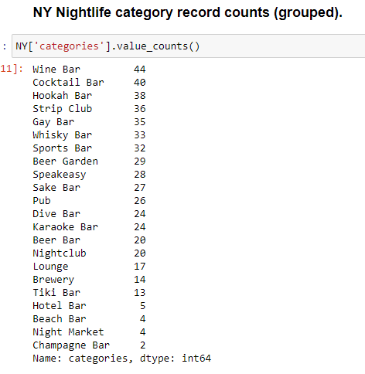

### Miami Nightlife Categories

Beach Bar

Beer Bar

Beer Garden

Champagne Bar

Champagne Bar not found

Cocktail Bar

Dive Bar

Gay Bar

Hookah Bar

Hotel Bar

Karaoke Bar

Pub

Sake Bar

Speakeasy

Sports Bar

Tiki Bar

Whisky Bar

Wine Bar

Brewery

Lounge

Night Market

Night Market not found

Nightclub

Other Nightlife

Strip Club

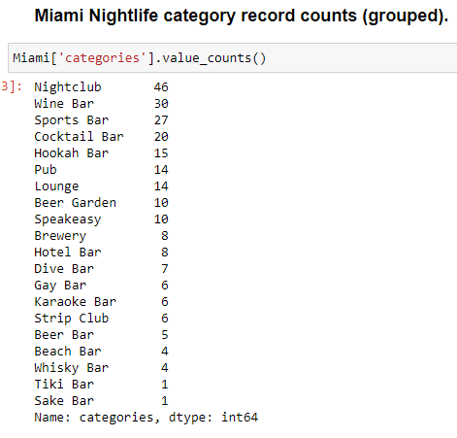

### Vegas Nightlife Categories

Beach Bar

Beer Bar

Beer Garden

Champagne Bar

Cocktail Bar

Dive Bar

Gay Bar

Hookah Bar

Hotel Bar

Karaoke Bar

Pub

Sake Bar

Speakeasy

Sports Bar

Tiki Bar

Whisky Bar

Wine Bar

Brewery

Lounge

Night Market

Night Market not found

Nightclub

Other Nightlife

Strip Club

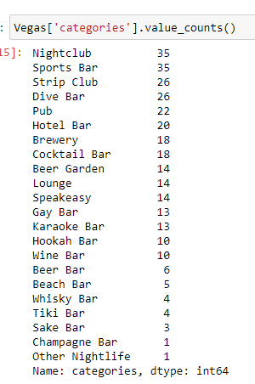

As we noticed, a couple of categories has very few record counts. Let’s consider only those categories which have at least 10 records.

Here, is the list of Nightlife categories common across three cities:

* Nightclub
* Pub
* Lounge
* Cocktail Bar
* Sports Bar

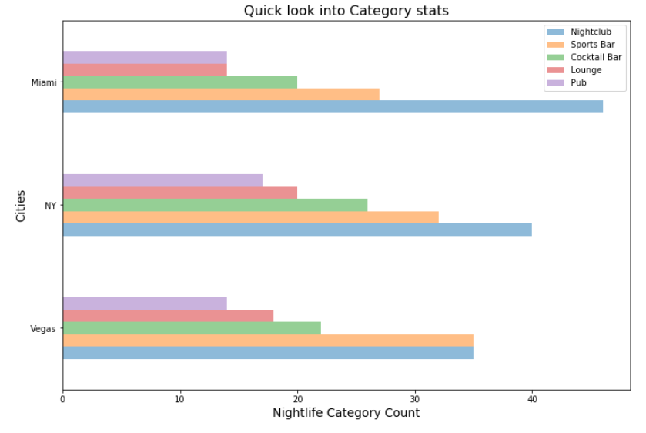

As we noticed, different categories have different counts. To be consistent let us get top 25 records for each category. Once we have further venue details like ratings etc. We will be sorting the data and narrow it down to top 10.

#### Vegas data filtered by nightlife categories

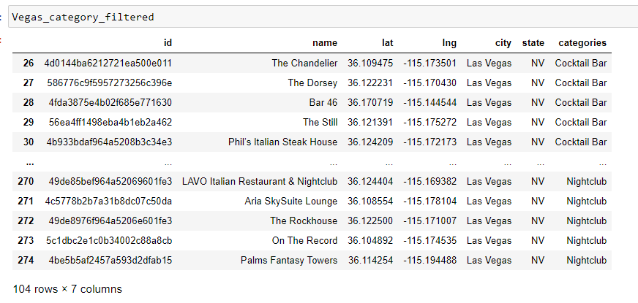

#### NY data filtered by nightlife categories

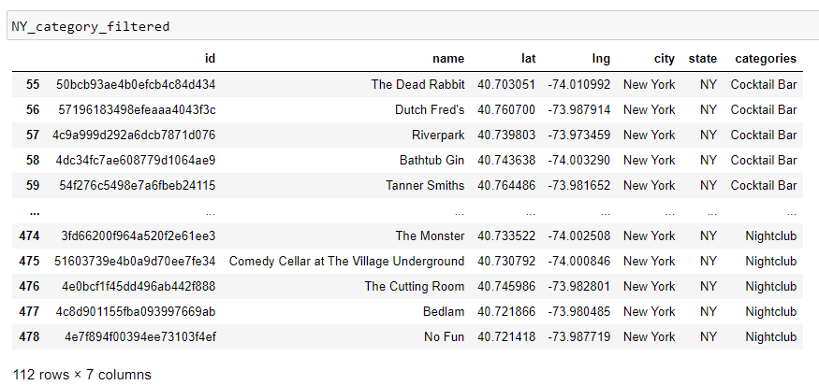

#### Miami data filtered by nightlife categories

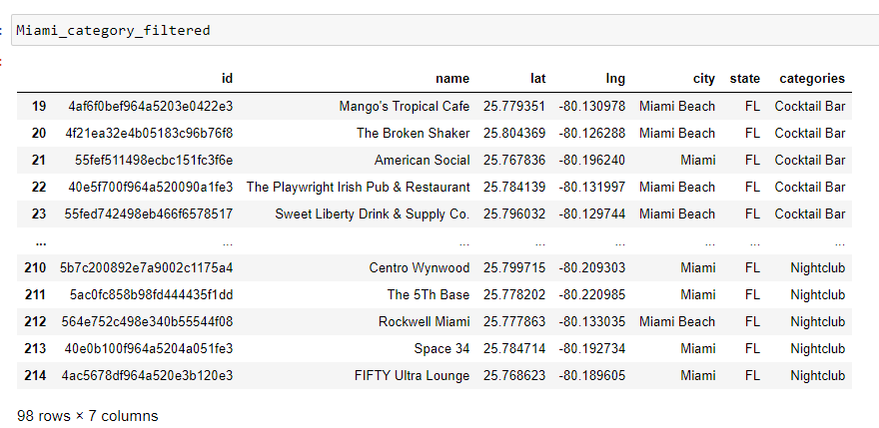

Now, we need to make a list of venue ids to pass it to the venue details Foursquare API.

We have a total of 314 venues.

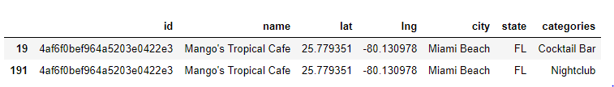

Now, we need to make a list of venue ids to pass it to the venue details Foursquare API.

We have a total of 314 venues.

We noticed a couple of venue ids have multiple categories as shown above. As we can only make 500 premium calls/day. Let us get the unique venue ids.

Now, we have 292 unique venue ids. The next step is to pass these venue ids in a loop to Foursquare API to get further venue details like price, ratings, tips, and likes, etc.

### Convert datatypes

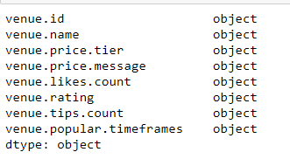

We need to convert datatypes for venue.rating, venue.tips.count,venue.likes.count and venue.price.tier to float and int respectively.

## Data: Part II

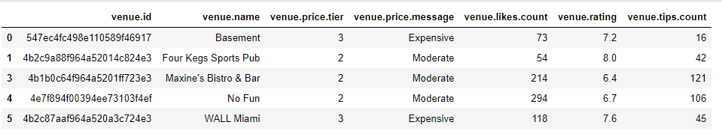

#### Vegas dataset after merging part 2 into part 1 of it.

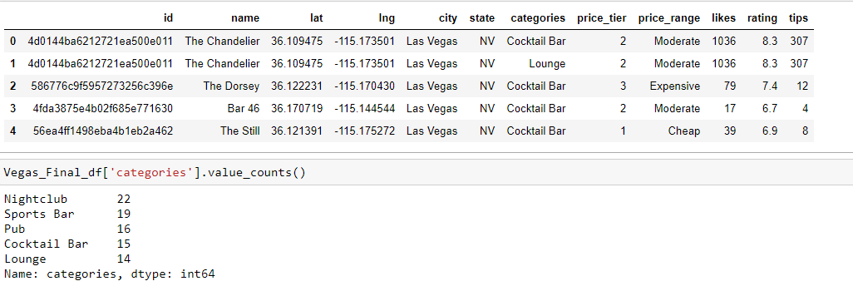

#### NY dataset after merging part 2 into part 1 of it.

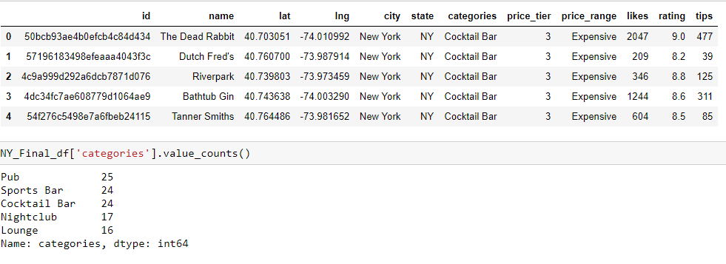

#### Miami dataset after merging part 2 into part 1 of it.

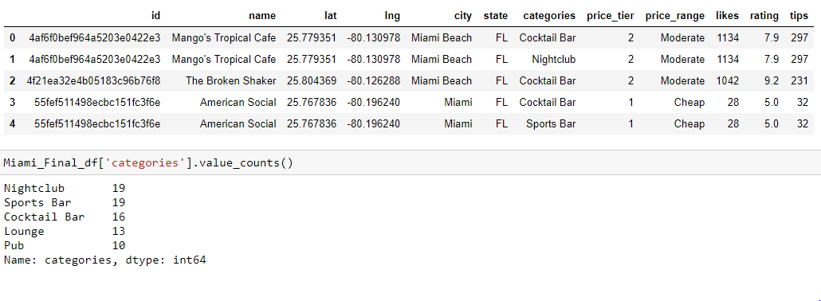

### 2.6 Hot Encoding

we Hot Encode any categorical data. Hot encoding converts categorical data into numeric values as shown below.

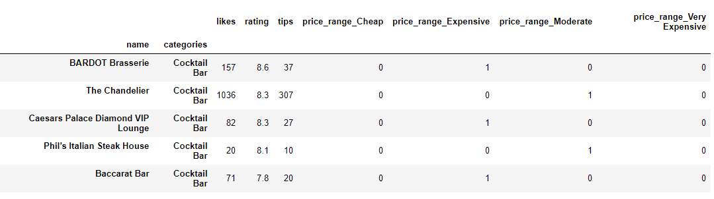

### 2.7 Normalize the data

We usually normalize the data. If the column values have a wide range of different numbers.

In our case ratings, likes and counts all have a different range of numbers. Let us normalize those values.

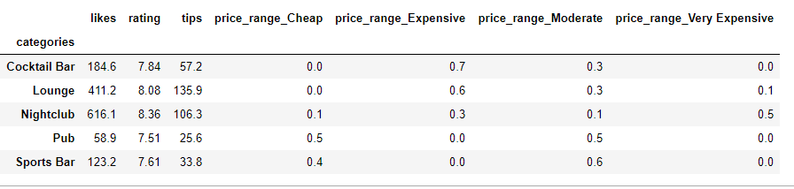

### 2.8 Final dataset

Now, we merge all the three individual data sets into one final dataset and group them by place and category.

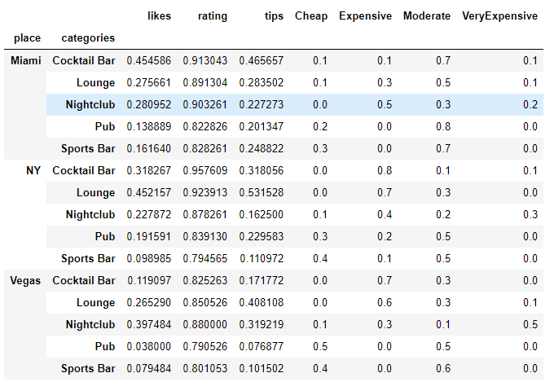

# Methodology

In this project, we will confine our efforts to the Nightlife categories suggested by Foursquare API, and the venues within 5 miles radius from the center of the city. Here in the final step, we deal with the **Top 10 records** from each category for each city.

In step one, we obtained the nightlife categories suggested by the Foursquare API. Later, we filtered the nightlife categories which are common across different cities. For these filtered categories, we gathered the **data: name, Lat, Lng, id of the venue for each category within 5 miles of radius** using FourSquare API. We limited our search for up to 50 records for each category.

In step two, we went ahead to get more details about each venue like **ratings, prices, likes, tips** bypassing the venue ids. After grouping the records based on the categories, we noticed different value counts for each group. To get accurate results, we decided to go with the top 10 records from each category. Repeat these steps for each city.

In step three, we **Hot Encode** any categorical data. In our case its the **price_range** column. Once we hot encode the price column, we normalize the data because data varies within a different range of numbers. After normalizing the data, we merge the data related to these three cities into a final data frame and obtained the mean values shown above.

### 

# Analysis

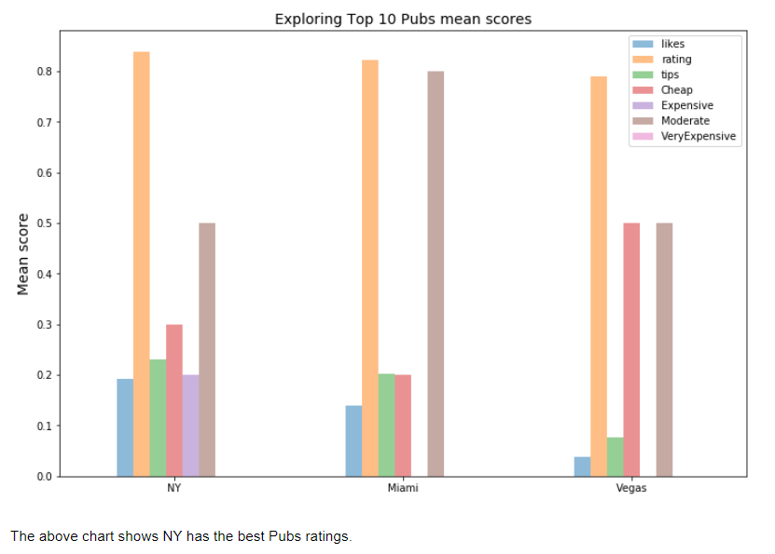

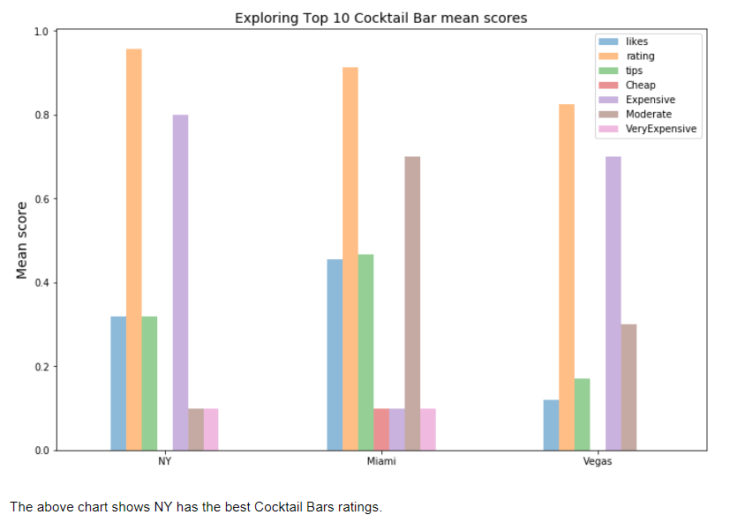

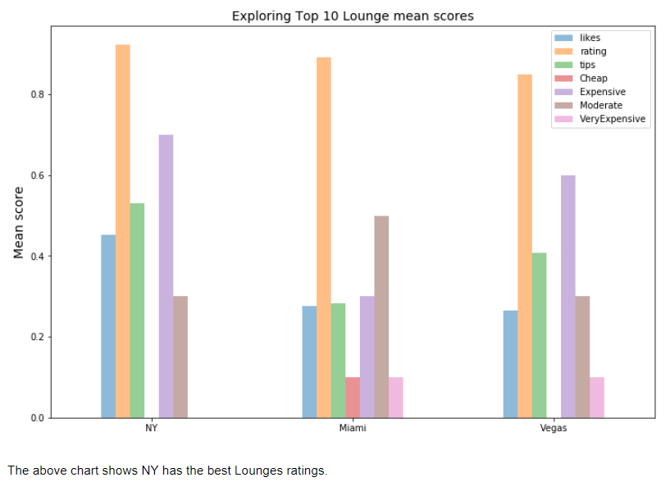

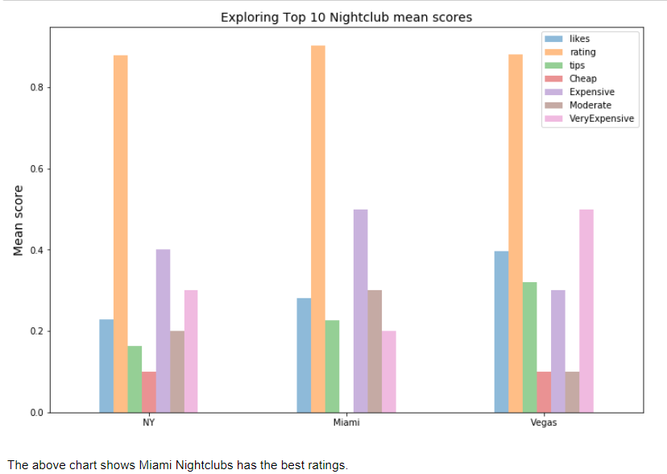

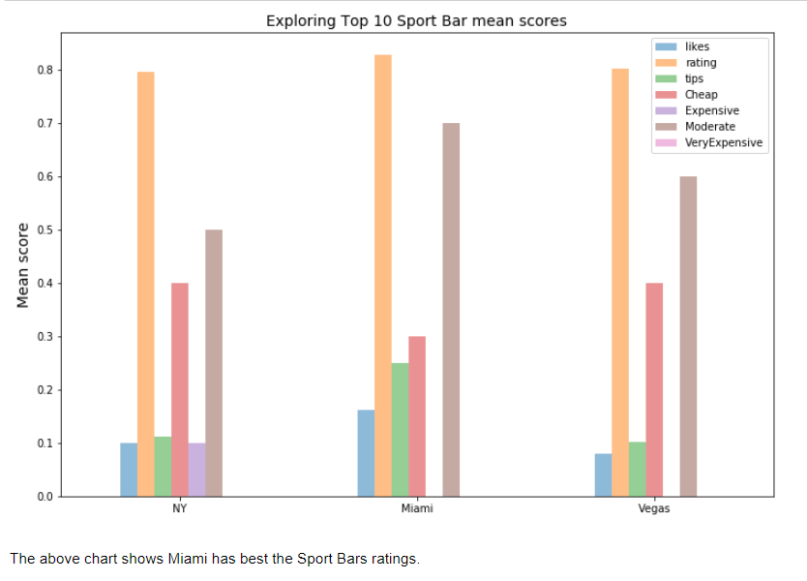

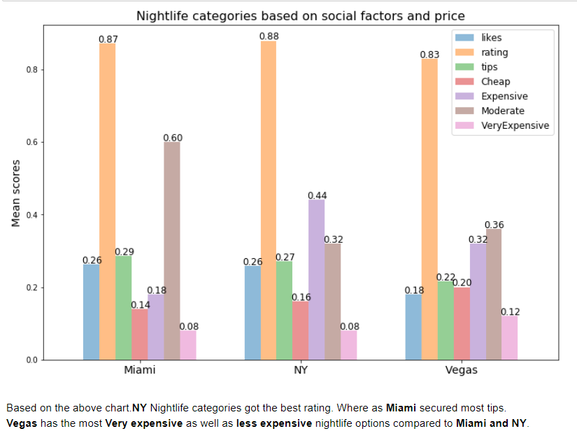

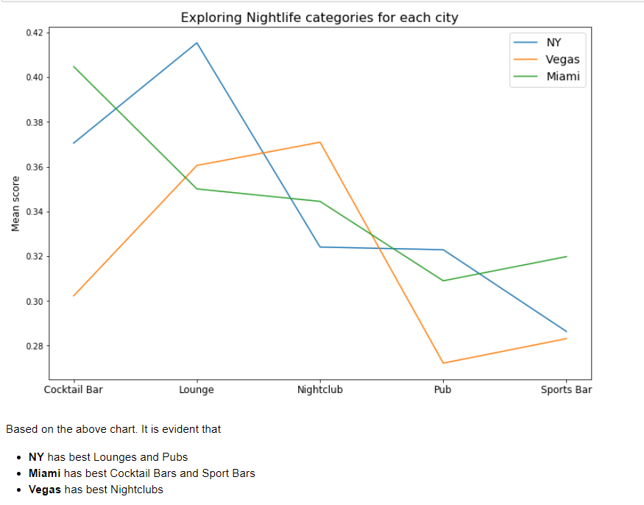

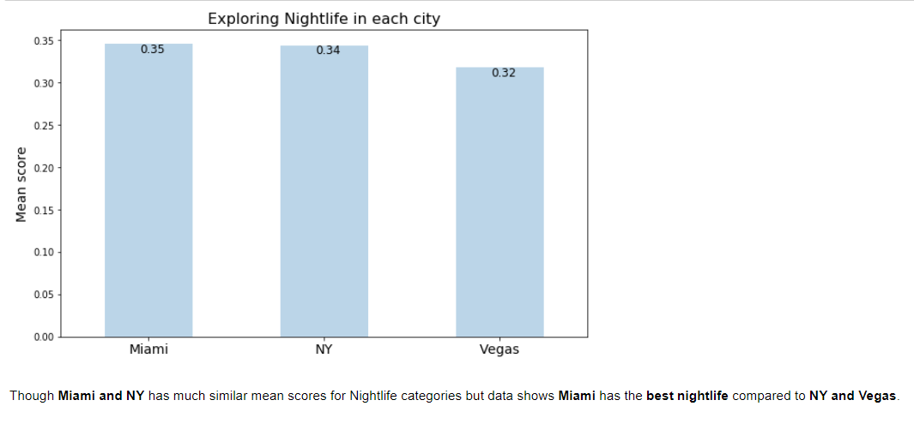

# Result & Discussion

We analyzed the five Nightlife categories **(Sport Bars, Pubs, Nightclubs, Cocktail Bars and Lounges)**. We considered social factors like ratings, likes, tips and prices for our analysis.

Based on the analysis, we found **NY** has the best *ratings*, **Miami** secured best *tips* and **Vegas** received minimum likes for their nightlife venues.  
**Vegas** has both **very expensive** and **less expensive** nightlife options. It is interesting to notice that people in **Miami and NY** gave equal *likes* to their nightlife venues.

Based on the Data. We also observed:

* **NY** has the best *Lounges and Pubs*
* **Miami** has the best *Cocktail Bars and Sport Bars*
* **Vegas** has the best *Nightclubs*

# Conclusion

Although **Miami and NY** have much similar mean scores for Nightlife categories. Which indicates both cities have similar Nightlife. But, based on the data **Miami** has the **best nightlife** compared to **NY and Vegas**.