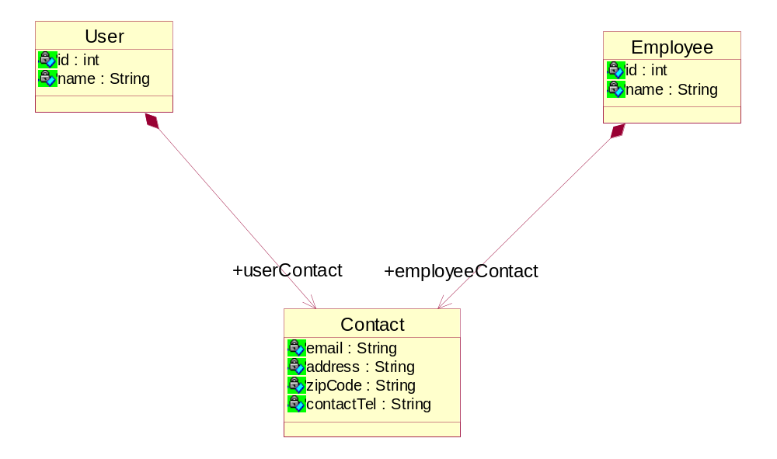
t_user
Id | Name | Email | Address | zipCode | contactTel
1 | 张三 | Aa | Dsss | Sss | sss

t_employee
Id | Name | Email | Address | zipCode | contactTel
1 | 李四 | Rr | ;; | kkkk | kllk

