Arduino + Gas Sensor

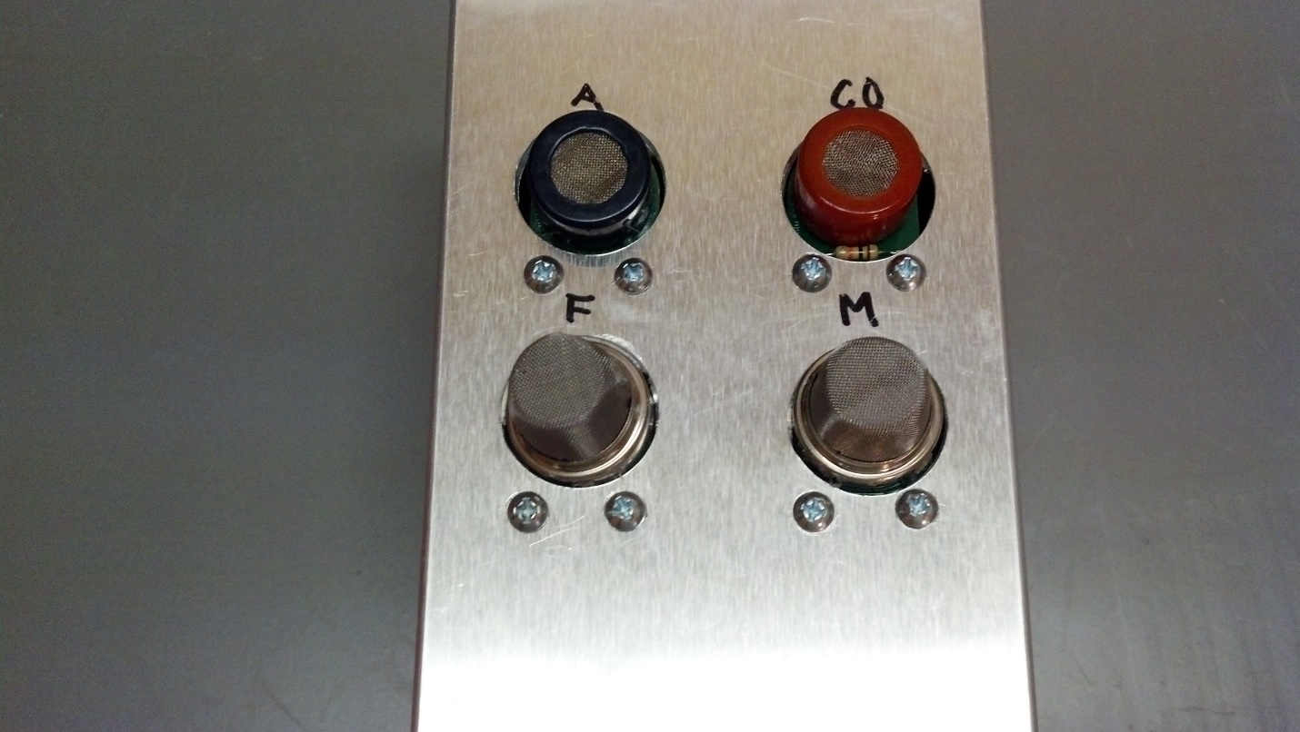

In order to convert the analog reading from the ADC into a sensible parameter such as PPM I referred to the datasheet. The datasheet gives us a log-log plot of Rs/Ro and PPM.

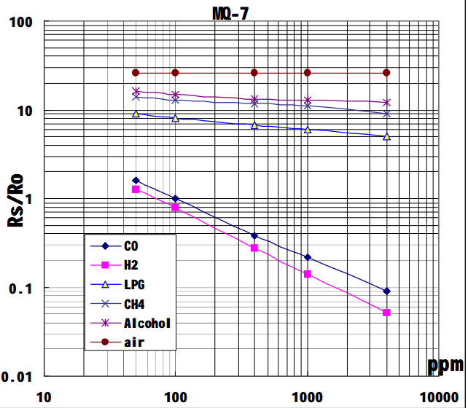

In order to calculate Rs, we use the formula Rs=(Vcc/VRL – 1) * RL. RL is the value of the resistor that was picked for the specific sensor used. VRL is the output voltage that is read into the ADC.

Next, Ro value needs to be calibrated. In order to do this a known source of a specific value is needed such as 100PPM CO source for the MQ-7 CO Sensor. That value then needs to be logged and programmed in.

Having Rs/Ro, the PPM can then be calculated. Since the plot in the datasheet gives us a log-log plot and not linear, we need to linearize this by taking several points in the plot and calculating the slope at from two points. This gives us a somewhat decent linear approximation of a logarithmic function.

I did this by eyeballing the data values from the plot on the datasheet and putting it in excel.

|  |  |  |
| --- | --- | --- |
| Ratio | PPM | Slope |
| 1.8 | 50 |  |
| 1.5 | 60 | -0.03 |
| 1.33 | 70 | -0.017 |
| 1.15 | 80 | -0.018 |
| 1.05 | 90 | -0.01 |
| 1 | 100 | -0.005 |
| 0.6 | 200 | -0.004 |
| 0.47 | 300 | -0.0013 |
| 0.39 | 400 | -0.0008 |
| 0.34 | 500 | -0.0005 |
| 0.3 | 600 | -0.0004 |
| 0.275 | 700 | -0.00025 |
| 0.25 | 800 | -0.00025 |
| 0.24 | 900 | -0.0001 |
| 0.22 | 1000 | -0.0002 |
| 0.16 | 2000 | -0.00006 |
| 0.11 | 3000 | -0.00005 |
| 0.09 | 4000 | -0.00002 |
| 0.01 | 10000 | -1.33333E-05 |
|  |  |  |