Reporter: Nguyen Duong Thu Thuy

**Database**

1. **SQLite**
2. **What is SQLite?**

* SQLite database feature is inbuilt provided by the iOS framework
* Structured Query Language (SQL)
* A pure Swift interface
* A type-safe, optional-aware SQL expression builder
* A flexible, chainable, lazy-executing query layer i.e a flexible coding style with queries that can be chained together to form a single query

1. **Realm**
2. **What is a Realm?**

* An instance of Realm Mobile Database container
* Loyal, synchronized, or in-memory

1. **Some notes**

* Realm is not a single application-wide database: an application often uses multiples Realms
* A Realm is not a table: A realm can contain multiple kinds of objects
* A Realm is not a schemaless document store

1. **Realm Model**

* Configuration

When you open a Realm, you pass the constructor a configuration object that defines how to access it. The configuration object specifies where the Realm database is located:

* A path on the device’s local file system
* A URL to a Realm Object Server, with appropriate access credentials (user/password, auth token)
* An identifier for an in-memory Realm

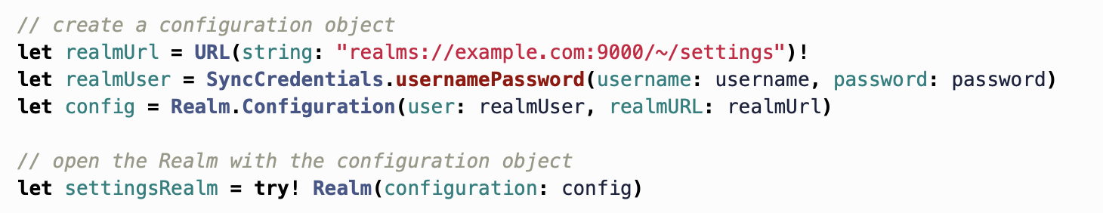

If you don’t provide a configureation object, you’ll open the default Realm, which is a local Realm specific to that application



* Realm URLS
* 3 types: **public**, **private** and **shared**.
* They’re all accessed the same way. The difference between them is access controls, which users can read and write to them. The URL format may also look a little different:

+ **Public**: can be accessed by all users. Owned by the admin user on the Realm Object Server, read-only to non-admins. ( realms://server/realm-name )

+ **Private**: Only the user that creates it has read and write permissions. ( realms://server/user-id/realm-name )

+ **Shared**: a private realm and owners grant other users read (and possibly write) access. ( realms://server/user-id/realm-name ) user-id is the userid of the owner. Everyone in that group has their own local copies of the Realm, but there’s only one “master” copy synced through the Object Server

* Permissions

Permission are set on each Realm using 3 boolean flags:

+ mayRead: can read

+ mayWrite: can write

+ mayManage: can change permissions on the Realm for other users

By default, a Realm is private.

* Models and Schema

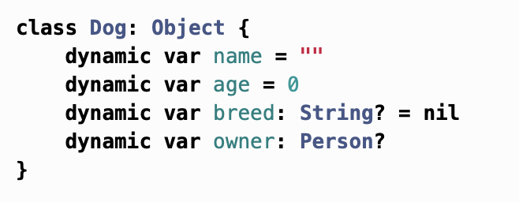

* To-one Relations

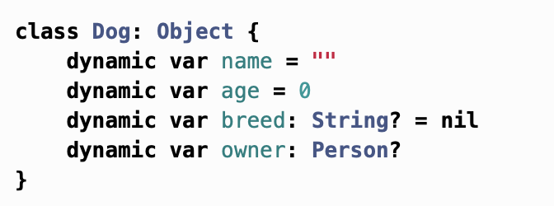

* To-Many Relationships

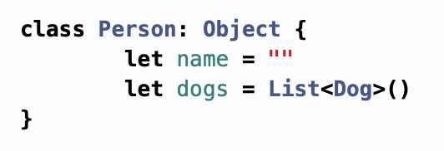

A list in Realm contains one or more Realm objects. To add Fido to Bob’s list of dogs:

Bob.dogs.append(fido)

* Inverse Relationship

You’ll note that defining the Person has-many Dogs relationship didn’t automatically create a Dog belongs-to Person relationship; both sides of the relationship need to be set explicitly. It’s important to define both sides of this relationship.

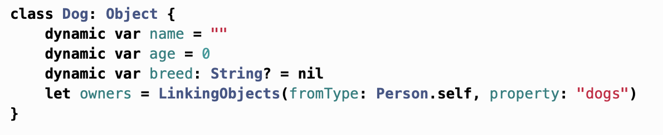

1. **Realm Objects**

Object instances are live, auto-updateing views into the underlying data. You never have to refresh objects.

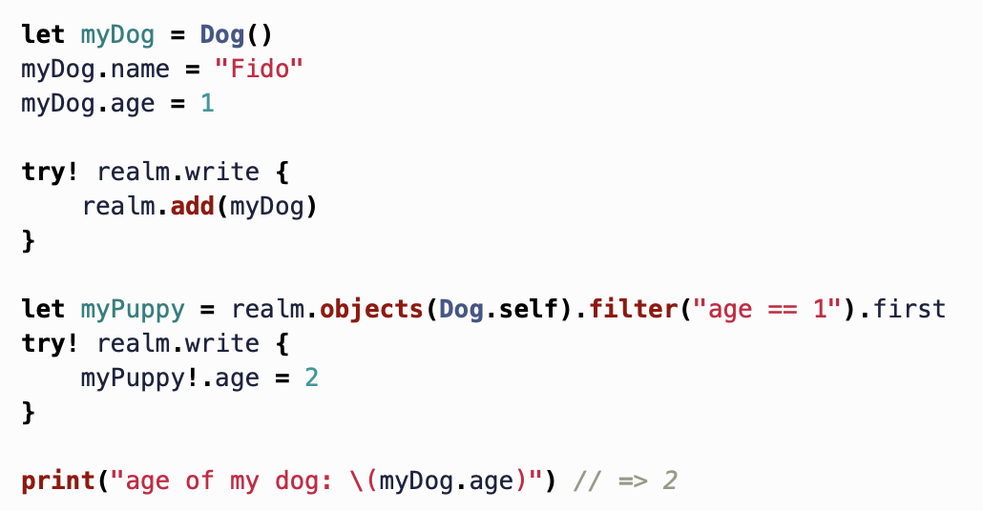

* Keep Realm fast and efficient, it also allow your code to be simpler and more reactive. If your UI code is dependent on a specific Realm object, you don’t need to worry about refreshing or re-fetching it before triggering a UI redraw.

1. **Some limitations**

* Some limits relate to class size, property name, data and string type.

1. **UserDefault**

* You can use Userdefaults to store any basic data type for as long as the app is installed. You can write basic types such as Bool, Float, Double, Int, String, URL. Some more complex ones: arrays, dictionaries, Date and even Data values
* When you write data to Userdefaults, it automatically gets loaded when your app runs so you can read it back again.
* Remember, it’s a bad idea to store lots of data in Userdefaults because it will slow loading of your app. (should not take up more than 100KB)
* Usage:

+ let defaults = UserDefaults.standard

* + set values:
  + Defaults.set(25, forKey: “Age”)

1. **NSCoding**

* NSCoding is a protocol that you can implement on your data classes to support encoding and decoding your data into a data buffer, which then can be persisted to disk
* Broadly speaking, NSCoing is the Objective-C way of archiving data and Codable is the Swift way.
* When to use: when you don’t want to use a more complex tool, like Core Data or Realm

** How to use:

* Declare class and make it conform to NSObject, NSCoding

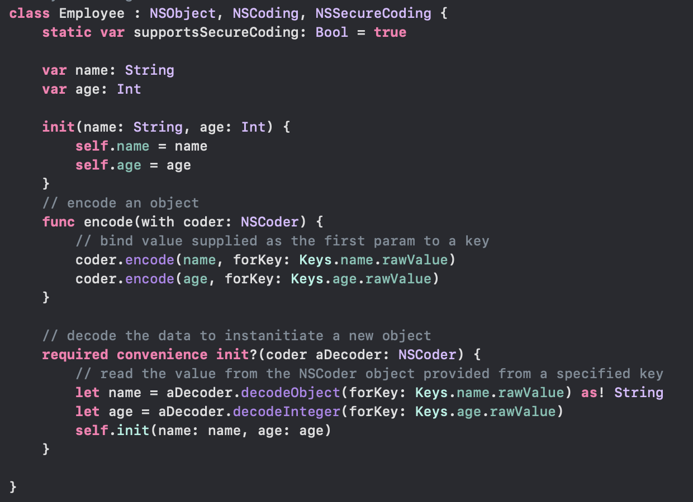

Archive that object to NSUserdefaults:

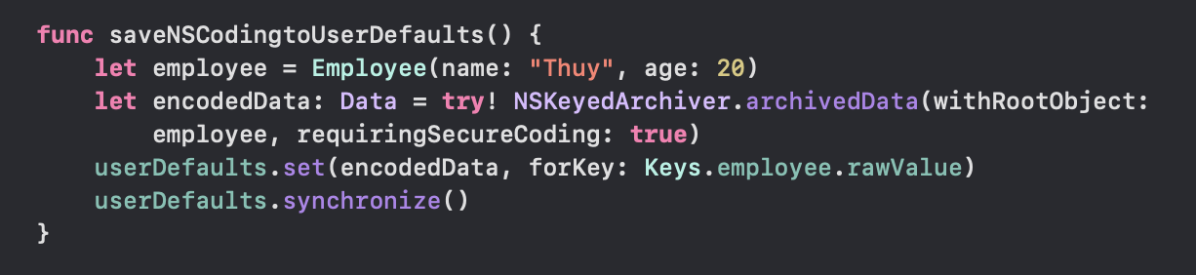

Then unarchive the data:



1. **Keychain**
2. **What is Keychain?**

* Keychain is storage of small, sensitive data such as passwords, bank account, number, or some other personal information that we want to keep confidential for your users.
* We can share the information between many applications on the same device which has the same Apple Developer Account.

**Some terminology:

* Keychain: The keychain is a secure an encrypted storage place for sensitive data. You can think of it as a database of sensitive information
* Keychain Item: a registry in the keychain
* Item Class: you can think of a class as a template of information you want to store. The keychain offers classes for different common credentials, like username/password pairs, a certificate, a genetic password, and more.

** Keychain is **tied** to the **developer provisioning profile** used to sign the app and its bundle ID