Reporter: Nguyen Duong Thu Thuy

**Xcode Debug**

**\*\* What is a retain cycle?**

*As we know each time we declare a class property by default it has a strong reference to object which it is pointing to unless we specify something, so when can a strong cycle appear?*

Cases were Parent has a strong reference with Child and Child, in turn, has a strong reference to Parent

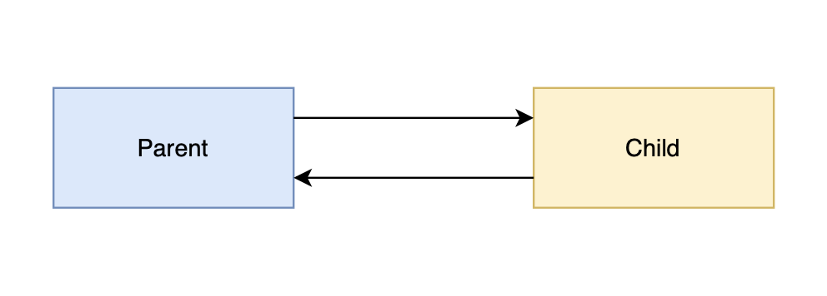

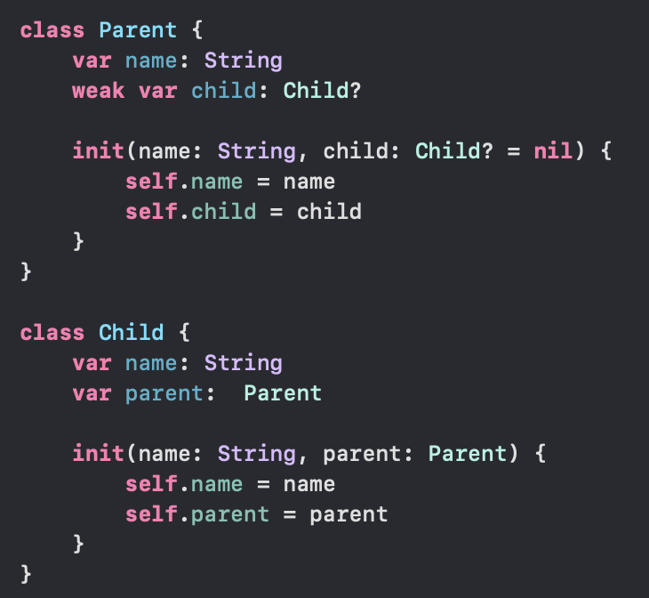

Strong variables increase the reference count. For instance, if an object has a reference count of 2 and is assigned to a new strong variable, its reference count increases to 3.

On the other hand, weak variables do not increase the reference count. If an object with a reference count of 2 is assigned to a new weak variable, its reference count will still be 2.

Furthermore, this means that, while a strong variable is active, its referenced component will be guaranteed to remain in memory. However, this guarantee will not apply to weak variables.

So, to fix the retain cycle problem, change strong to weak variable:

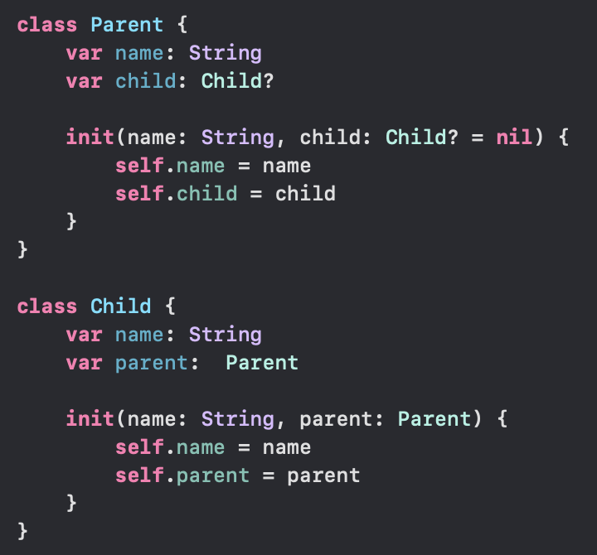

So that strong reference will disappear.

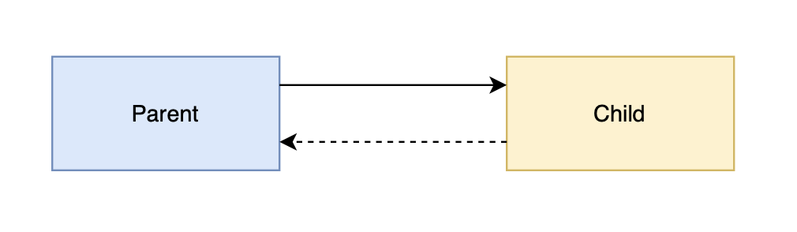

1. Debug Retain Cycle / Memory Leaks

* Debug RetainCtyle: Using Visual Memory Graph
* Debug Memory Leaks: Using Xcode Instrument

Link video: <https://drive.google.com/file/d/1z942soZv1DY9LF6_q8cjxQN45cwqEuPj/view?usp=sharing>