

SPECIFICATION

Product name： | Energy Storage Master Control Management Unit
Product model： | BCU-B3
Internal model： | C-1000V-312A01
Product code： | 60.01.002.0015
Version： | VER1.1
Customer name：
Signatures：

JKBMS Electronic Technology Co., Ltd.

Revision History
Revision date | Version number | Revised content | Reviser
2025-01-04 | VER1.0 | Initial Release
2025-10-11 | Ver1.1 | 1. Page 9, Pins 14 & 15: High-side Outputs 7 & 8 changed to Low-side Outputs 1 & 2.  2. Version updated to 1.1.

Contents

1. Product Overview 4
2. Functional Characteristics 4
3. Application Scope 5
4. Interface Configuration 5
5. Operating Environment 6
6. System Block Diagram 6
7. Electrical Characteristics 7
7.1Maximum Limit Parameters 7
7.2Basic Electrical Parameters 7
7.3Interface Parameters 7
8. Product Appearance 9
8.1 Interface Definitions 9
8.2 Interface Description 9
8.3 Appearance and Dimensions 13
9. Precautions 14
10. Packaging and Storage 14
10.1 Packaging 14
10.2 Transportation 14
10.3 Storage 14
11. Technical Support and Services 15

BCU-1000-B3Product Overview
BCU-B3 is a master control module for battery management systems independently developed by our company. It communicates with slave control units (BMUs) to monitor individual cell voltages, temperatures, etc. It also monitors external characteristic parameters of the battery pack, such as total voltage, current, temperature, and insulation resistance to ground. Based on physical cell model algorithms, it estimates and monitors internal battery states (SOC, SOH, SOP, etc.). Building on this foundation, it implements functions including battery pack system charge/discharge management, thermal management, insulation detection, cell balancing management, and fault alarm by controlling the on/off states of output switches. This prevents battery overcharging or over-discharging, ensuring the battery pack operates in an optimal state. The system employs self-developed SOC and active balancing algorithms to achieve energy balance management for lithium battery systems, thereby extending battery service life.
The system features high reliability, high precision, strong anti-interference capability, flexible configuration, broad applicability, support for remote monitoring, and remote OTA upgrades. It can exchange data with devices such as PCS, EMS, and HMIs via communication buses, and communicate with BMUs via CAN or daisy-chain protocols. It supports IoT remote monitoring, allowing real-time monitoring of system operational status and positioning via a monitoring backend. It also enables real-time monitoring and control of battery system information, status, and alarm data. The big data cloud platform enhances the customer experience.
The product design follows the ISO 26262 functional safety design standard.

Functional Characteristics
- Charge and discharge management
- Accurate voltage, current, and temperature acquisition
- SOC, SOH, SOP estimation
- Supports bidirectional controllable energy balancing (requires pairing with an active balancing BMU)
- Proprietary patent balancing control algorithm
- Protection against hot-plugging and connector misinsertion damage
- High expandability, simple field application
- Compatible with Lithium Iron Phosphate (LFP), Lithium Nickel Manganese Cobalt Oxide (NMC), Lithium Manganese Oxide (LMO), and other battery types
- Data storage, transmission, and processing
- Supports PCS communication
- Supports human-machine interface interaction
- Supports BeiDou and GPS positioning
- Supports remote real-time monitoring
- Supports CAN online upgrades
- Supports remote OTA upgrades

Application Scope
- Suitable for Lithium Iron Phosphate (LFP), Lithium Nickel Manganese Cobalt Oxide (NMC), Lithium Manganese Oxide (LMO), Lithium Titanate (LTO), and Lithium Cobalt Oxide (LCO) batteries.
- Commercial and industrial energy storage systems, energy storage power stations.
- Capacity enhancement for echelon used batteries.
- Distributed, high-series-count energy storage application systems.

Interface Configuration
- 22 channels of CAN communication interface
- 2 channels of RS-485 communication interface
- 6 GPIO interfaces
- 6 high-side switch interfaces
- 2 low-side switch interfaces
- 4 dry contact outputs
- 1 high-voltage interlock detection interface
- 4 high-voltage detection interfaces
- 1 shunt current detection interface
- 4 internal temperature sampling channels
- Supports remote real-time monitoring and GPS positioning configuration
- Supports remote program upgrade configuration

Operating Environment
- BCU-1000-B3Operating temperature: -25°C to 85°C
- Storage temperature: -40°C to 125°C
- Relative humidity: 5% to 95% RH, non-condensing
- Operating altitude: Up to 2000 meters

System Block Diagram
The BCU master control unit consists of an MCU control module, voltage/current acquisition modules, high/low-side switch control modules, and supported peripherals. The design incorporates highly reliable MCU control chips and employs the latest acquisition technologies, providing high acquisition accuracy and a solid physical foundation for State of Charge (SOC) estimation. Based on in-depth research into the complex electromagnetic environment of battery pack applications, product Electromagnetic Compatibility (EMC) was fully considered from the initial design phase. A multi-level power isolation scheme and high-redundancy design were adopted, and the product underwent rigorous testing to ensure reliable operation and stable performance in various environmental conditions. A typical application diagram for the master control unit is shown below:
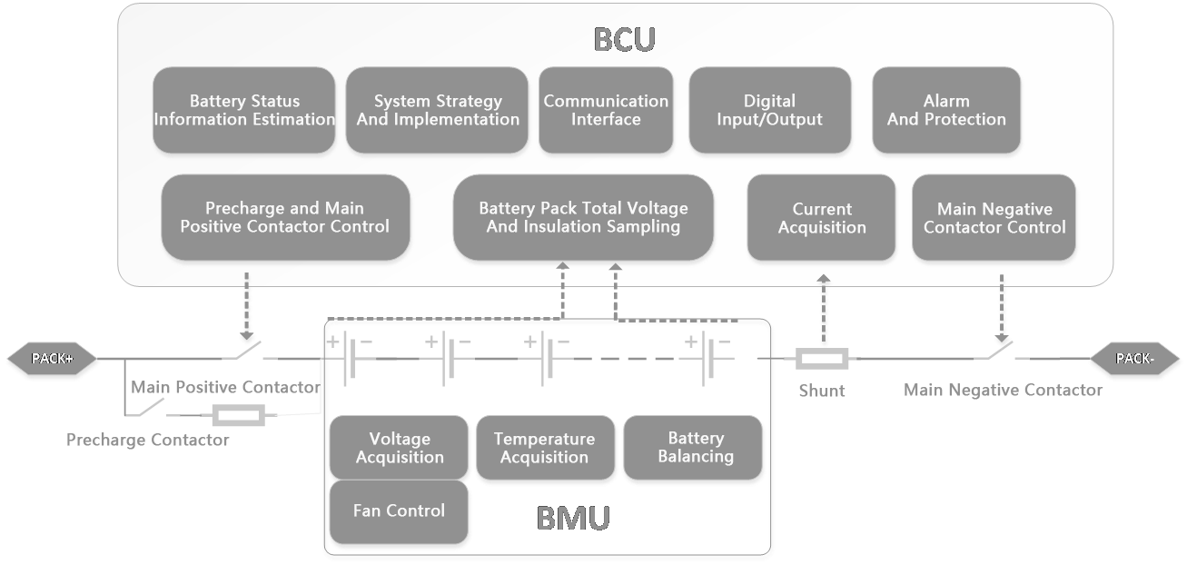
Figure 6.1 BCU System Block Diagram

Electrical Characteristics

7.1Maximum Limit Parameters
The following parameters, unless otherwise specified, represent the absolute maximum ratings at an ambient temperature of 25°C.
Characteristic | Symbol | Min | Max | Unit | Note
Auxiliary terminal maximum input voltage | Vmax | 7 | 33 | V
Operating ambient temperature | T_full | -40 | 105 | °C
Storage temperature | Tstg | -55 | 125 | °C
ESD protection | V_esd | - | 16 | kV | Air discharge
Note：
- Absolute maximum ratings indicate that permanent damage may occur if the module is operated beyond these limits.
- The maximum allowable power dissipation decreases with increasing temperature, determined by the maximum junction temperature (Tj), ambient temperature (TA), and thermal conditions.

7.2Basic Electrical Parameters
The following parameters, unless otherwise specified, represent basic electrical characteristics at an ambient temperature of 25°C.
Characteristic | Symbol | Test Condition | Min | Typical | Max | Unit
Auxiliary power consumption | I_pwr+ | PWR+=24V |  | 50 |  | mA
HSD high-side output current | I_hsd |  |  | 1 |  | A
GPIO | V_gp |  |  | 24 |  | V
Temperature sampling range | T_ran |  | -30 |  | 105 | ℃

7.3Interface and Electrical Parameters
The following parameters, unless otherwise specified, represent the absolute maximum ratings at an ambient temperature of 25°C.
Name | Qty | Parameter | Min | Typical | Max | Description
Auxiliary Power Supply | 1 | Voltage | 9V | 24V | 32V | Switch-mode power supply / Battery
 |  | Current | - | 0.1A | -
High Voltage Sampling | 3 | Detection Range | 0V | - | 1500V | Total voltage
 |  | Total Voltage Accuracy | - | - | ≤1%
 |  | Detection Period | - | - | ≤100ms
Current Sampling | 1 | Detection Range | -300A | - | 300A
 |  | Accuracy |  |  | ≤1%
 |  | Detection Period |  |  | ≤50ms
Insulation Resistance Sampling | 1 | 20M
High-Voltage Interlock | 1 |  |  |  |  | Interlock function detection
Analog Inputs | 4 | Sampling Error |  |  | ≤2% | For temperature, other AD inputs, etc.
High-side Switch Outputs | 6 | Voltage/Current | - | 1A | 3A @ 300ms | Vmax = 32V
Low-side Switch Outputs | 2 | Voltage/Current | - | 1A | -
GPIO | 6 | Voltage | - | 24V | - | For switch signal detection
Dry Contacts | 4 | Voltage/Current |  | 0.5A | 0.8A | Vmax = 32V
CAN Ports | 2 | Isolation |  |  |  | 250k/500k BPS
RS485 Ports | 4 | Isolation |  |  |  | 57600 BPS

Product Appearance

8.1Interface Definitions
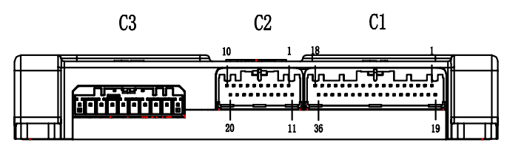
Figure 8.1 Interface Front View

Connector | Brand | Pin Count | Board Side Code/Model | Wire Side Code/Model
Crimp terminal:：63.09.002.0002/M34 S75C4F1/ suitable for wire gauge0.22~0.35mm2
C1 | JAE | 36 | 63.09.000.0027/ MX34036NF1 | 63.09.001.0009/MX34036SF1
C2 | JAE | 20 | 63.09.000.0003/ MX34020NF1 | 63.09.001.0008/MX34020SF1
Crimp terminal：63.09.002.0005/AAUTA179-K001B54CQ/suitable for wire gauge0.5~0.75mm2
C3 | LOTES | 10 | 63.09.000.0028/  AAUS07AP5-010K02 | 63.09.001.0007/ AAUS07AS0-010K01

8.2Interface Description
Connector | Model | Pin No. | Name | Function | Description
C1 | MX34036NF1 | 1 | DRY1+ | Dry contact output 1 positive | Dry contact switch 1
 |  | 2 | DRY1- | Dry contact output 1 negative
 |  | 3 | PWR+ | Input | Auxiliary power supply12~24V+
 |  | 4 | PWR+ | Input | Auxiliary power supply12~24V+
 |  | 5 | PWR- | Input | Auxiliary power supply-
 |  | 6 | PWR- | Input | Auxiliary power supply-
 |  | 7 | PWR- | Input | Auxiliary power supply-
 |  | 8 | H_OUT1 | Output | High-side switch 1 output port
 |  | 9 | H_OUT2 | Output | High-side switch 2 output port
 |  | 10 | H_OUT3 | Output | High-side switch 3 output port
 |  | 11 | H_OUT4 | Output | High-side switch 4 output port
 |  | 12 | H_OUT5 | Output | High-side switch 5 output port
 |  | 13 | H_OUT6 | Output | High-side switch 6 output port
 |  | 14 | L_OUT1 | Output | Low-side switch 1 output port
 |  | 15 | L_OUT2 | Output | Low-side switch 2 output port
 |  | 16 | NC | Vacant
 |  | 17 | NC | Vacant
 |  | 18 | NC | Vacant
 |  | 19 | DRY2+ | Dry contact output 2 positive | Dry contact switch 2
 |  | 20 | DRY2- | Dry contact output 2 negative
 |  | 21 | DRY3+ | Dry contact output 3 positive | Dry contact switch 3
 |  | 22 | DRY3- | Dry contact output 3 negative
 |  | 23 | DRY4+ | Dry contact output 4 positive | Dry contact switch 4
 |  | 24 | DRY4- | Dry contact output 4 negative
 |  | 25 | EXT_RT1 | NTC | NTC1 sampling, 33K pull-up
 |  | 26 | EXT_RT2 | NTC | NTC2 sampling, 33K pull-up
 |  | 27 | EXT_RT3 | NTC | NTC3 sampling, 33K pull-up
 |  | 28 | EXT_RT4 | NTC | NTC4 sampling, 33K pull-up
 |  | 29 | EXT_RT- |  | External NTC reference ground
 |  | 30 | EXT_DIO1 | GPIO | GPIO1 port, input/output configurable
 |  | 31 | EXT_DIO2 | GPIO | GPIO2 port, input/output configurable
 |  | 32 | EXT_DIO3 | GPIO | GPIO3 port, input/output configurable
 |  | 33 | EXT_DIO4 | GPIO | GPIO4 port, input/output configurable
 |  | 34 | EXT_DIO5 | GPIO | GPIO5 port, input/output configurable
 |  | 35 | EXT_DIO6 | GPIO | GPIO6 port, input/output configurable
 |  | 36 | NC | Vacant
C2 | MX34020NF1 | 1 | RS485A1 | 485_1Bus A | For PCS communication in two-tier architecture
 |  | 2 | RS485B1 | 485_1Bus B | For PCS communication in two-tier architecture
 |  | 3 | 485_EARTH1 | 485_1Shield Ground
 |  | 4 | RS485A2 | 485_2Bus A | For HMI communication in two-tier architecture
 |  | 5 | RS485B2 | 485_2Bus B | For HMI communication in two-tier architecture
 |  | 6 | 485_EARTH2 | 485_2Shield Ground
 |  | 7 | HVIL_IN | Interlock detection signal input
 |  | 8 | HVIL_OUT | Interlock detection signal output
 |  | 9 | NC | Vacant
 |  | 10 | NC | Vacant
 |  | 11 | CAN1_H | CAN_1Bus H | Debugging / Internal network CANH
 |  | 12 | CAN1_L | CAN_1Bus L | Debugging / Internal network CANL
 |  | 13 | CAN_EARTH1 | CAN_1 Shield Ground
 |  | 14 | CAN2_H | CAN_2 Bus H | Charger / BAU communication CANH
 |  | 15 | CAN2_L | CAN_2 Bus L | Charger / BAU communication CANL
 |  | 16 | CAN_EARTH2 | CAN_2 Shield Ground
 |  | 17 | IP0 | Daisy-chain communication | Daisy-chain communication cables inside/outside the cabinet must use unshielded twisted pair. Twist pitch ≤20mm, separation distance ≤50mm.
 |  | 18 | IM0
 |  | 19 | NC | Vacant
 |  | 20 | EARTH | Chassis | Insulation detection reference ground, connect to chassis
C3 | AAUS07AP5-010K02 | 1 | BAT- | Total voltage sampling negative | Connect to system battery total negative
 |  | 2 | IN0- | Shunt sampling negative terminal | Connect near battery total negative
 |  | 3 | IN0+ | Shunt sampling positive terminal | Connect to shunt output external terminal
 |  | 4 | HV_CH4 | Main negative contactor detection | Main negative contactor weld detection
 |  | 5 | NC | Vacant
 |  | 6 | NC | Vacant
 |  | 7 | HV_CH2 | Discharge (main positive) contactor detection | Discharge (main positive) contactor weld detection
 |  | 8 | HV_CH1 | Charge contactor detection | Charge contactor weld detection
 |  | 9 | NC | Vacant
 |  | 10 | BAT+ | Total voltage sampling positive | Total voltage sampling, connect to system battery total positive

8.3 Appearance and Dimensions
The product housing is made of sturdy sheet metal and features four elongated fixing holes, ensuring secure and reliable installation. This design offers broader application adaptability suitable for various scenarios.
Dimensions（Length、Width、Height）：155mm*121mm*27mm
Weight： g±10g
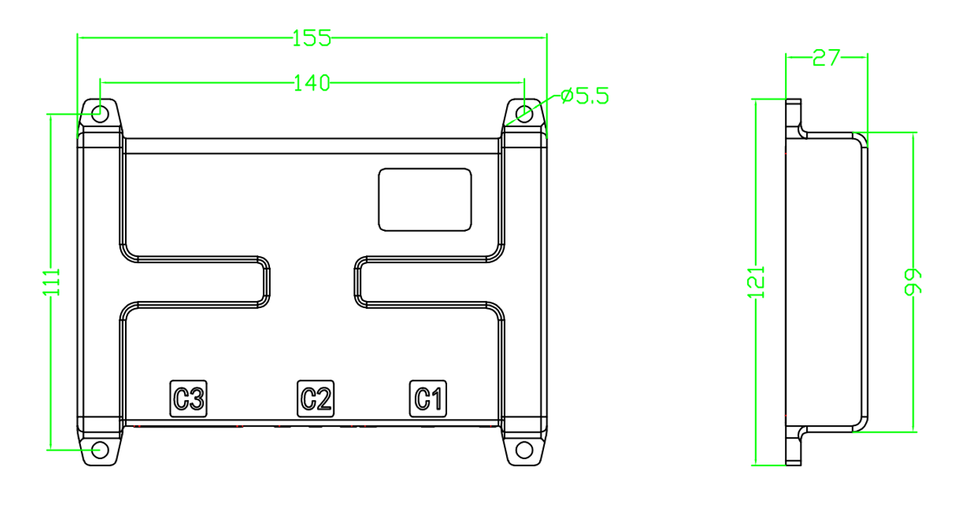

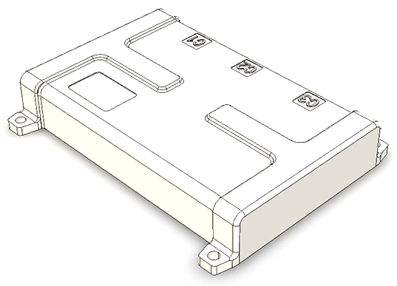

Figure 8.2 Product Housing Diagram

Precautions
- Ensure correct wiring before use. Refer to the product manual or contact the manufacturer's technical service center for specific wiring methods.
- If using relays, do not exceed the rated charge/discharge current parameters of the selected relay or contactor.
- Disconnect the system power when not in use.
- Do not arbitrarily modify system configuration parameters.
- If any product abnormality is detected, immediately power off and contact the company's technical support center.

Packaging and Storage

10.1 Packaging
- Individual modules are packaged in bubble bags.
- Cardboard boxes with partition boards are used for packaging.

10.2 Transportation
- During transportation, prevent severe vibration, drops from height, crushing, impact, exposure to sunlight, rain, etc.
- Stacking height should not exceed 5 layers. Do not place heavy objects on top.

10.3 Storage
- Recommended storage ambient temperature: 0°C to 45°C.
- Recommended storage relative humidity: 25% to 75%.
- Package with desiccant to reduce oxidation. The product must not be stored in atmospheres containing harmful gases such as sulfur or chlorine.

Technical Support and Services
- For packaging information, please refer to the "Product Shipping Packaging Information" document.
- If the product operates under loads exceeding those specified in this manual, performance compliance with all indicators in this manual cannot be guaranteed.
- Unless otherwise specified, the data in this document were measured under the following conditions: Ta=25°C, humidity <75%, nominal input voltage, and rated output load.
- All performance indicators listed above pertain to the products described in this manual.
- Our company supports product customization.
- For any questions regarding product usage and technical matters, please feel free to contact us. We will respond to your inquiry as soon as possible. We look forward to communicating with you!

