

**GEOG 390 / GEOG 660**

**Lab 4 – Presenting GIS Data**



**Name: Jonathan Janzen**

**Date: September 25, 2019**

**Section: 505**

**Ch. 3 Tutorial Questions**

**Begin tutorial on page 95**

1. **Question 1 (after step 3.5):** Describe the difference between a Map Scene in ArcGIS Pro and a complete map (i.e. pg. 109) (3-5 sentences).

**Explanation (3-5 sentences):**

Map Scenes provide an interactive interface that lacks many of the common features of complete maps. For example, there no scale bars, the legend is optional, and there is no obvious indication of the North direction. Another big distinction is ability for an user of a map scene to easily change what is shown and emphasized on a map scene, an user of a complete map cannot modify the finished product near as easily.

1. **Question 2 (after step 37.5):** Write the three terms (from left to right) that represent each part of the scale bar on Fig. 3.25 on pg. 105 (refer to pg. 92 for help).

**Three terms:** Division Unit, Division, Subdivision

1. **Question 3 (after completing tutorial):** List 3 pros/cons of making a Map Scene and taking a screenshot of it (as done in previous labs) and making a Map Layout (done in this tutorial) (6 pros and 6 cons total). Use Ch. 3, lecture notes, and the Internet to support your answers.

**3 Map Scene Pros:** Easy and quick to create; not as many choices in the design process which streamlines the process; efficient for GIS-minded consumers.

**3 Map Scene Cons:** Is not a real map; difficult for a non-GIS minded person to understand; not well formatted for printing or distributing.

**3 Map Layout Pros:** Provides a completed map; provides ways to creatively display information besides just the geographic map (such as text or a comprehensive legend); can easily be exported for printing or other uses.

**3 Map layout Cons:** Time-intensive to create; too many options; easy to distort information.



**Ch. 3 Practice Exercise**

1. Open your *ExploreGIS* project you created for the Ch. 1 (Lab 1) Practice Exercise.
2. Design and create a professional map layout for this project’s data. Refer to *Lab4_Example_Map.png* for designing your layout (you will likely be looking at a different area with different data).
   1. You can pick any topic you like, as long as your data is relevant to it and your map communicates it clearly. You can also play around with the labelling of your layers.
   2. Your map must have these required elements:
      1. *Title*
      2. *Legend*
      3. *Scalebar*
      4. *North Arrow*
      5. *Name*
      6. *Date*
      7. *Data Sources*

**\*Be sure to implement proper cartographic symbolization, labeling, and establish a clear visual hierarchy.**

1. Export the Map Layout as a PNG file, with a dpi of 300.

Insert PNG of map below: (see next page)

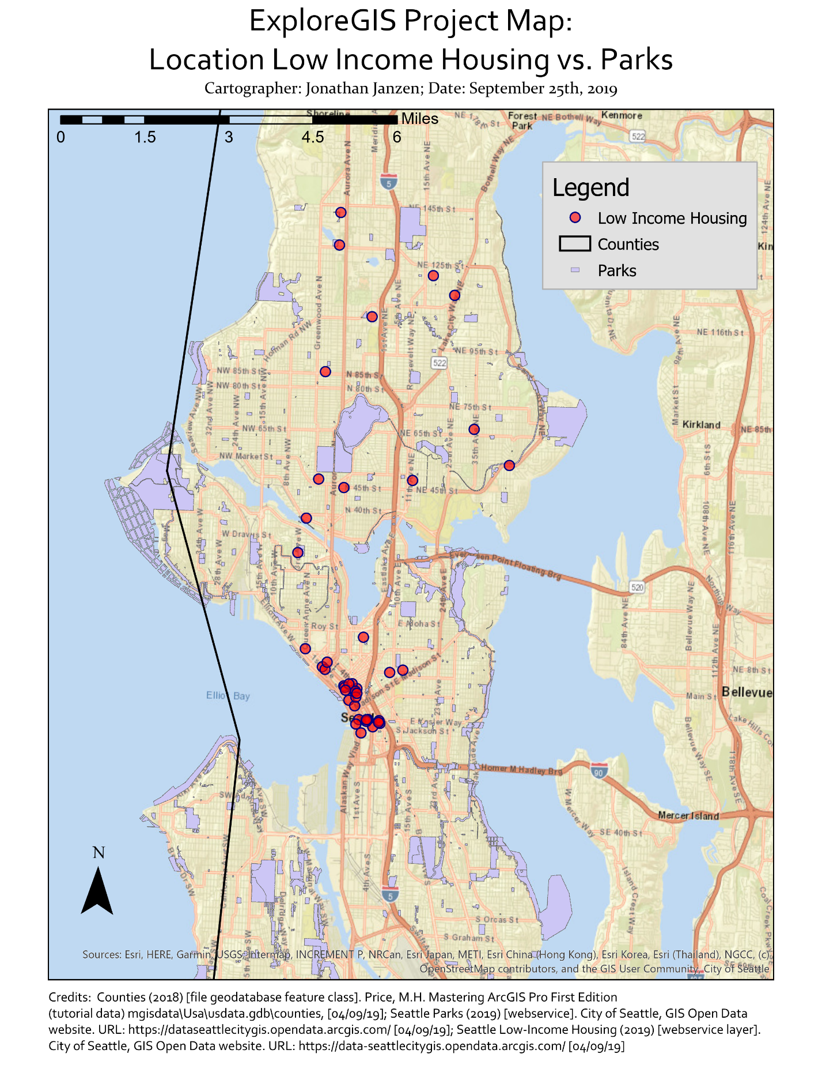

**When finished, save the Response Template as a PDF and upload it to Lab 4’s Assignment Dropbox on eCampus.**