

Response Template

**GEOG 390 / GEOG 660**

**Lab 6 – Editing**



**Name:**

**Date:**

**Section:**

**Ch. 8 Tutorial Questions**

**Begin tutorial on page 258**

1. **Question 1 (after step 4.6):** Why do you think the coordinate system for this project is NAD 1983 State Plane Texas Central (2-4 sentences)?

**Explanation (2-4 sentences):** In this geodatabase, the information provided is local in scope. The dimensions of the provided raster data only cover about 200 miles in each direction, so a highly localized projection is best for this use case. Furthermore, the data are about unchanging physical phenomena (geometry and faults) so we can get data with high precision and accuracy where

1. **Question 2 (after step 7.2):** Is creating fields and domains classified as an editing change (refer to pg. 247)? (true/false)

**true/false:** true

1. **Question 3 (after step 14.1):** What feature is this PNG depicting a portion of? Using the Measure tool, measure the diameter of BOTH a spring and sink/cave dot in feet.

**Aquifer depicted by PNG:** Edwards Aquifer (Recharge Zone)

**Diameter of spring:** 1,224 ft

**Diameter of sink/cave:** 941 ft



**Ch. 8 Practice Exercise**

1. Digitize all of the remaining caves/sinks and springs in the entire Edwards outcrop area map, placing them in the *karstfeatures* feature class. Remember to assign the attributes.
2. The Travis-Hays County line runs NW-SE across the Edwards outcrop area, cutting it roughly in half. Digitize all of the faults south of the county line, placing them in the faults feature class. Remember to assign the attributes. Finally, create a new feature class and trace the boundary of Edwards Outcrop feature.

Note: Use the county line on *EdwardsCrop.png* to determine the faults to digitize (if you use a basemap or counties layer, the line will not match up).

1. Create a map layout (it should be 8.5” x 11” portrait or landscape) showing only the Edwards (State Map) layer outline, karst features, and the faults. Assign different symbols to cave/sink and spring features and to the dashed and solid fault lines. Refer to *Lab6_Example_Map.png* on the class drive for guidance (do not make yours identical!). Your map should have the following elements:
   1. *Title*
   2. *Scale bar*
   3. *Legend*
   4. *North Arrow*
   5. *Name*
   6. *Date*
   7. *Projection/Datum*
   8. *Source Credits*

**\*Be sure to use proper symbolization and cartographic techniques.**

1. When you are finished, export your map layout as a PNG with a dpi = 300.

**Insert PNG map below:**

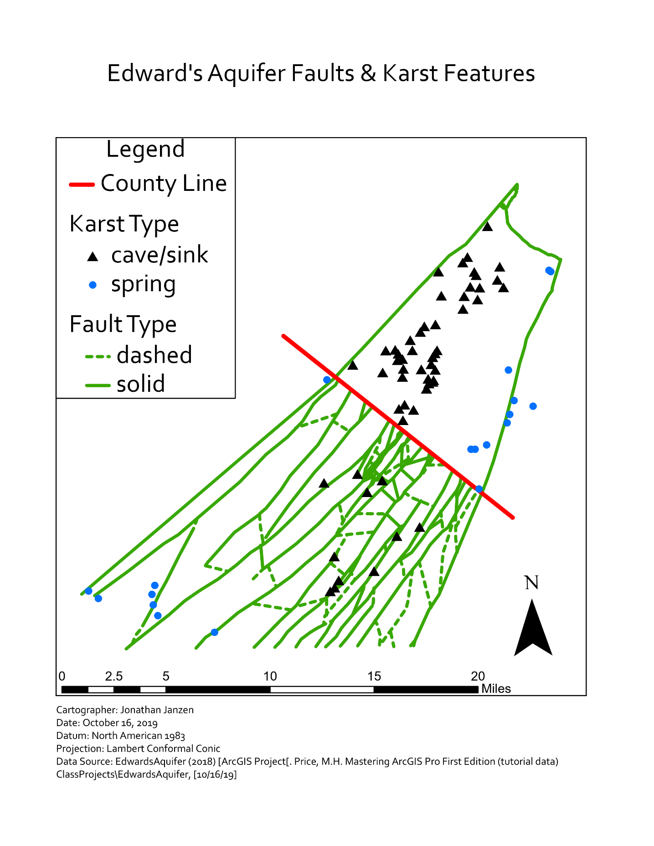

**When finished, save the Response Template as a PDF and upload it Lab 6’s Assignment Dropbox on eCampus.**