

**GEOG 390 / GEOG 660**

**Lab 7 – Attribute Data & Queries**



**Name: Jonathan Janzen**

**Date: October 23, 2019**

**Section: 505**

**Ch. 7 Tutorial Questions**

**Begin tutorial on page 227**

1. **Question 1 (after step 6.2):** How many Asians and Multiracial live in the United States (round to the nearest millionth)?

**# Asians:** 15,000,000

**#Multi-race:** 9,000,000

1. **Question 2 (after step 8.5):** Which subregion has the most Asians?

**Subregion:** Pacific

1. **Question 3 (after step 10.4):** What is the total number of districts in the *114th Congress* table? How many are Republican? How many are Democrat?

**Total # of districts:** 437

**# Republican districts:** 246

**# Democrat districts:** 190

1. **Question 4 (after step 19.2):** Are all fields the same between the 113th and 114th Congress tables (true/false)? Which field would be the best field to join the tables with?

**true/false:** false

**Field to join tables:** DISTRICTID

1. **Question 5 (after step 22.2):** What cardinality relationships can be used for a table join? For a table relate? Refer to pgs. 214-216.

**Table join cardinality relationships:** one-to-one, many-to-one

**Table relate cardinality relationships:** one-to-one, many-to-one, one-to-many

1. **Question 6 (after step 25.5)**: Run the Select by Attributes tool again (clear the selection before running it). How many representatives come from the Pacific subregion?

**# of representatives:** 71

1. **Question 7 (after step 45.2): Notice the spatial distribution of stations with values in the high 40s. Suggest an explanation (1-2 sentences) for why the western values scatter beyond the tight latitudinal range of the Central Plains and East Coast?**

**Explanation (1-2 sentences):** For the values in the high 40s, the tight band in from the east coast up to Colorado is interrupted by the Rocky Mountains which block rainfall from crossing. For the eastern side, the east-west flow is stopped. For the west, weather rolls in from northern California, Oregon, and Washington; though this rainfall appears to be much looser than on the eastern side.

1. **Question 8 (after step 49.6):** Why do we use the “LAT” and “LON” fields to display the XY data instead of using the other fields (i.e. LATDEG, LATMIN, LONDEG, LONMIN)? Explain in 1-3 sentences.

**Explanation (1-3 sentences):** For one, the LAT and LON fields provide data accurate enough to complete the operation, the LATDEG and other fields are just a different format of the same data. Secondly, in order to use the XY Table To Point tool we need a single field for X and Y, in order to use the DEG and MIN information we would need to perform extra steps to combine these data into a single field. But since that work has already been done for us with the LAT and LON fields we can skip that work.

1. **Question 9 (after step 51.3):** What is the common field between the two tables?

**Common Field:** STATION and STATION_NAME



**Ch. 7 Practice Exercise**

1. Insert a new Map Scene. Locate the *store_openings* csv file in *mgisdata/Usa* geodatabase.
2. Export the *store_openings* table from a .csv file to a table. Save the table in the *TablesPractice* geodatabase. Call it *STORE_OPENINGS_TABLE*.
3. How many stores are there? Where the first one open? Where did the latest open?

**# total stores:** 3176

**State where first store opened:** AR – Arkansas

**State where latest store opened:** WV – West Virginia

1. Examine the table and the metadata for the table. Is the latest date reported in the previous question actually the youngest store in the U.S.? Why or why not (1-3 sentences)?

**Explanation (1-3 sentences):** No. The data here ends in 2006, which is the same year as the youngest store. Most likely there have been more stores opened since the metadata indicates that the dataset ends. Additionally, the data excludes Alaska and Hawaii, so it is possible that there were stores opened there after the youngest store in the dataset.

1. Create a table in ArcGIS Pro that lists each state and the number of stores that it contains (use the Frequency tool). Which state in this table contains the most stores (the least)? How many do both states have? (Hint: set Frequency Field to the state field)

**State containing most stores:** TX – Texas

**# of stores in state:** 315

**State containing least stores:** VT -- Vermont

**# of stores in state:** 4

1. Create a map layout (it should be 8.5” x 11” portrait or landscape) showing the total number of stores in each state (display values using Graduated Colors with a monochromatic color ramp). Refer to *Lab7_Example1_Map.png* on the class drive for guidance (do not make yours identical!). Your map should have the following elements:
   1. *Title*
   2. *Legend*
   3. *Scalebar*
   4. *North Arrow*
   5. *Labels showing # of stores in each state*
   6. *Name*
   7. *Date*
   8. *Projection/Datum*
   9. *Source Credits*

Hint: Add the states layer from the *usdata geo*database in *mgisdata/Usa* folder. Join your store openings frequency tableto the *states* layer.

1. When you are finished, export your map layout as a PNG with a dpi = 300. Include your PNG in your Lab 7 Response Template.

**Insert Ch. 7 Practice Exercise PNG map below:**

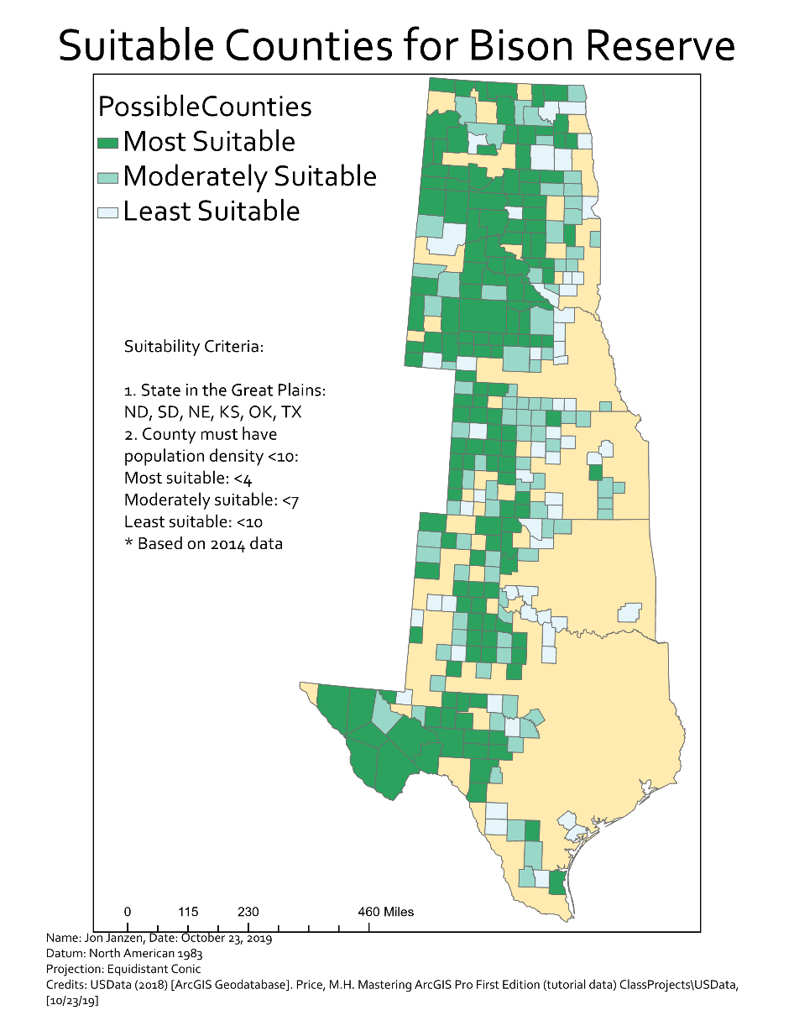



**Ch. 9 Tutorial Questions**

**Begin tutorial on page 293.**

1. **Question 1 (after step 13.8):** How many cities in the United States had more than 2 million people in 2014?

**# of cities:** 4

1. **Question 2 (after step 15.7):** How many counties with more females than males, lost population between 2010 and 2014?

**# of counties:** 573

1. **Question 3 (after step 16.3):** How many counties remain selected?

**# of counties remaining:** 133

1. **Question 4 (after step 19.5):** How many city names begin with the word “*San*”. Hint: put a space between the word and the second ‘%’ sign when viewing in SQL mode. Then run the tool.

**# of cities:** 37

1. **Question 5 (after question 4):** The answer given for question 4 includes cities like East San Gabriel and Rancho San Diego (which do not actually begin with “San”). Examine the SQL expression and edit it to exclude similar cities from the selection. How many cities meet this more stringent criteria? Hint: remove the first ‘%’ in the SQL expression.

**# of cities:** 33

1. **Question 6 (after step 23.4):** How many cities are within 10 miles of an interstate highway?

**# of cities:** 3,427

1. **Question 7 (after step 23.6):** Use a handheld calculator or the one on the computer to calculate the percentage of cities within 10 miles of an interstate? Round to the nearest whole number.

**% of cities:** 88%

1. **Question 8 (after step 25.2):** Which rivers intersect Oklahoma?

**Rivers:** 3

1. **Question 9 (after step 35.3):** Use the Summary Statistics tool to determine the total number of people in the risky cities.

**# people in risky cities:** 43129001 (using POP14)

1. **Question 10 (after step 41.2):** Explain why would summing the population in the *RiskyClip* layer overestimate the population in the buffers (1-2 sentences)?

**Explanation (1-2 sentences):** The values in attribute tables are not modified by clipping their respective geometry. Because of this, the population fields will retain the full count of the counties, instead of subtracting the people that are outside of the clip. Thus, the layer will overestimate the population within the buffers.



**Ch. 9 Practice Exercise**

1. Create a new project, call it *Bison_Preserve*.
2. A conservation group is looking for a place to establish a private bison preserve. The group has developed a set of criteria to narrow down possibilities. Help them with their analysis.
3. The criteria are:
   1. Counties within the Great Plains states (TX, OK, KS, NE, SD, and ND)
   2. Counties with a 2014 population density less than 10 people per square mile:
      1. < 10 people per square mile = least suitable
      2. < 7 people per square mile = moderately suitable
      3. < 4 people per square mile = most suitable
4. Create a map layout (it should be 8.5” x 11” portrait) showing the suitable counties in each Great Plains state (display values with 3 classes at the intervals stated in step 3). Refer to *Lab7_Example2_Map.png* on the class drive for guidance (do not make yours identical!). Your map should have the following elements:
   1. *Title*
   2. *Legend*
   3. *3 distinct classes showing suitability*
   4. *Text mentioning criteria and values for each suitability range*
   5. *Scale bar*
   6. *Name*
   7. *Date*
   8. *Projection/Datum*
   9. *Source Credits*
5. When finished, export your map layout as a PNG with a dpi = 300.

**Insert Ch. 9 Practice Exercise PNG map below:**

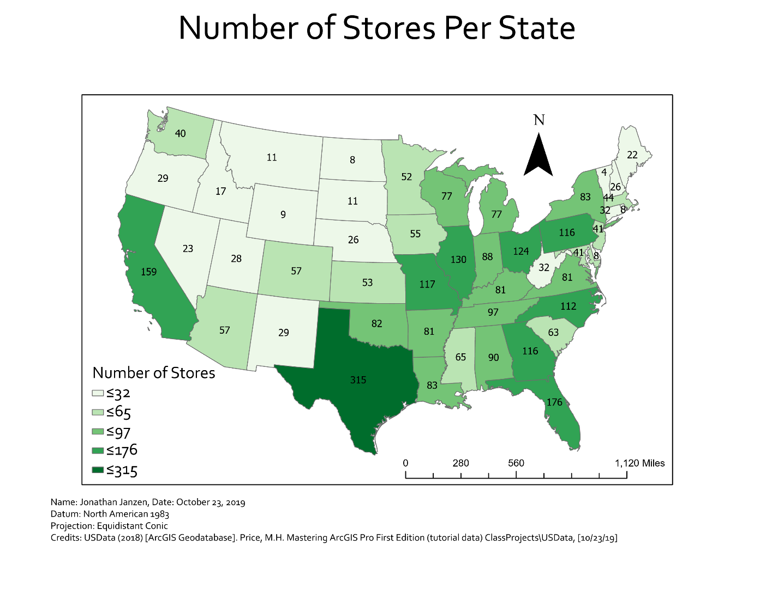

**When finished, save the Response Template as a PDF and upload it to Lab 7’s Assignment Dropbox on eCampus.**