

Response Template

**GEOG 390 / GEOG 660**

**Lab 1 – What is GIS?**



**Name: Jonathan Janzen**

**Date: September 4, 2019**

**Section: 505**

**Ch. 1 Tutorial Questions**

***\*All screenshots should have the Map Scene window and Contents Pane (with symbology for all visible layers shown).***

**Begin tutorial on page 26**

1. **Question 1 (after step 15.4)**: Using the Measure Area Tool, trace around the edge of Crater Lake. What is the approximate area of the lake in square miles? Provide a captioned screenshot of your Map Scene with the Measure tool’s dialogue box open.

**Area in mi2: 20.82 square miles**

**Insert captioned screenshot here:**

**Question 1 Image with Square Miles Reading:**

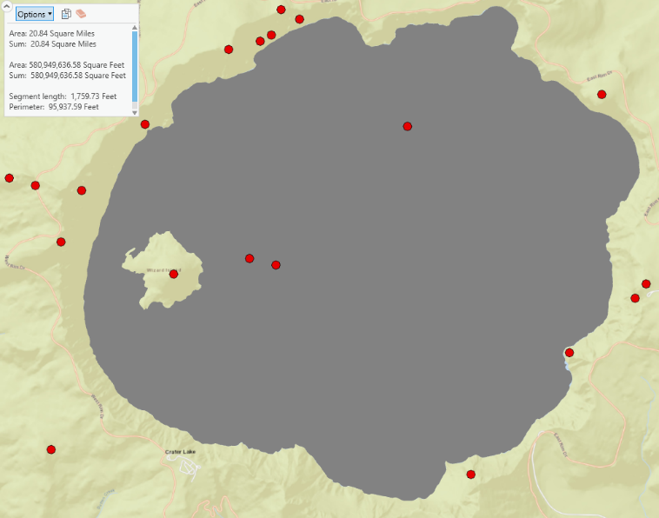

1. **Question 2 (after step 29.4)**: For each, list one feature class layer containing point, line, and polygon data. Also, list one layer that is a raster (4 total). Type the layer exactly as it is in the Catalog Pane. What file type is *CraterLakeUnits*?

**Point:** vents

**Line:** faults

**Polygon:** lake

**Raster:** dem30m (band 1)

***CraterLakeUnits* file type:** Table

1. **Question 3 (after step 31.6)**: Change the color of the Lake layer in the 2D Crater Lake Map View (expand the layer in the Contents Pane and double-click the symbol underneath to open the Symbology Pane, pick a color from the Gallery tab). Did the lake’s color update in the 3D scene? (Yes/No)?

**Yes/No:** Yes

*\*Skip steps 52-54*

1. **Question 4 (after step 57.3)**: How many counties does Oregon have? What is Oregon’s max, min, mean, and total 2014 population (round to the nearest whole number and do not use commas).

**# Counties:** 36

**Max Pop:** 758,700

**Min Pop:** 1,460

**Mean Pop:** 108,964.5

**Total Pop:** 3,922,722

1. **Question 5 (after step 57.5)**: List the smallest and largest counties with their respective 2014 populations. Also provide the POP14_SQMI value for both.

**Smallest county:** Wheeler (0.9 per sq. mi)

**Largest county:** Multnomah (1630 per sq. mi)

1. **Question 6 (After completing tutorial)**: Using the Select Layer by Attributes tool (use Counties layer), find how many counties in Oregon had a 2014 population less than 50,000 (don’t use commas when making the clause)? What is the percentage (round to nearest whole number)? What side of the state has most of the counties (east/west)?

**# Counties > 50,000:** 16

**Percent:** 44%

**East/West:** West



**Ch. 1 Practice Exercise**

1. Start a new project and call it *ExploreGIS* and save it in the *gisclass/ClassProjects folder.*
2. Choose an area or feature within the United States that interests you (state, city, national park, or other large geographic feature), be sure your area or feature is least the size of a moderate city to ensure you can find data.
3. Create a Map Scene for your area or feature of interest and give it an appropriate name. Choose a Basemap you think would best identify your area or feature of interest.
4. Search the *mgisdata* folder and use at least ONE dataset that covers your area or feature of interest.
5. Use the All Portal feature and search for at least TWO additional datasets that relate to a theme(s) that interests you within your study are or feature.
6. Create a 3D scene and add one or two of your chosen datasets to it. Put the 2D and 3D Map Scenes side-by-side.
7. Link the 2D and 3D maps and explore your area turning different layers on/off.
8. Write (at a minimum) a 500-word, single-spaced response on the next page including the following:
   1. *First explain why you chose the area/feature, Basemap, and your datasets (minimum of THREE).*
   2. *Beneath your report, provide one screen-capture of the 2D map and one of the 3D map scene with their Contents Panes visible (2 total). Be sure to number and caption them appropriately.*
   3. *Explain what each screenshot portrays in your write-up (location and data layers displayed)*
   4. *Conclude with discussing what you learned about your area from the 2D and 3D maps scenes.*
   5. *Finally, provide complete, formal citations for each dataset displayed (refer to pgs. 16-17).*

**When finished, save the Lab Response Template as a PDF and upload it to Lab 1’s Assignment Dropbox on eCampus.**

**Chapter 1 Practice Exercise Writeup:**

Once I graduate from Texas A&M University in December of 2019, I have a job lined up in Seattle, Washington. In the interest of doing some apartment hunting preparation, I chose to select the greater Seattle area as my selected feature. Since my primary reason for selecting this is city research, I chose the streets as my basemap so that I have a good idea about the layout of the city’s roads, freeways, and landmarks. Using the data provided in the mgisdata folder, I selected the counties layer to give me an idea of the impact of living in different counties. Using the portal feature of ArcGIS Pro, I added 2 other data sources. First, to get an idea of areas that might have more crime, I added a Low-Income Housing layer. Second, to get an idea of recreation areas, I added in city-provided data on parks, watersheds, and bodies of water. These data give me a good overall picture of the greater Seattle area as seen in the two screenshots below.

In Figure 1, the viewer can find a 3D scene containing a view looking west-north-west over the city of Seattle and its surrounding areas. The counties of the State of Washington are outlined in a black border. Additionally, low-income housing sites are listed as pink dots with thick black borders. In the screenshot, the large cluster seen in the middle is approximately the location of the downtown area. The areas highlighted in light purple are the watershed zones, which indicate areas that are prone to flooding in heavy rains. Finally, the areas highlighted in green are city-owned parks, the frequency of which increase the further one goes from downtown (which makes sense).

In Figure 2, the layers are the same as in figure 1 but the view is different. Figure 2 provides a 2-dimensional view zoomed in more tightly on the central area of Seattle. I reoriented the angle of the picture to be slightly off from directly north-south in order to more closely align with the orientation of streets in downtown which, as can be seen on the basemap, follow the western shoreline. I was able to use this viewpoint to zero in on the areas I am interested in living in: north and north-east of downtown. After checking Google Maps, I could see that these neighborhoods are called South Lake Union and Capitol Hill. These areas avoid low-income housing zones and avoid watershed areas but also include lots of parks and are still within the same county as the rest of Seattle.

I found working with these datasets using ArcGIS Pro to be a pretty positive experience. Based on the process of doing the lab assignment on previous pages of this report, I gained a sufficiently competent understanding of how to use the basics of this program in order to feel reasonably comfortable enough to do this practice problem. It didn’t take more than 15 minutes once I settled on a theme and location to map. Since ArcGIS Pro is based on a ribbon interface like that of the Microsoft Office suite of applications, I found the interface to be a natural extension of my knowledge of applications like Word, PowerPoint, and Excel. Overall, I had a positive experience with ArcGIS Pro and mapping Seattle.

**Citations**

Counties (2018) [file geodatabase feature class]. Price, M.H. Mastering ArcGIS Pro First Edition (tutorial data) mgisdata\Usa\usdata.gdb\counties, [04/09/19]

Seattle Parks (2019) [webservice]. City of Seattle, GIS Open Data website. URL: https://data-seattlecitygis.opendata.arcgis.com/ [04/09/19]

Seattle Low-Income Housing (2019) [webservice layer]. City of Seattle, GIS Open Data website. URL: https://data-seattlecitygis.opendata.arcgis.com/ [04/09/19]

**Screenshots**

Figure 1: 3D view of Seattle, with data on low income housing, parks, and counties

Figure 2: 2D view of Seattle, with data on low income housing, parks, and counties