

**GEOG 390 / GEOG 660**

**Lab 5 – Coordinate Systems**



**Name:**

**Date:**

**Section:**

**Ch. 4 Tutorial Questions**

**Begin tutorial on page 128**

1. **Question 1 (after step 5.5):** What coordinate system is the *country* layer in? What angular unit is used?

**Coordinate System:** GCS WGS 1984

**Angular Unit:** Degree (0.0174532925199433)

1. **Question 2 (after step 6.2):** Using the World Topographic basemap, what are the approximate coordinates (to the nearest hundredth in decimal degrees) of the south corner of Kyle Field (nearest to the *McFerrin Athletic Center Indoor Track*)?

**Long: 96.34 W**

**Lat: 30.61 N**

1. **Question 3 (after step 6.3):** The current Display Units are in decimal degrees. What are the other FIVE options in the drop-down (select each one to see the units, when finished revert back to decimal degrees)?

**Five options:** Degrees Minutes Seconds, Degrees Decimal Minutes, MGRS, US National Grid, UTM

1. **Question 4 (after step 7.8):** Go back into the *World* folder and click on *Robinson (world)*. What is the linear unit for this projection?

**Linear unit:** Meters (1.0)

1. **Question 5 (after step 8.4):** Which continent has negative *x* AND positive *y* coordinates in the Mercator projection? Which continent has positive *x* AND negative *y* coordinates in the Mercator projection?

***x* (+), *y* (-)**: Australia

***x* (-), *y* (+)**: North America

1. **Question 6 (after step 9.6):** What longitude is the central meridian? What is the latitude of origin? What are the two standard parallels?

**Central Meridian:** -96.0

**Latitude of Origin:** 40.0

**Standard Parallels:** 20.0, 60.0

1. **Question 7 (after step 23.5):** Will the new *StudyBoundary* dataset overwrite the old one? (true/false). Hint: look at where both layers are saved.

**true/false:** False

1. **Question 8 (after step 27.2):** What coordinate system is *HistoricMines* in? Explain why (2-4 sentences).

**Coordinate System:** NAD 1983 StatePlane South Dakota South FIPS 4002 Feet

**Explanation (2-4 sentences):** The HistoricMines layer is in the above coordinate because the dataset is localized within a tiny area *within* South Dakota, by using such a localized coordinate system, the authors can be assured that their data can be plotted extremely accurately. As to why it is in that coordinate system while the map it is projected in is in a different projection system, that is because ArcGIS Pro is projecting the layer on-the-fly.



**Ch. 4 Practice Exercise**

1. Create a new project, call it *Lab5_Practice_Exercise*.
2. In map properties, set the coordinate system to GCS WGS 1984.
3. Download the *TissotsIndicatrix* folder from the class drive. Move it into the *mgisdata* folder using Windows Explorer and unzip it (use 7-zip).
4. In your new project, connect to the *mgisdata* folder and add the *Countries*, *TissotEllipses*, and *World_30* layers to Contents. layers to Contents.
5. The layers should be placed from bottom-top as follows: *Basemap* (turn off), *Countries*, *World_30*, and *TissotEllipses*.
   1. Change the color/transparency of each layer if necessary.
   2. You may use additional layers if needed (i.e. states layer from *usdata* geodatabase)
6. Take a moment to look at the *TissotEllipses* layer, these features help visualize how a particular coordinate system affects certain areas and what properties are preserved (area, size, shape, and direction). Select a few other PCSs to see how the circles change.
7. Using the provided layers, Ch. 4, lecture notes, and online sources choose the best Projected Coordinate System for EACH scenario below:
   1. *You are a researcher working for NSF researching land cover in the Arctic. Your boss asks you to select a projection for some satellite imagery. They tell you that you will need to calculate the areas of certain land cover types based on the satellite images.*
   2. *You are a student working with a professor studying the paleoclimate of Norway and Sweden. They need a basemap of the entire area and tells you, “a little distortion of area is okay, the shapes need to be correct so certain landmarks can be identified.”*
   3. *You are working for an airline company that wants to make a map to hang in George Bush Intercontinental Airport. You are asked to select a map projection that best shows distance and direction from the departing destination (Houston, TX).*

Note: there is not a single correct choice for each scenario. The key is to first identify which property (or properties) are being preserved (area, size, shape, and direction) in each scenario. Remember, not all of these properties can be preserved at the same time. Use your class notes and the link on pg. 1 to help determine the best PCS (Cylindrical, Conic, or Azimuthal) then locate the best option under the Projected Coordinate Systems subfolder in the Map Properties > Coordinate Systems tab of your ArcGIS Pro Map Project. Be sure you can justify your choice for each scenario.

1. For each scenario, create a new map layout (it should be 8.5” x 11” portrait or landscape). Refer to *Lab5_Example_Map.png*.
   1. Be sure each map is zoomed into the area of interest and has the *TissotEllipses*, *World_30*, and *Countries* layers are visible (at a minimum).
   2. Each map should have the following elements:
      1. *Title*
      2. *Name*
      3. *Date*
      4. *Data Sources*
      5. *Projection & Datum*
   3. Be sure to use proper symbolization and cartographic techniques!
2. Export each map layout as a PNG with a dpi = 300 (total of 3 PNGs).
3. For each scenario, write 3-5 sentences justifying why the projection you chose is appropriate (refer to the circles and which properties are preserved by the PCS you selected) for the given scenario.
4. Include all 3 map layouts and justifications in your Lab 5 Response Template.

**Insert 3 PNG maps (with their respective justifications) below:**

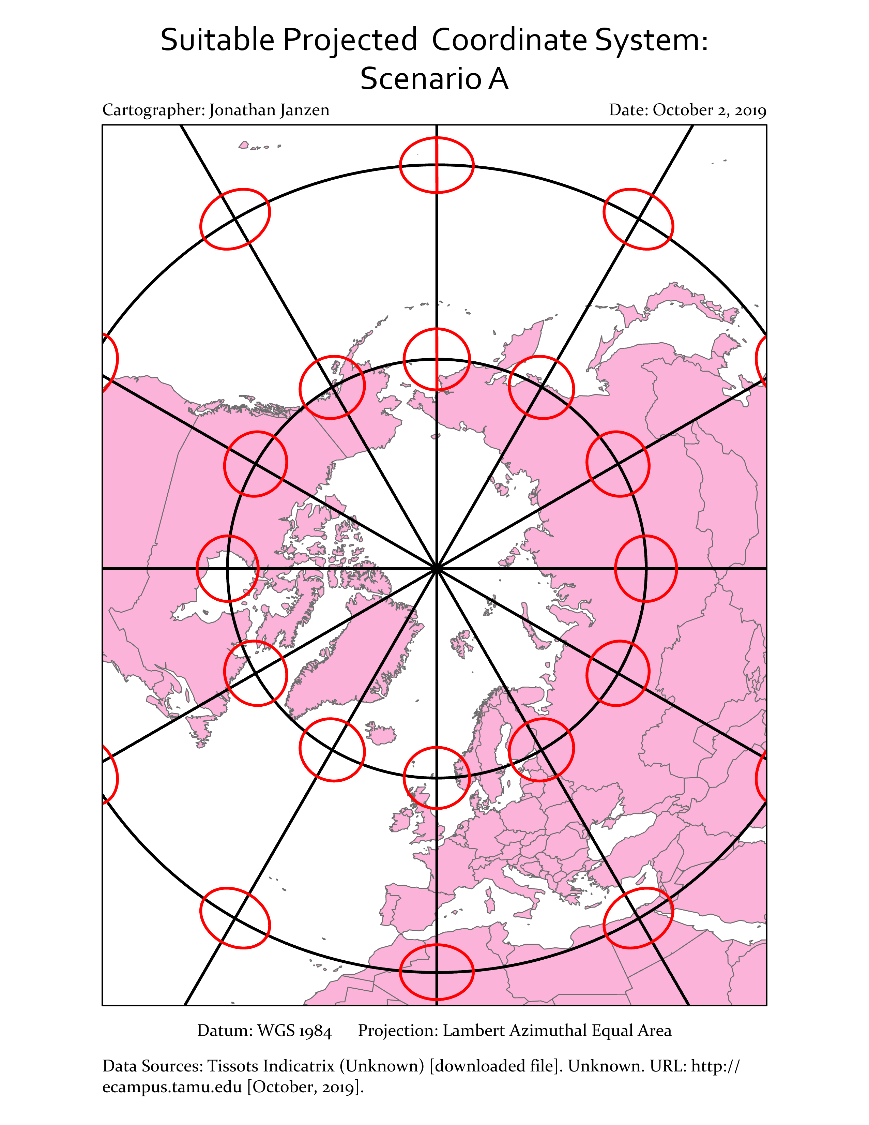

For scenario A, the researchers are trying to view the North Pole, so it seems obvious to pick an Azimuthal map. Additionally, since they are interested in preserving area, we can pick and Equal Area map. As you can see by the circles in the ring nearest the North Pole, the area of the circles are all identical. The area outside of this first ring has lots of distortion, but that doesn’t matter since we are only interested in the North Pole.

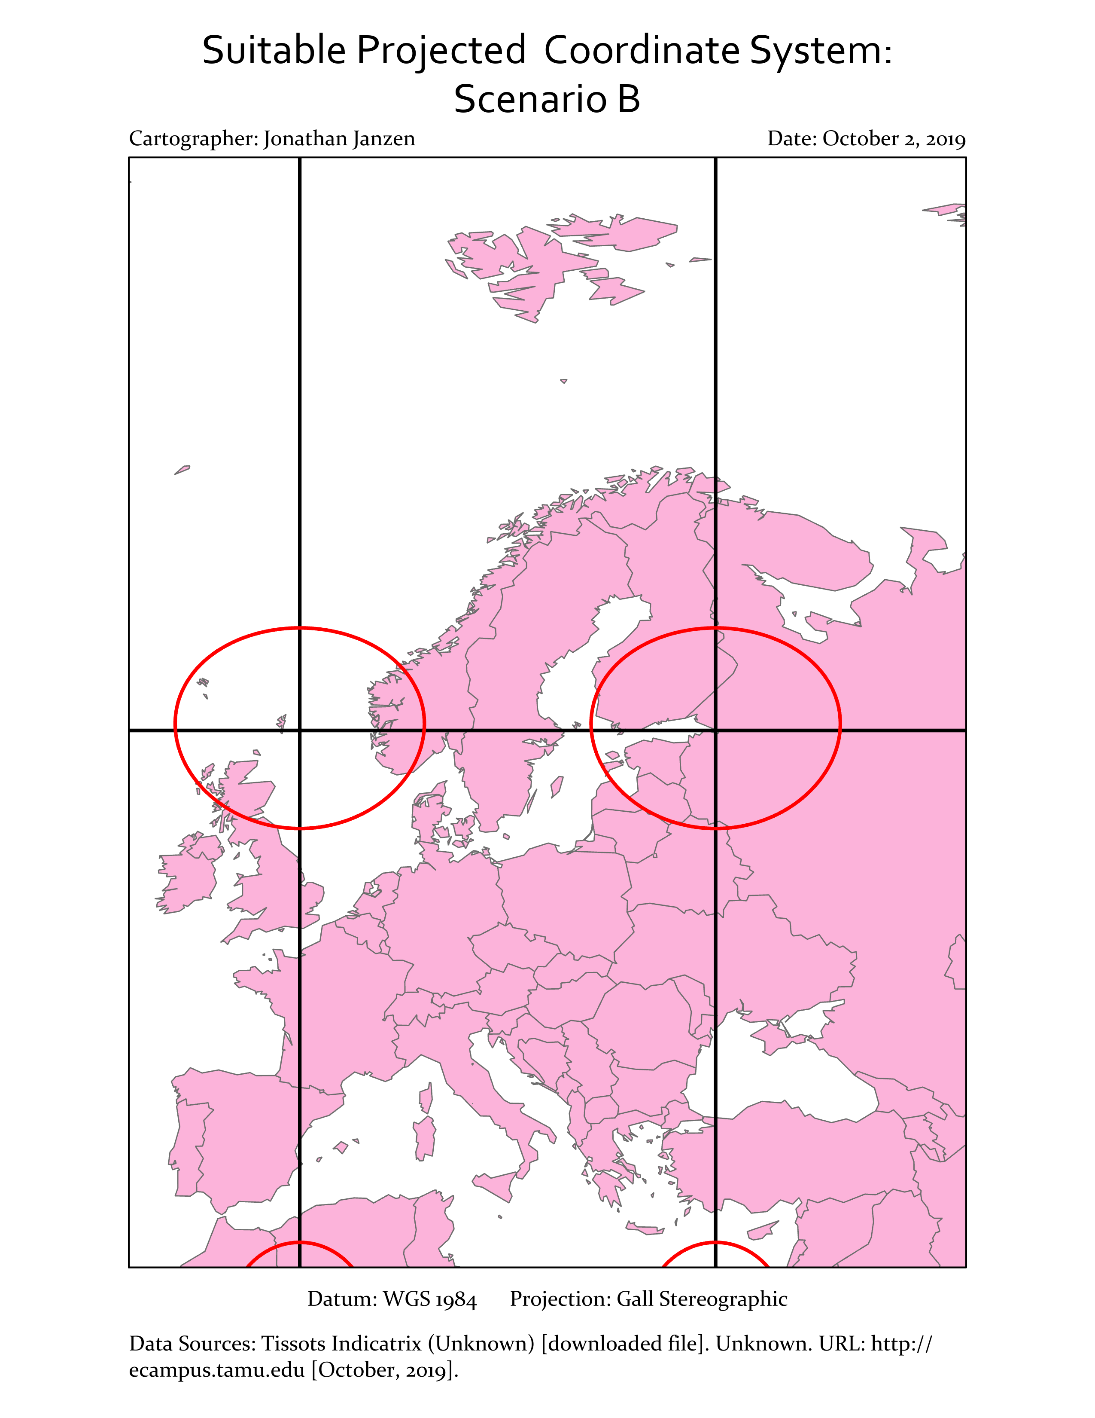

For Scenario B, the professor is interested in shape, not area. To preserve this property I selected the Gall Stereographic projection. Stereographic projections is conformal so shape is preserved. Since a little distortion is ok, according to the professor, we can use Gall Stereographic. As you can see, the red circles are slightly distorted, but the shape of Norway and Sweden is still identifiable.

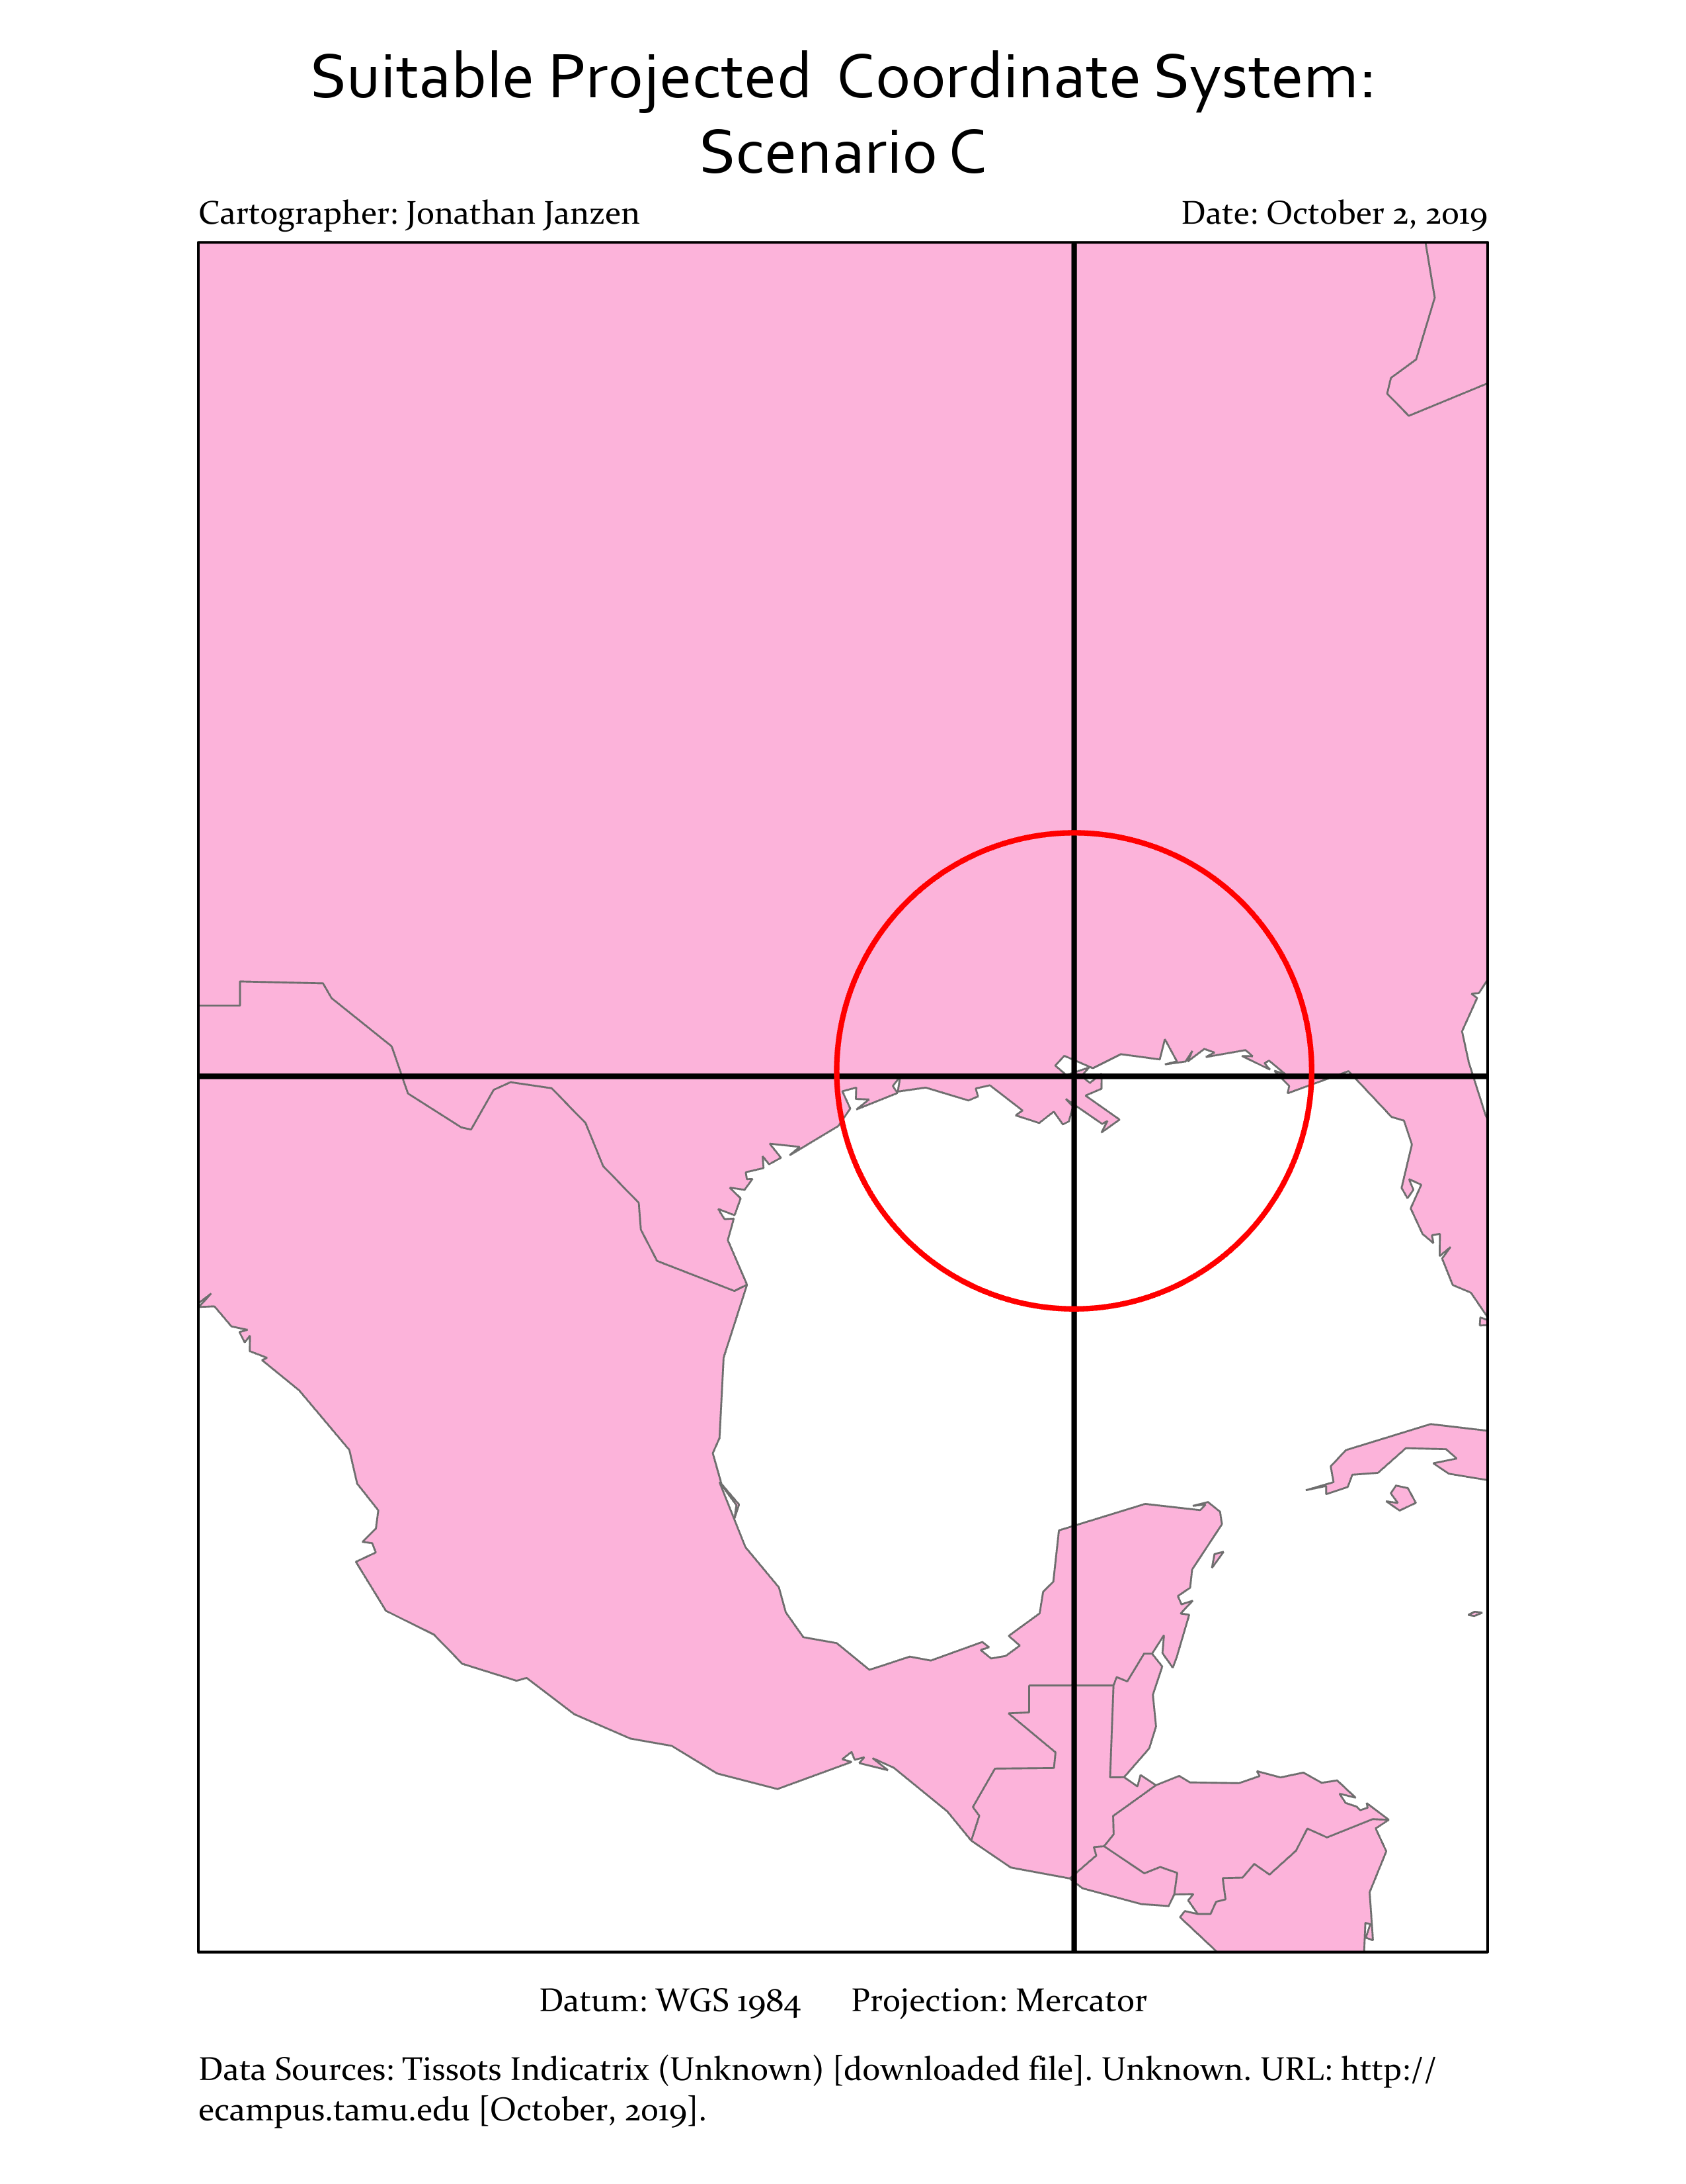

Finally, for Scenario C the airport is jointly interested in distance and direction. This is hard to do since there it is only possible to control for one of those variables. A good compromise is the Mercator projection since it attempts to preserve both and was designed for world navigation. The black lines are straight and the red circle is nearly correct.

**When finished, save the Response Template as a PDF and upload it to Lab 5’s Assignment Dropbox on eCampus.**