

**GEOG 390 / GEOG 660**

**Lab 8 – Joins and Overlay**



**Name:** Jonathan Janzen

**Date:** 30 October, 2019

**Section:** 505

**Ch. 10 Tutorial Questions**

**Begin tutorial on page 324**

1. **Question 1 (after step 3.2):** How many wells are situated on Shale?

**# of wells:** 26

1. **Question 2 (after step 17.1):** Which field contains the FULL street names? Which field contains the post office names? What units are values in the *PODistanceFt* filed?

**Field name containing full street names:** FULL_STREE

**Field name containing post office names:** FACILITY_NAME

**Units of PODistanceFt:** Feet

1. **Question 3 (after step 17.2):** How many streets are more than 2.5 miles (13,200 feet) from a post office?

**# of streets:** 12,333

1. **Question 4 (after step 20.2):** In 3-5 sentences, discuss how spatial joins differ from attribute joins (refer to pg. 309).

**Discussion (3-5 sentences):** While attribute joins apply in all cases involving relational data, spatial joins can only be applied within the scope of spatial data. Furthermore, attribute joins require equality on some field between the two tables, spatial joins can be based on a number of different operations, such as within or intersect. Finally, spatial joins allow the user to have more freedom in selecting how the data is joined due to the increased flexibility in join methods, but these methods are only available if both of the data sets are spatial.

1. **Question 5 (after step 33.3):** What is the total area of the proposed thinning in square miles (round to the nearest hundredth)?

**Total Area:** 0.92 square miles



**Ch. 10 Practice Exercise**

**Part I**

1. Use the data in mgisdata\Austin\Austin geodatabase for the following exercise.
2. Create a new map scene, name it *Lab8_PE1*.
3. Prompt: A study is being done to evaluate staffing levels in the Austin police districts. Determine the number of people (using the *blockpop* points) living in each district. Hint: refer to steps 13.1-7 on pg. 328 for procedure.
4. Create a map layout (it should be 8.5” x 11” portrait or landscape) showing the total number of people living in each police district (display values using Graduated Colors with a monochromatic color ramp). Refer to *Lab8_Example1_Map.png* on the class drive for guidance (do not make yours identical!). Your map should have the following elements:
   1. *Title*
   2. *Legend (with colors and associated population ranges)*
   3. *Scale bar*
   4. *North Arrow*
   5. *Text indicating why some districts have such low numbers of people.*

*Hint: compare the blockpop points to the Basemap (in your map scene)*

* 1. *Name*
  2. *Date*
  3. *Projection/Datum*
  4. *Source Credits*

**\*Be sure to use proper symbolization and cartographic techniques.**

1. When you are finished, export your map layout as a PNG with a dpi = 300.

**Part II**

1. Use the Austin data and classic overlay (intersect/union) for the following exercise.
2. Create a new map scene, name it *Lab8_PE2*.
3. Prompt: The impact of flooding on Austin would depend on the flood frequency and the density of the population. Use the *tracts* and *soils* feature classes to calculate a flood impact index based on the population density times the flood frequency, scaled from 1 to 10.
   1. Use the *AFLDFREQ* (soils) and *POP14_SQMI* (tracts) fields
   2. Union the tracts and soils layers
   3. Create a new field in the new unioned layer, call it Fl_Impact.
      1. Open attribute table > right-click on the column name > Calculate Field
      2. Multiply AFLDFREQ and POP14_SQMI fields in the unioned layer
   4. Create a new field, call it *Fl_Impact_Ind*.
      1. Right-click on the column name > Calculate Field > enter equation below:

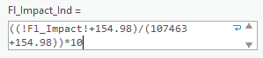

* 1. Your index is now normalized and ranges from 0-10. Go to Symbology, display values with Graduated Colors, use 5 classes (manual interval), and manually input < 1, < 2, < 3, < 6, and < 10.

1. Create a map layout (it should be 8.5” x 11” portrait or landscape) showing the flood impact in each tract (display values using Graduated Colors with a monochromatic color ramp). Refer to *Lab8_Example2_Map.png* on the class drive for guidance (do not make yours identical!). Your map should have the following elements:
   1. *Title*
   2. *Legend (with colors and associated risk level)*
   3. *Scalebar*
   4. *North Arrow*
   5. *Text indicating what data was used to calculate the index*
   6. *Text indicating possible limiting factors that reduce the applicability of the map*
   7. *Name*
   8. *Date*
   9. *Projection/Datum*
   10. *Source Credits*

**\*Be sure to use proper symbolization and cartographic techniques.**

1. When you are finished, export your map layout as a PNG with a dpi = 300.You should have a total of TWO PNG maps.

**Insert Ch. 10 Practice Exercise PNG maps (2 total) below:**

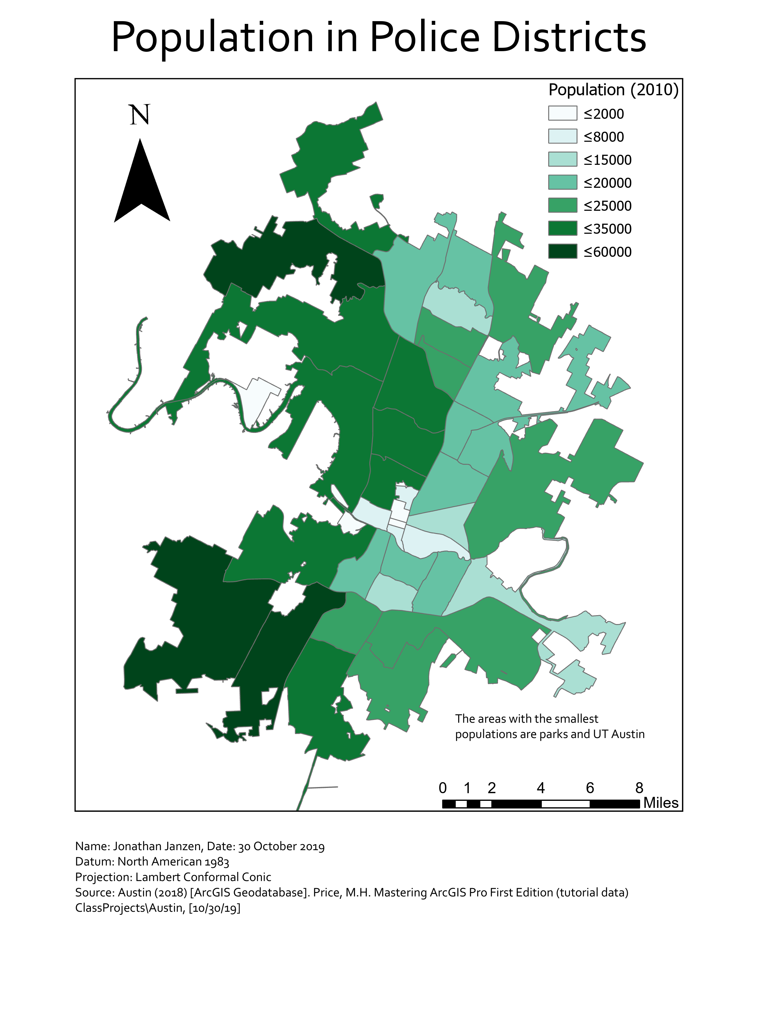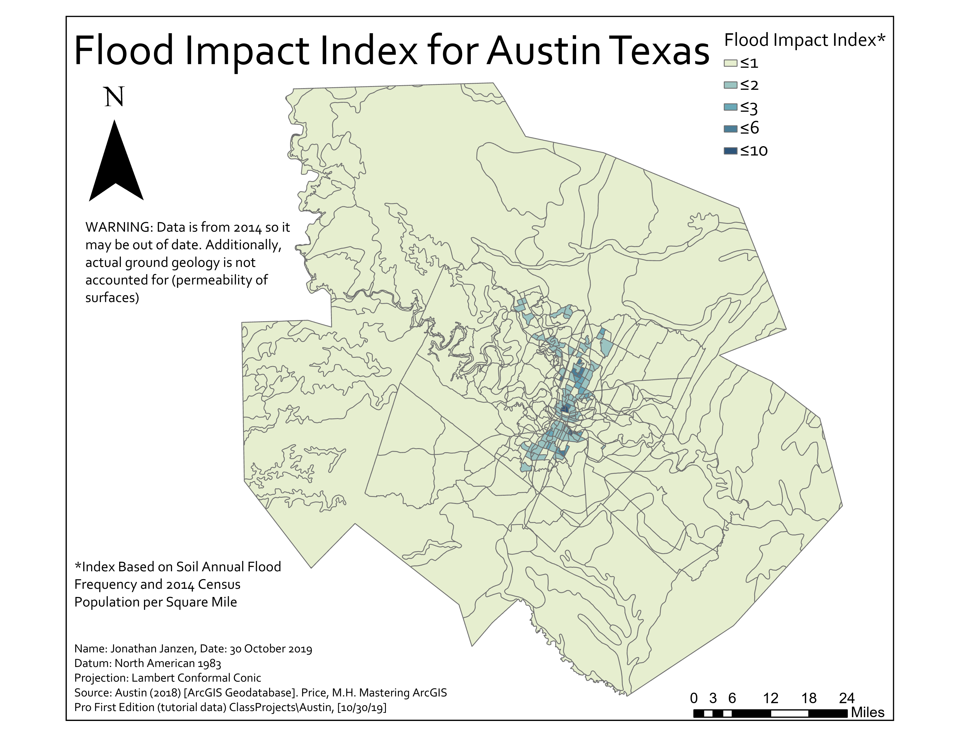

**When finished, save the Response Template as a PDF and upload it to Lab 8’s Assignment Dropbox on eCampus.**