Campaign Management:

Page 1:

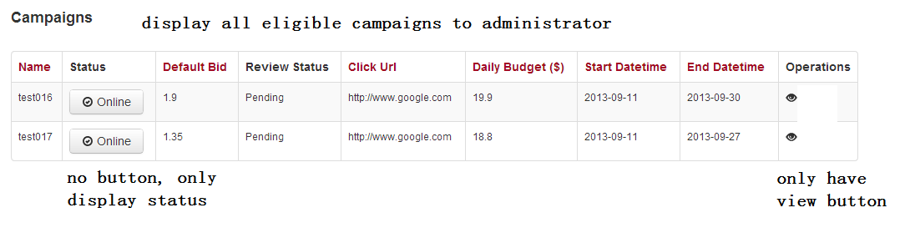

Page 2:

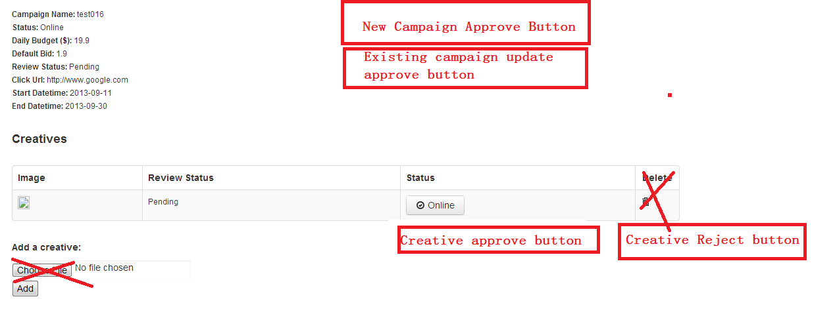

Business Logic:

* **Add a new review status for FD: *submitted*, and set creative and campaign *review status value = ‘submitted’* and *status = ‘online’* on:**

1. Campaign: NEW, UPDATE
2. Creative : NEW

* **Display ‘New Campaign Approve/Reject Button’ on:**

1. Campaign->Review Status = submitted
2. Campaign->SiteScout_Campaign_ID IS NULL
3. Campaign->status = online

* **Display ‘Update Campaign Approve/Reject Button’ on:**

1. Campaign->Review Status = submitted
2. Campaign->SiteScout_Campaign_ID IS **NOT** NULL
3. Campaign->status = online

* **Display ‘Creative Approve/Reject Button’ on:**

1. Creative->Review Status = submitted
2. Creative->SiteScout_Creative_ID IS NULL
3. Creative ->status = online
4. Campaign->SiteScout_Campaign_ID IS **NOT** NULL
5. Campaign->status = online