Fortune Data Reporting System

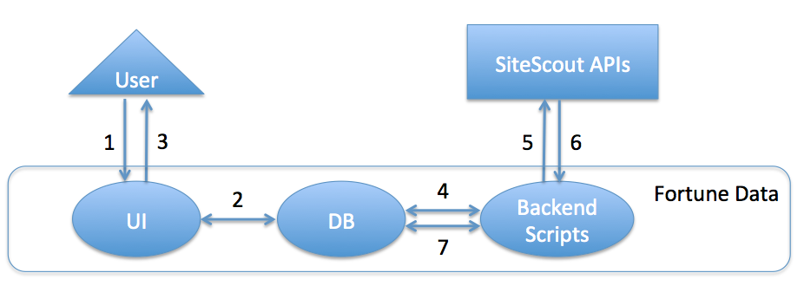

A. User interactions:

1: User asks to get stats

2: UI gets the stats from the DB

3: UI displays the stats details to the user

B. Backend interactions (cron jobs):

4: Scripts periodically checks the DB to get a list of active campaigns.

5: Scripts sends request to SiteScout APIs to retrieve hourly/daily stats for each campaign.

6: SiteScout APIs returns the stats (possibly errors).

7: Scripts combine the data and update the DB for each active campaign.

Details:

Section A should be light-weighted and no complicated calculations involved. When the user sends a request, it should be quickly handled.

Section B can do heavy work (if any) because it runs continuously in the background.