Final Project

IST 659

Brandon Liunoras

# Introduction

This project is the building of a SQL database made in Azure Data Studio and is used in the AdMiner provided at the beginning of the class. The purpose of the database is to manage the data of a fictitious event management company called Brandon’s Hospitality Holdings (BHH). This company has four different locations to provide a variety of events for their registrants/clients The data being analyzed is a plethora of events, people, companies, and objects, in order to provide organization for the different events that have occurred and will occur for future planning and execution. The coordinators are the only ones that use this database and no other external clients/registrants.

# 2.0 Tables

There are a total of 9 different tables that were created in the database. Below are the listed tables along with their important attributes and relationships

* bookings
  + This table is used to show the different events that are being hosted at Brandon’s Hospitality Holdings (BHH). Key information such as who is hosting, who is coordinating, and other businesses that are used during the event will appear here in this table. This table has the most foreign keys as it holds relationships with all other tables except for two tables. At least one element is present in the table from six of the eight other tables in the database.
* registrants
  + This table houses all of the clients that want to host an event at BHH. These people are the ones responsible for payment for the event and being present at the event. Each registrant is the point of contact for any changes to the event that they want to host.
* coordinators
  + This table holds all of the coordinators that work for BHH to execute the event for the registrant. This table has a special relationship with a lookup table to show the job titles of each different coordinator.
* vendors
  + This table holds all of the verified vendors that have been vetted and approved to be partner businesses for BHH. This table has a special relationship with a lookup table to show the different types of vendors that are available during an event.
* location_lookup
  + This lookup table houses the four locations that are available for event use for the registrants at BHH.
* vendor_type_lookup
  + This lookup table houses the different types of vendors that are available for use at a BHH event. Types of vendors include catering, entertainment, and utility for event management.
* job_title_lookup
  + This lookup table houses the different job titles for the many coordinators at BHH.
* event_type_lookup
  + This lookup table houses the different event types that a registrant can have at BHH. Such event types include weddings, birthdays, business meetings, and other general celebrations.
* event_status_lookup
  + This lookup table is especially important for the coordinators as this table denotes the different statuses of an event. It tells coordinators if an event has been completed, confirmed, canceled, and other different statuses that event can be attributed.

# 3.0 Relationships

Many of the relationships are forged with the bookings table as foreign keys. The primary keys of the other tables are the foreign keys of the other tables. There are two relationships where the bookings table is not used. These are connected to the lookup tables of their respective names. The relationships of the database are listed below.

* Coordinators to Bookings – 1 to Many
  + One coordinator can have many Bookings. One Booking can have only one Coordinator.
* Registrants to Bookings – 1 to Many
  + One Registrant can have many Bookings. One booking can only have one Registrant.
* Vendors to Bookings – Many to Many
  + One Vendor can have many Bookings. One Booking can have many vendors
* Event Type to Bookings – One to Many
  + One Event Type can be attributed to many Bookings. One Booking can have only one event type at a time.
* Event Status to Bookings – One to Many
  + One Event Status can be attributed to many Bookings. One Booking can have only one event status at a time.
* Location to Bookings – One to Many
  + One Location can be attributed to many Bookings. One Booking can only have one location at a time.
* Job Title to Coordinators – One to Many
  + One Job Title can be attributed to many Coordinators. One coordinator can only have one job title.
* Vendor Type to Vendors – One to Many
  + One Vendor Type can be attributed to many Vendors. One Vendor can only have one vendor type.

# 4.0 Conceptual and Logical Models

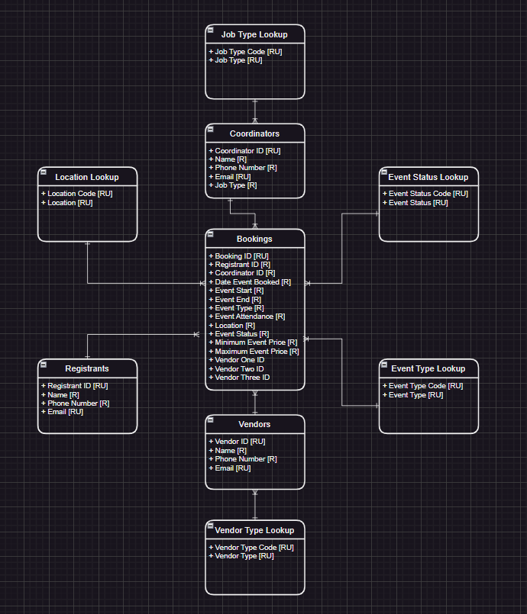

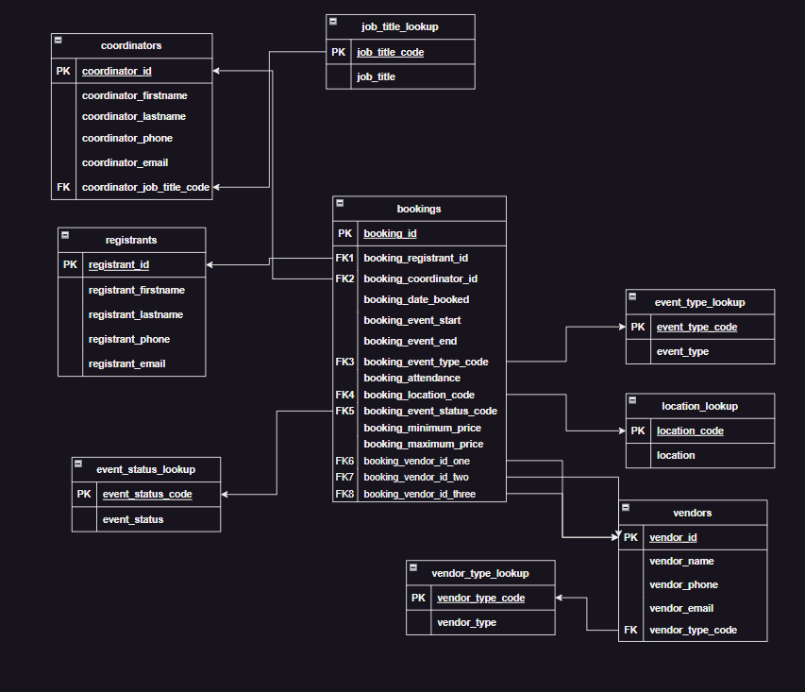

# 5.0 Real Applications & Reflections

As for real-world applications for the database, this type of database can be used in any scenario that needs either sales, events, or timings of logistics. The organization that this database offers gives streamlined information and can even be put into other formats such as invoice forms, calendars, and memos for invitations, depending on the different situations. The database houses a multitude of information for anything you can you use.

Looking at my project, I feel that if I had more time, I would put more effort into the database. I would put in triggers to automatically set up data and times for when each booking is created. I feel that if I had more knowledge in this field, I would set up versioning and locks to ensure that there is more data security.