Agentic HR Policy Email Triage Assistant
Agnos/Agno Multi-Agent Workflow + Zapier Agentic RAG Automation

1. Use Case Description and Importance
This project designs an Agentic HR Policy Email Triage Assistant that helps employees receive accurate answers to policy questions while automatically routing requests that need action. The selected use case focuses on HR emails related to sick leave, remote work, vacation, overtime, and security incidents. This workflow matters because HR teams often spend time reading repetitive emails, searching policy files, interpreting rules, drafting replies, and escalating approval or security cases. A standard LLM can generate fluent text, but it may answer from memory or invent policy details. Agentic RAG improves reliability by retrieving company policy evidence first, reasoning over that evidence, and then recommending or executing a workflow action through Zapier.
The business value is strongest where the request is not only informational. For example, a sick leave question can be answered directly, a remote work request can be routed for manager approval, and a phishing report can trigger an urgent IT/security escalation. The multi-agent design outperforms a single prompt because each agent has a narrow responsibility: retrieving internal evidence, gathering supporting workflow context, deciding the correct route, and synthesizing the final response. This reflects the assignment goal of combining retrieval, decision-making, tool execution, and multi-agent collaboration into a business-ready task.

2. Tools and Knowledge Sources
The system combines a coded multi-agent layer with a no-code automation layer. The Agnos/Agno component was implemented in Python using agent definitions, custom retrieval tools, OpenAI reasoning, and a coordinator team. Agno supports teams that coordinate specialized agents, which fits the design pattern used in this project. Zapier was used for the no-code Agentic RAG workflow because it can connect apps, add AI steps, use knowledge sources, and route workflows across actions. Zapier AI knowledge sources support Google Drive files, Google Docs, Notion, uploaded files, and related document stores, which makes it suitable for document-grounded HR automation.

Table 1. System Components
Component | Tool / Source | Purpose
Multi-agent framework | Agnos/Agno + OpenAI | Defines specialized agents and coordinator synthesis.
Internal policy RAG | HR policy files / Google Drive | Retrieves sick leave, remote work, vacation, overtime, and security policy evidence.
Second context source | External workflow context knowledge base | Supports business context without overriding internal policy.
No-code automation | Zapier | Runs Gmail trigger, filtering, AI classification, paths, drafts, logs, and alerts.
Operational logs | Google Sheets | Stores category, urgency, route action, policy evidence, final answer, and status.

3. Multi-Agent Architecture
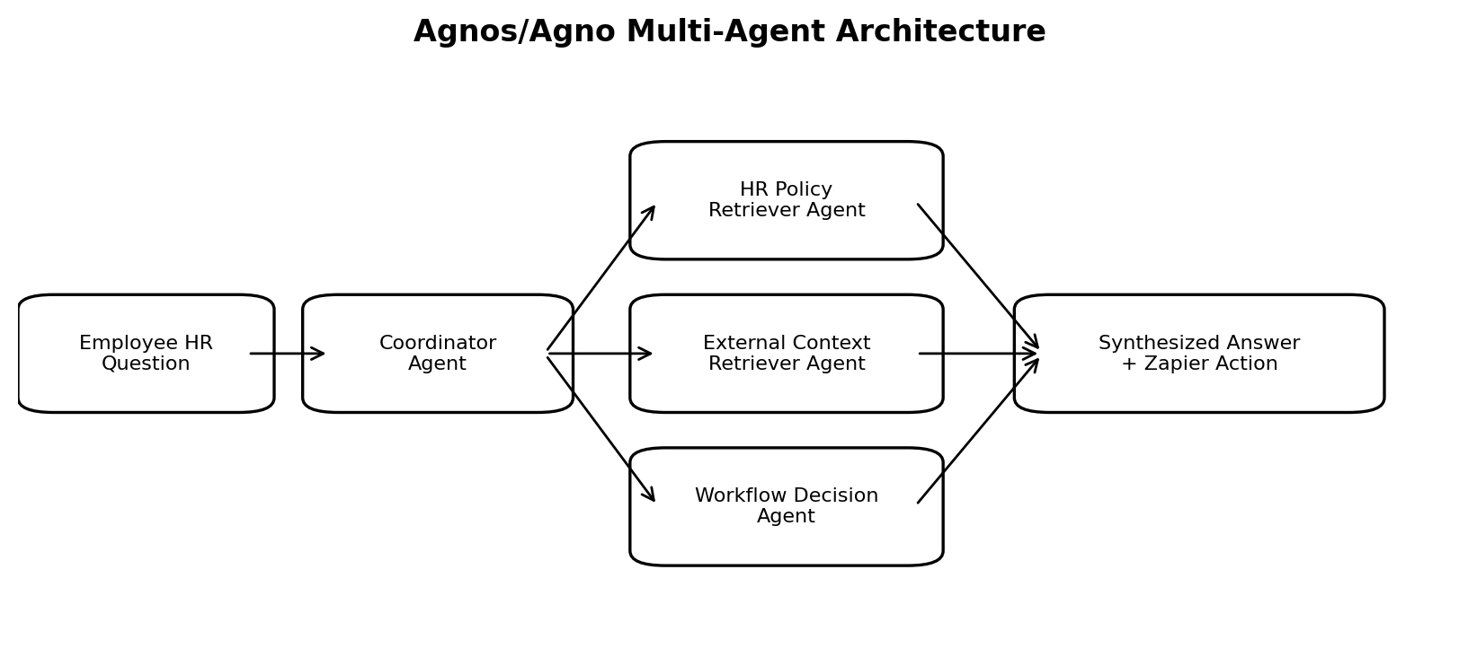
The Agnos/Agno workflow includes three specialized agents and one coordinator. The HR Policy Retriever Agent searches the internal policy knowledge base and returns source-specific evidence. The External Context Retriever Agent supplies supporting workflow context, such as HR automation or security escalation patterns. The Workflow Decision Agent determines whether the request should be answered only, routed for manager approval, or escalated urgently. The Coordinator Agent combines the outputs into a final structured response containing classification, policy evidence, supporting context, final answer, recommended Zapier action, business value, and risk case.
Testing confirmed the multi-agent flow. A sick leave question retrieved the sick leave policy and returned an answer-only route. A remote work question retrieved remote_work_policy.txt and recommended a manager approval task. A phishing-link question retrieved data security policy evidence and recommended urgent IT/security escalation. The strongest benefit of the architecture is that evidence and action routing are separated: the policy agent focuses on facts, the workflow agent focuses on routing, and the coordinator produces the final business-ready output.

4. Zapier Agentic RAG Workflow
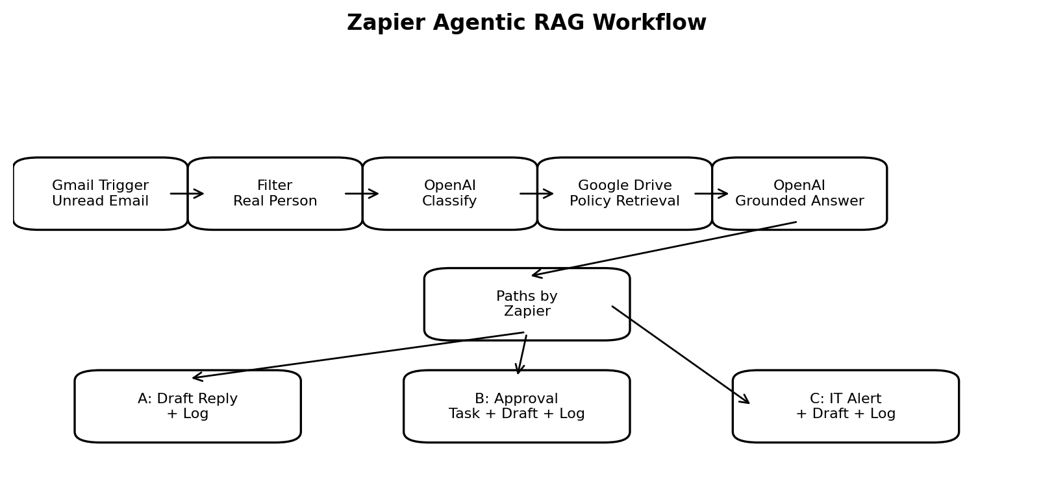
The Zapier workflow begins with a Gmail trigger for new unread messages. Filter by Zapier removes no-reply, promotional, newsletter, and sales-type emails so that only real employee-style requests continue. An AI classification step reads the email and returns route fields such as route_category, route_urgency, and route_action. The workflow then retrieves policy knowledge from the HR Policy Knowledge Base in Google Drive/Google Docs. A second AI step generates a grounded response using the retrieved policy content and returns a final employee answer, policy evidence summary, recommended Zapier action, and failure risk.
Paths by Zapier then performs task routing. Path A handles informational questions, such as sick leave, by creating a Gmail draft and logging the case in Google Sheets. Path B handles approval-required cases, such as remote work, by creating or logging a manager approval request, drafting an employee response, and storing the record. Path C handles urgent security incidents by sending an alert to IT/security, drafting a reply to the employee, and logging the escalation. This shows autonomous decision-making because the action changes based on the AI classification and retrieved policy evidence.

5. Reasoning Explanation and Test Cases
The reasoning process follows a simple agentic loop: classify the request, retrieve the relevant policy, reason over the retrieved evidence, decide the workflow action, and execute or simulate the action. For sick leave, the system identified the request as informational and used the sick leave policy stating that employees receive 8 paid sick days per calendar year. The route_action was answer_only, so the Zapier path created a draft reply and logged the request. For remote work, the retrieved policy stated that eligible employees may work remotely up to two days per week but manager approval is required before the remote work date. The route_action became manager_approval, so the workflow logged or created an approval task and drafted a response. For phishing, the data security policy required immediate reporting to IT/security and advised employees not to interact with suspicious links or attachments. The route_action became urgent_it_security_escalation, so the workflow sent or prepared an IT/security alert.

6. Failure Analysis
Several realistic failure cases were observed during implementation. First, the initial Agno code used parameters that did not match the installed library version, such as max_output_tokens and DuckDuckGoTools(max_results=3). These were corrected by using compatible model settings and by replacing unstable web search with a controlled external context retriever. Second, the OpenAI API produced authentication and quota errors before the valid key and credits were added. Third, the DuckDuckGo/DDGS web search tool sometimes returned "No results found," even though the internal policy retriever succeeded. This showed the importance of treating internal HR policy as the primary source of truth and using external context only as supporting evidence.
Zapier also had practical setup issues. Google Drive did not find files until the policy files were properly uploaded and the file search was configured correctly. The AI path routing step initially did not expose the category field, so the workflow was improved by adding explicit route_category, route_urgency, and route_action output fields in the Step 5 AI output. A future production version should include stronger validation: if a policy document is missing, if retrieval confidence is low, or if route fields do not match the allowed categories, the case should automatically route to human HR review instead of continuing.

7. Business Impact
The system has measurable operational value. A manual HR triage process may take about 10-15 minutes per email because a staff member must read the message, find the policy, interpret it, decide whether approval or escalation is needed, draft a response, and update a tracking sheet. The agentic workflow can perform these steps in roughly 20-60 seconds depending on API and Zapier processing time. If an HR team receives 40 routine policy emails per week, reducing each case by even 10 minutes saves about 400 minutes, or 6.7 hours, per week. At an estimated HR labor cost of $30 per hour, that equals about $200 per week or more than $10,000 per year in time value, before considering faster escalation and improved employee experience.
The impact is not only cost reduction. Policy-grounded answers reduce hallucination risk, Google Sheets logging improves auditability, and Zapier paths improve consistency across cases. Urgent security escalation has high business value because faster routing can reduce incident response time. Approval-based routing also reduces process gaps by ensuring employees do not assume that remote work, vacation, or overtime is automatically approved. Overall, the project demonstrates how Agentic RAG can move from text generation to operational decision support.

8. Future Improvements
- Add confidence thresholds for retrieval and classification so ambiguous questions route to human HR review.
- Replace synthetic HR policy files with a version-controlled policy repository in Google Drive, SharePoint, or Notion.
- Add manager lookup logic so approval tasks are automatically assigned to the correct supervisor.
- Create an audit dashboard showing volume by category, average response time, escalation count, and failure rate.
- Add human-in-the-loop approval before any real email is sent, especially for legal, disciplinary, or security-sensitive cases.
- Extend the workflow to support multilingual employees, attachments, and PDF policy manuals.

References
Agno. (2026). Teams overview and agent platform documentation. https://docs.agno.com/teams/overview
Zapier. (2025). Use knowledge sources in AI by Zapier. https://help.zapier.com/hc/en-us/articles/38906190895629-Use-knowledge-sources-in-AI-by-Zapier
Zapier. (2026). Automate AI workflows, agents, and apps. https://zapier.com/
Course assignment prompt. (2026). 8.7 Agentic RAG & Multi-Agent Intelligent Workflows (Zapier + Agnos).

Appendix: Zapier Implementation Evidence
The screenshots below show the actual Zapier workflow that was built and published. The first screenshot shows the end-to-end automation chain from Gmail trigger through filtering, AI reasoning, Google Drive retrieval, and the second AI response step. The second screenshot shows Paths by Zapier branching into the three required business routes: informational questions, approval-required requests, and urgent security escalation.
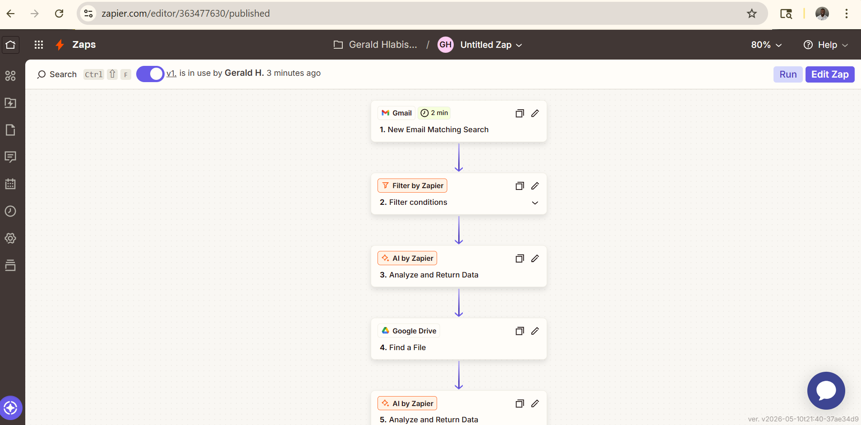
Figure A1. Published Zapier workflow overview: Gmail trigger, filter, AI classification, Google Drive retrieval, and AI grounded response.
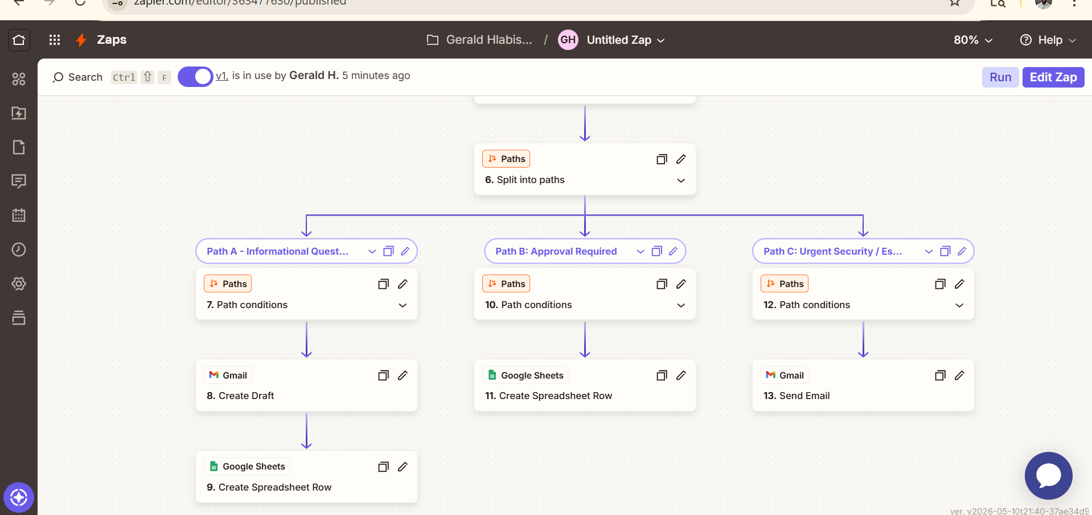
Figure A2. Paths by Zapier implementation: Path A drafts and logs informational answers, Path B logs approval-required requests, and Path C sends urgent security alerts.

