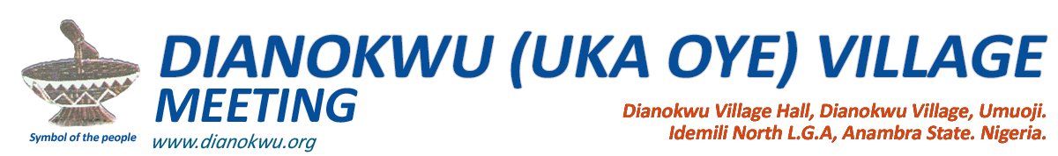**___________________________________________________**

16th September, 2017

Urueze Village Community,  
Umuoji.

**RE: INTIMIDATION AND HARRASMENT AND ARREST OF OUR BROTHERS**

During our recent Uka Oye general meeting the Dianokwu community got a sad report of arrest, intimidation and harassment and dirty scheming to imprison our brothers – Peter Iloabachie and Onyebuchi Ojukwu for something they knew nothing about. These people were arrested by Mr. Nonso Ughachukwu in connivance with other persons of Urueze Village with SARS police officials on trumped charges that they are armed robbers who attacked them with dangerous weapons and they were consequently detained for over a week at the SARS Unit where they faced all sorts of molestations. We also got wind of an eventual law suit against them in which they were alleged to be criminals who attacked them with dangerous weapons including other ridiculous charges brought against them.

While we are fully aware that Mr. Nonso Ughachukwu and others know that these persons are completely innocent of the charges brought against them but rather unfortunate victims of a move by the Mr. Nonso Ughachukwu and others to make a big statement out of someone, we wish to officially state here that these two persons are well known to Dianokwu Community are of impeccable characters who have never been known to engage in any criminal activities in their lives. These persons were hired to carry out legitimate labour jobs at the disputed site and are not owners nor claimants or party to any dispute that might exist at the construction site where they were arrested.

While Dianokwu community will wait for the eventual outcome of their lawsuit against our brothers, we wish to categorically state here that we are fully behind our brothers on this issue and henceforth we are transferring the burden of safety of their lives and properties over to Mr. Nonso Ughachukwu and others since they have decided to employ all sorts of dangerous tricks and scheming to make sure you make scapegoat of them.

We do not know where they are going with their actions but we are promising that we are not going to fold our arms and watch while they destroy the lives of our innocent brothers.

For the sake of records and posterity, are copying this letter to Igwe Umuoji and also the highest ruling body of Umuoji as well as Ndi Ichies of all Umuoji quarters while hoping that they will realize that it is not yet too late to retrace their steps and leave our brothers alone.

Thank you.

Yours Faithfully,

_________________________ _______________________

**John Machi** **Joseph Achebe**  
 Chairman Secretary

CC

**1. H.R.H Igwe Dr. Cyril Enweze  
(Ebube Igwulube Okodu)  
The Igwe of Umuoji  
  
2. The Igwe-in-Council Umuoji  
  
3. Ndi Ichie Eziora**

**4. Ndi Ichie Ifite-Ora**

**5. Ndi Ichie Dimechem**

**6. Ndi Ichie Akala**