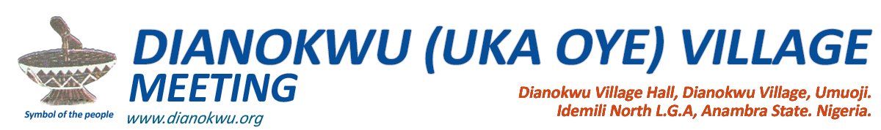**___________________________________________________**

4th October, 2017

The President General,  
Umuoji Improvement Union.

**RE: LAND DISPUTE WITH NKPOR PEOPLE**

Sequel to our meeting on the night of 29th September 2017 and on behalf of Dianokwu community, we wish to officially inform you of our protracted land dispute with some Nkpor people. This dispute has lasted for over four years and taken a lot of resources from us as a community. These people invaded our Okofia land and destroyed all the beacons and some structures already put in place by our people and employed armed thugs in harassing our people out of the land before engaging in massive sale and development within the land. We responded by filing a court case against them once again despite the fact that we have gotten court judgment against them on the same land most recently in 1984. The court proceedings are ongoing but these people have not relented. With this letter, we wish to officially request for your assistance in dealing with this issue. We believe that your involvement in this case will offer stronger position to our case by removing the notion on the mind of any party or umpire that might be viewing our case as a matter between a village in Umuoji and Nkpor people rather as a matter between Umuoji people and the other party from Nkpor.

It is important to point out here that our problem spots with Nkpor people include the Okofia land where some other villages from Umuoji as well face the same problem and also our Ngbuewu land.

We have strong belief that with the caliber of personalities within Umuoji and also considering the personality of the Igwe Umuoji and the full involvement of the U.I.U Nigeria, a quicker and final resolution to this matter will soon be reached and we on our own part pledge to give you full support in ensuring that there are not obstacles while you are assisting us.  
  
Yours Faithfully,

______________________ _______________________

John Machi Joseph Achebe  
 Chairman Secretary

CC.

**1. H.R.H Igwe Dr. Cyril Enweze  
(Ebube Igwulube Okodu)  
The Igwe of Umuoji  
  
2. Umuoji Vigilante Services**