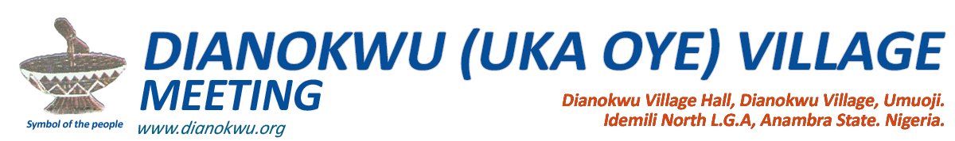

**___________________________________________________**

10th September, 2017

Emeka Udegbe,  
Dianokwu Village,  
Umuoji.

**RE: MISCONDUCT DURING EXECUTIVE MEETING**

Sequel to the decision taken on the Dianokwu Uka Oye executive meeting of 16th of July, 2017, you are by this letter officially informed that you have been suspended from the executives for a period of one month with effect from 10th September, 2017.

The reasons for your suspension are as follows:

1. Your flagrant disrespect and insult to the chairman on the Dianokwu executive meeting of June 18th, 2017.
2. Your conduct that is unbecoming of an elected official of Dianokwu which is also capable of leading to breakdown of order during the above mentioned meeting whence you kicked away seats and threatened physical fight to fellow executives.

You are also required to write an apology letter in which you will promise to never engage in any form of misconduct like the ones motioned above in the future.

Thank you.

Yours Faithfully,

_________________________ _________________________

John Mmachi Joseph Achebe

Chairman Secretary