**Homework Question 1**

* A = B + C
* B = 5 + D
* C = 4
* D = 2
* S = {A,B,C,D}
* R = (A,B),(A,C),(B,D)
* A = 11

Homework Question # 2

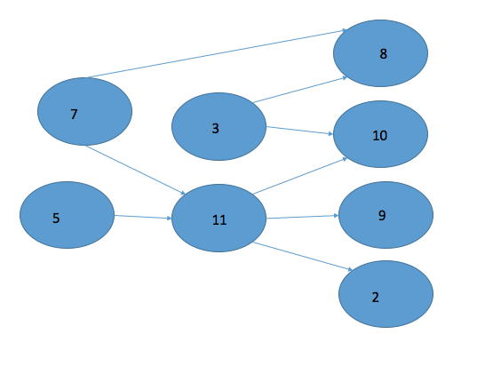

*Homework question 3 – give another example*

*analyze the relationship of different products in supermarket*