GCTAS

FZU MIEC

**Software**

**requirements**

**specification**

* Summary of file changes

|  |  |  |  |  |  |
| --- | --- | --- | --- | --- | --- |
| **Date** | **Version number** | **Revision note** | **Revisor** | **Auditor** | **Approver** |
| 2020.11.6 | V 1.0 | Create | GCTAS |  |  |
| 2020.11.8 | V 2.0 | Modify | GCTAS |  |  |
|  |  |  |  |  |  |
|  |  |  |  |  |  |
|  |  |  |  |  |  |
|  |  |  |  |  |  |
|  |  |  |  |  |  |
|  |  |  |  |  |  |
|  |  |  |  |  |  |
|  |  |  |  |  |  |
|  |  |  |  |  |  |
|  |  |  |  |  |  |
|  |  |  |  |  |  |
|  |  |  |  |  |  |
|  |  |  |  |  |  |
|  |  |  |  |  |  |
|  |  |  |  |  |  |
|  |  |  |  |  |  |
|  |  |  |  |  |  |
|  |  |  |  |  |  |
|  |  |  |  |  |  |
|  |  |  |  |  |  |
|  |  |  |  |  |  |
|  |  |  |  |  |  |
|  |  |  |  |  |  |
|  |  |  |  |  |  |
|  |  |  |  |  |  |
|  |  |  |  |  |  |
|  |  |  |  |  |  |
|  |  |  |  |  |  |
|  |  |  |  |  |  |
|  |  |  |  |  |  |
|  |  |  |  |  |  |
|  |  |  |  |  |  |
|  |  |  |  |  |  |
|  |  |  |  |  |  |
|  |  |  |  |  |  |
|  |  |  |  |  |  |

**Catalog**

1. Iterative record table···············································3
2. Introduction······················································3
3. Project logo······················································4
4. Mind mapping····················································4

4.1 General process··············································4

4.2 Process of socialization········································5

4.3 Process of filter··············································5

4.4 Team project················································6

1. Class diagram·····················································7
2. Interface prototype·················································7
3. Function description················································7
   1. Overall requirement functions···································8
   2. Requirements of socialization···································8
      1. Chat with friends········································9
      2. Teamwork·············································10
      3. Share location··········································10
   3. Requirements of filter········································12
      1. Search················································12
      2. Filter·················································13
   4. Requirements of project·······································14
      1. Communication with teammates···························14
      2. Check the schedule······································15
      3. Upload················································16
4. Acceptance criteria················································17
   1. The quantity of software······································17
   2. Design and implementation constraints··························17

1.Iterative record table

| No. | Version | Reviser | Revised content | Update time |
| --- | --- | --- | --- | --- |
| 1 | 1.0.0 | ALL | 1.Searching tool with sifting  2.Making friends module | 2021.10.25 |
| 2 | 1.0.1 | ALL | 1.Searching tool with sifting  2.Making friends module (Location marks)  3.Education source for beginner  4.Team projects | 2021.10.31 |
| 3 | 1.0.2 | ALL | 1.Searching tool (sifting in CSDN (blogs) and GitHub(projects))  2.Making friends module (showing the Location marks of mutual subscription accounts and teammates)  3.Education source for beginner  4.Project community with schedule design and comments | 2021.11.06 |

2. Introduction

Human is is a social animal. The community and communication take a crucial characteristics in human society. Communication can improve the exchange and progress of knowledge. What’s more, the formation of community can gather strength and wisdom to solve problem. Since it, we form our idea using these factors to solving current issue on open source platform and help open source project development group cooperation.

For source project part, we not only want to help developing group manage the processing and milestones of projects, but also build community between public and development group. Besides publishing information like announcement, next version preview, even searching needing ability, the group can also collect information about bugs or suggestions. What’s more, a voting mechanism is also planned to invoked allowing group get most popular suggestion. Last but no least, we hope providing a channel allowing other techniques exchange idea and experience with developing group.

In addition, the interior communication and community are also a crucial part we concerned on. User can see the location of other members in same group or Mutually close friends in mini map. The more information is allowed to access after click the icon. The private chat is also planned to implemented. We hope the user can communication with their teammates and friends better with those methods.

The significant increment of invaded blog, which general contains irrelevant, fragment even cheating information leading difficult to search and study information or knowledge on those platform, with the scale of open sources community, especially cnblogs or CSDN who is BBS form, is another point we are eager to solve. The sifting mechanism basing on project members recommendations help user get information on CSDN better.

3. Project logo



4. Mind mapping

4.1 General process

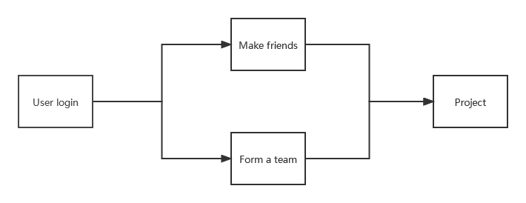

4.2 Process of socialization

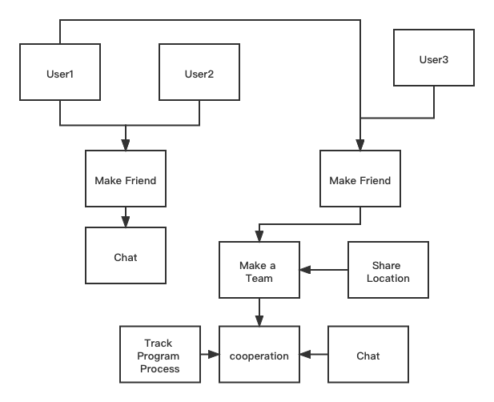

4.3 Process of filter

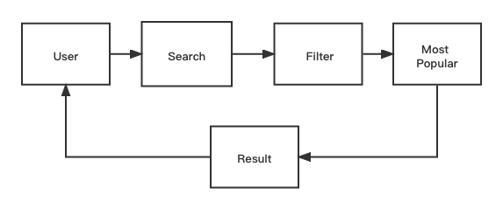

4.4 Team project

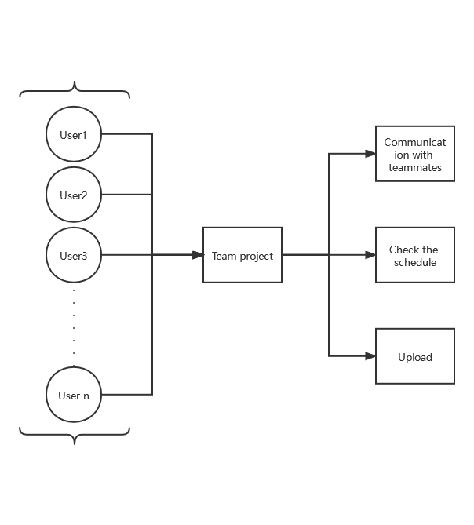

5. Class diagram

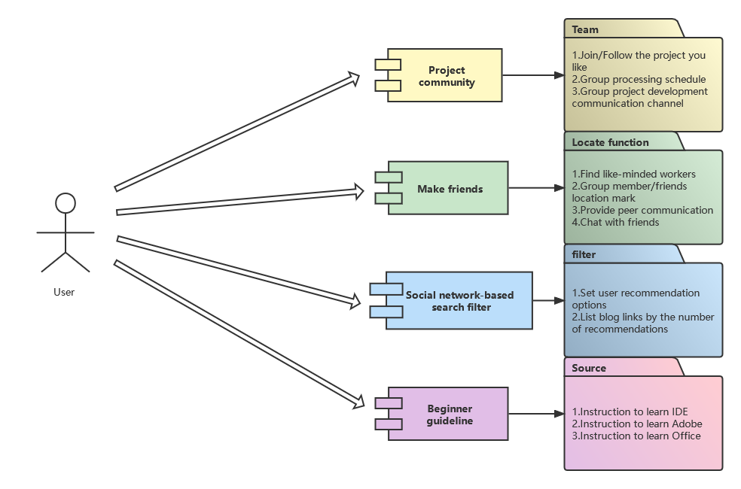

6. Interface prototype

*https://modao.cc/app/99b14ddc9c8b656e637e63ee070540d90a61e041 《GCTAS》*

7. Function description

7.1 Overall functional requirements

The system contains the functions as follow:

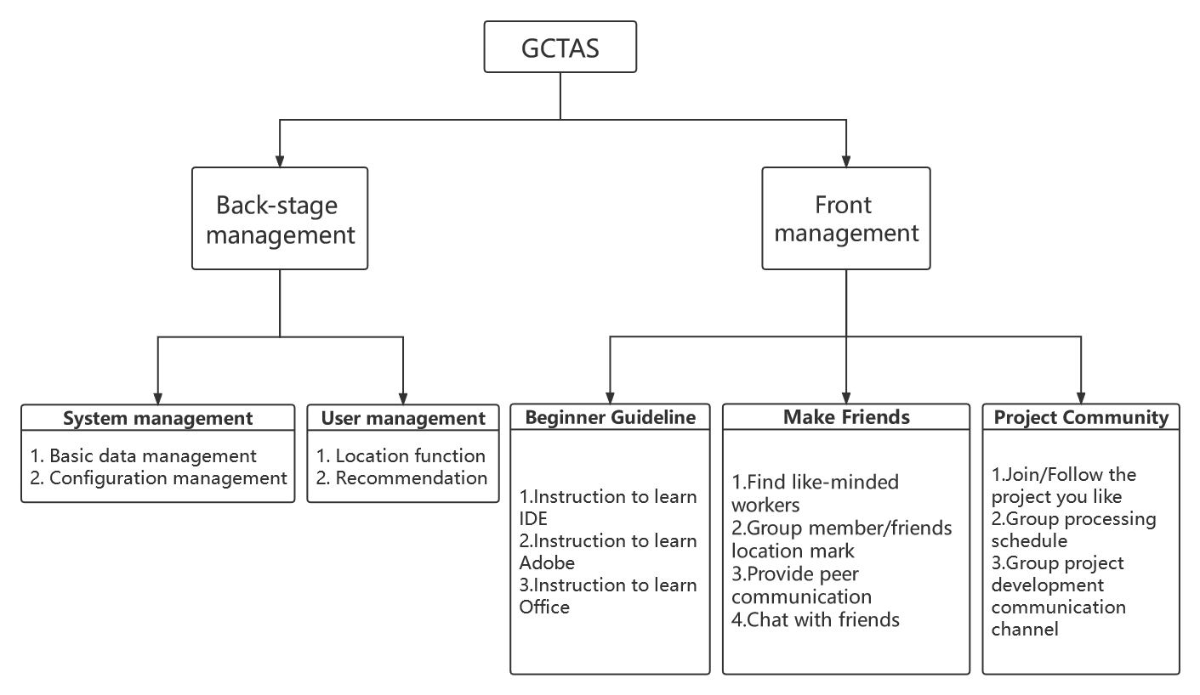

The location service can be enabled only with the user's consent in the requirements.

Beginner guideline contains some posts about how to use some software such as IDE, Adobe and Office, which are chosen from CSDN.

7.2 The requirement of socialization



|  |  |  |
| --- | --- | --- |
| ReqID | ReqName | Brief Service Description |
| 7.2.1 | Chat with friends | Provide communication channels according to user intention |
| 7.2.2 | Teamwork | Optimize the project team experience |
| 7.2.3 | Share location | Provide opportunities for offline communication in the same city |

7.2.1 Chat with friends

**Executor:**

User

**Process description:**

1. The user can select any friend from the two-way following list
2. Click the user's profile picture to enter the chat box

**UI Prototype:**

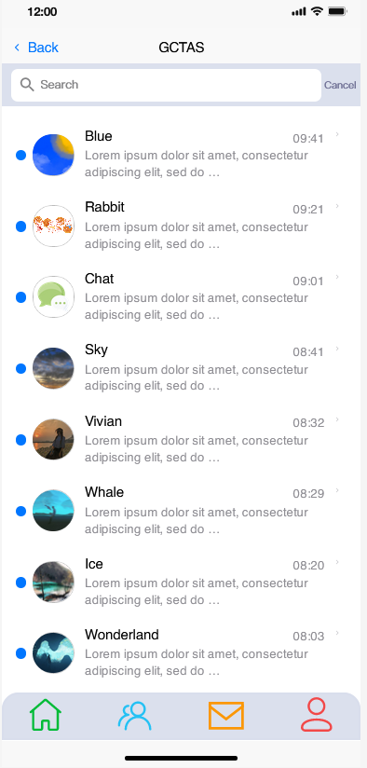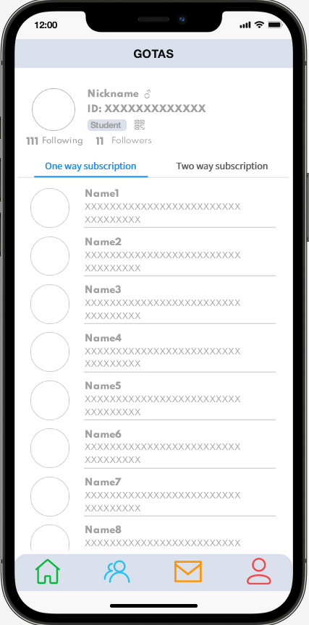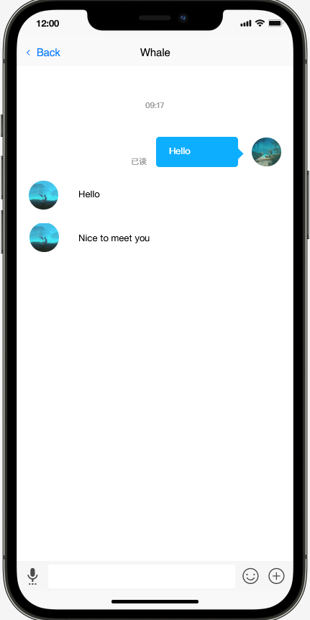

Message list Following list Chat box

**Rule Description:**

1. If not the first time to chat, User can find the chat box in the prototype of message list.
2. User can receive three messages at most if the other is not following mutually.
3. Voice bar support

7.2.2 Teamwork

**Executor:**

User

**Process description:**

1. The user should join or create a team before experience this feature.
2. User can check the content of the project that is cooperated with others in the prototype of team.

**UI Prototype:**

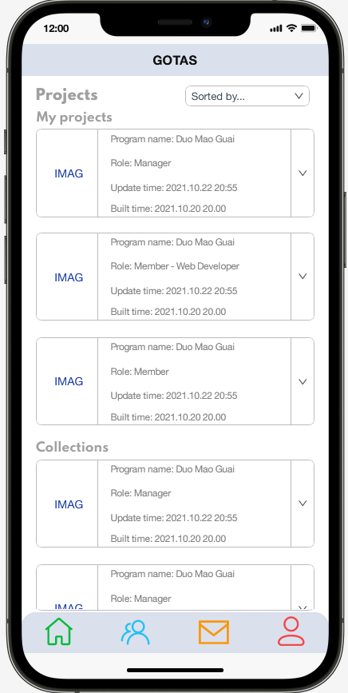 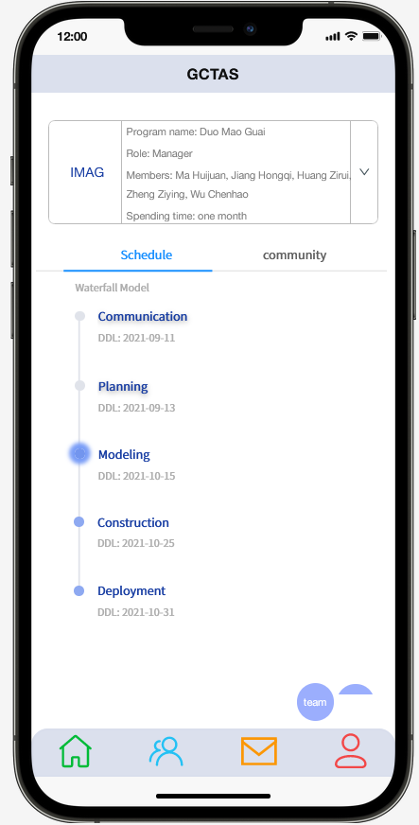

Team project Project detail

**Rule Description:**

1. When a user creates a team, they need to identify the team name and project.
2. Users can search by team name or team project to join a team.

7.2.3 Share location

**Executor:**

User

**Process description:**

1. The app will ask users if they want to enable location for their friends.

**UI Prototype:**

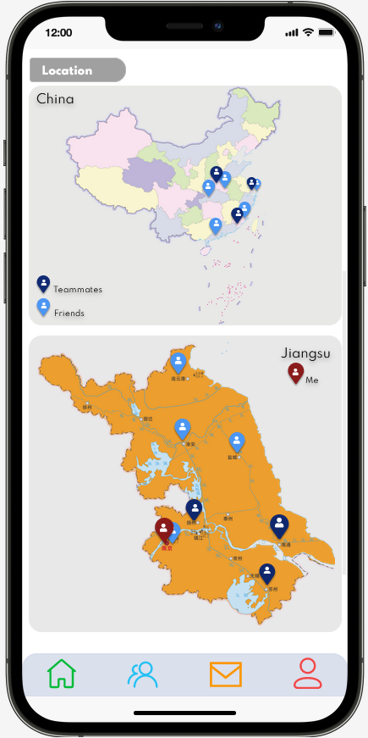

Location function

**Rule Description:**

1. Users can get the blogs from the CSDN through this program and they can follow the authors who they like. After that, users can chat with the authors.
2. Our program provides a platform where people can cooperate with others to make a project. First, program leader builds a project, then teammates enter the project by using their ID so that they can together do a project. Teammates can see the location of members who permit to share their locations with others on the map.

7.3 The requirement of filter



|  |  |  |
| --- | --- | --- |
| ReqID | ReqName | Brief Service Description |
| 7.3.1 | Search | Provide communication channels between teammates. |
| 7.3.2 | Filter | Optimize the efficiency of project |

7.3.1 Search

**Executor:**

User

**Process description:**

User can find the search box in home page.

**UI prototype：**

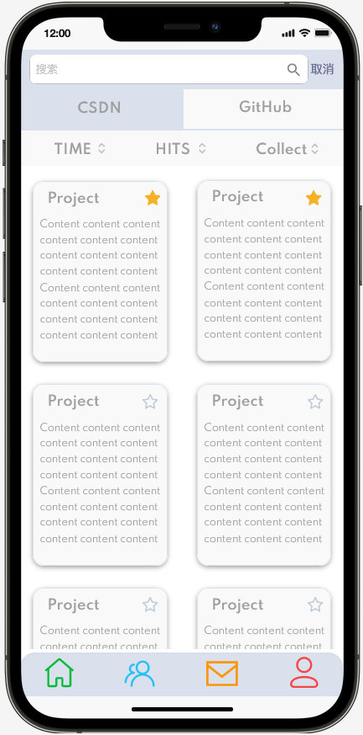

**Rule description：**

1. The app provides two platforms that are CSDN and GitHub.
2. Users can choose the community to find the posts they need or they like.

7.3.2 Filter

**Executor:**

User

**Process description:**

The program provides users with more useful posts based on what they search for.

**Rule description：**

1. The app can provide users with posts with high recommendation ratings.
2. Users can also click on recommendations for posts they find useful.

7.4 The requirement of project



|  |  |  |
| --- | --- | --- |
| ReqID | ReqName | Brief Service Description |
| 7.4.1 | Communication with teammates | Provide communication channels between teammates. |
| 7.4.2 | Check the Schedule | Optimize the efficiency of project |
| 7.4.3 | Upload | Provide work log function for users |

7.4.1 Communication with teammates

**Executor:**

User

**Process description:**

1. the user can start a dialog box with team members

2. The user can chat with group members in on message form

**UI prototype：**

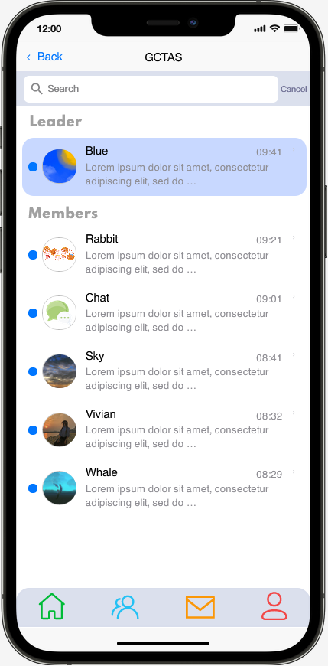

Chat with teammates

**Rule description：**

1.At the first stage of this process, the user should create a dialog box in group member form or the icon on the minimap.

2.The user should input the message on the second step, the system should invoke chat function to send the messages to receiver and remind receiver on message form.

3.The message should be store on local until user delete dialog box.

7.4.2 Check the Schedule

**Executor:**

User

**Process description:**

1.The user can access the general processing information of specifical group

2.The detail message of each stage like ddl,arrangements .etc can be obtianed after selecting a processing stage

**UI prototype：**

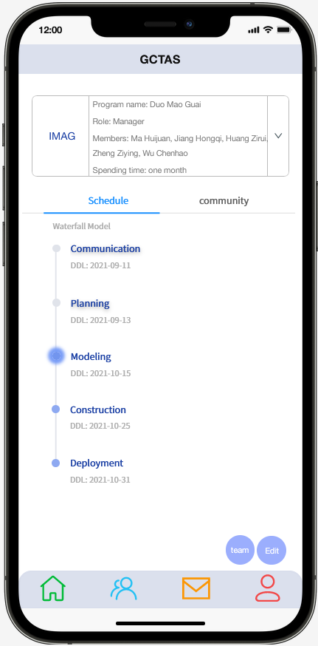 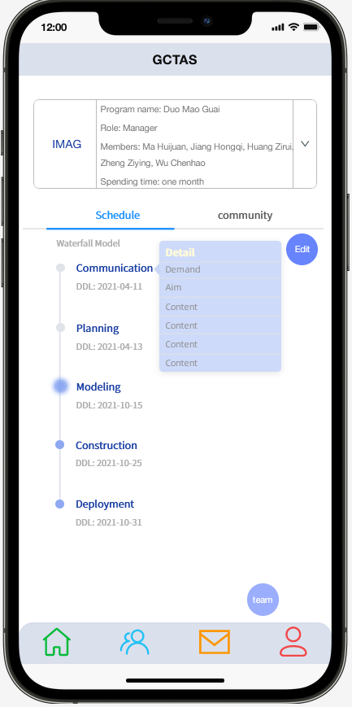 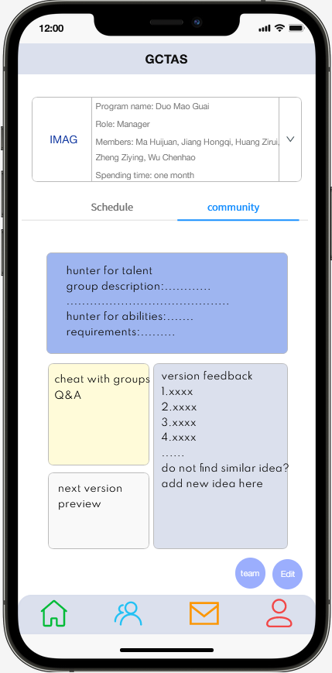

Schedule Community

**Rule description：**

1.The system should invoke the database of selected group according to the group selected by user in previous form.

2.The system will display the information as prototype once hop to page.

3.The detail information of each stage will be shown as prototype after selecting a stage.

7.4.3 Upload

**Executor:**

User(group holder or leader)

**Process description:**

this function allow user creat,edit and delete the processing model

**Rule description：**

1.The system check the user authority of Upload the upload function will be allowed invoked only if if the user is group holder or leader.

2.The user should select the three function(creat,edit and delete)

3.The function will return the interface allow user to change the processing model

4.The change information will upload and cover the old database.

8.Acceptance criteria

8.1 The quantity of software

For this system, it has these following requires and rules in quantity in order to satisfy possible demand in reality.

1. Functionality: the system should satisfy more demand to realize the convenience of all users and make the relationship of people in open-source neighborhood closer.
2. Reliability: the system can keep confidential the information of all users.
3. Availability: the system is available and efficient.
4. Maintainability: when a system error occurs, the system maintainer can find the error as quickly as possible and correct it.

8.2 Design and implementation constraints

1. The user of the system must operate the system according to the operation specifications. In case of system failure or paralysis, he must immediately deal with and reply to the original data.
2. If the user's database is changed, the interface is changed, and the hardware is replaced, resulting in incompatibility, the developer shall be notified in time.
3. The system is developed in strict accordance with user requirements and completed after multiple interactions with users. Users have the right to use the system.