13 October date started
I Herve Iradukunda will code for as much as I can during the week and DO SOMETHING! on the weekends.

What Do Web Developers Do?
In short, web developers build and maintain websites.
Web developers often work for clients who are trying to get their product or service onto the web. The work is typically very project focused and involves collaborating with a team that helps to coordinate the client’s needs into the end product. The client could be a tech company, an organization, or a government. The work could involve front-end, back-end, or full-stack web development.
Web development could be a good profession for you if you like solving logical problems, building useful things, and experimenting with new technologies. Web developers are in high demand, generally have a good work/life balance, and command comfortable salaries. Google your specific location to get a better sense of your local web development job opportunities.

Types of Web Developers
The front end is the stuff you see on the website in your browser, including the presentation of content and user interface elements like the navigation bar. Front-end developers use HTML, CSS, JavaScript, and their relevant frameworks to ensure that content is presented effectively and that users have an excellent experience.
The back end refers to the guts of the application, which live on the server. The back end stores and serves program data to ensure that the front end has what it needs. This process can become very complicated when a website has millions of users. Back-end developers use programming languages like Java, Python, and Ruby to work with data.
Full-stack developers are comfortable working with both the front and back ends.

Types of Careers
Now that you know about the different types of web developers, let’s cover what we mentioned earlier about the different types of clients and employers you may work with.
Large tech companies, such as Google, Facebook, and Amazon, have very stringent hiring requirements. If you successfully meet these expectations, they offer excellent pay, benefits, and opportunities.
Startups are a bit like the wild west. For a junior developer, it can feel like a trial by fire because of the pace of development. Startups often offer slightly lower salaries and require longer hours, but they may also offer equity in the company and highly unique environments. As a freelancer, you could command a strong hourly wage and the freedom to schedule and design your own products. However, you would be responsible for getting your own work (which means less coding time), managing billing from clients (which can be difficult), and being solely responsible. Strong people skills are necessary for this path.
As a consultant for a web consultancy, you would give up some of your freelancing wage potential but be able to focus more on the code and less on the hustle. This option also provides a good work/life balance and pay.
Finally, large, older companies still need web developers. These companies offer a good work/life balance, pay, and benefits but often move slower than a company that is highly focused on tech.

Motivation
Learning to code is incredibly rewarding but can also be difficult and frustrating. The strongest assets you can have as a student are a desire to build, a problem-solving mind, and persistence in the face of setbacks. The web development industry has a long history of successful developers with varying backgrounds, so people tend to care more about what you’ve actually built than how you got there.

Why I have decided to learn programming.
I am a 26 year old man who feels lost in life. I pass the days in front of my 2 screens all day from 11 am to 3am watching TV shows, movies, or sports non-stop every day without fail and I’m sick of it. I wan to fill my days learning a new skill I actually enjoy doing. I want to be fully mentally invested in the world of Full Stack Web Development within the next 12 months and when someone ask’s me what I do I want to be able to give a answer and be proud of it. “I HERVE am worthy of all the best in life and I can do anything I put my fucking mind to!” . The big one I want to be able to make the HERVE TRANSPORT & LOGISTICS website oneday.

Growth Mindset
Your mindset is very important when teaching yourself any new skills, not just programming. Your mindset will have more of an impact on your chances of success than just about anything else.
Someone with the fixed mindset believes if they don’t get something on their first attempt, they never will. They believe that they simply aren’t smart enough to be able to do or understand some things.
However, there is a wide body of research showing that intelligence is not fixed but can instead be developed. Someone with the growth mindset believes they can get better at anything with effort and persistence.
What does this mean for you? It means you can learn new skills and develop new talents with persistence and grit.
There will be many times in life that you will get stuck on a concept or a programming problem and may find yourself questioning your ability to learn programming. When you find yourself in this position, remind yourself that you may not get it yet but that with persistence and grit you will. Struggling with something is growth. It doesn’t matter how long you struggle with a concept or project; all that matters is that you have the grit and tenacity to see it through. That’s how real learning happens.
While you’re working through the curriculum, embrace the struggles you encounter with difficult concepts and complex projects. Be sure to celebrate your persistence at overcoming those struggles!
When you find yourself questioning your abilities, reflect on the successes you have already achieved while learning to program: the projects you have completed and the concepts you once didn’t understand but now do. This is all the proof you need that you can do it.

What To Do When You’re Stuck
You will inevitably get stuck at some point in the curriculum, perhaps due to a concept that you are having difficulty understanding or perhaps due to something not working correctly in a project. Whatever it is, use the following tools to get unstuck:
- Read the documentation or error
- Google it: You can be certain someone else out there has encountered the same problem as you at some point. A quick Google search can often lead to a solution.
- Take a break: Allow your diffuse learning state to work on the problem.
- Ask for help in our chat: Come prepared with your research. People will be more willing to help you when they can see you have already put effort into trying to figure out the solution on your own. When you get stuck, remember: Read-Search-Ask.
This is the most time-efficient way to handle being stuck, and it’s the most respectful of other people’s time, too. Most of the time, you’ll solve your problem after just one or two steps of this algorithm.

Managing Your Study Time
You will have more success by putting consistent time into it rather than working on it once a week. Building a habit of studying every day at a specific time and with a specific goal will ensure that you make consistent progress.

Procrastination
Procrastination will be your biggest enemy when trying to make progress so:

Take breaks
listen to music
Read
chess
meditate
play a quick game
go for a walk

Rabbit Holes
Because we cover so much material on The Odin Project and link to so many high quality courses and tools, it is easy for students to get pulled into rabbit holes by spending time trying to learn all there is to know about a subject that they aren’t ready for or won’t benefit them much. We have put a lot of effort into structuring the curriculum so that all of the important things that you need to know about web development are covered exactly when you need to know them. Stick to the path laid out as much as possible. Try to limit time spent going down rabbit holes as these sidetracks can really ruin your momentum.
Comparing Yourself to Others
Students often compare themselves to others who are farther along in their coding journey or have more experience. This is a recipe for depression and frustration. Only compare yourself to your past self. Have your abilities and knowledge improved from where you were last week, last month, or last year? Be proud of the progress that you’ve made!

What is the internet
The internet is a worldwide network of linked computers. Each of these computers can communicate with each other in a specific format.

What are packets and how they are used to transfer data.
Packets are the information of the internet. Packets are sent from the sender to the receiver in a specific format that contains all the information needed to communicate.

The differences between a web page, web server, web browser and search engine.
A web page is the page you look at in your browser.
A web server is the computer that has the code for how the webpage should look and act.
A web browser is a program on a computer that displays web pages.
A search engine is a web server that searches all other web servers for information. A user can then pull up the web page on their web browser and search for a site.

Briefly explain what a client is.
A client is a computer or internet device that requests information from a server.
What a server is.
A server is a computer that receives requests (as packets) from the client and responds with the appropriate data.

What IP addresses are
Internet Protocol addresses are numerical identifications that specify a destination in a network.

What DNS servers are.
Domain Name System Servers are the "phone book" of the internet. They translate domain names into IP addresses.

What happens when you run a search on google.com.
User sends request by clicking search button. Google receives the request, looks for the contents of the request in their databases, and sends back the result as a response.

The comand line
That black screen or window is the command line interface (CLI), where you’re able to enter commands that your computer will run for you. While there’s no need for you to re-enact the scene above, working with the command line is a critical skill for you to learn as a developer. The command line is like our base of operations, from which we can launch other programs and interact with them. It has a syntax of its own to learn. You can also open the terminal by pressing CTRL + ALT + T on your keyboard. You can use the cd command to change directories.
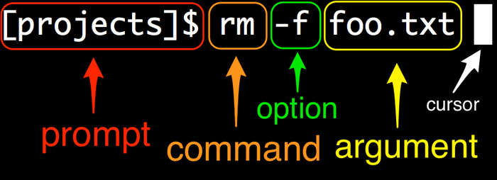
Anatomy of a command line

Technical sophistication
In technology, a skill (or, more accurately, set of skills) exists in the
form of technical sophistication. Essentially, this consists of a miscellaneous
toolkit of computer tricks, combined with an attitude of getting the machine to
do your bidding. Technical sophistication includes
things like looking for promising menu items and knowing the kinds of search
terms to drop into Google. These skills are hard to teach directly, so as you
progress through this always be on the lookout for opportunities to increase your technical sophistication by adding tools
to your kit (including, for example, the ability to get the gist of a program by scan-
ning its man page). Over time, the cumulative effect will be that, like you’ll have the seemingly magical ability to do everything in every program.
Command lines include several features to make it easy to repeat previous commands, possibly in edited form. The most basic is “up arrow”, which simply retrieves the previous command. There is also Ctrl-A ,which takes us to the beginning of the line. Similarly, Ctrl-E moves to the end of the line. Finally, Ctrl-U clears to the beginning of the line and lets us start over.

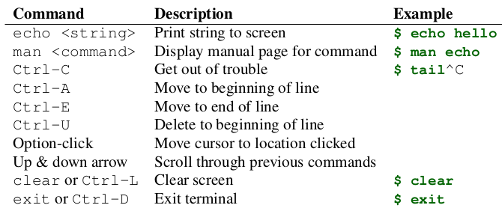
It’s not a bug, it’s a feature lol ¯\_(ツ)_/¯
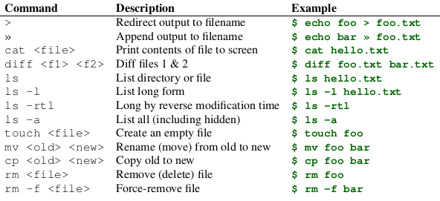
.

An even quicker way to find and immediately run a previous command involves using the exclamation point !, which in the context of software development is usually pronounced “bang”. Torun the previous command exactly as written, we can use “bang bang”
A closely related usage is “bang” followed by some number of characters, which
runs the last command that started with those characters. For example, to run the
last curl command, we could type this: !curl
This technique is especially useful when the desired command last happened many
commands ago, which can make hitting up arrow cumbersome.
A second and incredibly powerful technique is Ctrl-R, which lets you search
through your previous commands, and then optionally edit the result
before executing. For example, which could try this to bring up the last curl
command:
$ <Ctrl-R>
(reverse-i-search)`': curl
Hitting return would then put the last curl command after our prompt and allow
us to edit it (if desired) before hitting return to execute it. When your workflow
happens to involve repeatedly running a variety of similar commands, sometimes
it can seem like “all commands start with Ctrl-R.”

The most important less commands.

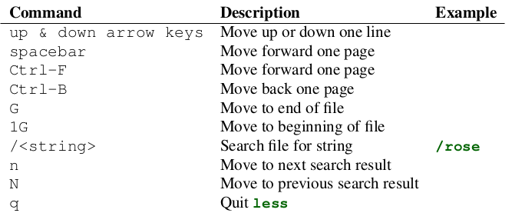
.
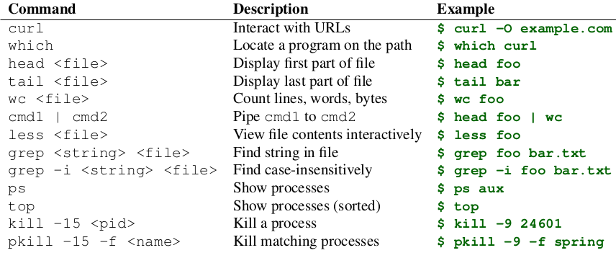
“sudo make me a sandwich.” lol ¯\_(ツ)_/¯
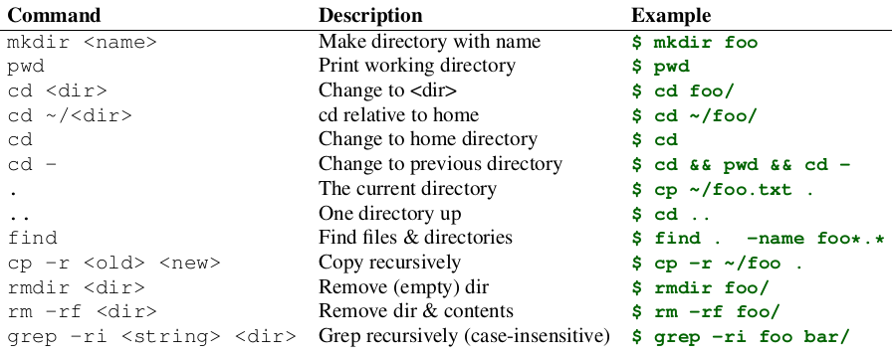
Vim Commands
ESC:q! The Most Important Vim CommandTM
i Exit normal mode, enter insertion mode
ESC Exit insertion mode, enter normal mode
Arrow keys Move around
0 Go to beginning of line
$ Go to end of line
:w Save (write) a file
:q Quit a file (must be saved)
:wq Write and quit a file
:q! Force-quit a file, discarding any changes
u Undo
x Delete the character under the cursor
dd Delete a line
p Put (paste) deleted texty

Git and GitHub what are the differences between the two
Simply put, Git is a version control system that lets you manage and keep track of your source code history Git also works on a local level. Any changes you make are saved locally with Git. GitHub is a cloud-based hosting service that lets you manage Git repositories. If you have open-source projects that use Git, then GitHub is designed to help you better manage them. GitHub works on a remote level. You must push your local changes (using Git) to GitHub.

The differences between Git and a text editor
A text editor can only make and save changes to a file, but Git tracks changes to the files and their contents over time.

Why Git is useful for an individual developer
Git is useful for creating snapshots of your work. If you realize halfway through that you've messed up, it's much easier to reset.

Why Git is useful for teams of developers
Git and GitHub are useful for teams because they can merge code together. A developer can work on one part of the code while a second developer works on another part. They can then use Git and GitHub to easily combine their changes.

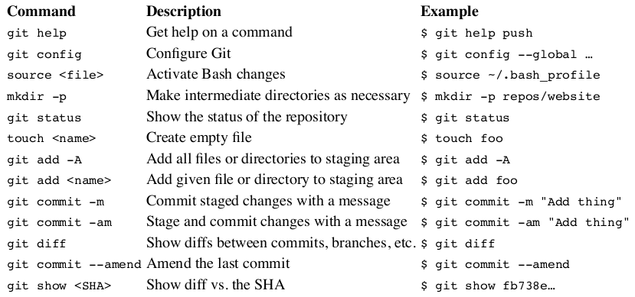
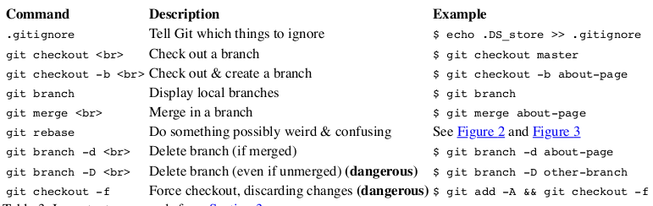
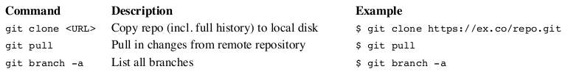
.

The two-stage system that Git uses to save files.
A save in Git is divided into two terminal commands: add and commit. The combination of these two commands gives you control of exactly what you want to be remembered in your snapshot. Staging: Think of add as adjusting the number of people or elements to be included in a photo. With Git, you can select the changes you want to save with git add. Imagine a project that contains multiple files where changes have been made to several files. You want to save some of the changes you have made and leave some other changes to continue working on them. Committing: Think of commit as actually taking a photo, resulting in a snapshot. For example, to commit a file named README.md, type git commit -m "Add README.md". The -m flag stands for "message" and must always be followed by a commit message inside quotation marks. In this example, the commit message was "Add README.md".

What is origin in git push origin main.
In Git, origin is a placeholder name for the URL of the remote repository. Git sets up the origin by default when it clones a remote repository. You can use origin to access the remote repository without having to enter a full URL every time. This also means that you can have multiple remotes for a repository by giving each a unique name.

What is main in git push origin main.
In Git, main is the branch of the remote repository you want to push your changes to. We will get more into branches in a later lesson, but the main thing to remember is that main is the official branch in your projects where production-ready code lives.

FRONT END lets go!

What is the role of HTML in a web page?
HyperText Markup Language, or HTML document is said to be the structural layer of a web page. It is the foundation upon which the presentation layer (instructions for how the elements should be delivered or displayed) and the behavioural layer (scripting and interactivity) are applied.

What is the role of CSS in a web page?
The role of CSS is describing the presentation of Web pages, including colours, layout, and fonts. It allows one to adapt the presentation to different types of devices, such as large screens, small screens, or printers. CSS is independent of HTML and can be used with any XML-based markup language.

What is the role of JavaScript in a web page?
The role of JavaScript is to carry out the higher, more advanced functions inherent to more and more of today's web pages, to add functionality, validate forms, detect browsers, and much more. The main benefit of JavaScript is to add additional interaction between the website and its visitors with just a little extra work by the web developer.

Why do we separate HTML and CSS?
The separation of HTML from CSS makes it easier to maintain sites, share style sheets across pages, and tailor pages to different environments. This is referred to as the separation of structure (or: content) from presentation.

What are classes and Ids
The id selector is used for selecting a single HTML element with a unique id attribute value. The class selector is used for selecting a single or a group of HTML elements with the same class attribute value. You can also apply a selector to a specific HTML element by simply stating the HTML selector first, so p.

What are elements?
An HTML element is defined by a starting tag. If the element contains other content, it ends with a closing tag. For example, <p> is starting tag of a paragraph and </p> is closing tag of the same paragraph but <p>This is paragraph</p> is a paragraph element.

What are tags?
Most tags must have two parts, an opening and a closing part. For example, <html> is the opening tag and </html> is the closing tag. Note that the closing tag has the same text as the opening tag, but has an additional forward-slash (/) character. I tend to interpret this as the "end" or "close" character. There are some tags that are an exception to this rule, and where a closing tag is not required. The <img> tag for showing images is one example of this. Each HTML file must have the essential tags for it to be valid, so that web browsers can understand it and display it correctly. The rest of the HTML file can contain as little or as many tags as you want to display your content. Some HTML tags can be nested, which means that one tag can be put inside another.

What are attributes?
Attributes allow you to customise a tag, and are defined within the opening tag, for example: <img src="image1.jpg"> or <p align="center"> ... </p>. Attributes are often assigned a value using the equals sign, such as border="0" or width="50%", but there are some that only need to be declared in the tag like this: <hr noshade>.Most attributes are optional for most tags, and are only used when you want to change something about the default way a tag is displayed by the browser. However, some tags such as the <img> tag has required attributes such as src and alt which are needed in order for the browser to display the web page properly.

What are forms?
Forms allow us to automate sending and receiving data from a web page, and are useful for: website and forum logins; signing guest books; web based email; online questionnaires etc.

What is a div?
The <div> tag defines a division or a section in an HTML document. The <div> tag is used as a container for HTML elements which is then styled with CSS or manipulated with JavaScript. The <div> tag is easily styled by using the class or id attribute. Any sort of content can be put inside the <div> tag!

What are selectors?
In CSS, selectors are used to target the HTML elements on our web pages that we want to style. There are a wide variety of CSS selectors available, allowing for fine-grained precision when selecting elements to style.

What is the “query string” in a URL
A query string is a part of a uniform resource locator (URL) that assigns values to specified parameters. A query string commonly includes fields added to a base URL by a Web browser or other client application, for example as part of an HTML form.

What is the difference between “pixels” and “ems”?
Pixel is a static measurement, while percent and EM are relative measurements. The size of an EM or percent depends on its parent. If the text size of body is 16 pixels, then 150% or 1.5 EM will be 24 pixels (1.5 * 16). Look at CSS Units for more measurement units.

Css inheritance
Inheritance and the cascade are two fundamental concepts in CSS, that are important ... certain properties are passed on from a parent element down to its children, ... Without inheritance, it would be necessary to specify styles like font family, font ... thus string those four components together to get the specificity for any rule.

What are the three different ways to include CSS
With an external style sheet, you can change the look of an entire website by changing just one file! Each HTML page must include a reference to the external style sheet file inside the <link> element, inside the head section. An external style sheet can be written in any text editor, and must be saved with a .css extension. The external .css file should not contain any HTML tags.
An internal style sheet may be used if one single HTML page has a unique style. The internal style is defined inside the <style> element, inside the head section. Internal styles are defined within the <style> element, inside the <head> section of an HTML page
An inline style may be used to apply a unique style for a single element. To use inline styles, add the style attribute to the relevant element. The style attribute can contain any CSS property.

Why use a CSS reset file?
CSS resets set new and consistent default values for you. If we look at Eric Meyer’s css reset file (probably the most used of all css resets) it starts by listing a number of html elements and applying the following css to all of them. There’s more to the file, but the idea is still to solve the problem of different browser defaults. If you use the css reset you can be sure that all the tags listed will have a margin of 0px, a padding of 0px, etc. The inconsistency has been removed.

What is the “default stylesheet”
Each browser provides a default stylesheet, called the user agent stylesheet, in case an HTML file does not specify one. Styles that you specify override the defaults. Because you have not specified values for the table element's box, the default styles have been applied.

Learning Outcomes

How do you declare a variable?
Creating a variable in JavaScript is called "declaring" a variable. You declare a JavaScript variable with the var keyword: var carName; After the declaration, the variable has no value (technically it has the value of undefined ).

What are three different ways to declare a variable?
You can declare variable using three ways:
- Using var an old way
- Using let
- Using const

We use var in old version of javascript but we still can use it.
Ex: var a=5;
We use let in new javascript it is use to declare block level scope.
Ex: let b='Hello';
We use const to declare constant variable which is constant through out the program. We can't change the value of that variable.
Ex: const pie=3.14;

what are the rules for naming variables in javascript
There are two limitations on variable names in JavaScript: The name must contain only letters, digits, or the symbols $ and _. The first character must not be a digit.
Examples of valid names:
let userName;
let test123_$;
When the name contains multiple words, camalCase is commonly used. That is: words go one after another, each word except first starting with a capital letter: myVeryLongName.
What’s interesting – the dollar sign '$' and the underscore '_' can also be used in names. They are regular symbols, just like letters, without any special meaning.
The rest of the variable name can include any letter, any number, or the underscore. You can't use any other characters, including spaces, symbols, and punctuation marks.
As with the rest of JavaScript, variable names are case sensitive. That is, a variable named Interest_Rate is treated as an entirely different variable than one named interest_rate.
There's no limit to the length of the variable name.You can't use one of JavaScript's reserved words as a variable name.

Name things right
Talking about variables, there’s one more extremely important thing.
A variable name should have a clean, obvious meaning, describing the data that it stores.
Variable naming is one of the most important and complex skills in programming. A quick glance at variable names can reveal which code was written by a beginner versus an experienced developer.
In a real project, most of the time is spent modifying and extending an existing code base rather than writing something completely separate from scratch. When we return to some code after doing something else for a while, it’s much easier to find information that is well-labeled. Or, in other words, when the variables have good names.
Please spend time thinking about the right name for a variable before declaring it. Doing so will repay you handsomely.
Some good-to-follow rules are:

Use human-readable names like userName or shoppingCart.
Stay away from abbreviations or short names like a, b, c, unless you really know what you’re doing.
Make names maximally descriptive and concise. Examples of bad names are data and value. Such names say nothing. It’s only okay to use them if the context of the code makes it exceptionally obvious which data or value the variable is referencing.
Agree on terms within your team and in your own mind. If a site visitor is called a “user” then we should name related variables currentUser or newUser instead of currentVisitor or newManInTown.

What happens when you add numbers and strings together?
When you "add" a number to a string the interpreter converts your number to a string and concatenates both together. When you use the - operator, however, the string is converted back into a number so that numeric subtraction may occur. When you then "add" a string "8" , string concatenation occurs again.

What is concatenation?
In formal language theory and computer programming, string concatenation is the operation of joining character strings end-to-end. For example, the concatenation of "snow" and "ball" is "snowball". In certain formalisations of concatenation theory, also called string theory, string concatenation is a primitive notion.

What is the difference between == and ===?
== is used for comparison between two variables irrespective of the datatype of variable.
=== is used for comparision between two variables but this will check strict type, which means it will check datatype and compare two values.

What are operator precedence values?
Operator precedence determines the order in which operators are evaluated. Operators with higher precedence are evaluated first. A common example: 3 + 4 * 5 // returns 23. The multiplication operator (" * ") has higher precedence than the addition operator (" + ") and thus will be evaluated first.

What are the increment/decrement operators?

(Increment ++) (Decrement –) What is the difference between prefixing and post-fixing them? Postfix decrement operator means the expression is evaluated first using the original value of the variable and then the variable is decremented(decreased). Prefix increment operator means the variable is incremented first and then the expression is evaluated using the new value of the variable.If we’d like to increase a value and immediately use the result of the operator, we need the prefix form: let counter = 0; alert( ++counter ); // 1

What is the “Unary +” Operator?
Although unary negation (-) also can convert non-numbers, unary plus is the fastest and preferred way of converting something into a number, because it does not perform any other operations on the number. It can convert string representations of integers and floats, as well as the non-string values true, false, and null. Integers in both decimal and hexadecimal (0x-prefixed) formats are supported. Negative numbers are supported (though not for hex). Using the operator on BigInt values throws a TypeError. If it cannot parse a particular value, it will evaluate to NaN.

What are assignment operators?
An assignment operator assigns a value to its left operand based on the value of its right operand. The simple assignment operator is equal (=), which assigns the value of its right operand to its left operand. That is, x = y assigns the value of y to x.

Variables
You can think of variables as simply “storage containers” for data in your code. Until recently there was only one way to create a variable in JavaScript — the var statement. But in the newest JavaScript versions we have two more ways — let and const.

Numbers
Numbers are the building blocks of programming logic! In fact, it’s hard to think of any useful programming task that doesn’t involve at least a little basic math… so knowing how numbers work is obviously quite important.
In programming, even the humble decimal number system that we all know so well is more complicated than you might think. We use different terms to describe different types of decimal numbers, for example:
Integers are whole numbers, e.g. 10, 400, or -5.
Floating point numbers (floats) have decimal points and decimal places, for example 12.5, and 56.7786543.
Doubles are a specific type of floating point number that have greater precision than standard floating point numbers (meaning that they are accurate to a greater number of decimal places).
We even have different types of number systems! Decimal is base 10 (meaning it uses 0–9 in each column), but we also have things like:
Binary — The lowest level language of computers; 0s and 1s.
Octal — Base 8, uses 0–7 in each column.
Hexadecimal — Base 16, uses 0–9 and then a–f in each column. You may have encountered these numbers before when setting colors in CSS.

What are Operators and Operands?
The numbers (in an arithmetic operation) are called operands.
The operation (to be performed between the two operands) is defined by an operator.

Comparison operators
Sometimes we will want to run true/false tests, then act accordingly depending on the result of that test — to do this we use comparison operators.
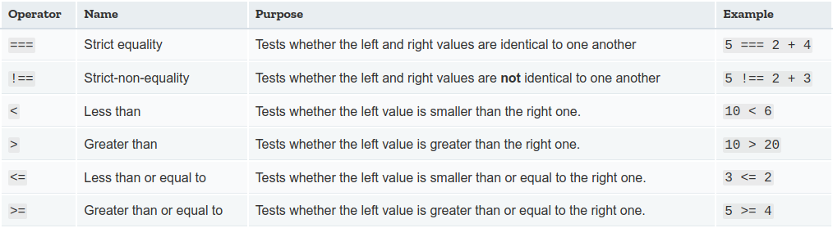

Arithmetic operators
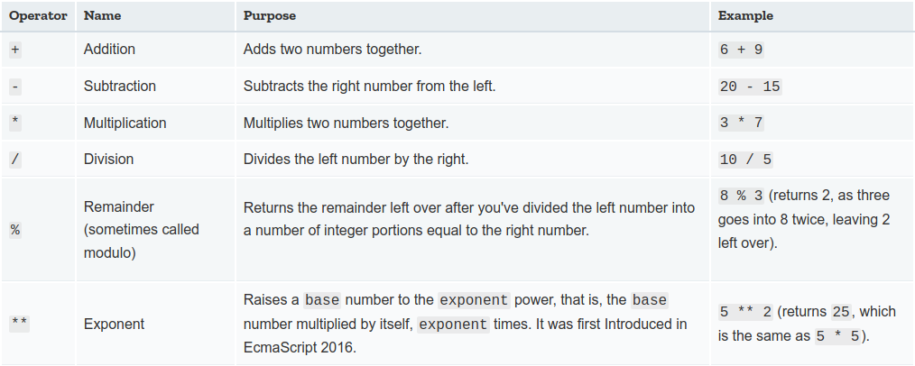
Operator precedence
The precedence of operators determines the order they are applied when evaluating an expression. You can override operator precedence by using parentheses.
The following table describes the precedence of operators, from highest to lowest.
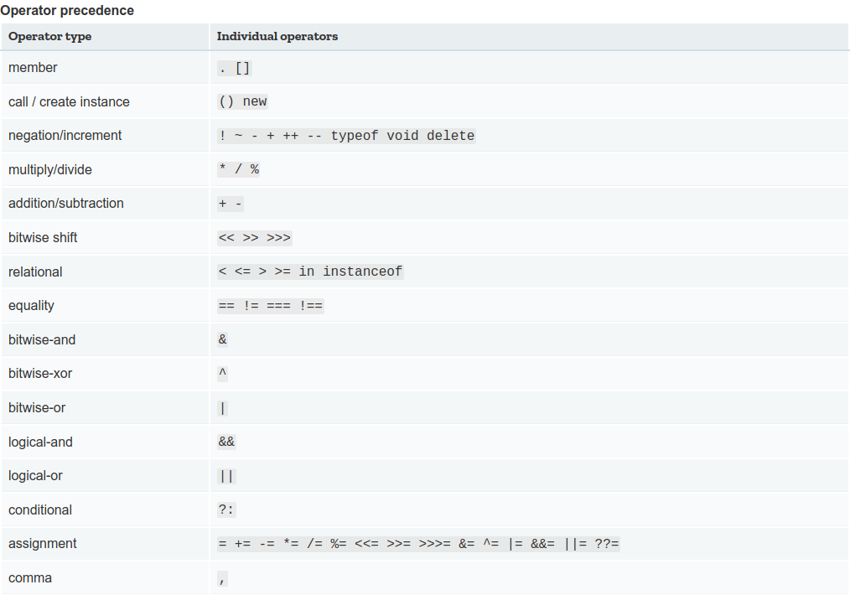

Assignment operators
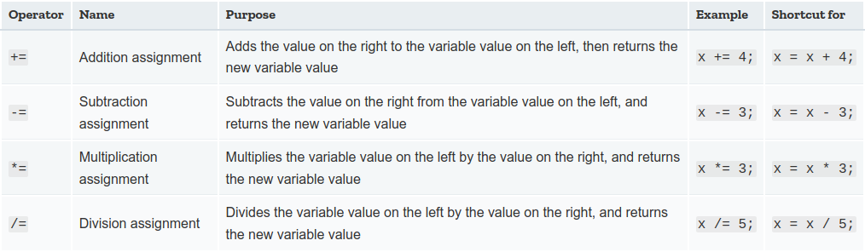
Assignment operators are operators that assign a value to a variable.

Data types
A value in JavaScript is always of a certain type. For example, a string or a number. There are eight basic data types in JavaScript. Here, we’ll cover them in general and in the next chapters we’ll talk about each of them in detail. We can put any type in a variable. For example, a variable can at one moment be a string and then store a number.

1 Number
The number type represents both integer and floating point numbers.
There are many operations for numbers, e.g. multiplication *, division /, addition +, subtraction -, and so on. Besides regular numbers, there are so-called “special numeric values” which also belong to this data type: Infinity, -Infinity and NaN. Infinity represents the mathematical iInfinity∞. It is a special value that’s greater than any number. NaN represents a computational error. It is a result of an incorrect or an undefined mathematical operation.

2 BigInt
In JavaScript, the “number” type cannot represent integer values larger than (253-1) (that’s 9007199254740991), or less than -(253-1) for negatives. It’s a technical limitation caused by their internal representation.
For most purposes that’s quite enough, but sometimes we need really big numbers, e.g. for cryptography or microsecond-precision timestamps.
BigInt type was recently added to the language to represent integers of arbitrary length.
A BigInt value is created by appending n to the end of an integer.

3 String
A string in JavaScript must be surrounded by quotes.
In JavaScript, there are 3 types of quotes.
Double quotes: "Hello".
Single quotes: 'Hello'.
Backticks: `Hello`.
Double and single quotes are “simple” quotes. There’s practically no difference between them in JavaScript.
Backticks are “extended functionality” quotes. They allow us to embed variables and expressions into a string by wrapping them in ${…}, for example:
let name = "John";

// embed a variable
alert( `Hello, ${name}!` ); // Hello, John!

// embed an expression
alert( `the result is ${1 + 2}` ); // the result is 3
The expression inside ${…} is evaluated and the result becomes a part of the string. We can put anything in there: a variable like name or an arithmetical expression like 1 + 2 or something more complex. Please note that this can only be done in backticks. Other quotes don’t have this embedding functionality!
alert( "the result is ${1 + 2}" ); // the result is ${1 + 2} (double quotes do nothing)
All string methods return a new string. They don't modify the original string.
Formally said: Strings are immutable: Strings cannot be changed, only replaced.
4 Boolean (logical type)
The boolean type has only two values: true and false. This type is commonly used to store yes/no values: true means “yes, correct”, and false means “no, incorrect”. Boolean values also come as a result of comparisons.

5 The “null” value
The special null value does not belong to any of the types described above. It forms a separate type of its own which contains only the null value:In JavaScript, null is not a “reference to a non-existing object” or a “null pointer” like in some other languages. It’s just a special value which represents “nothing”, “empty” or “value unknown”. The code above states that age is unknown.

6 The “undefined” value
The special value undefined also stands apart. It makes a type of its own, just like null. The meaning of undefined is “value is not assigned”. If a variable is declared, but not assigned, then its value is undefined

7 Objects and Symbols
The object type is special. All other types are called “primitive” because their values can contain only a single thing (be it a string or a number or whatever). In contrast, objects are used to store collections of data and more complex entities. The symbol type is used to create unique identifiers for objects. JavaScript arrays are written with square brackets.
JavaScript objects are written with curly braces {}.
Object properties are written as name:value pairs, separated by commas.
Example
var person = {firstName:"John", lastName:"Doe", age:50, eyeColor:"blue"};
The object (person) in the example above has 4 properties: firstName, lastName, age, and eyeColor.
You will learn more about objects later in this tutorial.

8 typeof
The typeof operator returns the type of the argument. It’s useful when we want to process values of different types differently or just want to do a quick check.
It supports two forms of syntax:
As an operator: typeof x.
As a function: typeof(x).
In other words, it works with parentheses or without them. The result is the same.
The call to typeof x returns a string with the type name.

What is the difference between slice/substring/substr?
The slice() method extracts parts of a string and returns the extracted parts in a new string. The substr() method extracts parts of a string, beginning at the character at the specified position, and returns the specified number of characters. ... if you know the length of characters to be extracted use substr() .

What are truthy and falsy values?
Truthy values are expressions that evaluate to the boolean value of true, and falsy values are expressions that evaluate to the boolean value of false. I have included a table with expressions that are falsy. Anything other than these six expressions is considered a truthy value.

What is the relationship between null and undefined?

In JavaScript, undefined is a type, whereas null an object. It means a variable declared, but no value has been assigned a value. Whereas, null in JavaScript is an assignment value. You can assign it to a variable. Null is an assigned value. It means nothing. undefined means a variable has been declared but not defined yet.

String comparison
To see whether a string is greater than another, JavaScript uses the so-called “dictionary” or “lexicographical” order.

In other words, strings are compared letter-by-letter.
For example:
alert( 'Z' > 'A' ); // true
alert( 'Glow' > 'Glee' ); // true
alert( 'Bee' > 'Be' ); // true
The algorithm to compare two strings is simple: Compare the first character of both strings.
If the first character from the first string is greater (or less) than the other string’s, then the first string is greater (or less) than the second. We’re done.
Otherwise, if both strings’ first characters are the same, compare the second characters the same way.
Repeat until the end of either string.
If both strings end at the same length, then they are equal. Otherwise, the longer string is greater.
In the first example above, the comparison 'Z' > 'A' gets to a result at the first step.

The second comparison 'Glow' and 'Glee' needs more steps as strings are compared character-by-character:
G is the same as G.
l is the same as l.
o is greater than e. Stop here. The first string is greater.
Not a real dictionary, but Unicode order. The comparison algorithm given above is roughly equivalent to the one used in dictionaries or phone books, but it’s not exactly the same.
For instance, case matters. A capital letter "A" is not equal to the lowercase "a". Which one is greater? The lowercase "a". Why? Because the lowercase character has a greater index in the internal encoding table JavaScript uses (Unicode). When comparing two strings, "2" will be greater than "12", because (alphabetically) 1 is less than 2.
Comparison of different types
When comparing values of different types, JavaScript converts the values to numbers.
For example:
alert( '2' > 1 ); // true, string '2' becomes a number 2
alert( '01' == 1 ); // true, string '01' becomes a number 1

For boolean values, true becomes 1 and false becomes 0.
For example:
alert( true == 1 ); // true
alert( false == 0 ); // true

A funny consequence It is possible that at the same time:
Two values are equal.
One of them is true as a boolean and the other one is false as a boolean.
For example:
let a = 0;
alert( Boolean(a) ); // false
let b = "0";
alert( Boolean(b) ); // true
alert(a == b); // true!
From JavaScript’s standpoint, this result is quite normal. An equality check converts values using the numeric conversion (hence "0" becomes 0), while the explicit Boolean conversion uses another set of rules.

Logical operators
There are three logical operators in JavaScript: || (OR), && (AND), ! (NOT).
Although they are called “logical”, they can be applied to values of any type, not only boolean. Their result can also be of any type.

|| (or)
The “OR” operator is represented with two vertical line symbols. In classical programming, the logical OR is meant to manipulate boolean values only. If any of its arguments are true, it returns true, otherwise it returns false. In JavaScript, the operator is a little bit trickier and more powerful. the result is always true except for the case when both operands are false. If an operand is not a boolean, it’s converted to a boolean for the evaluation.
&&(and)
The AND operator is represented with two ampersands &&. In classical programming, AND returns true if both operands are truthy and false otherwise. Just as with OR, any value is allowed as an operand of AND. The AND && operator does the following:Evaluates operands from left to right. For each operand, converts it to a boolean. If the result is false, stops and returns the original value of that operand. If all operands have been evaluated (i.e. all were truthy), returns the last operand. In other words, AND returns the first falsy value or the last value if none were found.
The rules above are similar to OR. The difference is that AND returns the first falsy value while OR returns the first truthy one. The precedence of AND && operator is higher than OR ||. So the code a && b || c && d is essentially the same as if the && expressions were in parentheses: (a && b) || (c && d).

!(not)
The boolean NOT operator is represented with an exclamation sign !.
The syntax is pretty simple: result = !value;
The operator accepts a single argument and does the following: Converts the operand to boolean type: true/false. Returns the inverse value.
For instance:
alert( !true ); // false
alert ( !0 ); // true
A double NOT !! is sometimes used for converting a value to boolean type:
alert( !!"non-empty string" ); // true
alert( !!null ); // false
That is, the first NOT converts the value to boolean and returns the inverse, and the second NOT inverses it again. In the end, we have a plain value-to-boolean conversion. The precedence of NOT ! is the highest of all logical operators, so it always executes first, before && or ||.

External JavaScript
Scripts can also be placed in external files External scripts are practical when the same code is used in many different web pages. javaScript files have the file extension .js.
To use an external script, put the name of the script file in the src (source) attribute of a <script> tag
External JavaScript Advantages
Placing scripts in external files has some advantages:
It separates HTML and code
It makes HTML and JavaScript easier to read and maintain
Cached JavaScript files can speed up page loads

JavaScript Display Possibilities

InnerHTML
To access an HTML element, JavaScript can use the document.getElementById(id) method.
The id attribute defines the HTML element. The innerHTML property defines the HTML content Changing the innerHTML property of an HTML element is a common way to display data in HTML.

document.write( )
For testing purposes, it is convenient to use document.write():
<script>
document.write (5 + 6);
</script>
Using document.write() after an HTML document is loaded, will delete all existing HTML.

window.alert( )
You can use an alert box to display data. You can skip the window keyword. In JavaScript, the window object is the global scope object, that means that variables, properties, and methods by default belong to the window object. This also means that specifying the window keyword is optional.

console.log( )
For debugging purposes, you can call the console.log() method in the browser to display data.

JavaScript Print
JavaScript does not have any print object or print methods.
You cannot access output devices from JavaScript.
The only exception is that you can call the window.print() method in the browser to print the content of the current window. <button onclick="window.print()">Print this page</button>

JavaScript Keywords
JavaScript statements often start with a keyword to identify the JavaScript action to be performed.
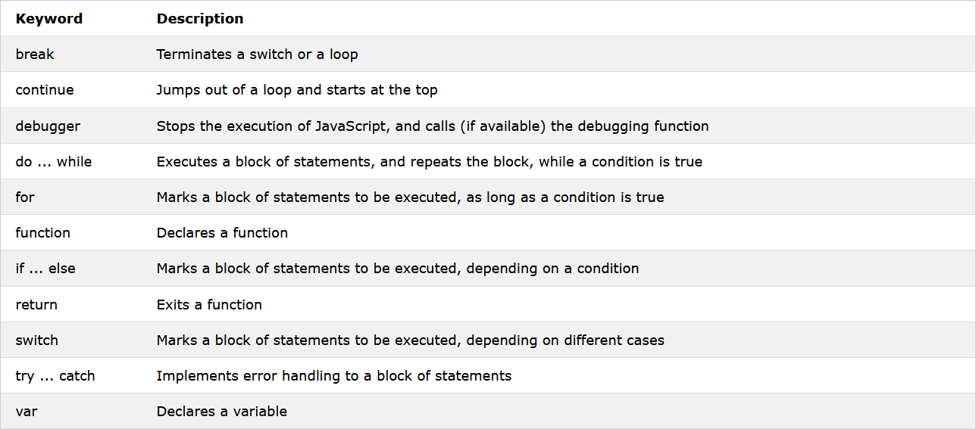
Visit our Reserved Words reference to view a full list of JavaScript Keywords.

Extracting String Parts
There are 3 methods for extracting a part of a string:
- slice(start, end)
- substring(start, end)
- substr(start, length)

The slice() Method
slice() extracts a part of a string and returns the extracted part in a new string. The method takes 2 parameters: the start position, and the end position (end not included). This example slices out a portion of a string from position 7 to position 12 (13-1)If a parameter is negative, the position is counted from the end of the string. This example slices out a portion of a string from position -12 to position -6. If you omit the second parameter, the method will slice out the rest of the string.

The substring() Method
substring() is similar to slice(). The difference is that substring() cannot accept negative indexes.

The substr() Method
substr() is similar to slice(). The difference is that the second parameter specifies the length of the extracted part.

Swich Statements
if...else statements do the job of enabling conditional code well, but they are not without their downsides. They are mainly good for cases where you've got a couple of choices, and each one requires a reasonable amount of code to be run, and/or the conditions are complex (for example, multiple logical operators). For cases where you just want to set a variable to a certain choice of value or print out a particular statement depending on a condition, the syntax can be a bit cumbersome, especially if you've got a large number of choices.
In such a case, switch statements are your friend — they take a single expression/value as an input, and then look through a number of choices until they find one that matches that value, executing the corresponding code that goes along with it.
switch (expression) {
case choice1:
run this code
break;

case choice2:
run this code instead
break;

// include as many cases as you like

default:
actually, just run this code
}
Here we've got:
- The keyword switch, followed by a set of parentheses.
- An expression or value inside the parentheses.
- The keyword case, followed by a choice that the expression/value could be, followed by a colon.
- Some code to run if the choice matches the expression.
- A break statement, followed by a semi-colon. If the previous choice matches the expression/value, the browser stops executing the code block here, and moves on to any code that appears below the switch statement.
- As many other cases (bullets 3–5) as you like.
- The keyword default, followed by exactly the same code pattern as one of the cases (bullets 3–5), except that default does not have a choice after it, and you don't need to break statement as there is nothing to run after this in the block anyway. This is the default option that runs if none of the choices match.

Ternary operator
There is one final bit of syntax we want to introduce you to before we get you to play with some examples. The ternary or conditional operator is a small bit of syntax that tests a condition and returns one value/expression if it is true, and another if it is false — this can be useful in some situations, and can take up a lot less code than an if...else block if you simply have two choices that are chosen between via a true/false condition. The pseudocode looks like this:
( condition ) ? run this code : run this code instead
So let's look at a simple example:
let greeting = ( isBirthday ) ? 'Happy birthday Mrs. Smith — we hope you have a great day!' : 'Good morning Mrs. Smith.';
Here we have a variable called isBirthday — if this is true, we give our guest a happy birthday message; if not, we give her the standard daily greeting.

