CO7516 Semantic Web
Assignment 1
James Lale (jl571)
Student Number 169048428

1.1

The ontology represents the boats and route planning domain. The scenario is for someone wishing to investigate what specific type of boat (commercial or leisure) could be taken on a specific route. The domain query will allow to determine which ports and harbours have berths (size/length) which are appropriate for his chosen boat. This domain has been chosen as it presents a suitable level of complexity for querying.

1.2

Competency questions

1. Leaving from a given port, what boat providers could I hire a leisure boat from?
2. Leaving from a given port, what boat providers could I hire a commercial boat from?
3. If I wanted to hire a cabin cruiser which sleeps 3 people, where could I hire one from?
4. If I've hired a Cutter for a vacation, which harbours could I stop at overnight?
5. If I've planned a route from Poole to Swanage, which boats are available to me which don't require crew other than myself?

1.3

Class Hierarchy

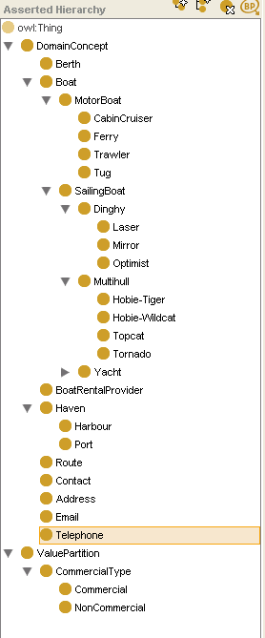
1.4

RDF Diagram

Property urls have been shortened to just include the bookmark portion, to save space.

Diagram on next page.
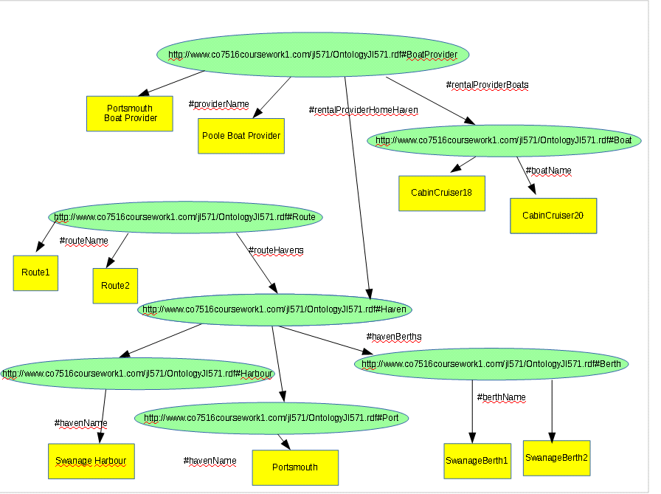

Jambalaya Diagram

