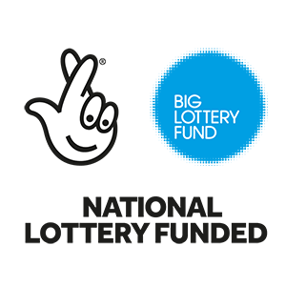

Northern Ireland

Empowering Young People

£30,000 to £500,000

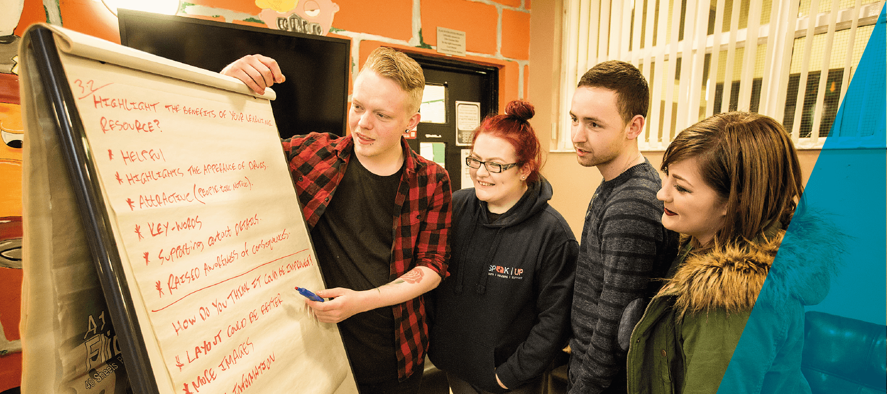

If you have any questions about completing this application form, or if you need it in a different format (for example large print), please contact us by email at [**enquiries.ni@biglotteryfund.org.uk**](mailto:enquiries.ni@biglotteryfund.org.uk) or call us on 028 9055 1455.

Our website also has further information, advice and tips to help you complete your application.

**Your project**

**1. Project name**

Give your project a short title, something we can use to promote your project if you are successful.

You can write up to 20 words.

|  |
| --- |
|  |

**2. Project delivery**

Where are the people or organisations who will benefit from your project based?

Select the relevant local council area/s from the table below and enter the percentage, for example

* If the people or organisations are in one area only, select the appropriate council area and put 100 percent in the space provided.
* If the people or organisations are in more than one area, select the area and estimate a percentage for each one selected. The total percentage must add up to 100 per cent.
* If your project is Northern Ireland wide you can select this option and put 100 per cent in the space provided.

|  |  |  |
| --- | --- | --- |
| **Local council area** | **Tick as required** | **% per area** |
| Antrim and Newtownabbey |  |  |
| Armagh, Banbridge and Craigavon |  |  |
| Belfast City |  |  |
| Causeway Coast and Glens |  |  |
| Derry City and Strabane |  |  |
| Fermanagh and Omagh |  |  |
| Lisburn and Castlereagh |  |  |
| Mid and East Antrim |  |  |
| Mid Ulster |  |  |
| Newry, Mourne and Down |  |  |
| North Down and Ards |  |  |
| Northern Ireland wide |  |  |

**3. Project summary**

* Summarise the purpose of the project.
* Tell us who will benefit, where they live, their age range and the numbers involved.
* Summarise the main activities.

You can write up to 600 words.

|  |
| --- |
|  |

**4. Young people and how they’re involved**

* What are the challenges young people have identified in their lives? How were you made aware of this?
* Tell us how young people were involved in planning the project and how they will be involved in delivering and managing it.
* How will young people’s support networks also be involved? (Support networks could include young people’s peers, their wider family, educators, youth workers, social workers and mentors).
* Briefly tell us about other consultations/research/evaluations that support the project.

You can write up to 1,000 words.

|  |
| --- |
|  |

**5. Your organisation and local services**

* Why is your organisation the best to deliver the project?
* What other services are available in the area for young people?
* How will your project fill a gap or link to and enhance these other services?

You can write up to 600 words.

|  |
| --- |
|  |

**6. The difference your project makes**

* Tell us about the changes or benefits you expect the project to bring to young people.
* How will the project help young people overcome the challenges they face?

You can write up to 600 words.

|  |
| --- |
|  |

**7. Project costs**

Some organisations may be registered with HM Revenue and Customs to recover VAT. If you are registered, then we cannot fund any VAT for your project.

If you are not registered, you can include VAT within your costs.

|  |  |  |  |
| --- | --- | --- | --- |
|  | **Total cost (£)** | **Amount from us (£)** | **How many years is this funding for?** |
| **Revenue** |  |  |  |
| **Capital** |  |  |  |
| **Total** |  |  |  |

* Write a list of what our funding will cover.

You can write up to 300 words.

|  |
| --- |
|  |

**Your organisation details**

**8. What is the full legal name of your organisation, as shown on your governing document?**

Please check this - if the full legal name is incorrect it may delay your application.

|  |
| --- |
|  |

#### 9. What is the main or registered address for your organisation?

Enter your organisation’s address including full postcode.

|  |  |
| --- | --- |
|  | |
| Organisation website (if applicable) |  |
| Twitter address (if applicable) |  |
| Facebook address (if applicable) |  |

**10. What type of organisation are you?**

Select all options that are relevant to you

|  |  |  |
| --- | --- | --- |
| **Organisation Type** | **Tick as required** | **Reference number** |
| Registered with Charity Commission for Northern Ireland |  |  |
| Recognised by HM Revenue and Customs in Northern Ireland as charitable for tax purposes |  |  |
| Registered with Charity Commission for England and Wales |  |  |
| Registered with Companies House as a Company Limited by Guarantee |  |  |
| Unregistered community organisation/club/society |  | **N/A** |
| Other (please specify) |  |  |

**Your contact details**

We need the date of birth and home address for all of your contacts. This includes a previous address if they’ve not lived at their current address for three years.

We use this to carry out some basic identity checks as part of our standard fraud prevention process, so please check that the information provided is correct. Our identity check may appear on a credit report, but it’s not a credit check and can only be seen by the person we’re checking, so their credit rating won’t be affected. You can find out more in our Guide to risk analysis, available at [www.biglotteryfund.org.uk/informationchecks](http://www.biglotteryfund.org.uk/informationchecks) and in the Data Protection policy at the end of this form.

**11. Main contact**

|  |  |  |  |  |  |  |  |  |  |
| --- | --- | --- | --- | --- | --- | --- | --- | --- | --- |
| **Who should we contact if we have questions about your application? They must be someone who runs or works for your organisation.** | | | | | | | | | |
| **Title** | | | | **Mr** | **Mrs** | | **Ms** | | **Miss** |
| **Forenames** | | | |  | | | | | |
| **Surname** | | | |  | | | | | |
| **Date of birth** | | | | **Day** | | **Month** | | **Year** | |
| **Job title or position** | | | |  | | | | | |
| **Daytime telephone** | | | |  | | | | | |
| **Mobile telephone** | | | |  | | | | | |
| **Email** | | | |  | | | | | |
| **If you have any particular communication needs, tell us what they are** | | | |  | | | | | |
| **Main contact home address and full postcode** | | | | | | | | | |
|  | | | | | | | | | |
| **Have they lived at this address for the last three years?** | | | | | | | | | |
|  | **Yes** |  | **No - you must give previous home address** | | | | | | |
| **Main contact previous home address and full postcode** | | | | | | | | | |
|  | | | | | | | | | |

**12. Legally responsible contact**

|  |  |  |  |  |  |  |  |  |  |
| --- | --- | --- | --- | --- | --- | --- | --- | --- | --- |
| This cannot be the same person as the main contact.  The legally responsible contact must be at least 18 years old. They are responsible for ensuring that this application is supported by the organisation applying, any funded project is delivered as set out in the application form, and that the funded organisation meets our monitoring requirements.  The legally responsible contact must hold one of the following positions, which is dependent on your organisation type:   * Company/Incorporated Charity - Director or Company Secretary * School - Head Teacher * Statutory body Chief Executive or Director * All other types of organisations (including Registered Charity) - Chair, Vice Chair, Treasurer or Trustee | | | | | | | | | |
| **Title** | | | | **Mr** | **Mrs** | | **Ms** | | **Miss** |
| **Forenames** | | | |  | | | | | |
| **Surname** | | | |  | | | | | |
| **Date of birth** | | | | **Day** | | **Month** | | **Year** | |
| **Position in organisation** | | | |  | | | | | |
| **Legally responsible contact home address and full postcode** | | | | | | | | | |
|  | | | | | | | | | |
| **Have they lived at this address for the last three years?** | | | | | | | | | |
|  | **Yes** |  | **No - you must give previous home address** | | | | | | |
| **Legally responsible contact previous home address and full postcode** | | | | | | | | | |
|  | | | | | | | | | |
| **Contact telephone number** | | | |  | | | | | |
| **Email** | | | |  | | | | | |
| **If they have any particular communication needs, tell us what they are** | | | |  | | | | | |

**Equality monitoring**

Your answers help us understand who benefits from our funding but we don’t use them to decide if we will fund your project.

**13.1 Will your project mostly benefit people from a particular ethnic background?**

|  |  |  |  |
| --- | --- | --- | --- |
|  | Yes |  | No |

If yes, which ethnic background? You can select up to three.

**White Asian / Asian UK**

English/Scottish/Welsh/Northern Irish/UK  Indian

Irish  Pakistani

Gypsy or Irish Traveller  Bangladeshi

Any other white background  Chinese

Any other Asian background

**Black / African / Caribbean / Black UK Other ethnic group**

African  Any other Asian background

Caribbean  Arab

Any other Black/African/Caribbean  Any other

background

**Mixed/Multiple ethnic groups**

Mixed ethnic background (this refers to

people whose parents are of a different ethnic

background to each other).

**13.2 Will your project mostly benefit people of a particular gender?**

|  |  |  |  |
| --- | --- | --- | --- |
|  | Yes |  | No |

If yes, which gender?  Male  Female

**13.3 Will your project mostly benefit people from a particular age group?**

|  |  |  |  |
| --- | --- | --- | --- |
|  | Yes |  | No |

If yes, which age group? You can select up to two.

0 – 24 years  25 – 64 years  65 + years

**13.4 Will your project mostly benefit disabled people?**

We use the definition from the Equality Act 2010, which defines a disabled person as someone who has a mental or physical impairment that has a substantial and long-term adverse effect on their ability to carry out normal day to day activity.

|  |  |  |  |
| --- | --- | --- | --- |
|  | Yes |  | No |

**13.5 Will your project mostly benefit people of a particular religion or belief?**

|  |  |  |  |
| --- | --- | --- | --- |
|  | Yes |  | No |

If yes, which religion or belief? You can select one.

No religion  Christian  Buddhist

Hindu  Jewish  Muslim

Sikh  Other

**13.6 Will your project mostly benefit lesbians, gay men or bisexual people?**

|  |  |  |  |
| --- | --- | --- | --- |
|  | Yes |  | No |

**13.7 Which community do the people who will benefit from your project belong to?**

Both Catholic and Protestant  Mainly Catholic (more than 60%)

Mainly Protestant (more than 60%)  Neither Catholic nor Protestant

**13.8 Will your project mostly benefit people with caring responsibilities?**

|  |  |  |  |
| --- | --- | --- | --- |
|  | Yes |  | No |

**Part three: Data protection and Freedom of Information Act**

**Data protection**

We hold and store your information in line with the data protection legislation currently in force and in line with our data protection policy as updated from time to time. Please read our full policy published on our website here: [www.biglotteryfund.org.uk/about-big/data-protection](http://www.biglotteryfund.org.uk/about-big/data-protection). There are circumstances where we will share the information you have provided to us in this application in line with the limitations of legislation. We may share information with organisations and individuals with a legitimate interest in Lottery applications and grants or specific funding programmes. We will use the information you give us during assessment and during the life of your grant (if awarded) to administer and analyse grants and for research purposes.

We will keep in contact with you throughout the life of your grant and we will send you regular email updates. These will contain useful information on a range of things including how to publicise your grant, information on other funding available and project ideas and tips from other grant holders.

**Freedom of information**

The Freedom of Information Act 2000 gives members of the public the right to request any information that we hold. This includes information received from third parties, such as, although not limited to grant applicants, grant holders and contractors. Please read our full policy published on our website here: [www.biglotteryfund.org.uk/freedom-of-information](https://www.biglotteryfund.org.uk/freedom-of-information). This policy may be updated from time to time.

If you think that there is information in your application that may be exempt from release if requested, then you should let us know when you apply. We will not usually release information about your project whilst it is being assessed. Otherwise we will use our judgement as to whether any exemptions may apply, which we may seek your opinion on. Personal information would be withheld subject to the requirements of the Data Protection Act 1998.

**Our approach to fraud**

We know the vast majority of the many thousands who seek and use our funding are genuine. However, if you provide false or inaccurate information in your application or at any point in the life of any funding we award you and fraud is identified, we will provide details to fraud prevention agencies to prevent fraud and money laundering. If you are a company this will include the names of the Company Directors at the time of the fraud. You must undertake to inform all Directors, Trustees and Committee members of this notice.

You can obtain further details explaining how the information held by fraud prevention agencies may be used by emailing [dataprotection@biglotteryfund.org.uk](mailto:dataprotection@biglotteryfund.org.uk), by telephoning our advice line on 0345 4 10 20 30, or by writing to: Customer services, Big Lottery Fund, 2 St James’ Gate, Newcastle upon Tyne, NE1 4BE.