- ADBCB
- CBDDA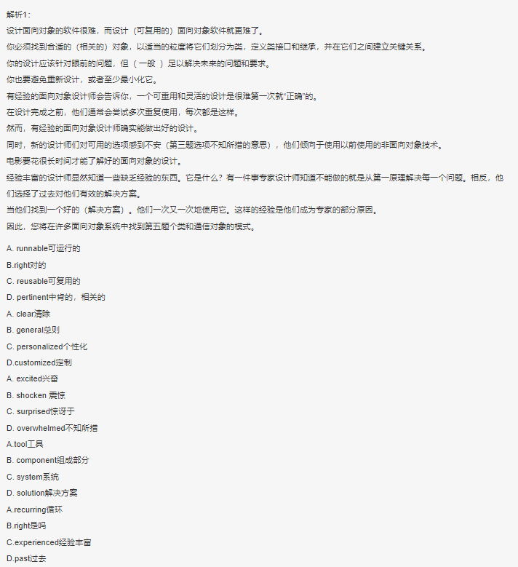
- BACDA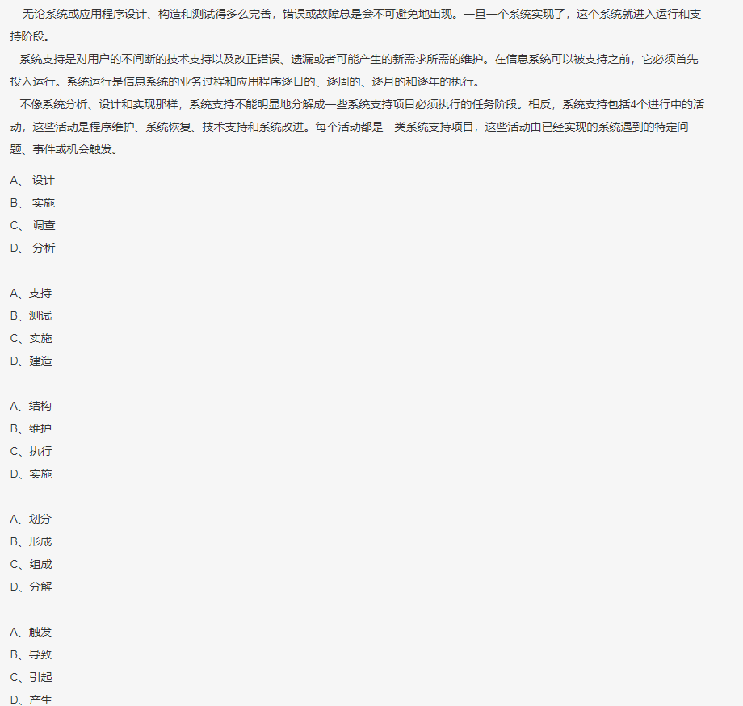
- ABABC
- CABAD
- ABCDC
- DCACB
- BACBD
- ACBDA
- CABDC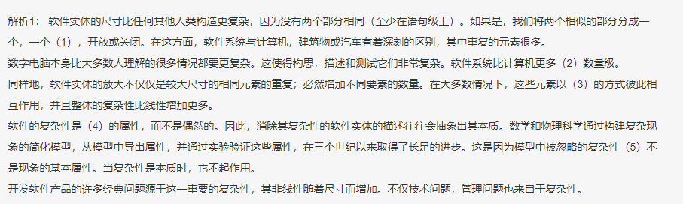
- DBCAB
- DABCA
- ADCAB
- CABCD
- ADABC
- DABAC
- BADCD
- BABDC
- CDACB
- DBDAC
- BCADD
- CABAB
- BCDBA
- BCBDA
- CBCAC
- ACBAD
- BCADB
- DCDAB
- ACBDA

