HW5

Shanqing Tan

st2972

Problem1

1.List the top 25 teams and their corresponding values in wt for t = 10, 100, 1000, 2500.

========iteration 10========

Rank 1: 435 Value=0.018045

Rank 2: 608 Value=0.013829

Rank 3: 440 Value=0.012406

Rank 4: 6 Value=0.012182

Rank 5: 363 Value=0.0090503

Rank 6: 343 Value=0.0088201

Rank 7: 673 Value=0.0082556

Rank 8: 133 Value=0.008

Rank 9: 696 Value=0.0074985

Rank 10: 668 Value=0.0067568

Rank 11: 465 Value=0.0067563

Rank 12: 719 Value=0.0067221

Rank 13: 432 Value=0.0065957

Rank 14: 564 Value=0.0065015

Rank 15: 598 Value=0.0064005

Rank 16: 736 Value=0.0063532

Rank 17: 715 Value=0.0061902

Rank 18: 643 Value=0.0061191

Rank 19: 489 Value=0.006018

Rank 20: 370 Value=0.0059251

Rank 21: 302 Value=0.0058792

Rank 22: 571 Value=0.0055652

Rank 23: 611 Value=0.0054736

Rank 24: 20 Value=0.0054464

Rank 25: 247 Value=0.0053441

========iteration 100========

Rank 1: 435 Value=0.058296

Rank 2: 6 Value=0.032117

Rank 3: 440 Value=0.030921

Rank 4: 608 Value=0.024293

Rank 5: 133 Value=0.016924

Rank 6: 409 Value=0.013411

Rank 7: 489 Value=0.012833

Rank 8: 492 Value=0.011267

Rank 9: 363 Value=0.011165

Rank 10: 611 Value=0.010525

Rank 11: 390 Value=0.010306

Rank 12: 274 Value=0.010047

Rank 13: 598 Value=0.0086909

Rank 14: 343 Value=0.0085609

Rank 15: 389 Value=0.0083131

Rank 16: 292 Value=0.0079689

Rank 17: 624 Value=0.0079641

Rank 18: 715 Value=0.0077226

Rank 19: 202 Value=0.0076445

Rank 20: 215 Value=0.0076107

Rank 21: 321 Value=0.0075459

Rank 22: 29 Value=0.0072822

Rank 23: 482 Value=0.0072056

Rank 24: 673 Value=0.0068827

Rank 25: 219 Value=0.0068485

========iteration 1000========

Rank 1: 6 Value=0.060949

Rank 2: 133 Value=0.031893

Rank 3: 409 Value=0.025395

Rank 4: 489 Value=0.024252

Rank 5: 492 Value=0.020878

Rank 6: 611 Value=0.019605

Rank 7: 390 Value=0.019349

Rank 8: 274 Value=0.019005

Rank 9: 389 Value=0.015638

Rank 10: 624 Value=0.014618

Rank 11: 292 Value=0.014613

Rank 12: 215 Value=0.01444

Rank 13: 321 Value=0.014259

Rank 14: 29 Value=0.013727

Rank 15: 482 Value=0.013527

Rank 16: 440 Value=0.012918

Rank 17: 219 Value=0.012813

Rank 18: 629 Value=0.012628

Rank 19: 435 Value=0.012445

Rank 20: 53 Value=0.011187

Rank 21: 679 Value=0.011006

Rank 22: 442 Value=0.010757

Rank 23: 494 Value=0.010739

Rank 24: 476 Value=0.01068

Rank 25: 458 Value=0.010112

========iteration 2500========

Rank 1: 6 Value=0.066742

Rank 2: 133 Value=0.034911

Rank 3: 409 Value=0.027803

Rank 4: 489 Value=0.026556

Rank 5: 492 Value=0.022822

Rank 6: 611 Value=0.021446

Rank 7: 390 Value=0.021177

Rank 8: 274 Value=0.020812

Rank 9: 389 Value=0.017118

Rank 10: 292 Value=0.015968

Rank 11: 624 Value=0.015968

Rank 12: 215 Value=0.015812

Rank 13: 321 Value=0.015609

Rank 14: 29 Value=0.015024

Rank 15: 482 Value=0.014806

Rank 16: 219 Value=0.014019

Rank 17: 629 Value=0.01382

Rank 18: 53 Value=0.012215

Rank 19: 679 Value=0.012036

Rank 20: 442 Value=0.011767

Rank 21: 494 Value=0.011726

Rank 22: 476 Value=0.011682

Rank 23: 458 Value=0.011056

Rank 24: 751 Value=0.010742

Rank 25: 498 Value=0.01066

2. Plot wt − w∞1 as a function of t for t = 1, . . . , 2500.

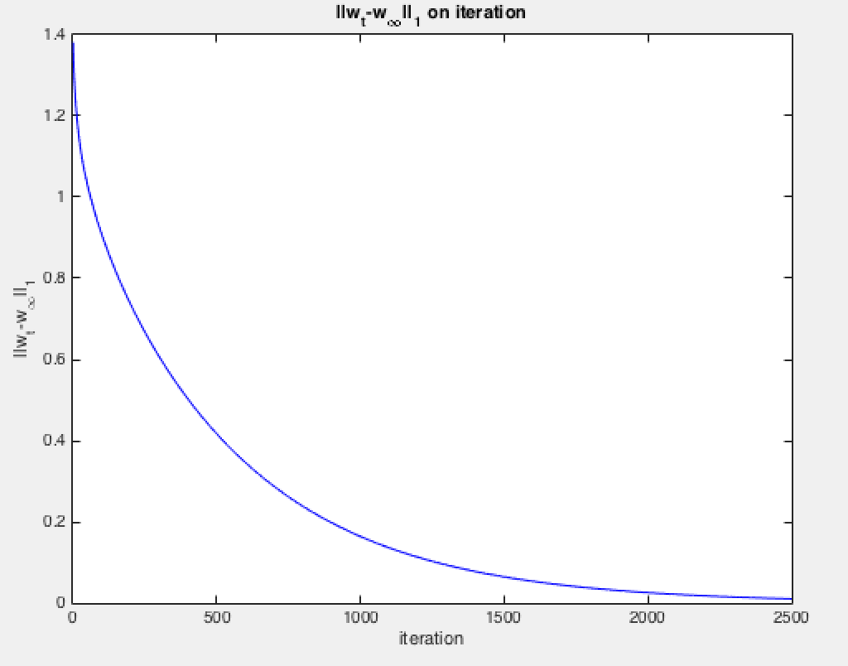

3.The value of w2500 − w∞1

||w_2500-w_inf||_1=0.010373

Problem2

Part1

Plot the objective as a function of iteration.

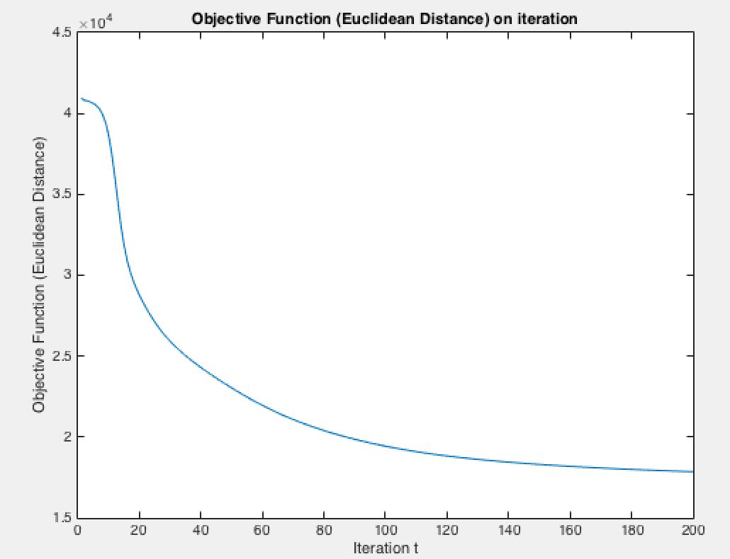

Pick 10 columns from W and show them as 32 × 32 images. For each vector you select from W, ﬁnd the column of H that places the highest weight on this vector and show the corresponding column of X as a 32 × 32 image.

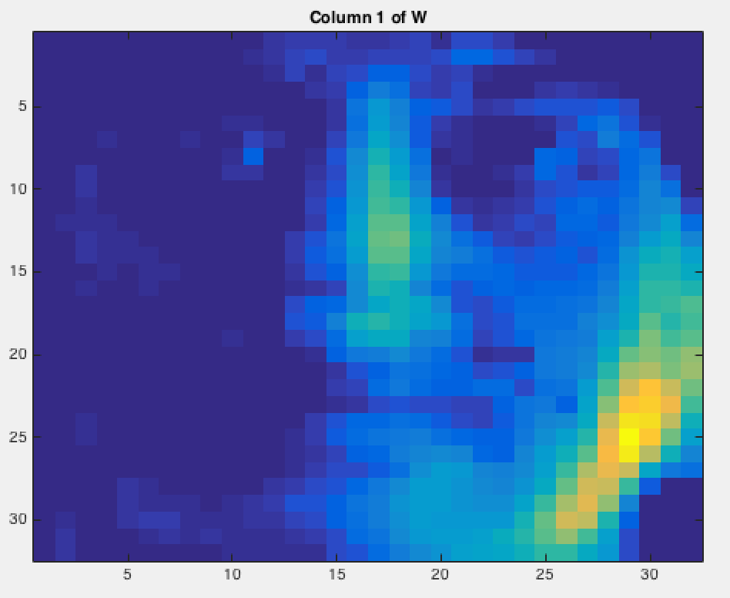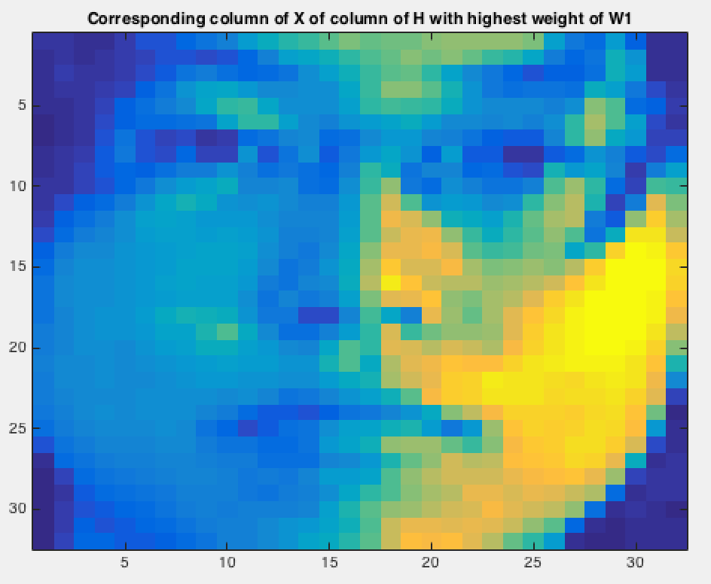

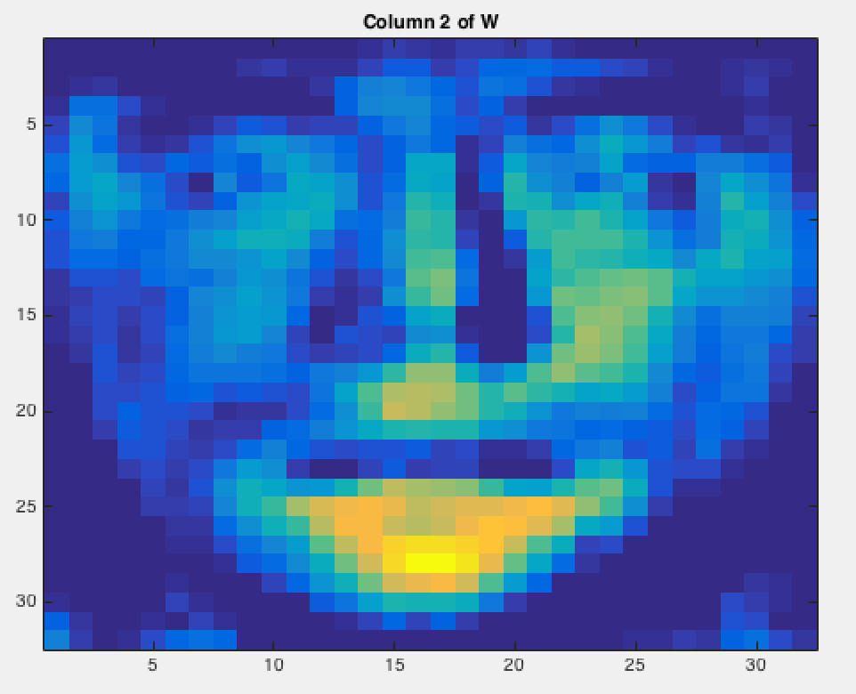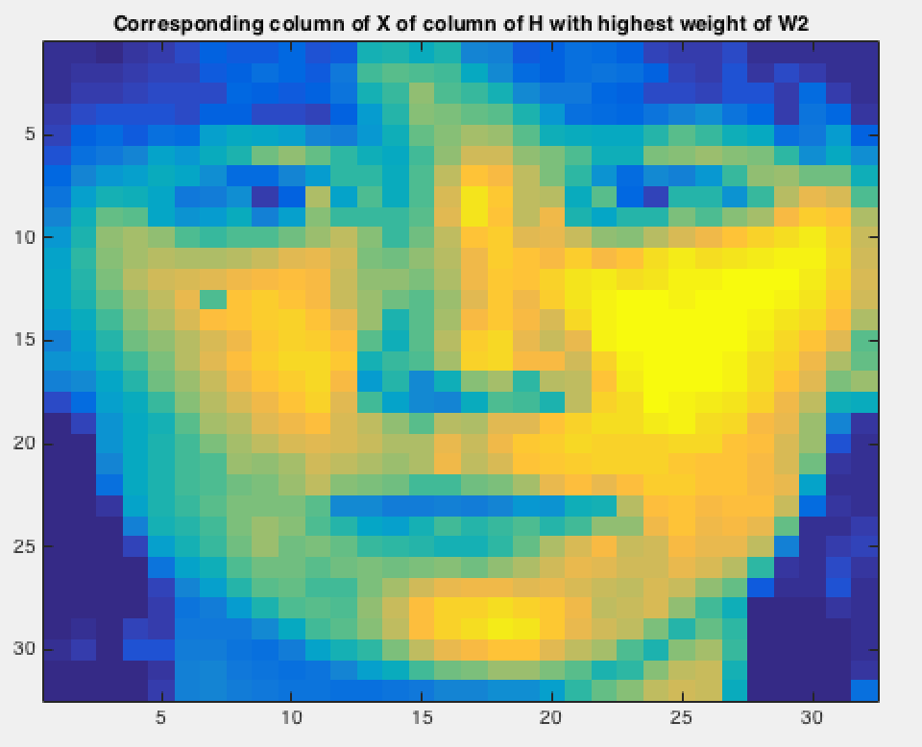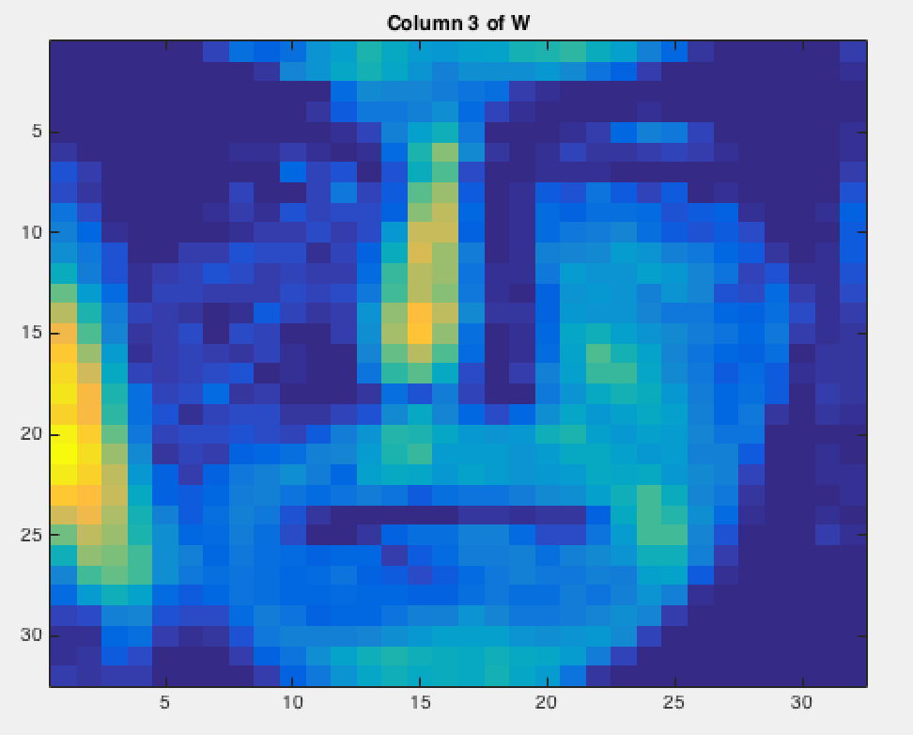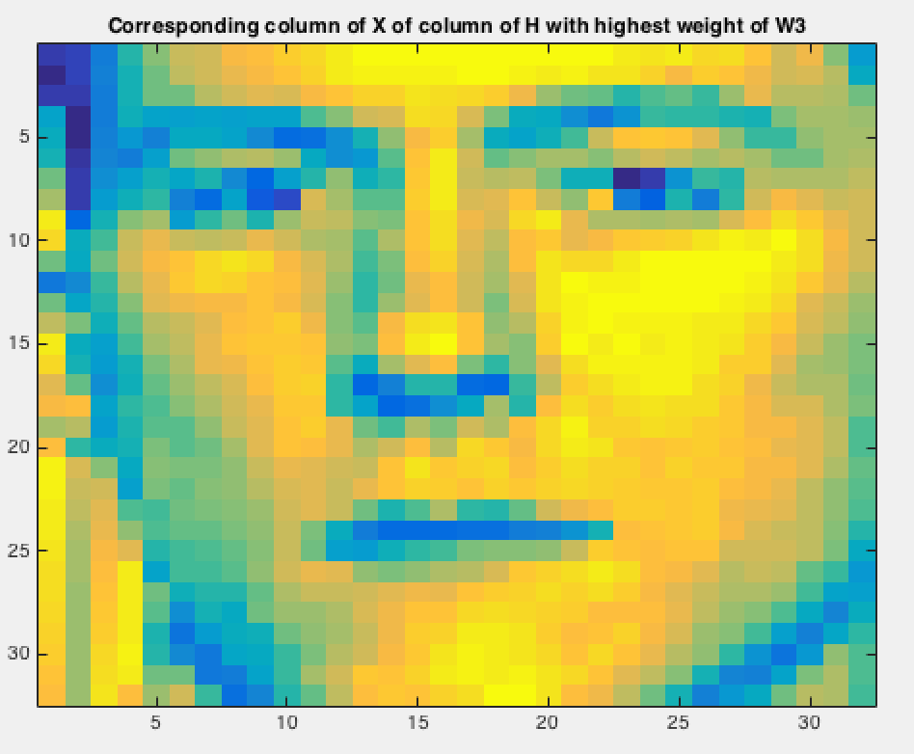

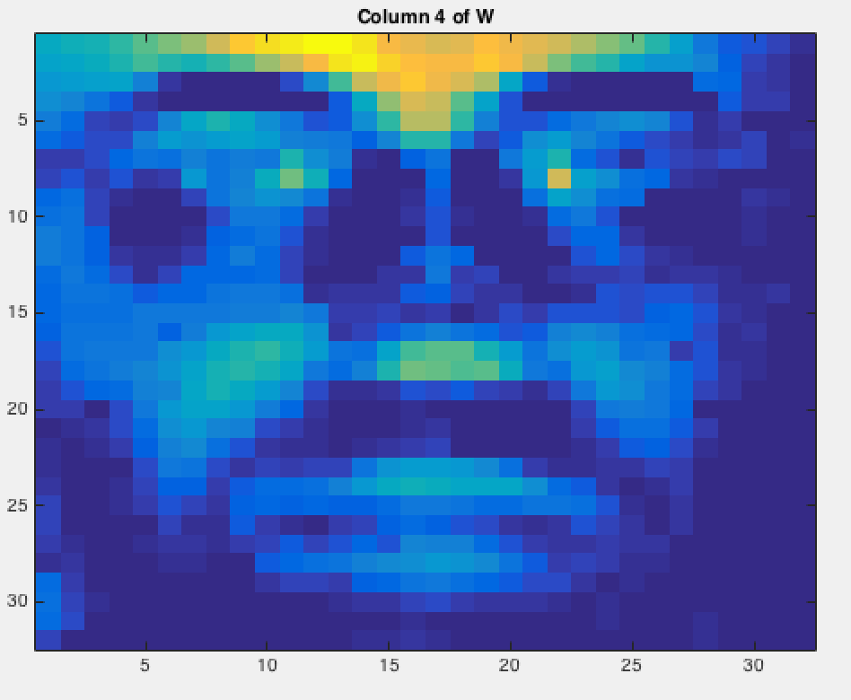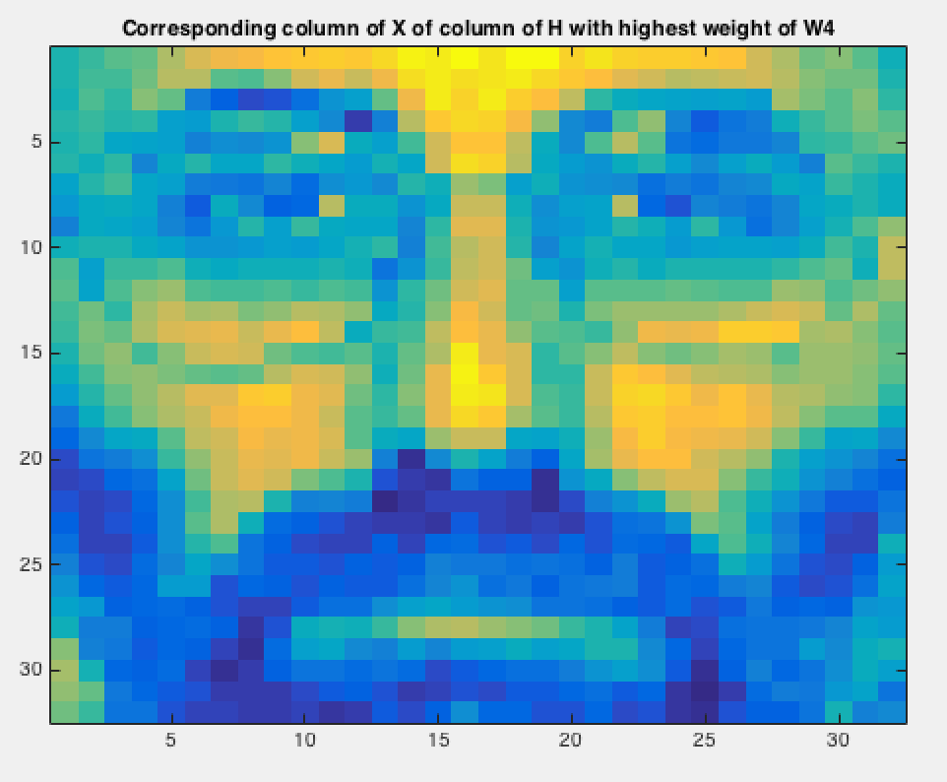

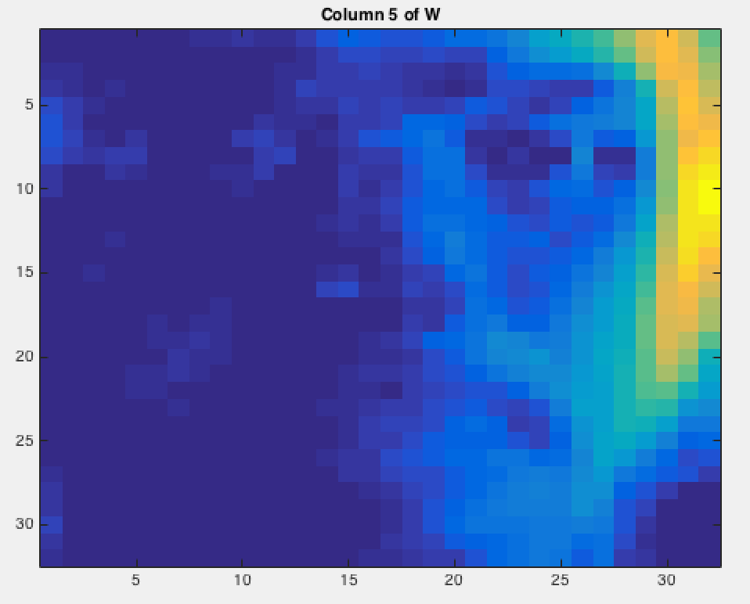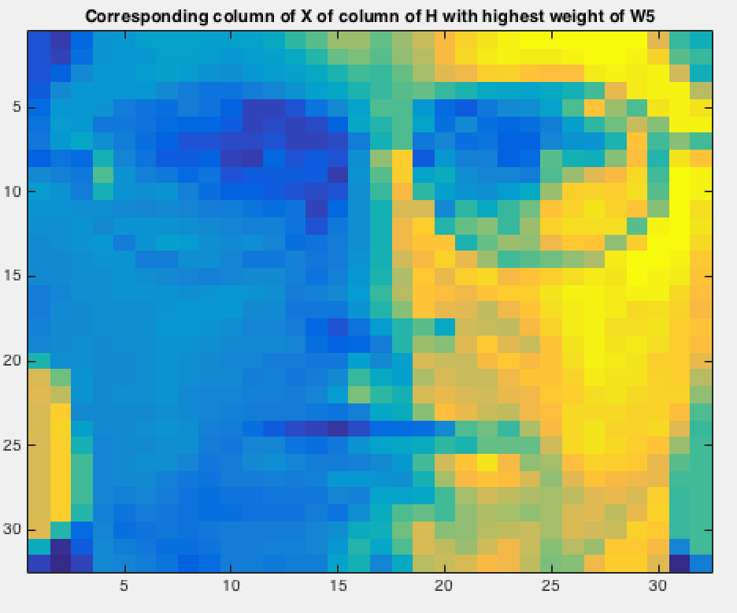

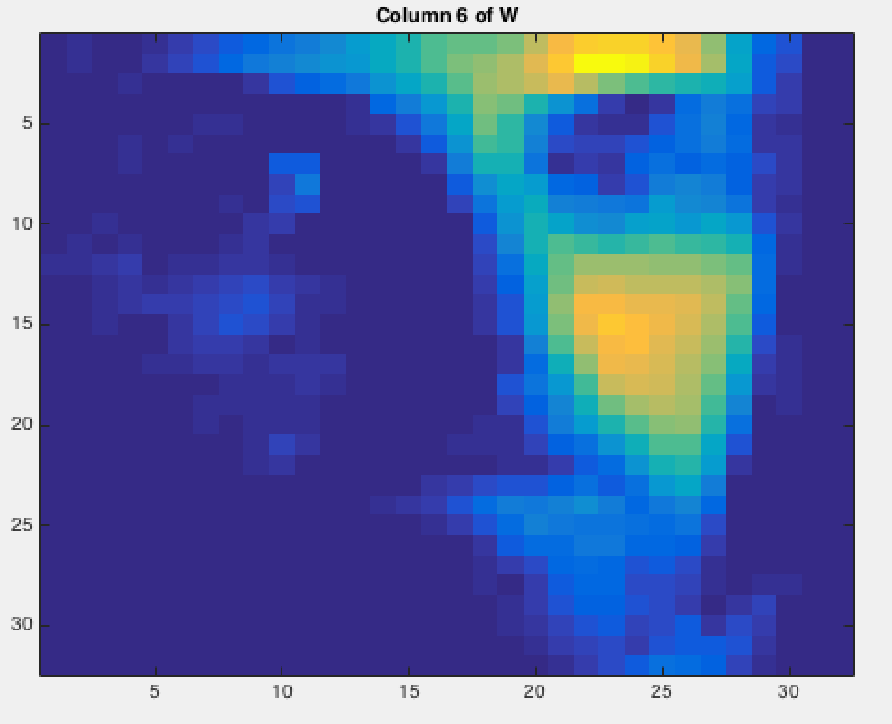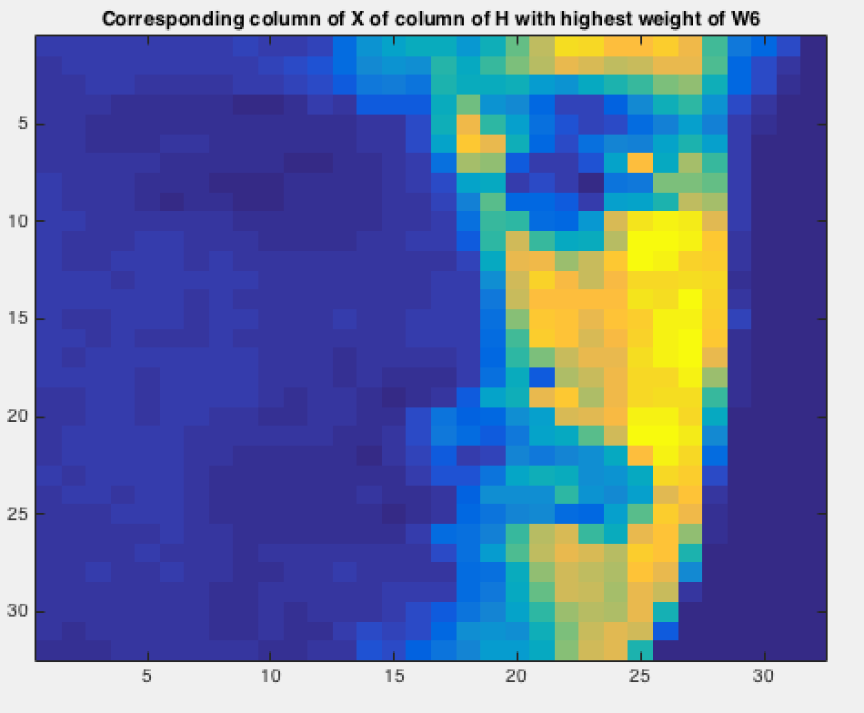

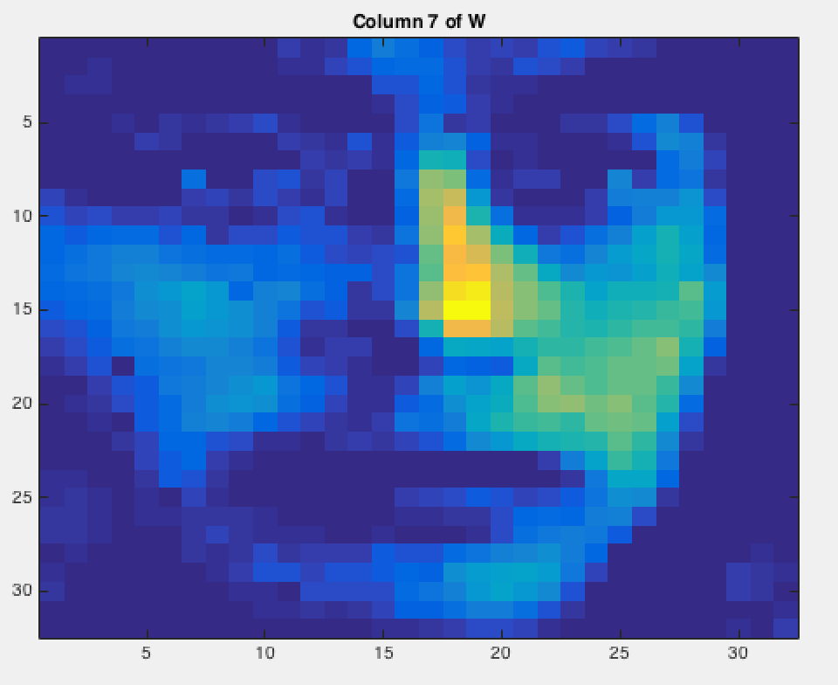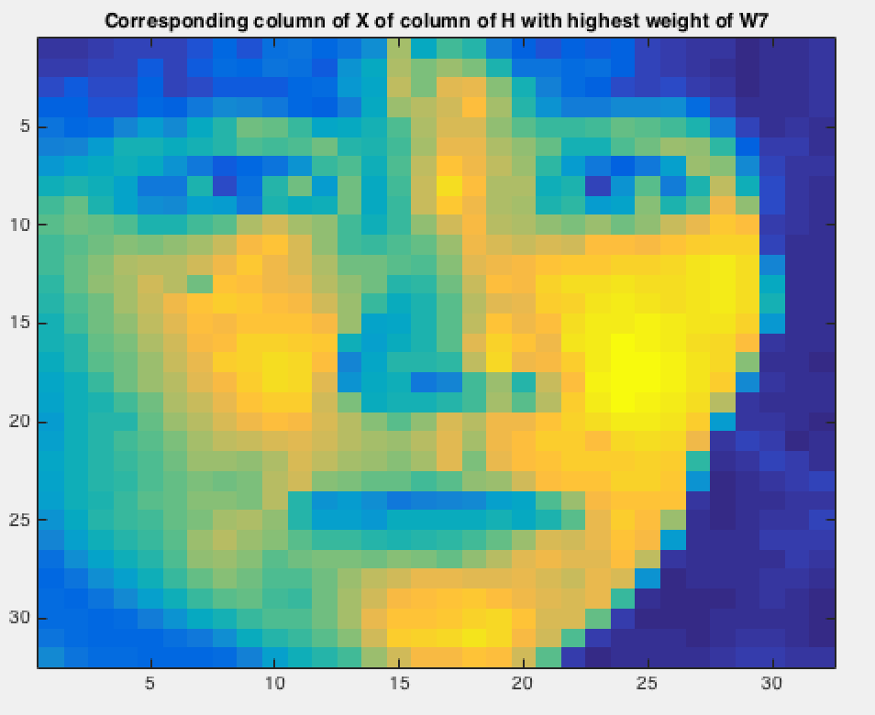

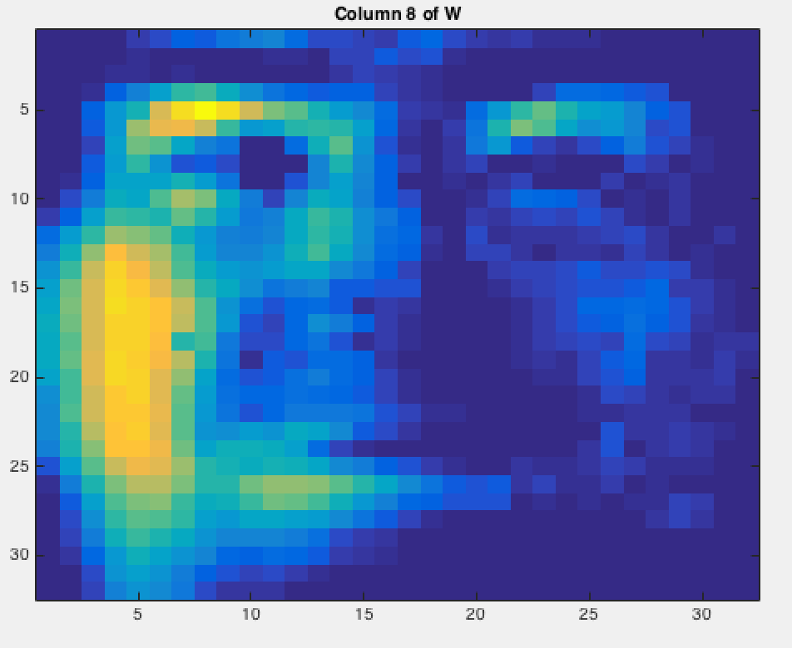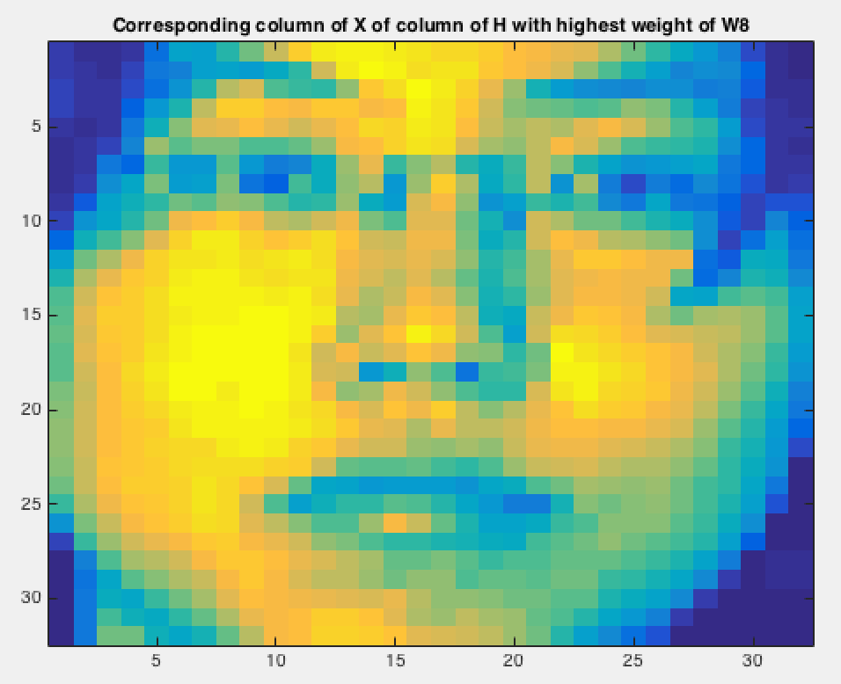

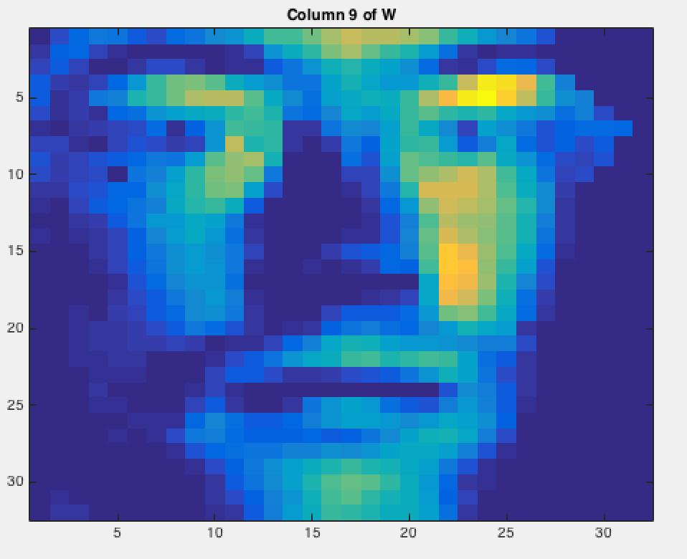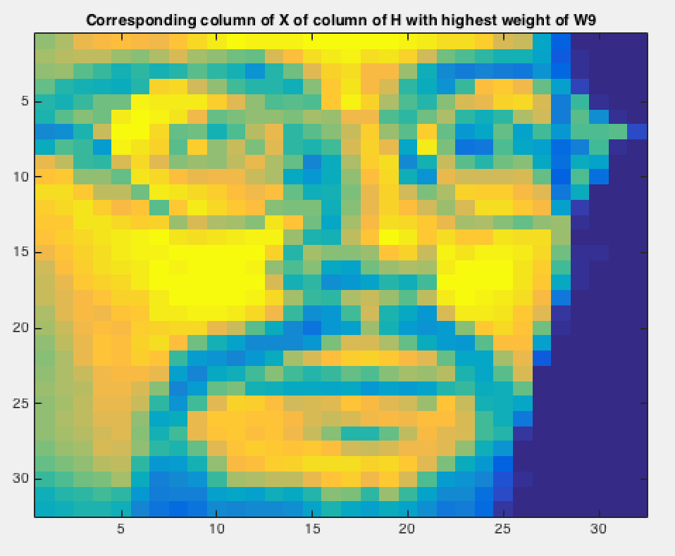

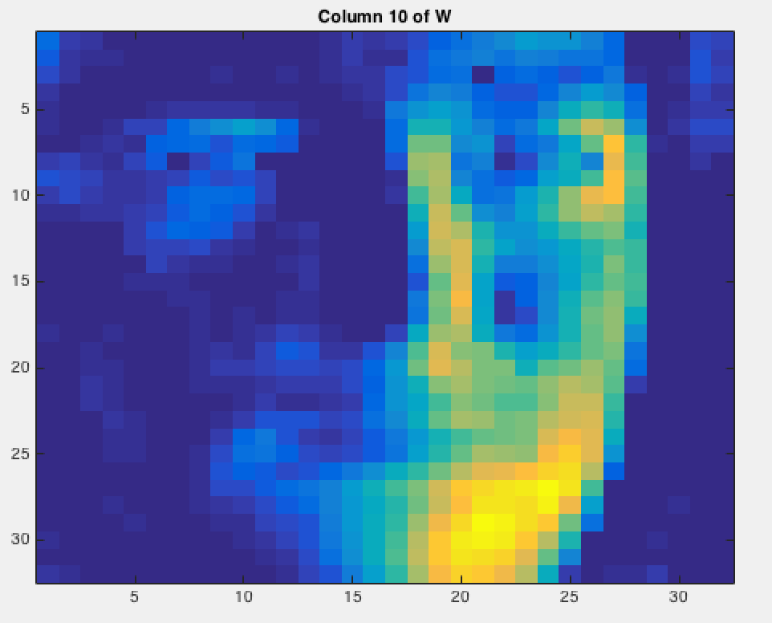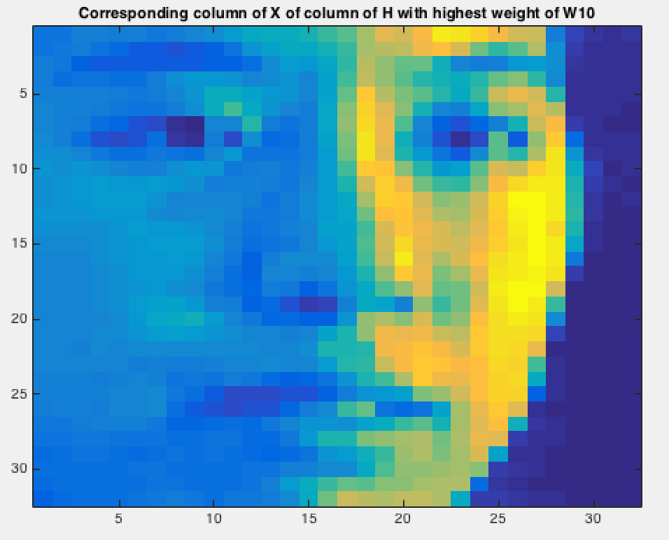

part2

Plot the objective as a function of iteration.

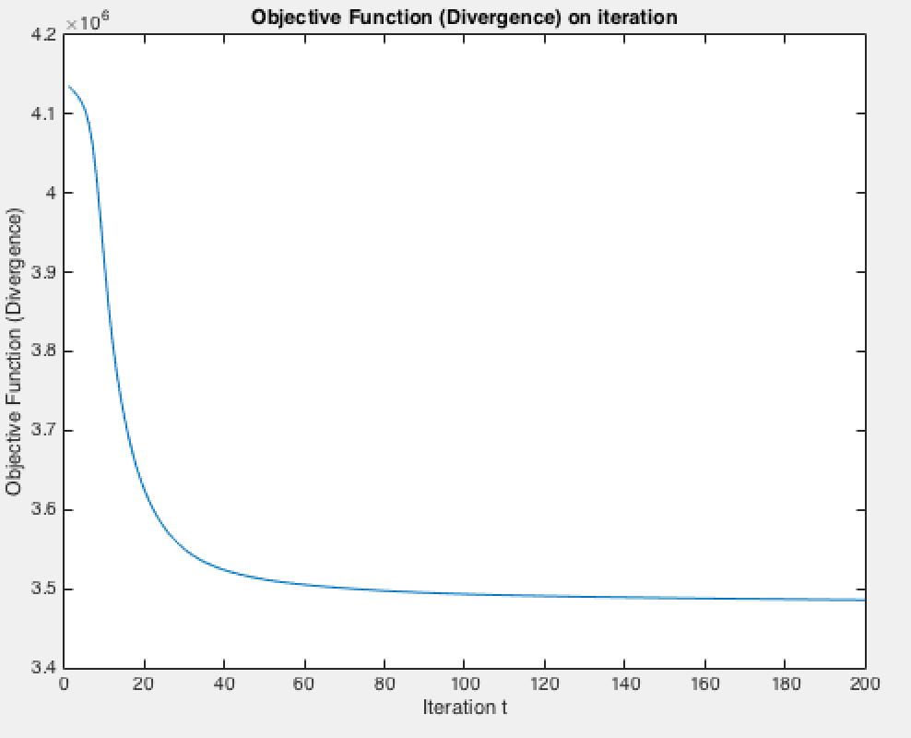

Pick 10 columns of W. For each column you select show the 10 words having the largest weight according to that vector and show the weight. The ith row of W corresponds to the ith word in the “dictionary” provided with the data.

==========Column 1============

food weight=0.016681

restaurant weight=0.0096089

serve weight=0.0093977

taste weight=0.008599

fresh weight=0.0080217

wine weight=0.0076946

add weight=0.0071088

fish weight=0.0070962

eat weight=0.0070442

dinner weight=0.0069888

==========Column 2============

vote weight=0.020169

political weight=0.017562

campaign weight=0.016931

election weight=0.014404

republican weight=0.014296

candidate weight=0.013629

party weight=0.013576

democratic weight=0.012718

leader weight=0.011408

state weight=0.010668

==========Column 3============

game weight=0.028543

team weight=0.024366

season weight=0.018832

play weight=0.018724

player weight=0.018656

second weight=0.012547

score weight=0.010577

coach weight=0.010102

victory weight=0.0095957

point weight=0.0084809

==========Column 4============

family weight=0.021513

child weight=0.019285

friend weight=0.017153

life weight=0.016763

live weight=0.016184

home weight=0.014895

woman weight=0.012189

tell weight=0.011984

wife weight=0.01155

man weight=0.011252

==========Column 5============

television weight=0.027188

executive weight=0.017462

news weight=0.017347

president weight=0.015945

network weight=0.015388

advertising weight=0.011925

medium weight=0.011248

business weight=0.0099283

broadcast weight=0.0090321

name weight=0.0082927

==========Column 6============

case weight=0.01937

lawyer weight=0.017586

court weight=0.017262

law weight=0.016608

charge weight=0.011828

judge weight=0.011339

legal weight=0.010587

state weight=0.0085039

investigation weight=0.008396

trial weight=0.0082467

==========Column 7============

official weight=0.015693

plan weight=0.015312

meeting weight=0.013524

announce weight=0.013068

agreement weight=0.012853

agree weight=0.012616

talk weight=0.011212

deal weight=0.010589

decision weight=0.010176

meet weight=0.0098618

==========Column 8============

drug weight=0.014281

health weight=0.013752

doctor weight=0.012708

study weight=0.011715

medical weight=0.01104

patient weight=0.010289

treatment weight=0.0095911

cause weight=0.0093727

report weight=0.0090331

problem weight=0.0081205

==========Column 9============

president weight=0.039716

father weight=0.03824

mrs weight=0.0342

retire weight=0.033306

graduate weight=0.032414

son weight=0.030793

director weight=0.023547

daughter weight=0.023465

receive weight=0.022499

vice weight=0.021967

==========Column 10============

company weight=0.03809

business weight=0.01737

executive weight=0.014627

share weight=0.01428

financial weight=0.012858

bank weight=0.012564

stock weight=0.011732

firm weight=0.010708

sell weight=0.010625

buy weight=0.0099293