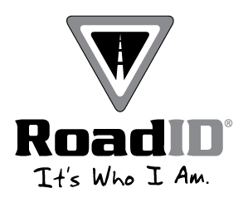
VIRA (Virtual Race Assistant)© CC/Nordic Ski Meet Results

Meet: Monticello Invitational

Date: 9/8/2011

Site: Vintage Golf Course

Enclosed are team and individual results from this meet. You will find enhanced results online at www.myvira.com within 24 hours (probably much sooner than that).

If you find any errors in the data, please contact us by email (bobs@h51software.net) or telephone (612-720-8427) as soon as possible.
Thank you for participating in a VIRA-run meet! If you know of anyone in need of cross-country meet management services, please forward our information to them or drop us an email with contact information for them!

Would you like to conserve time, work more efficiently, keep all of your coaching materials in on place that is accessible from school, home, or on the road, and help improve your runners’ documentation skills? Have a look at eTRaXC (http://www.etraxc.com/), an online service for running team management/online team training log-written by coaches for coaches.

Results For:
- All
- Boys/Men
- Girls/Women
- Co-Ed
- Relay
- Other (See Below)
_________________
_________________
_________________


