
VIRA (Virtual Race Assistant)
Cross-Country Meet Director Instructions
Having a meet you are hosting managed by VIRA carries some advantages not found with any other cross-country meet management system. Not only do we handle ALL timing and scoring-related duties but we handle all team contacts and roster/lineup gathering, supply bib numbers and pins, provide meet results for participants prior to leaving the site, post a map to the site online, and post results online in a couple of different formats for an indefinite period of time. No more scrambling to get results ready for the awards ceremony or long hours typing results by you or your secretarial staff after the meet.
Probably the thing that sets us apart from our competitors the most, however, is the web functionality that we provide for coaches and meet directors. The coach of each participating team and every meet director has a secure account at www.myvira.com where meet information can be accessed, rosters can be uploaded, lineups can be set, meet information can be made available to coaches (meet information sheet, course maps, etc), and more.
In order to make the system work for you and your participating teams we need a couple of things to happen for us. Instructions for those procedures are found below, along with helpful tips for taking full advantage of our system.
Prior to Meet Day
Please supply a meet information sheet as soon as one becomes available. This should include
  - the meet site,
  - the participating teams with email contact information for each coach,
  - the schedule of races,
  - the method of scoring (we will assume the meet is scored by the place of the first 5 finishers for each team if not otherwise noted)
  - any unusual circumstances surrounding your meet
In the event that we have difficulty contacting coaches to get their rosters/lineups submitted, we may ask for your assistance with that, although that is rare.
Meet Day Instructions
- We prefer to use your chute but we can set up our chute. In either case, we will set the chute and tent up ourselves .
- We will have packets for each team and would appreciate your help in distributing those.
- Please supply four (6) RESPONSIBLE workers to assist us at the finish line. Note that we do not take responsibility for ordering runners in the chute. We simply time each finisher and record their finish place in the order that they exit the chute.
- At your coaches meeting, please stress the following:
  - all participants must wear the bib assigned to them pinned on the front WITH 4 PINS!
  - all participants must run the race they are assigned to by their coach (subject to your approval, we do allow race-day line-up changes. We discourage, but will accommodate as possible, roster additions on race day)
  - all participants must exit the chute at the exit point and not duck out of the chute early
Certification of Results
We will make results available for awards within minutes of the final runner finishing the meet. Prior to the end of the awards ceremony we will have results ready to distribute to all participating teams. Initial results are unofficial but every effort is made to ensure the accuracy of the results prior to the awards ceremony. Results are certified as official once we have had a chance to cross-check our back-up information. In smaller meets (10 teams or less) we expect to be able to do this prior to leaving the site. For larger meets this could take more time and may not be done until later that evening.
Invoice
You will already have received an invoice via email prior to the meet. Please submit that to your business office for payment on race day.

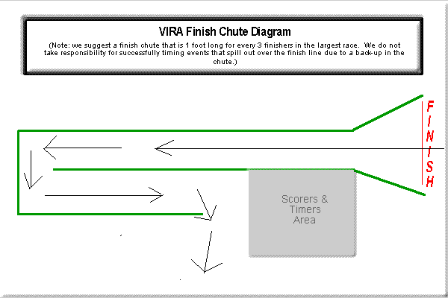
Thank you for participating in a VIRA-run meet! If you know of anyone in need of cross-country meet management services, please forward our information to them or drop us an email with contact information for them!

By having VIRA host your meet, you qualify for a 1-year subscription to CCLog. CCLog is the most innovative online management utility for high school, college, and club running teams on the web. CCLog serves as a team-based training log and team manager. You can find it online at www.cclog2.com.

