LUIGI

Integrantes

Víctor Alfonso López Canchola
Jorge López M.
Wilfrido Cortes Torres

Propósito

Crear el entorno adecuado para lograr la gestión y manipulación de la información de la base de datos NetFlix sobre el contenido calificado por los usuarios de los años 1998 a 2005; desde la extracción de los datos, transformación, carga, análisis de datos y su visualización.

Proceso

Datos

This is the official data set used in the Netflix Prize competition. The data consists of about 100 million movie ratings, and the goal is to predict missing entries in the movie-user rating matrix.
| Data Set Characteristics: | Multivariate, Time-Series |
| Attribute Characteristics: | Integer |
| Associated Tasks: | Clustering, Recommender-Systems |
| Number of Instances: | 100480507 |
| Number of Attributes: | 17770 |

Source:
The Netflix Prize
http://www.netflixprize.com

Data Set Information:
This dataset was constructed to support participants in the Netflix Prize.
There are over 480,000 customers in the dataset, each identified by a unique integer id.
The title and release year for each movie is also provided. There are over 17,000 movies in the dataset, each identified by a unique integer id.
The dataset contains over 100 million ratings. The ratings were collected between October 1998 and December 2005 and reflect the distribution of all ratings received during this period. Each rating has a customer id, a movie id, the date of the rating, and the value of the rating.
As part of the original Netflix Prize a set of ratings was identified whose rating values were not provided in the original dataset. The object of the Prize was to accurately predict the ratings from this 'qualifying' set. These missing ratings are now available in the grand_prize.tar.gz dataset file.
Attribute Information:
The format of the data is described fully in the README files contained in the dataset tar files.
MovieID:
Arbitrarily assigned unique integer in the range [1 .. 17770].
CustomerID:
Arbitrarily assigned unique integer in the range [1..2649429] (with gaps).
Rating:
Number of 'stars' assigned to a movie by a customer; an integer from 1 to 5.
Title:
English language title of the movie on the Netflix website.
YearOfRelease:
Year a movie was released in the range [1890..2005]. May correspond to the
release of corresponding DVD, not necessarily its theaterical release.
Date:
Timestamp of a rating in the form YYYY-MM-DD, in the range 1998-11-01 to
2005-12-31.
NetflixID:
Integer ID of a movie as currently used in the Netflix developer API
URL: http://archive.ics.uci.edu/ml/datasets/Netflix+Prize

Como equipo se definieron los siguientes puntos a cubrir en el análisis para estos datos:

- El contenido más visto
- El contenido menos visto
- El contenido mas visto por año
- El contenido menos visto por año
- El contenido mejor rankeado
- El contenido menor rankeado
- Reporte mensual en el periodo de un año (2000)
- Usuarios que más han calificado

Topología

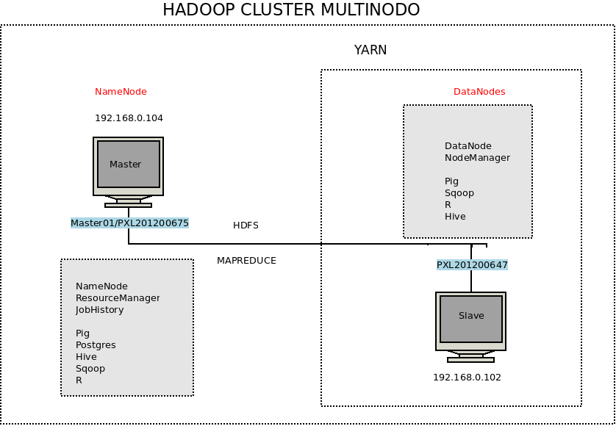

Proceso Desglosado

luigi
http://luigi.readthedocs.org/en/latest/index.html

instalar luigi.
pip install luigi

python setup.py install.
pip install tornado

se crea la clase que implementa el work flow

import luigi
import luigi.scheduler
import luigi.worker
import logging
from NetflixTask1 import PigJobTask1
from NetflixTask2 import PigJobTask2

#logger = logging.getLogger('luigi-interface')

class MyWorkflow(luigi.Task):
'''
An example luigi workflow task, which runs a whole workflow of other luigi
tasks when executed.
'''
# Here we define the whole workflow in the requires function
def requires(self):
print ':::::::::::::::::::::::::::::::::::::::::::::.'
task_a = PigJobTask1()
task_b = PigJobTask2(upstream_task=task_a)
# task_b = PigJobTask2()
return task_b

# Define a simple marker file to show that the workflow has completed
def output(self):
return luigi.LocalTarget("/usr/local/hadoop/luigi-1.3.0/examples/myexamples/prueba" + '.workflow_complete')

# Just write some text to the marker file
def run(self):
with self.output().open('w') as outfile:
outfile.write('Workflow complete!')

# If this file is executed as a script, let luigi take care of it:
if __name__ == '__main__':
print ':::::::::::::::::::::::::::::::::::::::::::::.'
luigi.run(["--local-scheduler"], main_task_cls=MyWorkflow)

NetflixQuery1.pig

/*Contenido mas visto cd /user/hduser/netflix/*/
highview1 = load 'netflixMoviesValidosSimple3.csv' using PigStorage('|') as (idmovie:int, title:chararray, iduser:int, ranking:int, date:chararray, yearmovie:chararray);
highview2 = cogroup highview1 by title;
highview3 = foreach highview2 generate group , COUNT(highview1.iduser) as veces;
highview4 = order highview3 by veces desc;
highview5 = limit highview4 15;
store highview5 into 'highview' using PigStorage('|');

NetflixTask1.py

from luigi.hadoop import HadoopRunContext
import tempfile
import os
import luigi
import logging
import subprocess
import signal
import shlex
import select
from luigi import six
#from luigi.hdfs import HdfsTarget
from luigi import configuration
__author__ = 'victor'

logger = logging.getLogger('luigi-interface')

class PigJobTask1(luigi.Task):

def requires(self):
return []

def output(self):
return luigi.LocalTarget("/usr/local/hadoop/luigi-1.3.0/examples/myexamples/Task1.complete")

def pig_env_vars(self):
return {}

def pig_home(self):
return configuration.get_config().get('pig', 'home', '/usr/local/hadoop/pig/')

def pig_command_path(self):
return luigi.configuration.get_config().get("pig", "command", "pig")

def pig_script_path(self):
return '/usr/local/hadoop/luigi-1.3.0/examples/myexamples/NetflixQuery1.pig'
#return 'hdfs://user/hduser/netflix/pruebaNF.pig'

def pig_options(self):
return ['-x', 'local']
#return []

def pig_parameters(self):
return {}

def pig_properties(self):
return {}

def _build_pig_cmd(self):
opts = self.pig_options()

for k, v in six.iteritems(self.pig_parameters()):
opts.append("-p")
opts.append("%s=%s" % (k, v))

if self.pig_properties():
with open('pig_property_file', 'w') as prop_file:
prop_file.writelines(["%s=%s%s" % (k, v, os.linesep) for (k, v) in six.iteritems(self.pig_properties())])
opts.append('-propertyFile')
opts.append('pig_property_file')

cmd = [self.pig_command_path()] + opts + ["-f", self.pig_script_path()]

return cmd

def run(self):
cmd = self._build_pig_cmd()
self.track_and_progress(cmd)
with self.output().open('w') as outfile:
outfile.write('Task1 complete!')

def track_and_progress(self, cmd):
temp_stdout = tempfile.TemporaryFile()
env = os.environ.copy()
env['PIG_HOME'] = self.pig_home()
for k, v in six.iteritems(self.pig_env_vars()):
env[k] = v

proc = subprocess.Popen(cmd, shell=False, stdout=subprocess.PIPE, stderr=subprocess.PIPE, env=env)

reads = [proc.stderr.fileno(), proc.stdout.fileno()]
# tracking the possible problems with this job
err_lines = []
with PigRunContext():
while proc.poll() is None:
ret = select.select(reads, [], [])
for fd in ret[0]:
if fd == proc.stderr.fileno():
line = proc.stderr.readline().decode('utf8')
err_lines.append(line)
if fd == proc.stdout.fileno():
line = proc.stdout.readline().decode('utf8')
temp_stdout.write(line)

err_line = line.lower()
if err_line.find('More information at:') != -1:
logger.info(err_line.split('more information at: ')[-1].strip())
if err_line.find(' - '):
t = err_line.split(' - ')[-1].strip()
if t != "":
logger.info(t)

# Read the rest + stdout
err = ''.join(err_lines + [err_line.decode('utf8') for err_line in proc.stderr])
if proc.returncode == 0:
logger.info("Job completed successfully!")
else:
logger.error("Error when running script:\n%s", self.pig_script_path())
logger.error(err)
raise PigJobError("Pig script failed with return value: %s" % (proc.returncode,), err=err)

class PigRunContext(object):
def __init__(self):
self.job_id = None

def __enter__(self):
self.__old_signal = signal.getsignal(signal.SIGTERM)
signal.signal(signal.SIGTERM, self.kill_job)
return self

def kill_job(self, captured_signal=None, stack_frame=None):
if self.job_id:
logger.info('Job interrupted, killing job %s', self.job_id)
subprocess.call(['pig', '-e', '"kill %s"' % self.job_id])
if captured_signal is not None:
# adding 128 gives the exit code corresponding to a signal
sys.exit(128 + captured_signal)

def __exit__(self, exc_type, exc_val, exc_tb):
if exc_type is KeyboardInterrupt:
self.kill_job()
signal.signal(signal.SIGTERM, self.__old_signal)

class PigJobError(RuntimeError):
def __init__(self, message, out=None, err=None):
super(PigJobError, self).__init__(message, out, err)
self.message = message
self.out = out
self.err = err

def __str__(self):
info = self.message
if self.out:
info += "\nSTDOUT: " + str(self.out)
if self.err:
info += "\nSTDERR: " + str(self.err)
return info

# if __name__ == '__main__':
# luigi.run(["--local-scheduler"], main_task_cls=PigJobTask1)

De manera similiar se crea la clase NetflixTask1.py y el NetflixQuery1.pig

Para ejecutar el workflow
$ python MyWorkflow.py

