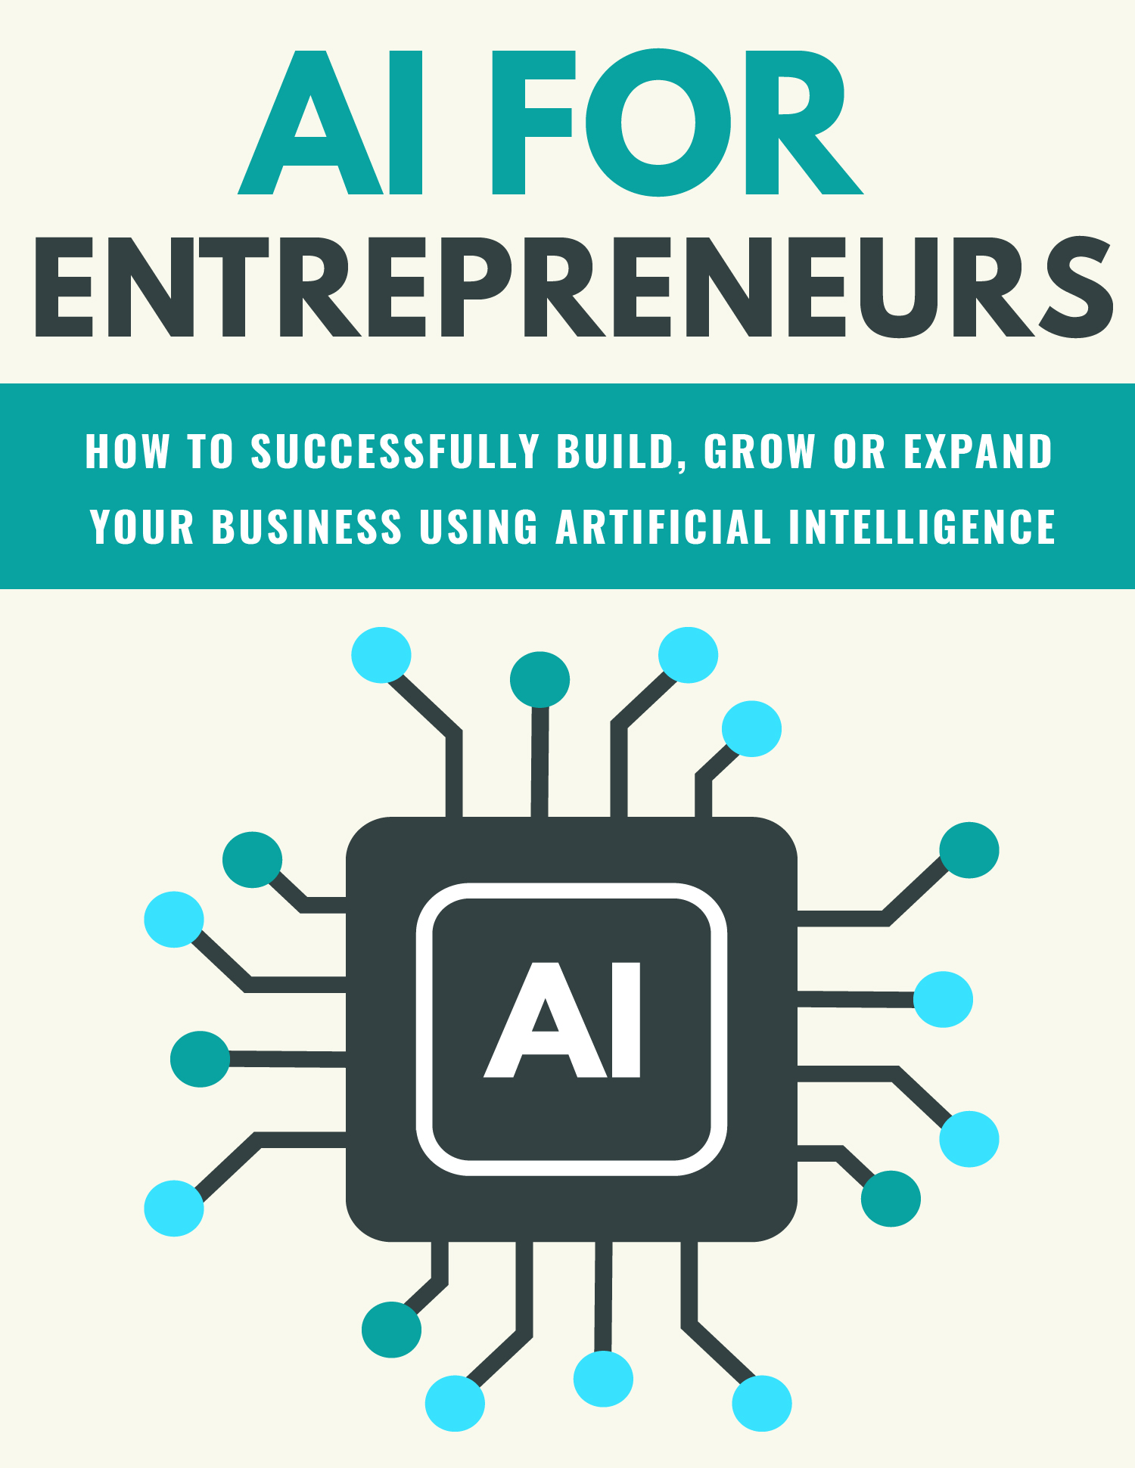­­

**Copyright ©** All rights reserved worldwide.

**YOUR RIGHTS:** This book is restricted to your personal use only. It does not come with any other rights.

**LEGAL DISCLAIMER:** This book is protected by international copyright law and may not be copied, reproduced, given away, or used to create derivative works without the publisher’s expressed permission. The publisher retains full copyrights to this book.

The author has made every reasonable effort to be as accurate and complete as possible in the creation of this book and to ensure that the information provided is free from errors; however, the author/publisher/ reseller assumes no responsibility for errors, omissions, or contrary interpretation of the subject matter herein and does not warrant or represent at any time that the contents within are accurate due to the rapidly changing nature of the internet.

Any perceived slights of specific persons, peoples, or organizations are unintentional.

The purpose of this book is to educate, and there are no guarantees of income, sales, or results implied. The publisher/author/reseller can, therefore, not be held accountable for any poor results you may attain when implementing the techniques or when following any guidelines set out for you in this book.

Any product, website, and company names mentioned in this report are the trademarks or copyright properties of their respective owners. The author/publisher/reseller are not associated or affiliated with them in any way. Nor does the referred product, website, and company names sponsor, endorse, or approve this product.

**COMPENSATION DISCLOSURE:** Unless otherwise expressly stated, you should assume that the links contained in this book may be affiliate links, and either the author/publisher/reseller will earn a commission if you click on them and buy the product/service mentioned in this book. However, the author/publisher/reseller disclaims any liability that may result from your involvement with any such websites/products. You should perform due diligence before buying the mentioned products or services.

This constitutes the entire license agreement. Any disputes or terms not discussed in this agreement are at the sole discretion of the publisher.

**Table of Contents**

Introduction 5

What AI Can Do for You 8

How to Incorporate AI into Your Business 14

How to Get Started Quickly 20

Taking Your Business to the Next Level with AI 24

3 Tips to Using AI Successfully 29

Final Words 34

Resources 36

Introduction

The technology industry has fallen in love with artificial intelligence, also known as AI. With applications that range from automated customer service to high-end data services, artificial intelligence is popping up all over the place.

Rob Marvin and Brian Horowitz from *PC Magazine* point out that AI is clearly a growing force in the industry, taking center-stage at conventions and conferences and showing a lot of potential for a wide variety of industries (including manufacturing and retail).

New products are already equipped with virtual assistants and chatbots are answering your customers’ questions for you. And companies like Google and Microsoft are “integrating AI as an intelligence layer across their entire tech stack.”

This isn’t the artificial intelligence that science fiction has conditioned us to expect, though. While there are a few robotic androids, there’s no Skynet. We don’t even have Jarvis, the AI butler from the Iron Man movies. What we do have is smarter tech and far more powerful data.

And what that means is that, according to the CEO of Sas.com, “Widespread advancement in machine learning (ML), computer vision, deep learning, and natural language processing (NLP) have made it easier than ever to bake an algorithm layer into your software or cloud platform.”

For your business, practical AI applications can take almost any form, depending on your organizational needs and “the business intelligence (BI) insights derived from the data you collect.”

You can use AI for everything from “mining” social data, automating customer growth and data collection, to driving customer engagement to optimizing logistics and overall efficiency.

In this special report, we’ll take a close look at how you can use AI in your business successfully.

Let’s begin!

What AI Can Do for You

A survey of CEOs from small- to medium-sized businesses (conducted by Vistage, an executive coaching company) found that artificial intelligence is quickly becoming an important part of business processes.

In that survey, 29.5% of business leaders said that AI, of all new technologies, would have the greatest impact on their business in the next year.

In the finance industry, some of the lenders have already started using AI or machine learning to improve the risk assessment process.

But you don’t have to look toward the future to see what artificial intelligence can do for you now. AI-based tools can offer you several benefits, including:

* Lowering costs
* Reducing risk
* Reducing time spent on tasks
* Increasing results
* Improving flexibility and responsiveness

Here are **four specific areas** where artificial intelligence can help you grow and manage your business:

**Improving sales and marketing**—Customer relationship management (CRM) systems are designed to collect customer information from communication channels like phone, email, and social media.

The goal is to help improve and even automate the sales process.

Platforms like Salesforce have begun using AI that helps small businesses analyze the data from those communication channels and then adjust lead generation activities and marketing based on that information.

AI-infused CRMs can help you generate more leads for the same amount of marketing money. They also show how AI can be used to gather marketing- and sales-relevant insights to optimize nearly the entire customer acquisition process.

Automating customer communication. Many small businesses have started using chatbots on their websites.

Chatbots can initiate conversations and help answer customer questions. It’s like a 24/7 sales or customer service rep.

You’ve probably already encountered a chatbot, even if you didn’t think of it as artificial intelligence. It’s that little pop-up chat box at the corner of a website that asks if you have any questions or problems.

If you don’t have a dedicated customer service or sales team yet, a chatbot might be the way to go, taking some of the pressure off your shoulders and letting you put your focus on the things that are important.

**Streamlining human resources tasks**—An unexpected area where AI has started appearing is in the field of human resources.

AI tools are available to not only streamline the hiring and “onboarding” processes, but also gather information from new employees that helps HR improve those processes. And both of these can have a major impact on your bottom line.

AI can automatically sort through that stack of applicants to find the people who most closely match the criteria you’re looking for.

This can not only improve your odds on finding the perfect candidate, but also save you valuable time and resources.

And once that candidate is brought onboard, the software can help educate employees with questions about company benefits or policies.

This can reduce the time you spend on the hiring process and increase the number of high-quality candidates you see, since you just don’t have the time to wade through all those applications yourself.

It then reduces the amount of time HR spends on answering questions from your new employees.

**Acquiring competitive intelligence**—You’ve probably dreamed of being able to gather and analyze your competition easily—from written and video content to social media posts and marketing campaigns that help them better position their business.   
  
Well, the great news is that artificial intelligence can do that for you!  
There are several tools that let you keep tabs on your competitors and their activities, including collecting the information for you, and then convert it into easy-to-read reports.

*Crayon*, for example, a competitor analysis tool, uses artificial intelligence to track competitors across a variety of digital channels such as their websites or social media posts.

It then collects a variety of information for you, like slight adjustments in their marketing language or pricing changes.

These types of AI tools allow you to gather more detailed information faster, which means you respond faster and more efficiently to industry changes that might affect your business!

How to Incorporate AI into Your Business

There are many ways you can begin to implement AI into your business to maximize exposure and growth.

*Here are a few ideas:*

**Become familiar with AI, and what it’s capable of.**

Luke Tang’s *TechCode Accelerator* can give you a wide variety of resources since it partners with organizations like Stanford University and with “corporations in the AI space.”

Take advantage of the treasure trove of information out there, and familiarize yourself with the basic concepts of artificial intelligence.

Tang himself recommends some of the workshops and online classes offered organizations like Udacity.   
  
They’re easy ways for you to get started with artificial intelligence and help improve your knowledge of things like machine learning and predictive analytics.

*Here are some resources you can use to get started (not all are free):*

* Udacity’s “Intro to AI” course and their Artificial Intelligence Nanodegree Program.
* Stanford University’s online lectures: Artificial Intelligence, Principles & Techniques.
* Microsoft’s open-source “Cognitive Toolkit” (previously called CNTK) to help master deep-learning algorithms.
* Google’s open-source “TensorFlow” software library for machine intelligence.
* AI Resources, an open-source code directory from the AI Access Foundation.

**Start by identifying the problems you want artificial intelligence to solve for you.**

Once you’ve got the basics down, the next step is to start exploring and brainstorming ideas.

Start thinking about how you can incorporate AI into your existing services and products. You probably already have specific cases in mind where artificial intelligence could solve some of your problems or provide demonstrable value.

Maybe it’s streamlining the hiring process or helping your customers by answering questions.

“When we’re working with a company,” Tang says, “we start with an overview of its key tech programs and problems. We want to be able to show it how natural language processing, image recognition, machine learning, etc. fit into those products, usually with a workshop of some sort with the management of the company. The specifics always vary by industry.

For example, if the company does video surveillance, it can capture a lot of value by adding machine learning to that process.”

**Prioritize value.**

Your next step is to sit down and assess the potential value, both business and financial, of the artificial intelligence implementations you’re thinking about implementing into your business.

Tang stresses the importance of not getting lost in “pie in the sky” discussion, but instead, hooking your initiatives directly to solid business values.

This way, you won’t get distracted by all the possibilities, but will aim for something attainable.

“To prioritize,” Tang says, “look at the dimensions of potential and feasibility and put them into a two-by-two matrix. This should help you prioritize based on near-term visibility and know what the financial value is for the company.

For this step, you usually need ownership and recognition from managers and top-level executives.”

**Acknowledge your capability gap.**

There’s a big difference between what you want to accomplish for your business and what you can succeed at doing within a certain time frame.

According to Tang, a business should know what it is an is not capable of doing “from a tech and business process perspective” before leaping directly into a full-blown artificial intelligence initiative.

“Sometimes this can take a long time to do,” he says. “Addressing your internal capability gap means identifying what you need to acquire and any processes that need to be internally involved before you get going.

Depending on the business, there may be existing projects or teams that can help do this organically for certain business units.”

How to Get Started Quickly

When you’re ready to begin implementing AI into your business, it may be time to turn to the experts.

Once your business seems to be ready (from a tech and organizational standpoint), it’s time to start creating and integrating.

Tang says that the most important factors are to start small, have concrete project goals, and (most importantly), be aware of what you do and don’t know about artificial intelligence.

Here’s where bringing in some outside experts can be most valuable.

“You don’t need a lot of time for a first project,” says Tang. “Usually for a pilot project, two to three months is a good range. You want to bring internal and external people together in a small team, maybe four to five people, and that tighter time frame will keep the team focused on straightforward goals.

After the pilot is completed, you should be able to decide what the longer-term, more elaborate project will be and whether the value proposition makes sense for your business.

It’s also important that expertise from both sides—the people how know about the business and the people who know about AI—is merged on your pilot project team.”  
  
Next, you’ll want to create a **task force.**

Tang also notes that, before you start a project, you need to clean up your data and avoid a “garbage in/garbage out” situation.

“Internal corporate data is typically spread out,” he says, “in multiple data silos of different legacy systems, and may even be in the hands of different business groups with different priorities.

Therefore, a very important step toward obtaining high-quality data is to form a … taskforce, integrate different data sets together, and sort out inconsistencies so that the data is accurate and rich, with all the right dimensions required for machine learning.”

This taskforce will help you implement your plans for artificial intelligence and get your information cleaned up and tidy so the AI can use it effectively.  
  
And finally, **start off slow and steady!**

Don’t bite off more than you can chew with artificial intelligence. Start by applying AI to a small sample of your data instead of trying to take on too much all at once.

Aaron Brauser, Vice President of Solutions Management at M*Modal, which offers natural language understanding, tech for health care organizations, and an AI platform that integrates with electronic records, reiterates this point.

“Start simple,” he says, “use AI incrementally to prove value, collect feedback, and then expand accordingly.”

Chief Medical Information Officer at M*Modal Gilan el Saadawi has this to add:

“Be selective in what the AI will be reading. For example, pick a certain problem you want to solve, focus the AI on it, and give it a specific question to answer and not throw all the data at it.”

Taking Your Business to the Next Level with AI

Upgrading your business to one powered by artificial intelligence requires everyone’s participation. And even though it takes time to transform a company, you can get a start now.

One step you can take is to change your culture into one that embraces experimentation, information, and agile principles.

Moving to a digital environment involves more than just automating a few tasks. You need to involve that digital environment so that it permeates and evolves every action within your organization.

AI isn’t just for the Fortune 500 companies any longer. More and more entrepreneurs and small businesses are entering the artificial intelligence market.

Analytics helps you convert information into intelligence so you can make better business decisions and become more relevant.

AI can help build better marketing strategies and help you get to know your customers better. The ability to analyze information to increase sales is one of the most lucrative applications of AI.

Artificial intelligence algorithms can sort through huge amounts of user data for trends and patterns. And that can lead to more effective marketing and help inform your content strategy.

A report from Harvard shows that sifting through chat logs for pertinent words and phrases correlating with successful sales can improve your success rates by as much as 54 percent.

Social media activity can give AI algorithms like Amazon’s recommendation system enough information to pinpoint purchasing trends for individual shoppers.

Jeff Wilke, CEO of Worldwide Consumers for Amazon, uses behavior-tracking artificial intelligence in the place of traditional memory-based marketing algorithms.

AI can also be used to help determine price. An algorithm can track trends to help figure out your ideal prices, optimizing your profit margins.

Artificial intelligence algorithms can also replace human beings on a variety of mundane tasks, freeing up time, resources, and money for other uses.

Although this may not be good news to some (robot apocalypse, anyone?), most entrepreneurs have a more practical view.

An AI can be a fantastic compliment to a human employee. Artificial intelligence can breeze through administrative tasks, letting your workers concentrate on more creative activities in more essential areas of your business.

Freeing your employees from simple tasks more easily done by AI allows them to put their talents and efforts to better use.

You wouldn’t think artificial intelligence could get a handle on human emotions, but the tech has surprising applications for something called “sentiment analysis.”

Using image recognition software, surveys, social media, and even more techniques, sentiment analysis algorithms can make some pretty accurate predictions about human reactions to specific topics.

This technology has been around for a while and was even used in President Obama’s 2012 election campaign to assess public opinions on some of his specific policy announcements. Sentiment analysis can help your business predict customer behavior, and you can react in real time as marketing trends change.

Improving your daily operations can also help your business grow faster. AI algorithms are ready and willing to do your “heavy lifting.”

Artificial intelligence can analyze areas like workflows and supply chains and spot places that need improvement.

Streamlining your workflow can insure that resources are used more effectively, minimizing costs associated with maintenance, lost time, and redundancy.

Manufacturing businesses stand to benefit from the integration of artificial intelligence Forbes magazine says there’s a potential 20% increase in production capacity and a 4% drop in materials for materials operations that utilize artificial intelligence.

3 Tips to Using AI Successfully

**Tip #1:** Remember to include **storage as part of your plan.**

Philip Pokorny, Chief Technical Officer at Penguin Computing, which offers high-performance computing, artificial intelligence, and machine learning solutions, says you need to remember to include storage requirements when you increase from a small data sample.

“Improving algorithms is important to reaching research results,” he wrote (in “*Critical Decisions: A Guide to Building the Complete Artificial Intelligence Solution Without Regrets*”).

“But without huge volumes of data to help build more accurate models, AI systems cannot improve enough to achieve your computing objectives.

That’s why the inclusion of fast, optimized storage should be considered at the start of AI system design.”

You should also optimize artificial intelligence storage for “data ingest, workflow, and modeling,” he suggests. “Taking the time to review your options can have a huge, positive impact to how the system runs once it’s online.”

**Tip #2: Make AI part of your daily routine.**

With the extra automation and insight offered by artificial intelligence, you’ve got a tool to make AI part of your daily routine, instead of trying to replace that routine entirely, according to Dominic Wellington, Global IT Evangelist at Moogsoft (a provider of AI for IT operations).

“Some employees may be wary of technology that can affect their job,” he says, “so introducing the solution as a way to augment their daily tasks is important.”

He also adds that you should be transparent with your employees on the way that tech works to resolve issues in your workflow.

“This gives employees an ‘under the hood’ experience so that they can clearly visualize how AI augments their role rather than eliminating it,” he says.

**Tip #3: Balance, balance, balance.**

When you’re building an artificial intelligence system, Pokorny explains, you need to not only meet the needs of the tech but also of the research project, so you need to carefully balance your construction.

“The overall consideration,” says Pokorny, “even before starting to design an AI system, is that you should build the system with balance.

This may sound obvious, but, too often, AI systems are designed around specific aspects of how the team envisions achieving its research goals, without understanding the requirements and limitations of the hardware and software that would support the research.

The result is a less-than-optional, even dysfunctional system that fails to achieve the desired goals.”

To balance your system, you need to build in enough bandwidth for storage, networking, the graphics processing unit (GPU), and for security.

Artificial intelligence requires access to vast amounts of data if it’s to do the job. You need to make sure you understand what kinds of data are going to be involved with your project—and realize that your usual security methods (anti-malware, encryption, and virtual private networks or VPN) may not be enough.

The more contact with the outside world your computer has, the more chances for a security problem.

“Similarly,” Pokorny says, “you have to balance how the overall budget is spent to achieve research with the need to protect against power failure and other scenarios through redundancies.

You may also need to build in flexibility to allow repurposing of hardware as user requirements change.”

Final Words

Before you invest in artificial intelligence, make sure you have everything you need to make it work properly.

Figure out what you’re going to need, what specialists you might need to bring onboard, and what additional costs might pop up down the line.

You don’t always need to hire a data scientist to bring an AI into your business. There are hundreds of companies designing user-friendly AI tools for small businesses and entrepreneurs.

For example, using tools from Legal Robot can help you develop clear and compliant legal documents and contracts, and an AI-powered application like *Grammarly* can give you consistent, high-quality writing.

Many businesses are already using Chatbots for customer service, and those can be predesigned for you.

Chatbots have come a long way since they were first introduced, and have become better with things like natural language processing, making them even more useful and reducing wait times for human customer service agents.

With nearly limitless applications for artificial intelligence, entrepreneurs like you have tons of opportunities to stand apart from your competition.  
  
To your success!

Resources

Here are links to a few resources that I believe will help you:

**How to Leverage the Power of AI:**

**>>** <https://startupnation.com/grow-your-business/leverage-artificial-intelligence/>

**10 Steps to Adopting AI in Your Business:**

**>>** <https://www.pcmag.com/news/10-steps-to-adopting-artificial-intelligence-in-your-business>

**How AI is Revolutionizing Small Business:**

**>>** <https://www.entrepreneur.com/article/341976>

**AI Applications for Small Businesses:**

**>>** <https://www.fisher401k.com/blog/ai-tools-for-small-business>