International Debt Analusis

A. KPI’s

1. Number of Distinct Countries:
SELECT
COUNT(DISTINCT country_name) AS Total_Countries
FROM
ids;

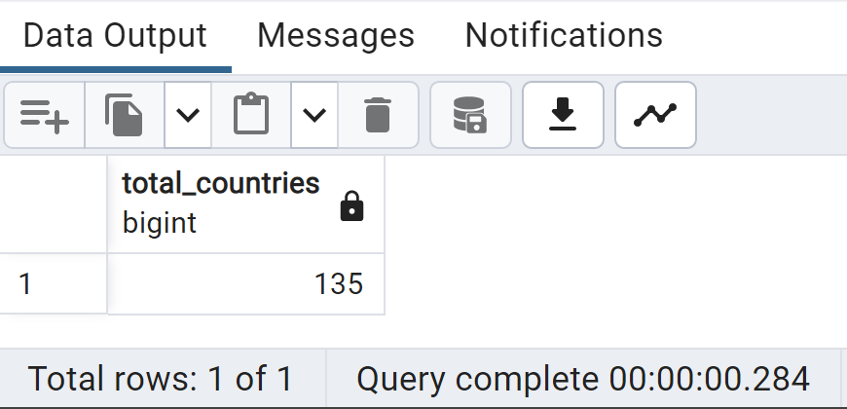

2. Number of Distinct Debt indicators:
SELECT
COUNT(DISTINCT series_name) AS total_indicators
FROM
Ids;
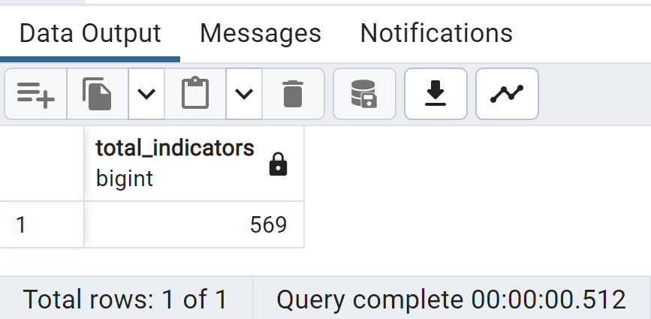

3. Total amount of Debt owed by countries for 2022
SELECT
country_name, SUM(_2022) AS Total_Debt_2022
FROM
ids
GROUP BY 1
ORDER BY 1;
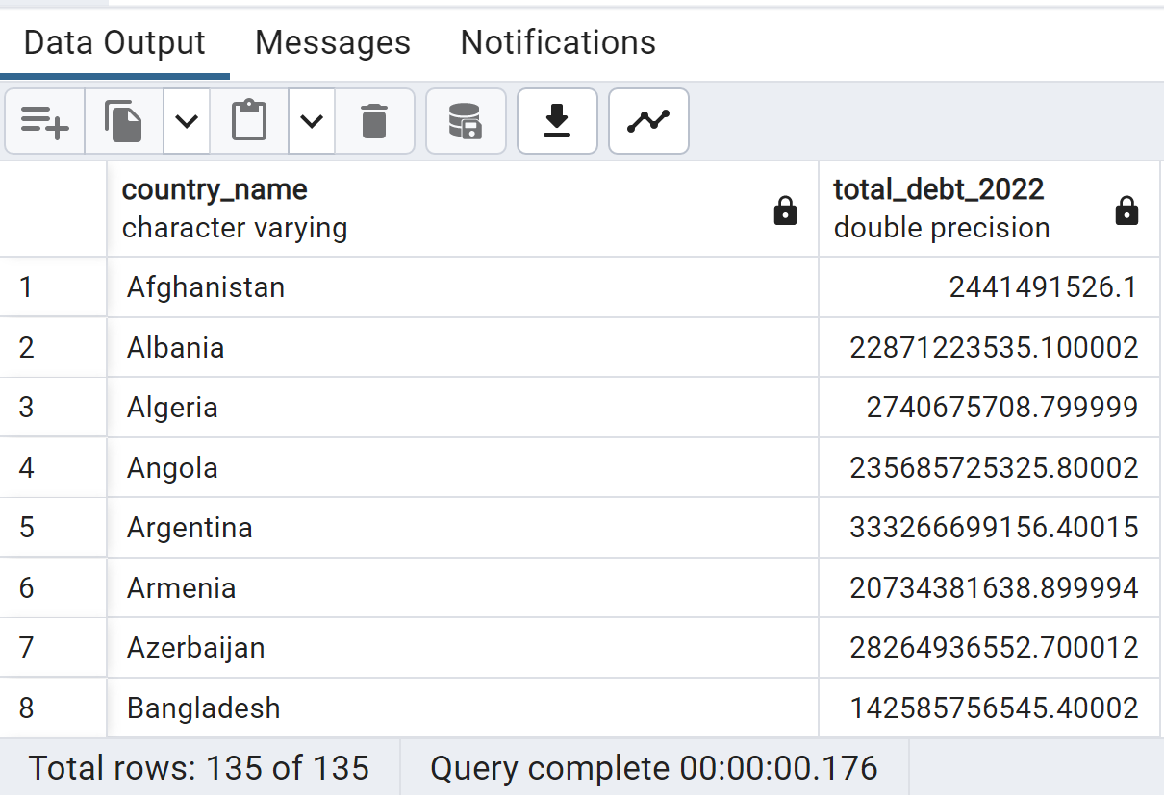

4. Country with highest Total Debt in 2022
SELECT
country_name, SUM(_2022) AS Total_Debt_2022
FROM
ids
GROUP BY 1
ORDER BY 2 DESC
LIMIT 8;
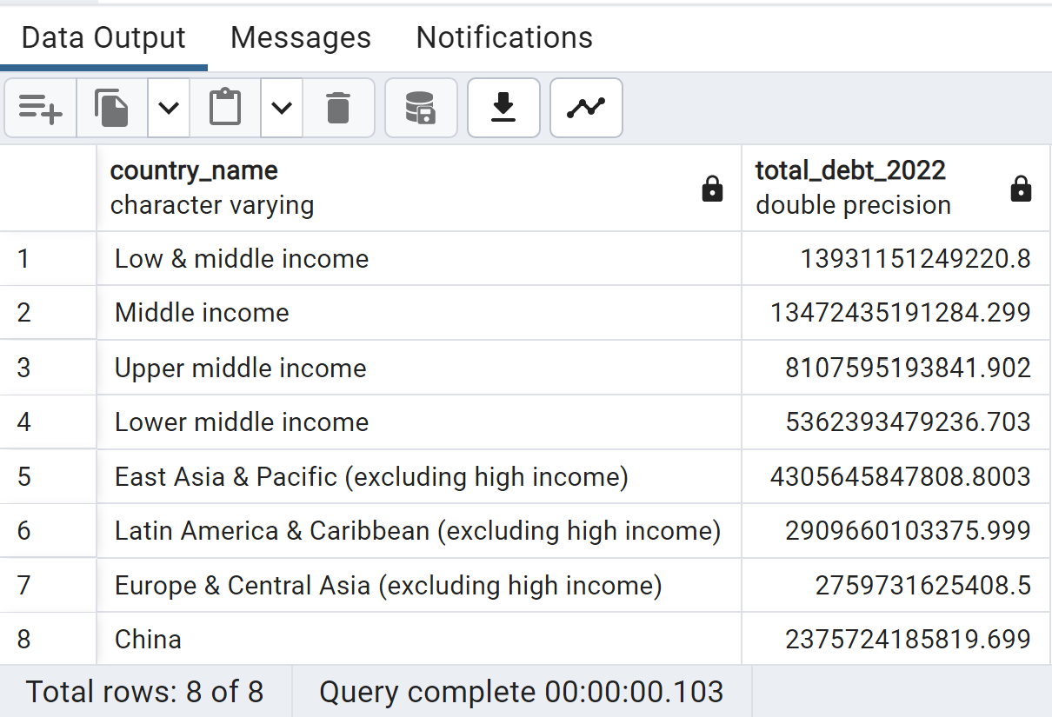

5. Average debt across all indicators for 2022
SELECT
series_code, ROUND((AVG(_2022))::numeric, 2) AS Average_Debt
FROM
ids
GROUP BY 1
ORDER BY 2 DESC
;
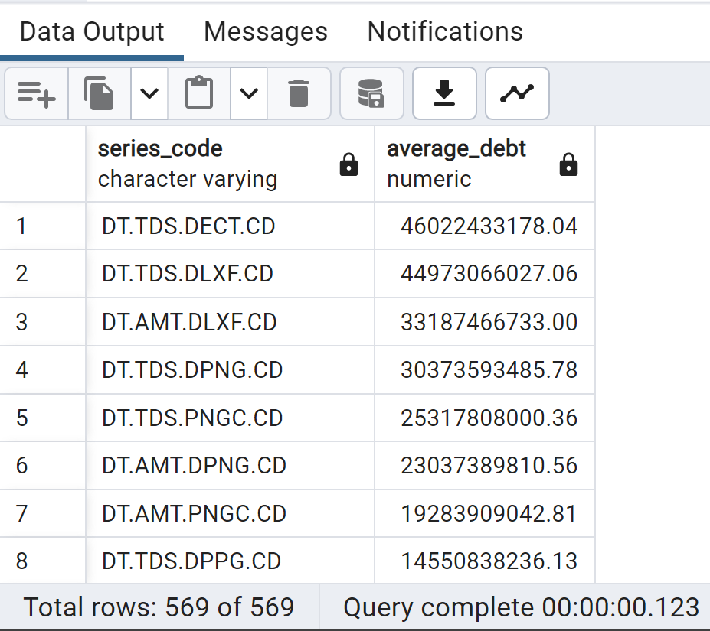

B. Country with the Highest Debt Increase from 2021 to 2022
SELECT
Country_Name, (_2022 - _2021) AS debt_increase
FROM
ids
ORDER BY
debt_increase DESC
LIMIT 25;
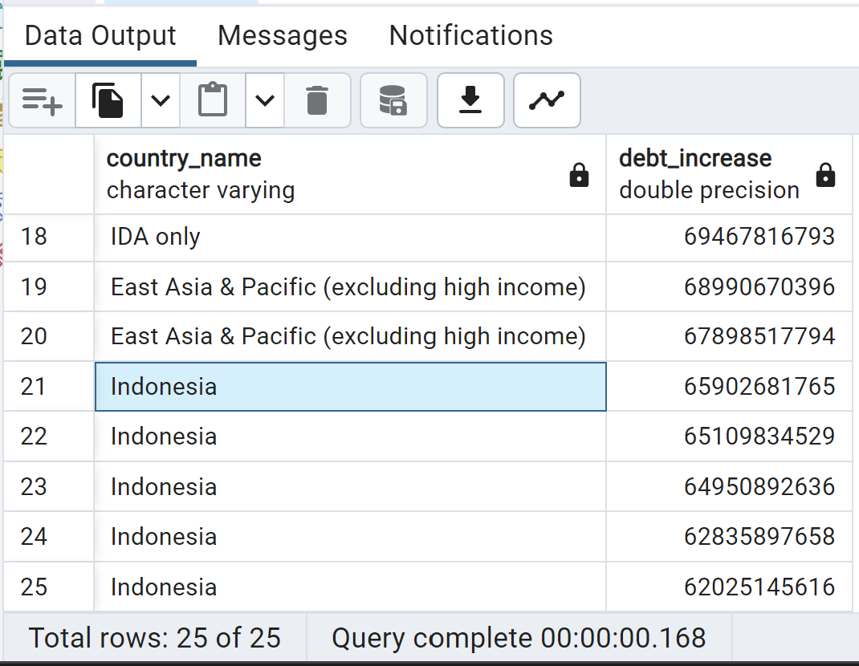
C. Country with the Highest Accumulated Debt Over All Years(2006-2022)
SELECT Country_Name,
(_2006 + _2007 + _2008 + _2009 + _2010 + _2011 + _2012 +
_2013 + _2014 + _2015 + _2016 + _2017 + _2018 + _2019 +
_2020 + _2021 + _2022 ) AS total_accumulated_debt
FROM ids
ORDER BY total_accumulated_debt DESC
LIMIT 25;
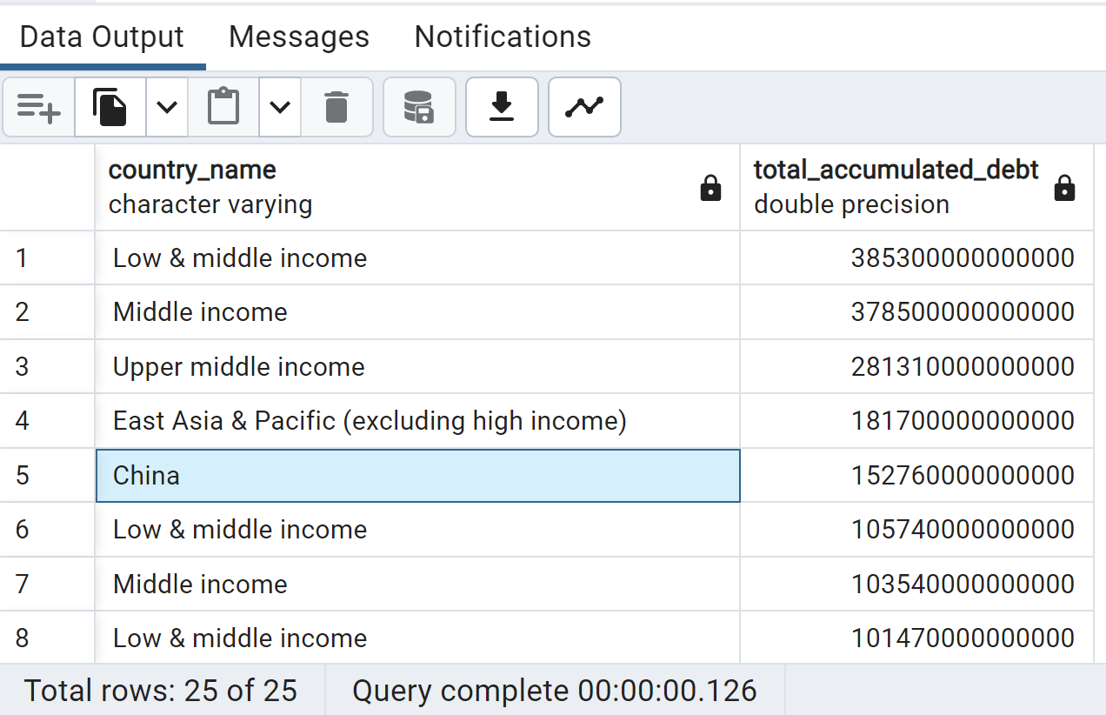
D. Debt Change Percentage between 2021 and 2022 for Each Country
SELECT
Country_Name,
ROUND(((_2022 - _2021) / _2021 * 100)::numeric, 2) AS debt_change_percentage
FROM
ids
WHERE
_2021 != 0
ORDER BY
debt_change_percentage DESC;
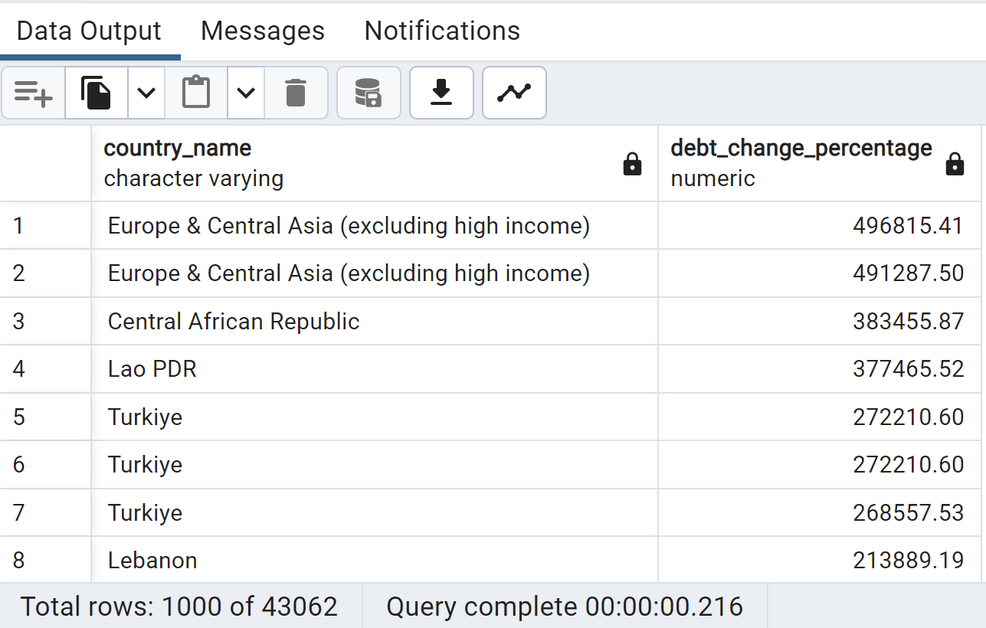
E.

