Design and Implementation of Gun Alignment Analysis Tool using Intelligent Image System

Si-Wan Kim¹, Kwan-Wook Kim², and Dong-Seong Kim³
¹Department of IT Convergence Engineering, Kumoh National Institute of Technology, Korea
²Hanhwa systems, Gumi, Korea
³Senior Member, IEEE
¹bigshow@kumoh.ac.kr, ²kwanwook.ki@hanwha.com, ³dskim@kumoh.ac.kr

Abstract: This Paper proposes the design and implementation of gun alignment analysis program. The proposed gun alignment analysis program utilizes tilt of sensor, stability of gyro, Inclination of Gun and offset between tracking sensor and Gun. by the gun alignment analysis program, it supports to ensure that the shooting results meet the specification by revising sensor and BCU(Ballistic Computing Unit) parameter. By reflecting the analyzed measured data result which is measured data in marine environment and real time video on parameter, shooting accuracy on actual shooting was improved..
Keywords: Naval Gun Alignment Firing System , Naval Gun Fire Control System, Boresight Telescope, Command and Fire Control System, Barrel Alignment
.

Introduction
The naval combat system improves the survivability and combat power of the traps and performs various types of naval missions[1]. Most naval vessels are equipped with one or more guns and are used as combat systems and are an important part of the assessment of naval combat capabilities[2-3]. When the ship is dried after launching into the sea, or when the ship is impacted due to a long voyage, the hull will twist finely[4]. When the hull is twisted, the foundation of the gun mounted on the deck is tilted. At this time, the tilt angle of foundation of the gun is called the tilt. The tilt also occurs when the ship is not properly installed and maintained in equilibrium with the deck. When a tilt occurs, the gun is aimed at a point different from the entered shooting specification. Especially, in the case of a long distance target, a considerable error occurs with the target, resulting in a decrease in shooting accuracy of the gun. Therefore, to correct the error due to the tilt value, mechanical correction or software correction is done. This process is called a gun array.
VERITAS and VRAS have been operated for more than 20 years and are imported from abroad. In addition to the performance degradation caused by long-term use, these devices require a long period of repair time in case of failure of any one of the components of the array equipment. If the failed parts are discontinued, In addition, due to limited system expansion function and lack of compatibility with other equipment, it is difficult to add or maintain the functions desired by the operator.
To meet operator's requirements and to maintain maintenance, we developed a new array equipment and array analysis tool to meet the basic functions of VERITAS or VRAS. We will propose the implementation result through this paper.

Arrangement of guns using intelligent image system
Gun Alignment Analysis Tool measures and analyzes the mechanical and electrical tilt, turn, and elevation error of guns or sensors by installing a camera on the guns that require armed arrangements. Also, the compensation value for the error is provided to minimize the compensation value through the fire control system, thereby providing a function to increase the shooting accuracy of the gun.
The inspection module is divided into three functions. First, the TILT function measures the slope of each sensor using a clinometer based on the mechanical reference plane (MRP, Master Reference Plane) of the sensor (radar, tracking equipment, etc.). also inputs the value to the analysis tool to calculate the compensation value. Second, the stability check function analyzes the measured values according to the attitude information of the gyro installed in the ship through the analysis tool. The analyzed information is used as data to determine the progress of the array process and provides a function to calculate the compensation value of the correct operating arrangement. Third, the horizontal inspection function measures the mechanical and electrical inclination of the ship by the direction of the horizon and calculates the compensation value through the analysis tool. The three functions of the inspection module must be performed in advance in order to perform the functions of the dynamic array module. The dynamic array performs the function of calculating the compensation value by measuring the electrical error between the sensor installed in the ship and the ship by bearing. It confirms the compensated TILT and OFFSET value in the sensor and the ship in the sailing condition, By analyzing the error through the analysis tool and compensating the result to the fire control system, it is possible to increase the Shooting accuracy
Figure 1 shows the equipment configuration diagram of the analysis tool for capturing. In order to receive the inspection and arrangement data, the analyzing computer equipped with the analysis tool receives the video signal from the array camera through the video cable.

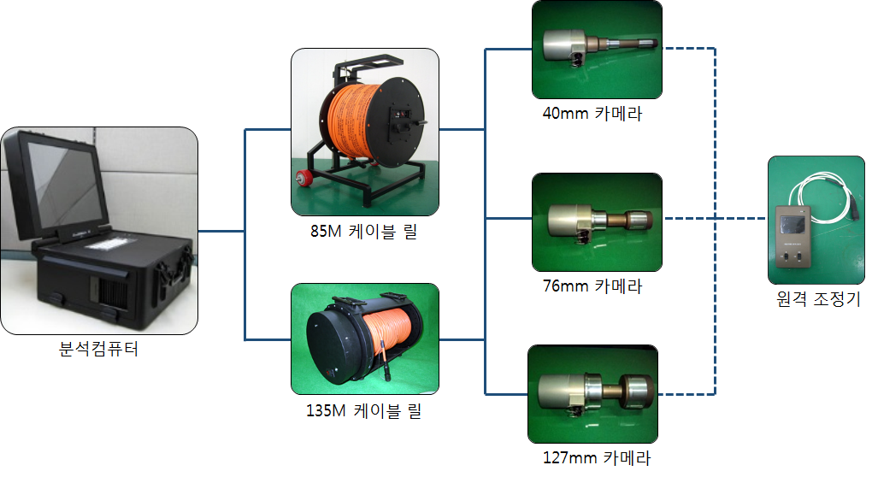
Figure 1 Diagram of gun arrangement

The software structure of the Gun Alignment analysis tool is composed of one CSCI, and includes TILT inspection module, horizontal inspection module, stability inspection module, dynamic array module, WCS-86 radar array module, A configuration module, a unit conversion module, and other modules, and functions independently or in cooperation with each other. The TILT test module calculates the tilt error between the MRP and the sensor, and the horizontal test uses the horizontal line to measure and analyze the angle error of the gun. The stability check module performs the gyro's high angle error calculation and analysis function. The dynamic array module uses the target to calculate the swing error and elevation error of the gun. The radar array module performs the function of calculating the radar azimuth error of the ship equipped with the WCS-86 fire control device. The environment setting module performs the list management, camera setting, various lines and character color Can be set. The unit conversion module calculates the conversion and vector sum between units used in fire control devices such as WSA-423, WM-28, etc., and units frequently used in various navies. Other modules provide notes for ship array history management.

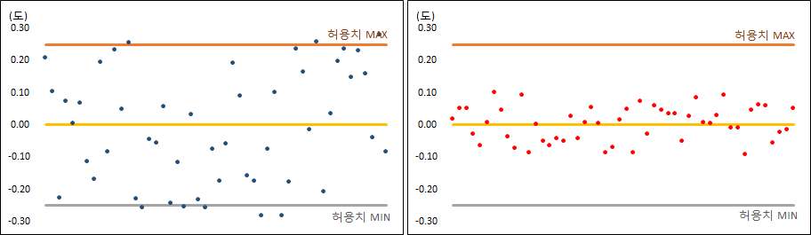
Figure 2 Comparison of ROLL measurement values before and after TILT error correction

Performance analysis results of naval gun array analysis program
As shown in [Figure 3], it is a distribution chart comparing the measured values of the TILT error value after the initial measurement (before correction) and the error value after the first measurement (after correction).The distributions before the calibration are mostly within the allowable reference range, but the standard deviation at the 0 ° standard is 72% of the measured ROLL. After the calibration, the ROLL measurement value was 22% and the improvement was about 70%.

Conclusion and Future Research
Gun Arrangement Analysis Tool measures the mechanical and electrical gradients of guns and sensors by installing an array camera on the gun arsenal that is needed for arming arrangements. The correction values calculated by the analysis tool are then designed to compensate the fire control system and minimize the resulting values (error values).
However, in the case of the analysis tool proposed in this paper, there is a problem that a lot of manpower is required in the installation process since it is a wired method. Future research will need to complement the wired system to minimize the manpower.

Acknowledgment
"This work was supported by Priority Research Centers Program through the National Research Foundation of Korea(NRF) funded by the Ministry of Education, Science and Technology”(2018R1A6A1A030240

References

.
- Eui-Jin Kim, “Naval Gun Fire Control System Simulation for Verification Depending on Development Phase”, Journal of the Korea Society for Simulation Technology, Vol. 20, no. 2, pp. 41-48, 2011
- Jane's Fighting Ships, "Ulsan Class(FFG)", Jane's Information Group, Mar, 14, 2005.
- Junfei Xu, Hangyu Wang, Liang Cao, Faxing Lu, “Approach for Combat Capability Requirement Generation and Evaluation of New Naval Gun”, Proceedings of the 36th Chinese Control Conference, Dalian, China, July. 2017
- Mun-Gwan Choi, In-Kyu Park andWeon-Cheol Koo, “Numerical Prediction of Slamming Impact Loads and Response on a Ship in Waves Considering Relative Vertical Velocity,” Journal of the Society of Naval Architects of Korea, vol. 51, no. 6, pp. 503-509, 2014

