1.Logging into Suite CRM
2.Suite CRM Sales
It has 4 tabs
- Home
- Accounts
- Contacts
- Opportunities
- Leads
Home Page :
The home page is the first page that is displayed to you post-authentication. The home page has various elements that can be used and configured such as Dashlets, Dashboards and the Sidebar.
Dashlets :
Dashlets are user-configurable sections displayed on the home page that give you a quick overview of your records and activity immediately after login. This is particularly useful for sales and support led teams as this reduces the number of clicks required to view/modify data.
Dashlets can be dragged/dropped within the home page. You can add dashlets by clicking the 'Add Dashlets' link on the home page.

Add Dashlets :
Clicking on the 'Add Dashlets' link on the home page will open up the Add Dashlets popup which allows users to select from a multitude of out of the box dashlets.

You can modify dashlets by clicking the pencil icon on the desired dashlet.

Dashboards
Dashboards are new in SuiteCRM. These are configurable per user and can be added/removed similar to dashlets. To add a dashboard tab, you can click the 'Add Tab' link on the homepage.
Clicking on the 'Add Tab' link on the home page will open up the Add Tab popup which allows users to specify a name for the tab and also how many dashlet columns are required. You can opt for one, two or three columns.
Once you have specified the details for the dashboard tab, you can click 'Save'. You can also click 'Cancel' to undo any changes. Once you have saved your changes, the Dashboard Tab will be added and will display on the tab list on user Homepage. You can then add Dashlets to your new dashboard tab.

Activity Stream
The Activity Stream is an excellent way of keeping track of your colleague's interactions with SuiteCRM. By default the Activity Stream displays recent updates for the Opportunities, Contacts, Leads and Cases modules. Your organisation's Facebook and Twitter feeds can also be included in your Activity Steam dashlets if desired and this can be configurable by an Admin user.

Search
Searching is a vital aspect within the CRM as this allows you to quickly define what it is you want to see. Many CRM's will have large data sets so it is vital to you that you have a way to refine your search. In the following sub-sections we will cover the various searching options available to you.

Full Text Search
SuiteCRM has an option to enable or disable a full text global search. The search works very similar to the standard global search, but provides the enhanced functionality of searching text in documents and other files, compared to the record-level search provided by the standard global search.

Edit View
This is the view that you are presented with when you edit a record.
The Edit View allows you to modify record information that is displayed on the view. This allows users to update existing data and also add/remove data. Once you have made changes on the Edit View, you can click 'Save' to apply to changes or click 'Cancel'. Clicking either options will redirect you to the Detail View of the record you are editing. You can click the 'View Change Log' button. This allows users to view changes to audited fields which can be useful before making your intended changes

Record Management
We have covered the several views that you are presented with so we will now move onto record management. In this section we will cover all areas of record management so that you can efficiently store and manage customer data.

Creating Records
You can create records within modules from various different areas of your Interface. Detailed below are screen shots of record creation points.
This allows you to fill in the appropriate data for that record. Fields with the red star(*) are required fields. Validation is performed so that a record cannot be saved within the CRM unless data is valid for required fields.

Editing Records
You can edit records within modules from various different areas of your Interface. Detailed below are screen shots of record editing points.

Deleting Records
You can delete records within modules from both the List View and Detail View. Detailed below are screen shots of record editing points:
Detail View Deletion method
Deleting records from the Detail View is a simple process. You simply have to click the 'Delete' button.

List View Deletion method
To delete records from the List View, you can select records using the checkbox option on the left hand side of the view. It is possible to select single records or use the 'Select this Page' or 'Select All' options, to select all records from the page or all records within the module.
Once the records are selected to delete, you can click the 'Delete' button. When you click the delete button on a record, you will receive a popup which will display the number of records being deleted and ask you to confirm that you want to delete the record.

Mass Updating Records
You can mass update records from the List View of any module, given this option is made available to you. To mass update records, you have to check the records in the List View and then select the 'Mass Update' option from the dropdown menu (next to the delete link).

Merging Records
You can merge records from the List View of any module, given this option is made available to you, or via the Detail View if you follow the 'Find Duplicates' process.
To merge records, you have to check the records in the List View and then select the 'Merge' option from the dropdown menu (next to the delete link).
Importing Records
It is possible to import data easily by using SuiteCRM's easy-to-use User Import Wizard. There are many hints and tips as you progress through the Import Wizard on the requirements of importing data and for further steps in the Wizard.
User Import Wizard features
There are many features of the Import Wizard which make it easier for you to map data to CRM fields and also for future imports. These are:
- Sample .csv file for easier import of data — Use the available sample .csv file as a template for import of files
- Retain settings from previous imports — Save/preserve import file properties, mappings, and duplicate check indexes from previous imports for ease of current data import process
- Ability to accept both database name and display labels of drop-down and multi-select field items — Field labels as well as database names are accepted and mapped during import, but only the field labels are displayed for ease of use
- Ability to accept both usernames and full names in user fields during import and export of data — Full names of Users displayed for Assigned To and other User-related fields in exported .csv file for easier identification of user records
- Ability to auto-detect file properties in import file — Upload import files without specifying file properties such as tab, comma, double and single quotes, date and time formats, making the process simpler and faster
- Ability to import contacts from external sources such as Google — Ability to import Google Contacts for person-type modules such as Contacts, Leads, and Targets, relate SuiteCRM records to Google Contacts, and communicate with Google Contacts from within SuiteCRM
Steps to Import data
Note: Always import the Account data first and then import Contacts and other data related to Accounts (such as Meetings, Calls, Notes) to automatically create a relationship between the imported Account and Contacts and activity records related to the Account.
Follow the steps listed below to import data for a module, such as Accounts:
- Select Import from the Actions drop-down list in the module menu options.
- This displays Step 1 of the import process with a link to a sample Import File Template.
- Upload your import file to this page using the Browse button in the Select File field or,
- Optionally, download the available template, delete the existing data, input your data and upload to this page using the Browse button.
- Click Next.
- This displays Step 2 (Confirm Import File Properties).
- Auto-detection of imported data takes place at this step.
- Click View Import File Properties button to verify and change the data as needed, if you notice irregularities in the Confirm Import File Properties table.
- Click the Hide Import File Properties to collapse the panel.
- Click Next.
- This displays Step 3: Confirm Field Mappings.
- The table in this page displays all the fields in the module that can be mapped to the data in the import file. If the file contains a header row, the columns in the file map to matching fields.
- Check for correct mapping and modify if necessary.
- Map to all of the required fields (indicated by an asterisk).
- Click Next.
- This displays Step 4: Check for Possible Duplicates.
- Follow the instructions on this page.
- Step 4 also provides the option of saving the current import file properties, mappings, and duplicate check indexes for future imports.
- (Optionally) Save the import settings.
- Click Import Now.
- Click the Errors tab to check for errors in the process. Follow the instructions to fix problems (if any) and Click Import Again.
- This displays Step 1 of the import process.
- Follow all the steps in the wizard through Step 5.
- If the import was successful, you can to view all the imported records at Step 5.
- Click Undo Import if you are not satisfied with the imported records,
- Or, click Import Again to import more data
- Or, click Exit to navigate to the List View page of the module that you imported your records into.
Exporting Records
You can export SuiteCRM records in .csv format. When you exports records from the CRM, you will be provided with the .csv file to download when the export has finished executing. You can save and open this file in applications such as Libre Office Calc or Microsoft Office Excel.
The .csv file displays in a tabular format with columns and rows. When data is exported from the CRM, the record ID is included with all other fields that are specified in the export list for that module. You can then use the record ID as a reference for performing a 'Create new records and update existing records' import, as detailed in the Importing Records section of the user guide.
Note: When exporting values from drop-down lists, SuiteCRM exports the ID associated with each option and not the display labels. For example, if a drop down list has options labelled High, Medium and Low with an ID of 1, 2 and 3 – the .csv file will show the drop down options as 1, 2 or 3.
Steps to Export Records
- Select the records from the List View on the module's home page.
- Select Export from the Actions drop-down menu in the List View.
- To export all records listed on the page, click Select located above the item list and select one of the following options:
- This Page. To export all the records listed on the page, select this option.
- All Records. To export all records on the list (if it is more than a page long), select this option.
- This displays an Opening.csv dialog box.
- Select Open to open the export file in .csv format or select Save to Disk to save the .csv file to your local machine.
- Click OK to execute the operation. If you chose to open the file, the csv file opens in Microsoft Excel.
- The file contains all the fields in the module from which you are exporting the data.

In-line Editing
In-line editing gives you the ability to change values “on the fly”. In-line editing has been implemented on both List View and Detail View, providing an advantage to users wishing to change field values quickly, reducing the number of clicks/processes that would normally be taken to edit the full record.
Note: In-line editing can be enabled/disabled for both List View and Detail View. This can be done in the main System Settings for the CRM, by the System Administrator.

List View In-line Editing
You can edit record information on the List View of a module using in-line editing by clicking on a field where the pencil icon is shown.
Detail View In-line Editing
Similar to List View, you can edit record information on the Detail View of a module using in-line editing by clicking on a field where the pencil icon is shown.
Enabling Desktop Notifications
You can enable desktop notifications by accessing the 'Advanced' tab within your user preferences. This will enable desktop notifications only for that browser on that computer. you can choose to enable the desktop notifications just for that browser session, or to always enable desktop notifications.
Note: Users will have to enable desktop notifications on all browsers and computers if you use more than one.
Managing Desktop Notifications
If you have no notifications, the notification count will show '0' to tell you you currently have no notifications to check.
If you do not click on a desktop notification when it is displayed in the browser, for example you are AFK(Away From Keyboard) your notifications will be added to the notification list which shows as a count on the main navigation bar.
You can manage your desktop notifications by clicking the icon which will show any existing notifications.
You can either click the notification which will take you to the record the notification is related to or you can click the small 'x' icon to clear you immediately.

Core Modules
Accounts
The Accounts module is the centralised base from which you can create an association with most records in SuiteCRM. It is possible to create a relationship with Contacts, Converted Leads, Opportunities, any Activity such as Emails or Meetings and Cases. Accounts in SuiteCRM will typically hold all information specific to a company that your organisation will have a relationship with. In real world terms an Account may be a business entity that is a qualified Sales Prospect, Customer, Supplier or Re-seller and can be used to track all interactions that take place between these entities and your organisation.
Accounts Actions
You can access the accounts actions from the Accounts module menu drop down or via the Sidebar. The Accounts actions are as follows:
- Create Account – Once clicked, a new form is opened in Edit View to allow you to create a new Account record.
- View Accounts – Once clicked, you will be redirected to the List View for the Accounts module. This allows you to search and list Accounts records.
- Import Accounts –
Managing Accounts
- To sort records on the Accounts List View, click any column title which is sortable. This will sort the column either ascending or descending.
- To duplicate a Account, you can click the Duplicate button on the Detail View and then save the duplicate record.
- To view the details of a Account, click the Account Name in the List View. This will open the record in Detail View.
- To edit the Account details, click Edit icon within the List View or click the edit button on the Detail View, make the necessary changes, and click Save.
- To track all changes to audited fields, in the Account record, you can click the View Change Log button on the Account's Detail View or Edit View.
Contacts
In SuiteCRM a Contact is an individual who is typically associated with an Account (organisation) or Opportunity (qualified prospect). For example if Techco is the Account, then John Smith, Sales Manager of Techco is the Contact. This module holds all information relating to these individuals and also provides a vantage point for any history relating to a Contact record, for example if they were involved in a Meeting, raised a Case or sent an Email.
Contacts Actions
You can access the Contacts actions from the Contacts module menu drop down or via the Sidebar. The Contacts actions are as follows:
- Create Contact – A new form is opened in Edit View to allow you to create a new Contact record.
- View Contacts – Redirects you to the List View for the Contacts module. This allows you to search and list Contact records.

Managing Contacts
- To sort records on the Contacts List View, click any column title which is sortable. This will sort the column either ascending or descending.

- To duplicate a Contact, you can click the Duplicate button on the Detail View and then save the duplicate record.
- To view the details of a Contact, click the Contact Name in the List View. This will open the record in Detail View.
- To edit the Contact details, click Edit icon within the List View or click the edit button on the Detail View, make the necessary changes, and click Save.
- To track all changes to audited fields, in the Contact record, you can click the View Change Log button on the Contact's Detail View or Edit View.
Contacts
In SuiteCRM a Contact is an individual who is typically associated with an Account (organisation) or Opportunity (qualified prospect). For example if Techco is the Account, then John Smith, Sales Manager of Techco is the Contact. This module holds all information relating to these individuals and also provides a vantage point for any history relating to a Contact record, for example if they were involved in a Meeting, raised a Case or sent an Email.
Contacts Actions
You can access the Contacts actions from the Contacts module menu drop down or via the Sidebar. The Contacts actions are as follows:
- Create Contact – A new form is opened in Edit View to allow you to create a new Contact record.
- View Contacts – Redirects you to the List View for the Contacts module. This allows you to search and list Contact records.
- Import Contacts – Redirects you to the Import Wizard for the Contacts module. For more information, see Importing Records.
To view the full list of fields available when creating an Contact, See Contacts Field List.
Managing Contacts
- To sort records on the Contacts List View, click any column title which is sortable. This will sort the column either ascending or descending.
- To search for a Contact, see the Search section of this user guide.
- To update some or all the Contacts on the List View, use the Mass Update panel as described in the Mass Updating Records section of this user guide.
- To duplicate a Contact, you can click the Duplicate button on the Detail View and then save the duplicate record.
- To merge duplicate Contacts, select the records from the Contacts List View, click the Merge link in the Actions drop-down list, and progress through the merge process. For more information on Merging Duplicates, see the Merging Records section of this user guide.
- To delete one or multiple Contacts, you can select multiple records from the List View and click delete. You can also delete a Contact from the Detail View by clicking the Delete button. For a more detailed guide on deleting records, see the Deleting Records section of this user guide.
- To view the details of a Contact, click the Contact Name in the List View. This will open the record in Detail View.
- To edit the Contact details, click Edit icon within the List View or click the edit button on the Detail View, make the necessary changes, and click Save.
- For a detailed guide on importing and exporting Contacts, see the Importing Records and Exporting Records sections of this user guide.
- To track all changes to audited fields, in the Contact record, you can click the View Change Log button on the Contact's Detail View or Edit View.
Opportunities
An Opportunity is a qualified Sales prospect with a likely chance that they will be able to do business with your company. You have established that they have buying power and have entered into the buying cycle. This module allows you to track your Opportunities throughout the Sales Pipeline until the deal is 'Closed Lost or 'Closed Won'.
Opportunities Actions
You can access the Opportunities actions from the Opportunities module menu drop down or via the Sidebar. The Opportunities actions are as follows:
- Create Opportunity – A new form is opened in Edit View to allow you to create a new Account record.
- View Opportunities – Redirects you to the List View for the Opportunities module. This allows you to search and list Opportunity records.
- Import Opportunities – Redirects you to the Import Wizard for the Opportunities module. For more information, see Importing Records.
To view the full list of fields available when creating an Opportunity, See Opportunities Field List.
Managing Opportunities
- To sort records on the Opportunities List View, click any column title which is sortable. This will sort the column either ascending or descending.
- To search for a Opportunity, see the Search section of this user guide.
- To update some or all the Opportunities on the List View, use the Mass Update panel as described in the Mass Updating Records section of this user guide.
- To duplicate a Opportunity, you can click the Duplicate button on the Detail View and then save the duplicate record.
- To merge duplicate Opportunities, select the records from the Opportunities List View, click the Merge link in the Actions drop-down list, and progress through the merge process. For more information on Merging Duplicates, see thevMerging Records section of this user guide.
- To delete one or multiple Opportunities, you can select multiple records from the List View and click delete. You can also delete a Opportunity from the Detail View by clicking the delete button. For a more detailed guide on deleting records, see the Deleting Records section of this user guide.
- To view the details of a Opportunity, click the Opportunity Name in the List View. This will open the record in Detail View.
- To edit the Opportunity details, click the Edit icon within the List View or click the edit button on the Detail View, make the necessary changes, and click Save.
- For a detailed guide on importing and exporting Opportunities, see the Importing Records and Exporting Records sections of this user guide.
- To track all changes to audited fields, in the Opportunity record, you can click the View Change Log button on the Opportunities Detail View or Edit View.
Opportunities
An Opportunity is a qualified Sales prospect with a likely chance that they will be able to do business with your company. You have established that they have buying power and have entered into the buying cycle. This module allows you to track your Opportunities throughout the Sales Pipeline until the deal is 'Closed Lost or 'Closed Won'.
Opportunities Actions
You can access the Opportunities actions from the Opportunities module menu drop down or via the Sidebar. The Opportunities actions are as follows:
- Create Opportunity – A new form is opened in Edit View to allow you to create a new Account record.
- View Opportunities – Redirects you to the List View for the Opportunities module. This allows you to search and list Opportunity records.
- Import Opportunities – Redirects you to the Import Wizard for the Opportunities module. For more information, see Importing Records.
To view the full list of fields available when creating an Opportunity, See Opportunities Field List.
Managing Opportunities
- To sort records on the Opportunities List View, click any column title which is sortable. This will sort the column either ascending or descending.
- To search for a Opportunity, see the Search section of this user guide.
- To update some or all the Opportunities on the List View, use the Mass Update panel as described in the Mass Updating Records section of this user guide.
- To duplicate a Opportunity, you can click the Duplicate button on the Detail View and then save the duplicate record.
- To merge duplicate Opportunities, select the records from the Opportunities List View, click the Merge link in the Actions drop-down list, and progress through the merge process. For more information on Merging Duplicates, see theMerging Records section of this user guide.
- To delete one or multiple Opportunities, you can select multiple records from the List View and click delete. You can also delete a Opportunity from the Detail View by clicking the delete button. For a more detailed guide on deleting records, see the Deleting Records section of this user guide.
- To view the details of a Opportunity, click the Opportunity Name in the List View. This will open the record in Detail View.
- To edit the Opportunity details, click the Edit icon within the List View or click the edit button on the Detail View, make the necessary changes, and click Save.
- For a detailed guide on importing and exporting Opportunities, see the Importing Records and Exporting Records sections of this user guide.
- To track all changes to audited fields, in the Opportunity record, you can click the View Change Log button on the Opportunities Detail View or Edit View.
Leads
In SuiteCRM a Lead is an unqualified contact usually generated from some form of marketing related event, for example it could be a person that has filled out a form on your website or someone that you met at a trade show and you are not sure yet if they have buying authority. Once a Lead is qualified and converted then it can be split into three parts; a Contact once you have established 'Who' it is, an Account when you know 'Where' they work and an Opportunity once it is known 'What' they might buy.
Leads Actions
You can access the Leads actions from the Leads module menu drop down or via the Sidebar. The Leads actions are as follows:
- Create Lead – A new form is opened in Edit View to allow you to create a new Account record.
- View Leads – Redirects you to the List View for the Leads module. This allows you to search and list Lead records.
- Import Leads – Redirects you to the Import Wizard for the Leads module. For more information, see Importing Records.
To view the full list of fields available when creating a Lead, See Leads Field List.
Managing Leads
- To sort records on the Leads List View, click any column title which is sortable. This will sort the column either ascending or descending.
- To search for a Leads, see the Search section of this user guide.
- To update some or all the Leads on the List View, use the Mass Update panel as described in the Mass Updating Records section of this user guide.
- To duplicate a Lead, you can click the Duplicate button on the Detail View and then save the duplicate record.
- To merge duplicate Leads, select the records from the Leads List View, click the Merge link in the Actions drop-down list, and progress through the merge process. For more information on Merging Duplicates, see the Merging Records section of this user guide.
- To delete one or multiple Leads, you can select multiple records from the List View and click delete. you can also delete a Lead from the Detail View by clicking the Delete button. For a more detailed guide on deleting records, see theDeleting Records s ection of this user guide.
- To view the details of a Lead, click the Lead Name in the List View. This will open the record in Detail View.
- To edit the Lead details, click Edit icon within the List View or click the edit button on the Detail View, make the necessary changes, and click Save.
- For a detailed guide on importing and exporting Leads, see the Importing Records and Exporting Records sections of this user guide.
- To track all changes to audited fields, in the Lead record, you can click the View Change Log button on the Lead Detail View or Edit View.
Converting a Lead
Once enough information is gathered about a Lead, then the Lead can be progressed to the next Sales stage and the Lead can be converted into a Contact, Account and Opportunity. The way in which a Lead is converted depends on how the System Administrator has set up SuiteCRM. To convert a Lead with the default SuiteCRM setup you have to click on an individual Lead record to access the Detail View of the Lead and click on the arrow next to the Edit button, then click on 'Convert Lead' from the drop-down menu shown in the image below:
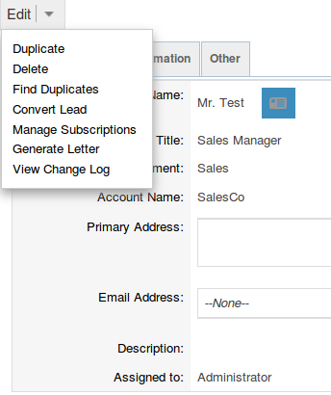
Convert Lead to Contact
On this page you will be able to Create or Select Contact:
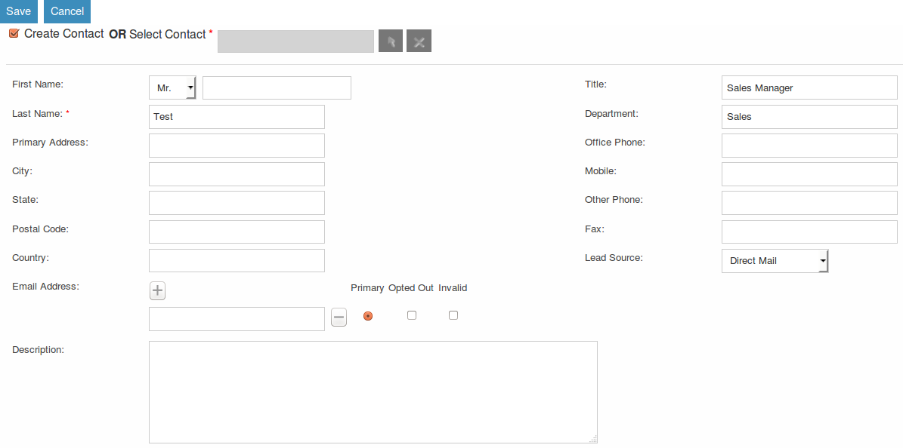
By deselecting the checkbox next to 'Create Contact' you will be able to associate the Lead to an existing Contact. However, in most cases when converting a Lead there will be no existing Contact. Make sure the Create Contact checkbox is selected. Some of the fields will automatically be populated using the Lead information. Fill out the remaining relevant fields and move to the next Stage below:

Convert Lead to Account
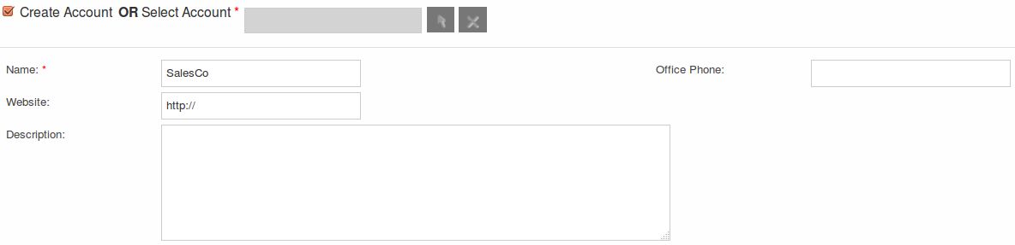
To create an Account from a converted Lead you will follow the same process as with a Contact, some information will populate from the Lead automatically, just complete the rest.

Convert Lead to Opportunity
Other Lead Conversion Options
Other records can be created when converting a Lead in the same way as Contacts/Accounts and Opportunities.
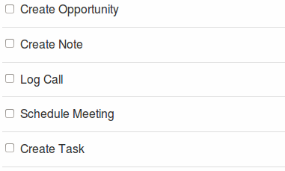
After you have completed the relevant sections click the Save button to confirm the changes.
Duplicate Record Check
When converting a Lead SuiteCRM will automatically check for any duplicate records and will return a warning if a matching record is found

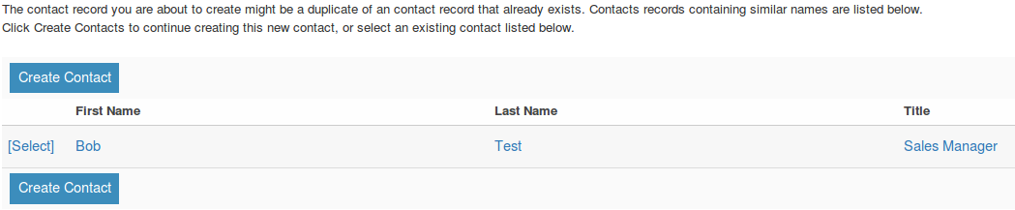
If you find that the duplicate warning is not valid and you still wish to create a new record, then click the Create button. Otherwise if you decide that the warning is correct and the record does already exist in the CRM then you should click on the Select button.
Calendar
The Calendar module in SuiteCRM allows you to manage your time by scheduling Meetings, Calls and Tasks. Users may share their Calendar so they can allow others to view their upcoming activities. These activities will be displayed in the Calendar module given that the User concerned is a participant or the task has been assigned to them.
Calendar Actions
You can access the Calendar actions from the Calendar module menu drop down or via the Sidebar. The Calendar actions are as follows:
- Schedule Meetings – A new form is opened in the Edit View of the Meetings module to allow you to create a new Meeting record. This record will display on the Calendar.
- Schedule Calls – A new form is opened in the Edit View of the Call module to allow you to create a new Call record. This record will display on the Calendar.
- Create Task – A new form is opened in the Edit View of the Tasks module to allow you to create a new Task record. This record will display on the Calendar.
- Today – Redirects you to the Day format of the Calendar for the current day.
Calls
The Calls module in SuiteCRM allows Users to schedule and log a record of inbound and outbound calls that they may be a participant of.
Calls Actions
You can access the Calls actions from the Calls module menu drop down or via the Sidebar. The Calls actions are as follows:
- Log Call – A new form is opened in Edit View to allow you to create a new Call record.
- View Calls – Redirects you to the List View for the Calls module. This allows you to search and list Call records.
- Import Calls – Redirects you to the Import Wizard for the Calls module. For more information, see Importing Records.
To view the full list of fields available when logging a Call, See Calls Field List.
Managing Calls
- To sort records on the Calls List View, click any column title which is sortable. This will sort the column either ascending or descending.
- To search for a Call, see the Search section of this user guide.
- To update some or all of the Calls on the List View, use the Mass Update panel as described in the Mass Updating Records section of this user guide.
- To duplicate a Call, you can click the Duplicate button on the Detail View and then save the duplicate record.
- To close a Call, click on the 'x' icon on the Calls List View. You can also close a Call by clicking the Close button on the Detail View of a Call. You can also click the Close and Create New button. This will close the Call you are viewing and redirect you to the Edit View to create a new record.
- To Reschedule a call, you can click the Reschedule button on the Detail View of a Call. For a detailed guide on rescheduling calls, see the Reschedule section of this user guide.
- To delete one or multiple Calls, you can select multiple records from the List View and click delete. You can also delete a Call from the Detail View by clicking the Delete button. For a more detailed guide on deleting records, see the Deleting Records section of this user guide.
- To view the details of a Call, click the Call Subject in the List View. This will open the record in Detail View.
- To edit the Call details, click Edit icon within the List View or click the edit button on the Detail View, make the necessary changes, and click Save.
- For a detailed guide on importing and exporting Calls, see the Importing Records and Exporting Records sections of this user guide.
- To track all changes to audited fields, in the Call record, you can click the View Change Log button on the Call Detail View or Edit View.
Meetings
Like the Calls module, the Meetings module in SuiteCRM allows Users to create a record of any Meeting that they have been involved in. The Meeting scheduler allows a User to invite attendees, email invitees, set reminders, reschedule and relate to other modules including an Account, Contact, Project and many other Objects. This module has many more helpful functions that assist the User to plan and organise their Meetings.
Meetings Actions
You can access the Meetings actions from the Meetings module menu drop down or via the Sidebar. The Meetings actions are as follows:
- Schedule Meeting – A new form is opened in Edit View to allow you to create a new Meeting record.
- View Meetings – Redirects you to the List View for the Meetings module. This allows you to search and list Meeting records.
- Import Meetings – Redirects you to the Import Wizard for the Meetings module. For more information.
To view the full list of fields available when creating scheduling a Meeting.
Managing Meetings
- To sort records on the Meetings List View, click any column title which is sortable. This will sort the column either ascending or descending.
- To search for a Meeting, see the Search section of this user guide.
- To update some or all of the Meetings on the List View, use the Mass Update panel as described in the Mass Updating Records section of this user guide.
- To duplicate a Meeting, you can click the Duplicate button on the Detail View and then save the duplicate record.
- To close a Meeting, click on the 'x' icon on the Meetings List View. You can also close a Meeting by clicking the Close button on the Detail View of a Meeting. You can also click the Close and Create New button. This will close the Meeting you are viewing and redirect you to the Edit View to create a new record.
- To Reschedule a Meeting, you can click the Reschedule button on the Detail View of a Meeting. For a detailed guide on rescheduling Meetings, see the Reschedule section of this user guide.
- To delete one or multiple Meetings, you can select multiple records from the List View and click delete. You can also delete a Meeting from the Detail View by clicking the Delete button. For a more detailed guide on deleting records, see the Deleting Records section of this user guide.
- To view the details of a Meeting, click the Meeting Subject in the List View. This will open the record in Detail View.
- To edit the Meeting details, click the Edit icon within the List View or click the edit button on the Detail View, make the necessary changes, and click Save.
- For a detailed guide on importing and exporting Meeting, see the Import and Export Importing Records and Exporting Records sections of this user guide.
- To track all changes to audited fields, in the Meeting record, you can click the View Change Log button on the Meeting's Detail View or Edit View.
Emails
The Emails module in SuiteCRM allows Users to view, store, compose, send and receive email from their own personal Email account or a shared inbox, for example a Support or Sales inbox. Emails can be related to Accounts, Cases, Contacts and many more records in the CRM.
Emails Actions
You can access the Emails actions from the Emails module menu drop down or via the Sidebar. The Emails actions are as follows:
- View My Email – Redirects you to your mailbox so that you can view and manage emails displayed/imported to the CRM.
- Create Email Template - A WYSIWYG editor where you can create Emails by dragging and dropping components, inserting variables and amending the plain text.
- View Email Templates - Takes you to the List View page of your existing Email Templates. This allows you to search and list Email Template records.
To view the full list of fields available for the Emails module, See Emails Field List.
Tasks
SuiteCRM can assist Users with productivity, offering a way to record, relate and assign Tasks and to-do items that require action.
Tasks Actions
You can access the Tasks actions from the Tasks module menu drop down or via the Sidebar. The Tasks actions are as follows:
- Create Task – A new form is opened in Edit View to allow you to create a new Task record.
- View Tasks – Redirects you to the List View for the Tasks module. This allows you to search and list Task records.
- Import Tasks – Redirects you to the Import Wizard for the Tasks module. For more information,
To view the full list of fields available when creating a Task,
Managing Tasks
- To sort records on the Tasks List View, click any column title which is sortable. This will sort the column either ascending or descending.
- To search for a Task, see the Search section of this user guide.
- To update some or all of the Task on the List View, use the Mass Update panel as described in the Mass Updating Records section of this user guide.
- To duplicate a Task, you can click the Duplicate button on the Detail View and then save the duplicate record.
- To close a Task, click on the 'x' icon on the Tasks List View. You can also close a Meeting by clicking the Close button on the Detail View of a Task. You can also click the Close and Create New button. This will close the Task you are viewing and redirect you to the Edit View to create a new record.
- To delete one or multiple Tasks, you can select multiple records from the List View and click delete. You can also delete a Task from the Detail View by clicking the Delete button. For a more detailed guide on deleting records, see the Deleting Records section of this user guide.
- To view the details of a Task, click the Meeting Subject in the List View. This will open the record in Detail View.
- To edit the Task details, click Edit icon within the List View or click the edit button on the Detail View, make the necessary changes, and click Save.
- For a detailed guide on importing and exporting Tasks, see the Importing Records and Exporting Records sections of this user guide.
- To track all changes to audited fields, in the Task record, you can click the View Change Log button on the Task's Detail View or Edit View.
Notes
The Notes module in SuiteCRM can be used to keep a record of any comments, observations or explanations that a User may have relating internally to their organisation or relating to another SuiteCRM record such as an Account, Contact, Lead or many more. Notes are also used to keep record of interactions with Customers regarding Cases and Bugs.

Notes Actions
You can access the Notes actions from the Notes module menu drop down or via the Sidebar. The Notes actions are as follows:
- Create Note or Attachment – A new form is opened in Edit View to allow you to create a new Note record (with attachment).
- View Notes – Redirects you to the List View for the Notes module. This allows you to search and list Note records.
- Import Notes – Redirects you will be taken to the Import Wizard for the Notes module. For more information .
To view the full list of fields available when creating a Note .

Managing Notes
- To sort records on the Notes List View, click any column title which is sortable. This will sort the column either ascending or descending.
- To search for a Note, see the Search section of this user guide.
- To update some or all the Notes on the List View, use the Mass Update panel as described in the Mass Updating Records section of this user guide.
- To duplicate a Note, you can click the Duplicate button on the Detail View and then save the duplicate record.
- To delete one or multiple Notes, you can select multiple records from the List View and click delete. You can also delete a Note from the Detail View by clicking the Delete button. For a more detailed guide on deleting records, see the Deleting Records section of this user guide.
- To view the details of a Note, click the Note Subject in the List View. This will open the record in Detail View.
- To edit the Note details, click Edit icon within the List View or click the edit button on the Detail View, make the necessary changes, and click Save.
- For a detailed guide on importing and exporting Notes, see the Importing Records and Exporting Records sections of this user guide.
- To track all changes to audited fields, in the Note record, you can click the View Change Log button on the Note's Detail View or Edit View.
Documents
The Documents module can be used as a repository for Customer issued or internal files. This content can be uploaded, revised and viewed in addition to relating to individual records within SuiteCRM.

Documents Actions
You can access the Documents actions from the Documents module menu drop down or via the Sidebar. The Documents actions are as follows:
- Create Document – A new form is opened in Edit View to allow you to create a new Document record.
- View Documents – Redirects you to the List View for the Documents module. This allows you to search and list Document records.
To view the full list of fields available when creating a Document, See Documents Field List.

Managing Documents
- To sort records on the Documents List View, click any column title which is sortable. This will sort the column either ascending or descending.
- To search for a Document, see the Search section of this user guide.
- To update some or all the Documents on the List View, use the Mass Update panel as described in the Mass Updating Records section of this user guide.
- To duplicate a Document, you can click the Duplicate button on the Detail View and then save the duplicate record.
- To delete one or multiple Documents, you can select multiple records from the List View and click delete. You can also delete a Document from the Detail View by clicking the Delete button. For a more detailed guide on deleting records, see the Deleting Records section of this user guide.
- To view the details of a Document, click the Document Name in the List View. This will open the record in Detail View.
- To view an attachment, click the attachment link on the List View or Detail View of the Document. To update a document, you can create a Document Revision.
- To edit the Document details, click Edit icon within the List View or click the edit button on the Detail View, make the necessary changes, and click Save.
- For a detailed guide on importing and exporting Documents .
- To track all changes to audited fields, in the Document record, you can click the View Change Log button on the Document's Detail View or Edit View.

Targets
Typically Targets are used as the recipients of a Marketing Campaign, your organisation knows very little about these individuals and they may be re-used for new Campaigns or deleted without any impact to the business. Your organisation will spend little resources on Targets and will usually be contacted en masse. Targets can be acquired from purchased email lists or gathered from trade shows your organisation has been present. The Targets module in SuiteCRM is used to store and manage information about these individuals.
Targets Actions
You can access the Targets actions from the Targets module menu drop down or via the Sidebar. The Targets actions are as follows:
- Create Target – A new form is opened in Edit View to allow you to create a new Target record.
- View Targets – Redirects you to the List View for the Targets module. This allows you to search and list Target records.
- Import Targets – Redirects you will be taken to the Import Wizard for the Targets module. For more information, see Importing Records.
To view the full list of fields available when creating a Target,
Managing Targets
- To sort records on the Targets List View, click any column title which is sortable. This will sort the column either ascending or descending.
- To search for a Target.
- To update some or all the Targets on the List View, use the Mass Update panel as described in the Mass Updating Records section of this user guide.
- To duplicate a Target, you can click the Duplicate button on the Detail View and then save the duplicate record.
- To delete one or multiple Targets, you can select multiple records from the List View and click delete. You can also delete a Target from the Detail View by clicking the Delete button. For a more detailed guide on deleting records, see the Deleting Records section of this user guide.
- To view the details of a Target, click the Target Name in the List View. This will open the record in Detail View.
- To edit the Target details, click Edit icon within the List View or click the edit button on the Detail View, make the necessary changes, and click Save.
- For a detailed guide on importing and exporting Targets, see the Importing Records and Exporting Records sections of this user guide.
- To track all changes to audited fields, in the Target record, you can click the View Change Log button on the Target's Detail View or Edit View.
Target Lists
The Target Lists module in SuiteCRM is used to separate Targets into groups, these can be groups of individuals that should be excluded from a particular Campaign, test groups or a list of Targets grouped by certain criteria, for example area or market an organisation works in.

Target Lists Actions
You can access the Target Lists actions from the Target Lists module menu drop down or via the Sidebar. The Target Lists actions are as follows:
- Create Target List – A new form is opened in Edit View to allow you to create a new Target List record.
- View Target Lists – Redirects you to the List View for the Target Lists module. This allows you to search and list Target List records.
To view the full list of fields available when creating a Target List, See Target Lists Field List.

Managing Target Lists
- To sort records on the Target List List View, click any column title which is sortable. This will sort the column either ascending or descending.
- To search for a Target List, see the Search section of this user guide.
- To update some or all the Target Lists on the List View, use the Mass Update panel as described in the Mass Updating Records section of this user guide.
- To duplicate a Target List, you can click the Duplicate button on the Detail View and then save the duplicate record.
- To delete one or multiple Target Lists, you can select multiple records from the List View and click delete. You can also delete a Target List from the Detail View by clicking the Delete button. For a more detailed guide on deleting records, see the Deleting Records section of this user guide.
- To view the details of a Target List, click the Target List Name in the List View. This will open the record in Detail View.
- To edit the Target List details, click Edit icon within the List View or click the edit button on the Detail View, make the necessary changes, and click Save.
- For a detailed guide on importing and exporting Target Lists, see the Importing Records and Exporting Records sections of this user guide.
- To track all changes to audited fields, in the Target List, you can click the View Change Log button on the Target List's Detail View or Edit View.

Campaigns
This section is being revised and will be updated soon. Please refer to the forum for help.

Cases
In SuiteCRM Cases are used to record interactions with Customers when they ask for help or advice, for example in a Sales or Support function. A Case can be created, updated when a User is working on it, assigned to a colleague and closed when resolved. At each stage of the Case the User can track and update the incoming and outgoing conversation thread so a clear record of what has occurred is registered in the CRM. Cases can be related to individual records such as Accounts, Contacts and Bugs.

Cases Actions
You can access the Cases actions from the Cases module menu drop down or via the Sidebar. The Cases actions are as follows:
- Create Case – A new form is opened in Edit View to allow you to create a new Account record.
- View Cases – Redirects you to the List View for the Cases module. This allows you to search and list Case records.
- Import Cases – Redirects you will be taken to the Import Wizard for the Cases module. For more information, see Importing Records.
To view the full list of fields available when creating a Case, See Cases Field List.
Advanced functionality for Cases can be found in the Advanced Cases section of this User Guide.

Managing Cases
- To sort records on the Cases List View, click any column title which is sortable. This will sort the column either ascending or descending.
- To search for a Case, see the Search section of this user guide.
- To update some or all the Cases on the List View, use the Mass Update panel as described in the Mass Updating Records section of this user guide.
- To duplicate a Case, you can click the Duplicate button on the Detail View and then save the duplicate record.
- To merge duplicate Cases, select the records from the Cases List View, click the Merge link in the Actions drop-down list, and progress through the merge process. For more information on Merging Duplicates, see the Merging Records section of this user guide.
- To delete one or multiple Cases, you can select multiple records from the List View and click delete. You can also delete a Case from the Detail View by clicking the Delete button. For a more detailed guide on deleting records, see the Deleting Records section of this user guide.
- To view the details of a Cases, click the Case Subject in the List View. This will open the record in Detail View.
- To edit the Case details, click Edit icon within the List View or click the edit button on the Detail View, make the necessary changes, and click Save.
- For a detailed guide on importing and exporting Cases, see the Importing Records and Exporting Records sections of this user guide.
- To track all changes to audited fields, in the Case record, you can click the View Change Log button on the Case's Detail View or Edit View.

Projects
In SuiteCRM the Projects module allows the User to arrange their organisation's projects by tracking a number of Tasks and allocating resources. Once set up, a project can be visualised in the form of a Gantt chart or using the project grid.

Projects Actions

You can access the Projects actions from the Projects module menu drop down or via the Sidebar once you have clicked to view the module. The Projects actions are as follows:
- Create Project – A new form is opened in Edit View to allow you to create a new Project record.
- View Project – Redirects you to the List View for the Projects module. This allows you to search and list Project records.
- View Project Tasks – Allows you to list Project Tasks, which are related to a parent Project.
- Import Project – Redirects you to the Import Wizard for the Projects module. For more information.
To view the full list of fields available when creating a Project.

Creating Projects

In the Projects module, you can create, manage, and duplicate Projects and Project Tasks.
You can define multiple Project Tasks for each Project. When you create a Project Task, you must associate it with a Project. You can associate a Project with multiple activities, Accounts, Opportunities, and Cases. You can also create Projects and Project Tasks from an Email’s detail page.
- In the Actions bar, click Create Project.
- On the Projects page, enter information for the following fields:
  - Name. Enter a name for the Project.
  - Status. From the drop-down list, select the Project status such as Draft, In Review, or Published.
  - Start Date. Click the Calendar icon and select the Project start date.
  - End Date. Click the Calendar icon and select the Project end date.
  - Assigned to. Enter the name of you who has ownership of the Project. By default, it is assigned to you.
  - Priority. From the drop-down list, select the importance of the Project such as Low, Medium, or High.
  - Description. Enter a brief description of the Project.
- Click Save to create the Project; click Cancel to exit the page without creating the Project.
When you save the Project, the Project’s detail page displays on the page.
From this page, you can relate the Project to records such as Contacts and Opportunities.

Creating Project Tasks

- In the Project Tasks sub-panel, click Create.
- On the Project Tasks page, enter information for the following fields:
  - Name. Enter a name for the task.
  - Task ID. Enter a numerical value as the task identification number.
  - Start Date. Click the Calendar icon and select the date when the task is due to begin.
  - Finish Date. Click the Calendar icon and select a date when the task is due to be completed; enter the start time in the adjoining field.
  - Percentage Complete. Enter a numerical value to indicate what percentage of the task has been completed.
  - Priority. From the drop-down list, select a priority level that reflects the importance of completing this task.
  - Milestone. Check this box if the completion on this task is considered a milestone for project completion.
  - Project Name. Click Select and choose the project associated with the task.
  - Description. Enter a brief description of the task.
- Click Save to create the task; click Cancel to return to the project detail page without creating the task.

Managing Projects and Project Tasks
- To sort the List View on the Projects and Project Tasks list view, click any column title which is sortable. This will sort the column either ascending or descending.
- To search for a Project or Project task, see the Search section of this user guide.
- To update some or all the Projects or Project Tasks on the List View, use the Mass Update panel as described in th Mass Updating Records section of this user guide.
- To duplicate a Project, you can click the Duplicate button on the Detail View and then save the duplicate record.
- To delete one or multiple Projects, you can select multiple records from the List View and click delete. You can also delete a Project from the Detail View by clicking the Delete button. For a more detailed guide on deleting records, see the Deleting Records section of this user guide.
- To view the details of a Project or Project Task, click the Project or Project Task Name in the List View. This will open the record in Detail View.
- To edit the Project or Project Task details, click Edit icon within the List View or click the edit button on the Detail View, make the necessary changes, and click Save.
- For a detailed guide on importing and exporting Projects and Project Tasks, see the Importing Records and Exporting Records sections of this user guide.
- To track all changes to audited fields, in the Project or Project Task record, you can click the View Change Log button on the Project's or Project Task's Detail View or Edit View.

Summary
In this chapter we have covered the functionality of the core modules. These modules allow the user to define and refine sales processes, with the ability to record data in detail within the required module.
In the next chapter, we will cover the advanced modules within SuiteCRM. These modules allow the user to manage further sales processes, create automated workflows, design reports and more.
Advanced Modules
By now, you should have a fundamental understanding of the SuiteCRM user interface, basic modules, layouts, creating, searching and managing records.
The next section of this User Guide covers in detail the Advanced CRM modules. SuiteCRM has Advanced CRM modules which allow Users to further enhance your Sales Force Automation Capabilities and improve business processes.

Advanced Open Sales
The first 'Suite' of advanced modules is AOS(Advanced Open Sales). The various modules that are part of the AOS suite of modules allow you to manage the Post-Opportunity Sales processes such as Quoting, Invoicing and recurring Contracting. This functionality is made available to you through the following modules:

- Product Categories
- Products
- PDF Templates
- Quotations
- Invoices
- Contracts
AOS Settings
System Administrator users can alter the settings for AOS using the AOS Settings page under the Advanced OpenSales panel within the Admin Panel.
You can customise the following settings within the AOS Settings:

- Renewal Reminder Period – This defines how many days before the Contract End Date that a reminder call should be created.
- Initial Invoice Number – Allows users to set the initial invoice number. For example 20001.
- Initial Quote Number – Allows users to set the initial quote number. For example 456.
- Enable Line Items Groups – If selected then users will be able to bundle line items into groups. If this is not selected then you will not be able to use the AOS Group functionality.Note: This setting should be selected before using AOS – It is difficult to migrate from/to groups once Quotes/Invoices have been created.
- Add Tax to Line Total – If this is selected then the Tax will be added into the Line Total on Line Items. If this is not the selected the Line Total will not include Tax.
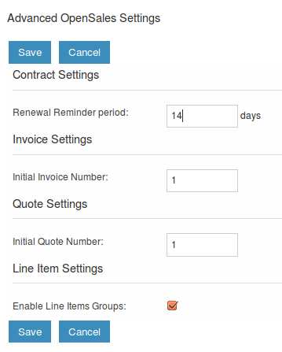
Once configured, click 'Save' to apply your AOS Settings.
Products Module
You can create Product records using the Products module. Creating products allows users to select product lines when preparing Quotes using AOS. The products module allows users to specify the Products Name, Part Number, Category and Type. Additional fields for Products can be added using Studio.
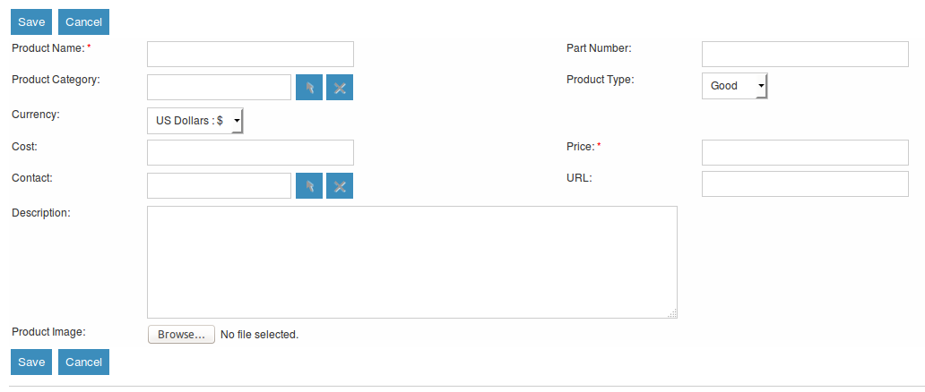
The module also allows users to define a Cost and Price for the product. Price is the selling price which will be used in the quoting process. A related Contact can be associated to the product. This is the point of contact with the supplier concerning this product. If you have an Image of the product then this can be uploaded within the products record. A URL to the products page on your website can also be specified.
Products Categories Module
The Product Categories module allows Users to structure Products into a hierarchical category structure. To create a Product Category record, navigate to the Product Categories module and click the 'Create Product Categories' button in the action bar.
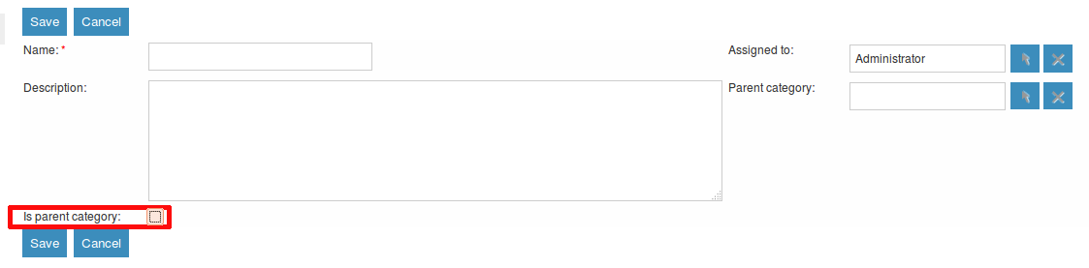
The Parent Category field is a relationship field to another Product Categories record. If you check the 'Is Parent Category' field then this signifies that the category is the highest level. Once selected you will not be able to select a Parent Category using the relate field.
PDF Templates
Creating Templates
AOS allows users to generate PDF documents and merge data from SuiteCRM modules. You must however create a PDF template first.
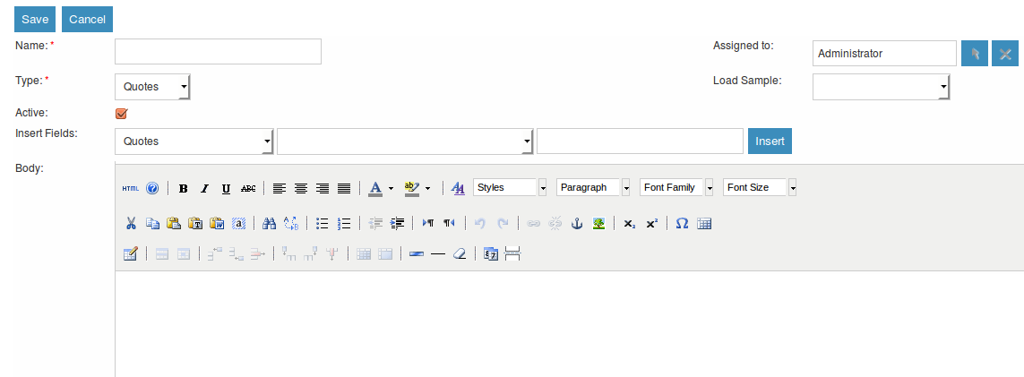
This module provides a WYSIWYG interface to create dynamic PDF templates. You must select a Type. This is the module you are building the PDF Template for. By default the modules you can select are: Quotes Invoices Accounts Contacts Leads
System Administrator users can extend this list by editing the 'pdf_template_type_dom' using the drop down editor functionality. Please note that the drop down 'Item Name' must be the name of the module directory.
To insert fields into the Body of the template users will first select a module. This will be the either the same module as the Type or a related module to the Type module. This is selected using the first drop down on the Insert Fields row.
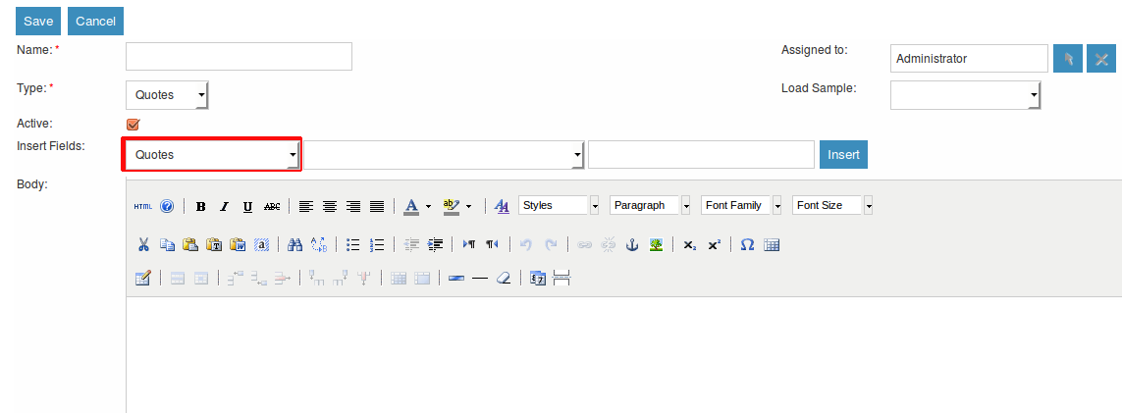
This will populate the second drop down with all the fields found within that module. Once you have selected the field you wish to insert, the text field will populate with the field variable name. Click 'Insert' to place this field into the Body of the template. If the Active check box is selected then users will be able to generate PDFs from this template. If it is not selected you will not.
Loading Samples
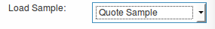
AOS comes with seven pre-defined PDF templates to help you create your own. These can be loaded by selecting the appropriate template from the Load Sample drop down list.
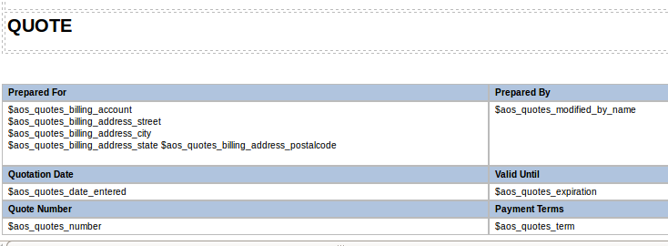
Line Items
When using a sample to create a template for Quotes or Invoices the Line Items are formatted within a table. You can change the fields found in this table as well as add or remove columns. Please note that if you are creating the template from scratch you must format the Line Items section as a table.
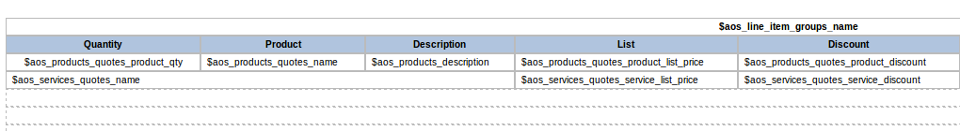
Margins
At the bottom of the PDF Template Edit View, you can specify the margin width for the PDF output.
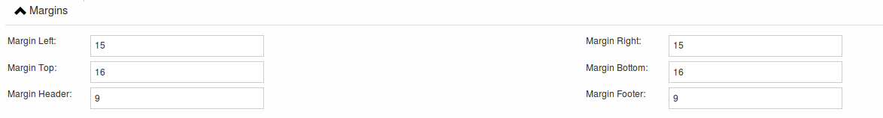
Header and Footer
Within the PDF Templates Edit View, you can also define a Header and a Footer for your templates. These can be completed using the Header and Footer text areas found below the Body text area.
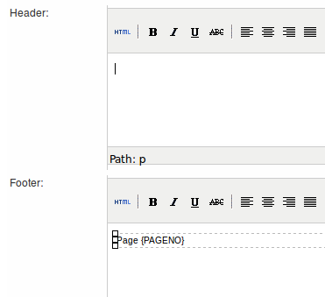
Generate Letter
You can generate PDF documents for Accounts, Contacts and Leads using the Generate Letter functionality.
Clicking the 'Generate Letter' button found on these modules Detail View will prompt a pop-up asking to select a template.
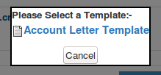
The template selector pop-up will show all the active templates which have the same Type as the module of the record. Clicking the template name will generate a PDF document with date populated from the record and it's related records. The Generate Letter functionality can also be actioned from the List View. This allows you to select multiple records and click the 'Generate Letter' button within the List View action menu.
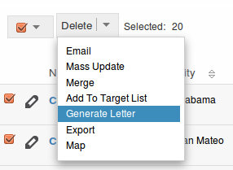
The process for generating PDFs for Quotes, Invoices and Contracts is described in your respective sections.
Quotes Module
Creating a Quote
You can create a Quote by going to the Quotes module and clicking 'Create Quote' from within the actions bar. The first panel allows you to specify details concerning the quote such as the Title, related Opportunity, Stage and Payment Terms. The Quote Number field is calculated automatically.
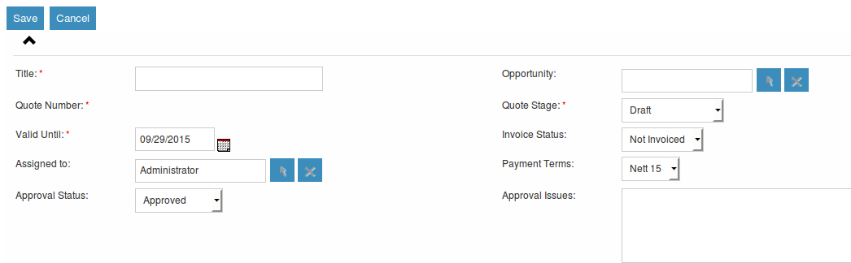
The second panel allows you to specify who the Quote is for by relating an Account and Contact to the Quote. When you select the Account, the Billing Address and Shipping Address are dynamically pulled from the Account and populated into the fields on the Quote record.
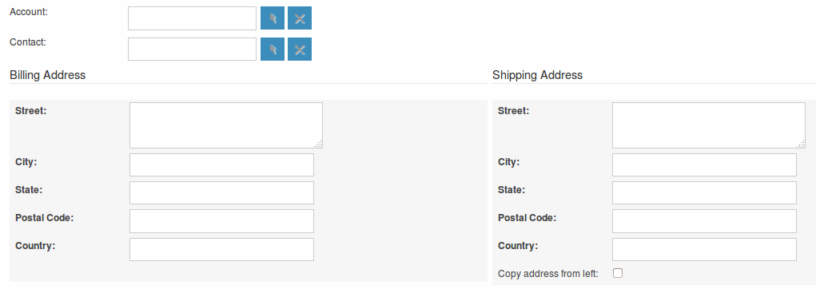
Line Items with Groups
The third panel allows users to specify the Quote Groups, Line Items and the Currency. A Group is a collection of Line Items with its own Group Total. A Line Item can be a Product Line or a Service Line. To add a Quote Group, click the 'Add Group' button.
Note: Add Group will be displayed if “Enable Line Item groups” is selected in Admin.
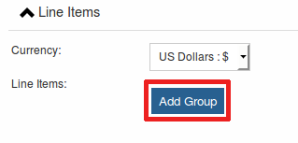
This will display the Group, allowing you to insert a Group Name and add a Product Line or Service Line. It will also display the Group Totals.
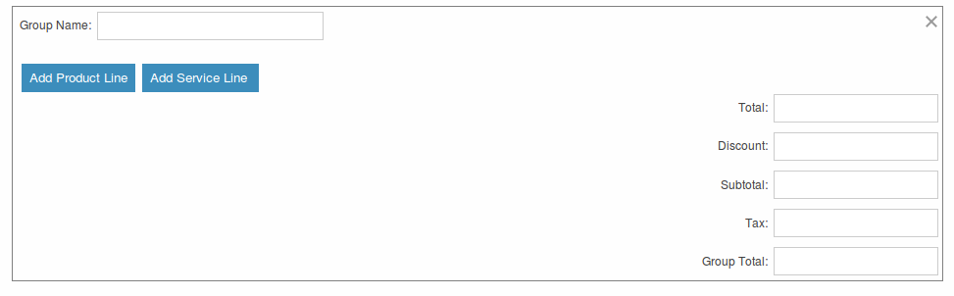
To add a Product Line, click the 'Add Product Line' button. This will allow users to quote for Products from the Products module.
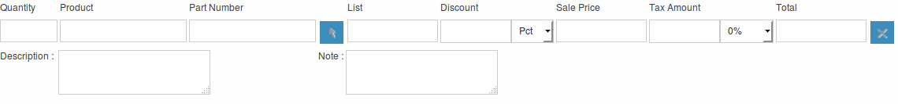
To select a Product, you can start typing in the Product or Part Number field which will provide a list of results similar to any relate field. Alternatively click the arrow button next to the Part Number field. This will display a pop-up window allowing you to select from a list of Products.
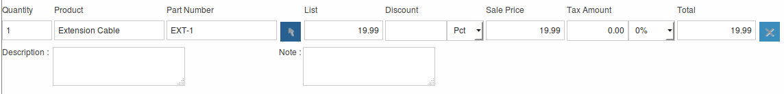
Once you have selected a Product, the List, Sale Price and Total will populate automatically. You can change the Quality, add Discounts (Percentage or Amount) and increase the Tax percentage. These will alter the Sale Price, Total Price and Group Total fields. To add a Service Line, click the 'Add Service Line' button. This will allow users to quote for Services.
For Service Lines, you must specify the List price. This will populate the Sale Price. Tax and Discounts can be added similarly to the Product Line. AOS will keep a Grand Total for each Group.
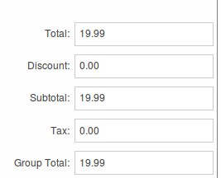
AOS will also keep a Grand Total for all Groups combined.
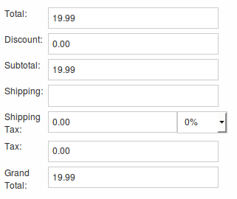
The Shipping field allows you to add a shipping cost. The Shipping Tax field allows you to add tax to this value. Once the Quote has been compiled, click 'Save' to save the Quote.
Line Items without Groups
Creating Quotes without Groups is very similar to creating Quotes with Groups. The only difference is you do not have to click 'Add Group'. You simply 'Add Product Line' and 'Add Service Line' to the quote. Without Groups you are cannot see the Group Total fields. You will only see the Grand Total fields.
Sending Quotations
To output a Quote you can select one of following three buttons from the Quote Detail View.
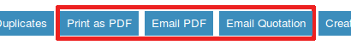
AOS provides users with three methods of sending Quotes:

- Print as PDF – Allows you to select a template and download or save a PDF of the Quote.
- Email PDF – Allows you to select a template then directs you to the SuiteCRM email client 'Compose' screen. The Quote PDF will be attached to email and the email will be addressed to the related Contact of the Quote. This allows you to fill out the email body.
- Email Quotation – This directs you to the SuiteCRM email client 'Compose' screen. The email will be addressed to the related Contact of the Quote. There will be no attachment and the Quote will be displayed within the body of the email.
Convert To Invoice
With AOS you can convert Quotes to Invoices. This can be achieved by clicking the 'Convert to Invoice' button on the Quote Detail View.
This functionality will redirect users to the Edit View of an Invoice record. Fields will be populated based on your Quote counterparts and Line Items will be copied over. When you are ready to create the Invoice, click the 'Save' button. Converting a Quote to an Invoice will set the Invoice Status of the quote to 'Invoiced'.
Create Contract
As well as converting to an Invoice, AOS allows users to create a Contract based on a Quote. This can be done by clicking the 'Create Contract' button on the Quote Detail View.
This will redirect you to the Edit View of a Contract record, pulling through any appropriate fields from the Quote. This includes any Line Items on the Quote.
Invoices Module
Creating an Invoice
Creating an Invoice record is very similar to creating a Quote record. You can create an Invoice by going to the Invoices module and clicking 'Create Invoice' from within the actions bar. The first panel allows you to specify details about the Invoice such as Status and Due Date.
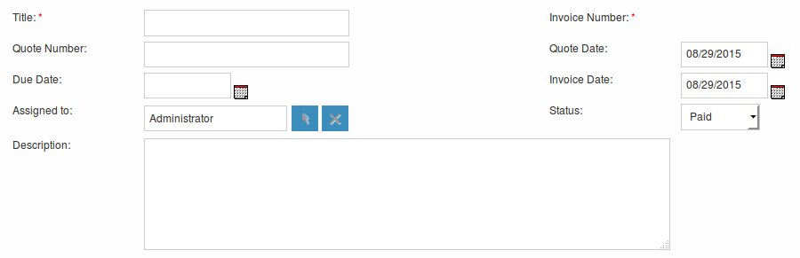
The second panel allows you to specify who the Invoice is for by relating an Account and Contact to the Invoice. When you select the Account, the Billing Address and Shipping Address are dynamically pulled from the Account and populated into the fields on the Invoice record.
Groups and Line Items
AOS allows users to add Groups and Line Items to Invoices. This is completed in the exact same way as Quotes. Please refer to Quotes section for details on how to create Groups and Line Items.
Sending Invoices
To output an Invoice you can select one of following three buttons from the Invoice Detail View.
AOS provides users with three methods of sending Invoices:

- Print as PDF – Allows users to select a template and download or save a PDF of the Invoice.
- Email PDF – Allows users to select a template then directs you to the SuiteCRM email client 'Compose' screen. The Invoice PDF will be attached to email and the email will be addressed to the related Contact of the Invoice. This allows user to fill out the email body.
- Email Invoice – This directs you to the SuiteCRM email client 'Compose' screen. The email will be addressed to the related Contact of the Invoice. There will be no attachment and the Invoice will be displayed within the body of the email.
Contracts Module
Creating a Contract
AOS allows users to create Contracts using the Contracts module.
When the Contract is created the Renewal Reminder Date will populate automatically based on the amount of days specified in the AOS Settings in Admin. A Call will be scheduled and assigned to the Contract Manger for this date.
Groups and Line Items
AOS allows users to add Groups and Line Items for Contracts. This is completed in the exact same way as Quotes. Please refer to Quotes section for details on how to create Groups and Line Items.
Advanced Open Workflow
Advanced OpenWorkflow (AOW) is a module for SuiteCRM, allowing users to create custom workflow processes. This module allows users to trigger various system actions based on conditions from any SuiteCRM module.

Creating a Workflow Process
You can create workflow processes by navigating to the 'WorkFlow' module within SuiteCRM. Click the 'Create WorkFlow' button within the action bar to start creating the process. The first panel allows users to set up the workflow process.
This allows you to specify the following:

- Name – The name of the process.
- Assigned To - The assigned user of the workflow process.
- WorkFlow Module – A drop down list of all the modules found within the SuiteCRM instance. This is the module the workflow is run against. For example, When an Account is created/edited.
- Status – Active or Inactive. Only active processes will run.
- Run – Always, On Save or On Scheduler.
- Run On – All Records, Modified Records or New Records.
- Repeated Runs – If checked, the process will continue to run over and over. Ideally this should only be checked if one of the specified Actions negates (or will lead to the negation) of one of the specified Conditions.
- Description – A description of the process.
Conditions
Adding Conditions
Once set up, you can add conditions to a workflow process using the conditions panel. This allows users to specify the criteria that should trigger the workflow actions.
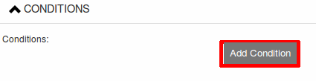
To add a Condition Line you must click the 'Add Condition' button.
Note: You must select your WorkFlow Module on the first panel before adding a Condition Line.
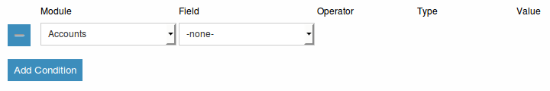
You can have an unlimited amount of Condition Lines. To add another line click the 'Add Condition' button again and it will appear. On the line you will have four fields; Field, Operator, Type and Value.
Field and Operator
Field is a drop down which automatically populates with all the fields found in the WorkFlow Module.
The Field selected will determine the options available for Operator and Type. If the field type is not a number or date then the operators available will be 'Equal To' or 'Not Equal To'. For number and date fields you can also choose from additional logical operators; 'Less Than', 'Greater Than', 'Less Than or Equal To' or 'Greater Than or Equal To'.
Condition Types
You can specify workflow processes to trigger on different condition types. These are as follows:
Value – This is used to directly compare the Field to a value. The value type offered is dynamic to the field type of the Field selected. For example, if the field type is a drop down then the value field type will be the same drop down list.
Field – This is used to action a workflow process when one field is compared to another field in the record.
Multiple – This can be selected if the Field is a drop down/multiselect. This allows users to specify multiple values to action the workflow from.
Date – This allows you to specify the workflow to occur after/before an amount of time from either another date field or 'Now'. For example, when the start date of a call is 'Now + 10 minutes'. This can only be used when the Field is a date field. The amount of time before or after the date can be specified in Minutes, Hours, Days, Weeks or Months.
Removing Conditions
You can remove Condition Lines by clicking the '-' button on the left hand side of the condition.

Actions
Adding Actions
Actions are defined in the third panel. These specify what events should occur when the conditions have been met. You can add an Action by clicking the 'Add Action' button.
This will cause the Action Line to appear.
From the Action Line you can Select Action and give it a Name. The actions available are; 'Create Record', 'Modify Record' and 'Send Email'. You can specify an unlimited amount of actions for each workflow process.
Create Record
If you select 'Create Record' you will be prompted to select a Record Type. This is the module type of the record you are looking to create.
Once selected you can add fields or relationships to this record using the 'Add Field' and 'Add Relationship' buttons.
When Adding fields the first drop down in the line will populate with all the fields from that module. The second drop down allows you to specify how the value for that field is going to be derived. For most cases the options are as follows:

- Value – This will allow you to input the value directly using the same field type as the field selected.
- Field – This will make the field the same value as a field found in the WorkFlow Module.
- Date – Only selectable if the field is a date field. This will allow you to specify the value as an amount of time after/before another date field or 'Now'.
Selecting the 'Assigned-To' field also gives you more options. As well as by value and field you can assign a user by:
Round Robin – This will select each user in turn.
Least Busy – This will select you with the least amount of records assigned to you for that module.
Random – This will select a random user.
For each of the above options you can choose if you want you to be selected from all users or users from a specific role. If you have the SecuritySuite module installed you can additionally choose if you want you to be selected from all users from a particular Security Group or all users from a particular security group with a particular role
When adding relationships you must select the related module from the drop down list then select the record that the new record should be related to.
Note: You must selected the related module using the arrow button – The auto completion on the text field is not currently developed.
Modify Record
This provides the same functionality as 'Create Record' but instead of creating a new record you are modifying the record which met the conditions of the workflow process. With this action you can modify any field found within the record or you can add a relationship to another record. This is completed in the same way as 'Create Record' except you are not required to specify the Record Type.
Send Email
The 'Send Email' action allows users to create workflow processes which will send an email based on an template to individuals. Using this action there are four different types of recipient.
Email – This will send an email to a specific email address. You must specify the email address and the email template.

Record Email – This will send an email to the primary email address specified on the record which actioned the workflow process. This can only be used if the record has an email field such as Accounts and Contacts. For this option you only need to specify the template.
User – This will send the email to a specified Users email address. You must specify the recipient user and the template of the email.
Related Field – This will send an email to the primary email address specified on a related modules record. In this case you must specify the related module (From a drop down list) and the email template.
Calculate Fields
If you select 'Calculate Fields' from the Action dropdown the Calculate Fields user interface will be loaded after a second and looks like the picture below.

Calculate Fields - Adding parameters
It is possible to add parameters to the formulas by using the dropdown in the Parameters section of the Calculate Fields’s user interface. The dropdown contains all of the (basic and custom) fields which belongs to the module selected in the basic fields section.
To add a parameter, select the field from the dropdown and click on the Add parameter button. After this action, a new line appears in the parameter table with the name of the field and the given identifier.
For some fields (dropdowns and multi-selects) an additional dropdown shown up where the user can select if the raw or the formatted value should be used in Calculated Fields. The raw format means the value which is stored in the database and the formatted value means the label for that database value.
To remove a parameter from the table, simply click on the minus button in the row of the parameter. Be aware, that if you remove a parameter, all of the identifiers are recalculated, so the identifiers could change for fields!
The identifier is used to reference this field when the user creates the formula. For example all appearances of the {P0} identifier will be replaced with the Account’s name in the formula. All parameters are like {Px} where x is the sequential order of the parameter. The amount of the parameters is not limited.

