VENKATESH KUMAR.S 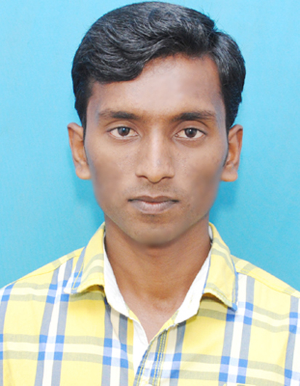

Email: venkateshkumar4034@gmail.com

Mobile: 91-9865684034

OBJECTIVE

To work consistently in any challenging environment and contribute to organizational development and self improvement.
STRENGTHS
• Hardwork.
• Self-Confidence.
• Creative and innovative.
• Flexible.
EDUCATIONAL QUALIFICATION

Academic year | Course | Institution | Percentage/CGPA
Sep 2012- June 2015 | MCA | Dr.Sivanthi Aditanar College of Engineering | 7.5%
June 2009-May 2012 | BSC(MATHS) | V.O.C arts & science college | 68%
June 2008-  Mar 2009 | HSC | St. Ignatius Hr.Sec.School,  Tuticorin. | 77.5%
June 2006-  May 2007 | SSLC | St.Ignatius Hr.Sec.School,  Tuticorin. | 81%

AREA OF INTREST

- Database Management system.
- Object Oriented Programming.
TECHNICAL SKILLS
- Basics of PHP, C, C++.
- Database: Oracle.

PERSONAL TRAITS
- Team Player.
- Member of Computer Society of India.

CURRENT PROJECT

Title | Tools used | Description
Credit card fraud detection system | php & my sql | P To detect the credit card fraud detection during transaction.

WORKSHOPS/ SEMINARS ATTENDED
- Attended a workshop on “ADVANCED COMPUTER TECHNIQUES” organized by computer society of India at Sivanthi aditanar college of engineering,Tiruchendur.

EXTRA CURRICULAR ACTIVITIES
- Participated in NSS voluntary activities.
- Participated in Cricket and games.

PERSONAL DETAILS
Father’s Name : Mr. P. Selvaraj.
Date of Birth : 12th Jan 1992.
Mother tongue : Tamil
Age : 23 Years.
Gender : Male.
Marital status : Single
Alternate Email : venkatesh4034@gmail.com
Languages Known : English, Tamil.
Permanent Address : 9A/5744 Sahayamathapattinam,
4th street,
Tuticorin
Pin code - 628002.

Declaration

I hereby declare that the above particulars are true to the best of my knowledge.

Place :
Date : (VENKATESH KUMAR.S)

