Unit Testing Report Dt- 05-07-201

1. No Pop upmessage showing after submiting the billing.

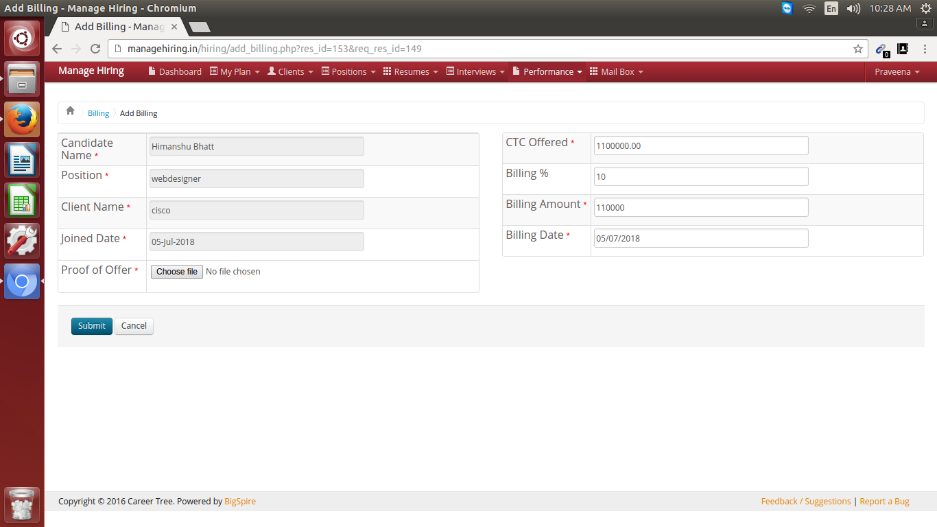

2. Mail is not submitting after click submit of send Cv.Problem in sending mail.

