**11. BUG TRACKER**

**11.1 INTRODUCTION**

A bug tracker is a software application that is designed to help quality assurance and programmers keep track of reported software bugs in their work. It may be regarded as a type of issue tracker.

Overview of Bug Tracker

a. Category –To which the issue belongs

b. Status – The current status of the Issue

c. Priority – The Priority determines the urgency of the issue to be fixed.

d. Assign To – It states for whom the issue is assigned to be fixed.

e. Schedule Release – The task to be fixed by developers before the release date.

f. Summary – The short form of the issue meant to be fixed has been mentioned.

g. Initial Description – The Detailed description of the software has been mentioned.

h. Add files – The files can be added to assist developers to fix issue (for eg. Screenshot in word

document)

**11.2 REPORT BUGS**

**1. Create a Bug:**

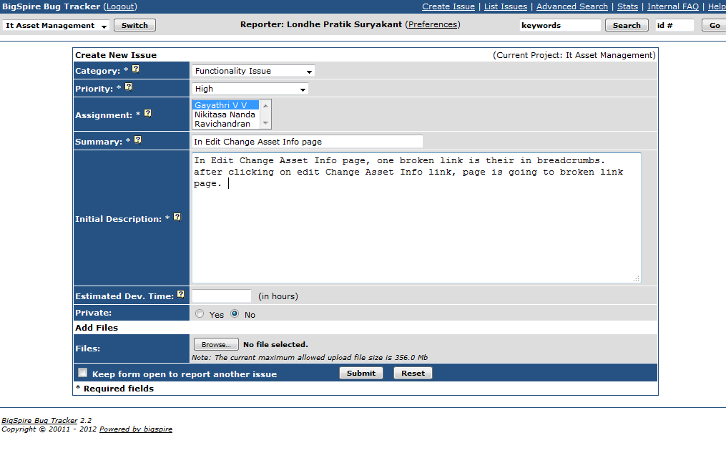

**2. List Bugs:**

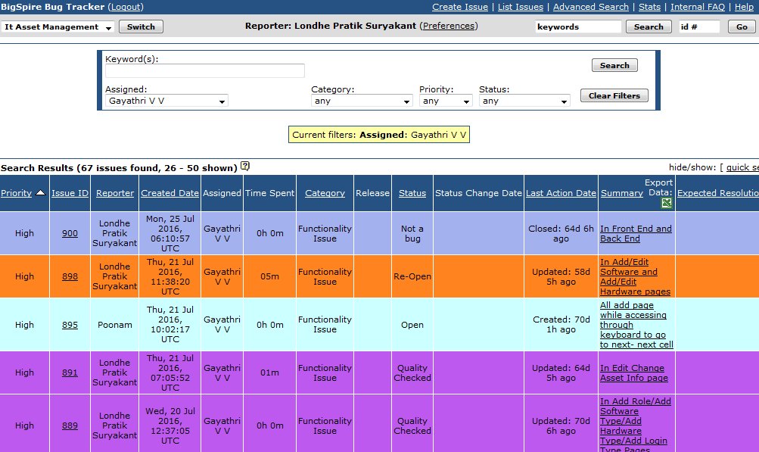

**3. Update a Bug**

