**Verification And Validation In Software Testing**

**V-Model –**

V-Model means Verification and Validation**.**Verification and Validation are very widely and commonly userd terms.Most of the times we consider the terms same,but actually the terms are quite different.

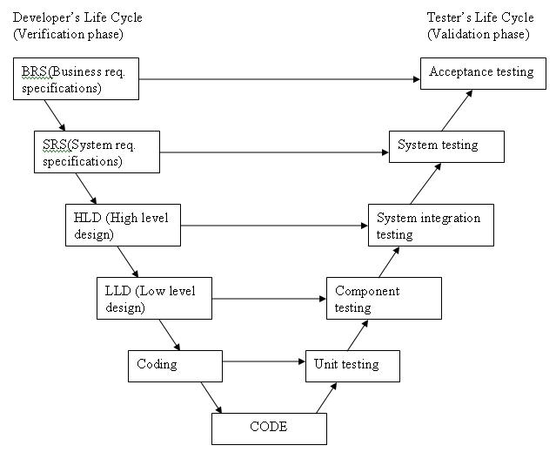

Advantages of V-model:

* Testing activities like planning, [test designing](http://istqbexamcertification.com/what-is-test-design-or-how-to-specify-test-cases/) happens well before coding. This saves a lot of time. Hence higher chance of success over the waterfall model.
* Proactive defect tracking – that is defects are found at early stage.
* Avoids the downward flow of the defects.
* Works well for small projects where requirements are easily understood.
* Simple and easy to use.

Disadvantages of V-model:

* Very rigid and least flexible.
* Software is developed during the implementation phase, so no early prototypes of the software are produced.
* If any changes happen in midway, then the test documents along with requirement documents has to be updated.

When to use the V-model:

* The V-shaped model should be used for small to medium sized projects where requirements are clearly defined and fixed.
* The V-Shaped model should be chosen when ample technical resources are available with needed technical expertise.

**1) Verification := Are we building the product right?**

Verification focuses on 'Find defects as early as possible'.

Verification is the process of evaluating work-products of a development phase to determine whether they meet the specified requirements. verification ensures that the product is built according to the requirements and design specifications.

verification testing can be best demonstrated using V-Model. The examples such as test Plans, requirement specification, design, code and test cases are evaluated.

Verification is done at the starting of the development process. It includes reviews and meetings, walkthroughs, inspection, etc. to evaluate documents, plans, code, requirements and specifications.

**Example :**

Suppose you are building a table. Here the verification is about checking all the parts of the table, whether all the four legs are of correct size or not. If one leg of table is not of the right size it will imbalance the end product.Similar behavior is also noticed in case of the software product or application. If any feature of software product or application is not up to the mark or if any defect is found then it will result into the failure of the end product. Hence, verification is very important. It takes place at the starting of the development process.

**Advantages of Verification** :=

1)filter is applied at every stage during SDLC to 'purify' the application as it progresses.

2)Verification helps in identifying not only the presence of defects but also theire location.

3)Defects can get detected even before they get coded or tested.

4)It helps to identify and remove issues early.

Verification is also known as **Static testing** as software application is not actually used or executed but the documents or code is checked statically to find the defects.

**2) Validation := Are we building the right product?**

The process of evaluating software during the development process or at the end of the development process to determine whether it satisfies specified business requirements.

Validation Testing ensures that the product actually meets the client's needs. It can also be defined as to demonstrate that the product fulfills its intended use when deployed on appropriate environment.

Validation testing can be best demonstrated using V-Model. The Software/product under test is evaluated during this type of testing.

1)**Unit Testing** :-

**What is Unit**?

- The smallest piece of software that can be tested in isolation to verify its behavior.

**Who does it** ?

- It is actually done by developers.

**What is its purpose**?

- Ensures that the code meets the requirements.

Unit testing only tests the functionality of the units themselves.

**Benifits** :=

**1) Faster error detection** – Unit testing tests smaller amounts of code making it easy to find errors.

**2) Easy to isolate erros** – As small pieces of code are tested at one go.

**3) Faster development** – less time spent in debugging.

**2) Integration Testing :=**

Integration testingis the phase in software testing in which individual software modules are combined and tested as a group. It occurs after unit testing and before validation testing.

Also after integrating two different components together we do the integration testing. As displayed in the image below when two different modules ‘Module A’ and ‘Module B’ are integrated then the integration testing is done.

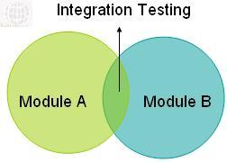

Integration testing is done by a specific integration tester or test team.

Integration testing follows two approach known as ‘Top Down’ approach and ‘Bottom Up’ approach as shown in the image below:

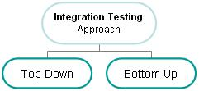

**3) System Testing : =**

In system testing the behavior of whole system/product is tested.Validates taht the system meets its functional and non-functional requirements.

System testing is always done by a Tester.

**4) User Acceptance Testing** :=

User acceptance testing (UAT) is the last phase of the software testing process. During UAT, actual software users test the software to make sure it can handle required tasks in real-world scenarios, according to specifications.

User acceptance is performed by **customers and end users.**

Validation is also known as **Dynamic Testing** as the application is actually uses to test and find the defects.

Advantages of Validation:

1. During verification if some defects are missed then during validation process it can be caught as failures.
2. If during verification some specification is misunderstood and development had happened then during validation process while executing that functionality the difference between the actual result and expected result can be understood.
3. Validation is done during testing like feature testing, integration testing, system testing, load testing, compatibility testing, stress testing, etc.
4. Validation helps in building the right product as per the customer’s requirement and helps in satisfying their needs.

## **Example of verification and validation are explained below**:-

Suppose we have the specifications related to the project than by checking that specifications without executing to see whether the specifications are up to the mark or not is what we have done in verification.  
Similarly Validation of the software is done to make sure that the software always meets the requirements of the customer by executing the specifications of the project and product.

**Difference Between Verification and Validation** :-

|  |  |
| --- | --- |
| **Verification** | **Validation** |
| 1. Verification is a static practice of verifying documents, design, code and program. | 1. Validation is a dynamic mechanism of validating and testing the actual product. |
| 2. It does not involve executing the code. | 2. It always involves executing the code. |
| 3. It is human based checking of documents and files. | 3. It is computer based execution of program. |
| 4.Verification uses methods like inspections, reviews, walkthroughs, and Desk-checking etc. | 4.Validation uses methods like black box (functional) testing, gray box testing, and white box (structural) testing etc. |
| 5.**Verification** is to check whether the software conforms to specifications. | 5. **Validation** is to check whether software meets the customer expectations and requirements. |
| 6.It can catch errors that validation cannot catch. It is low level exercise. | 6.It can catch errors that verification cannot catch. It is High Level Exercise. |
| 7.Target is requirements specification, application and software architecture, high level, complete design, and database design etc. | 7. Target is actual product-a unit, a module, a bent of integrated modules, and effective final product. |
| 8.Verification is done by QA team to ensure that the software is as per the specifications in the SRS document. | 8.Validation is carried out with the involvement of testing team. |
| 9. It generally comes first-done before validation. | 9. It generally follows after **verification**. |

**Reference** :=

https://ifs.host.cs.st-andrews.ac.uk/Books/SE7/Presentations/PDF/ch22.pdf