# How to diff branches in Tortoise Git

1. Right click the root directory of git repo and select the “Revision graph” in the context menu.

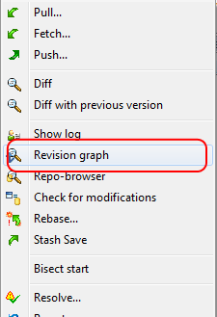

1. In the Revision Graph window, left click the branch you want to compare, and then click the Git in the menu bar. In the pull down menu, select “Compare HEAD revisions”.

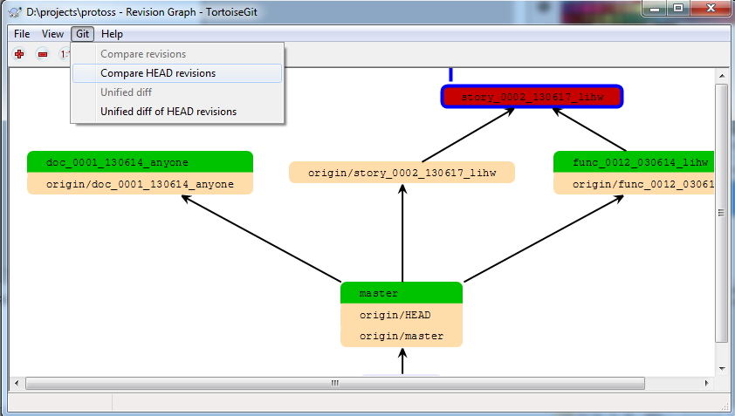

1. Input the branch name in the input text field called Version 1; input the branch we want to compare with “Version 1” in version 2. We can make use of “RefBrowse” button on the right to browse branches, saving the typing.

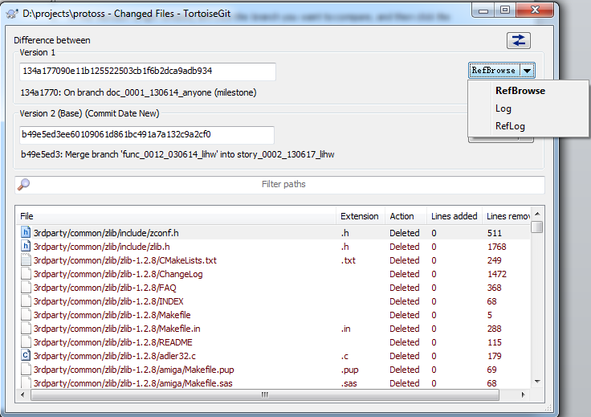

1. Select the branch name after we choose “RefBrowse” in the pull down menu of “RefBrowse” button.

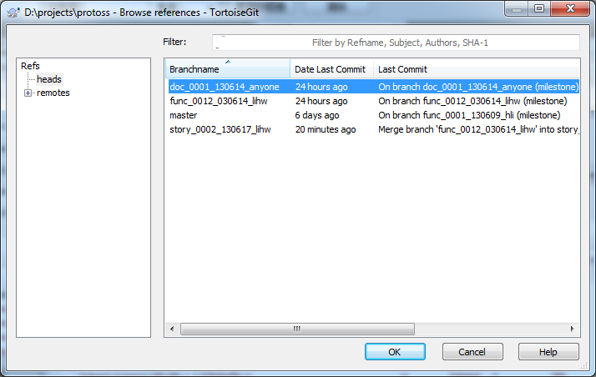

1. In the list box at the bottom of “Changed Files” lists the all changed files. We can right click any one of them, and choose “Compare revisions”. There will be another dialogue showing the difference between versions of the same file in two branches.

