**A**

**PROJECT REPORT ON**

**FOOD DELIVERY SYSTEM**

For

Partial Fulfillment of Degree

Master of computer application

**Submitted By**

(Big Sun |Alan，Carter，Hope，Crystal)

(胖太阳|张贺，肖林剑，高子喃，张雨欣)

Instructor: 刘德才老师 Delucia

张贺 Alan RBJ9400164

肖林剑 Carter RBJ9400174

高子喃 Hope RBJ9400183

张雨欣 Crystal RBJ9400182

B3 | 2019.5.5—2019.5.23

**External Guide**

**Mr. Peter Parker**

**Head of Computer Science**

**NIIT**



***[Indian Institute of Technology Delhi](http://www.iitd.ac.in/" \t "_blank)***

PROJECT INDEX

[一、 Software requirements 3](#_Toc9508093)

[二、 Data Flow Diagram:- 3](#_Toc9508094)

[三、A Login Module 4](#_Toc9508095)

[四、A Menu And Buy Module 4](#_Toc9508096)

[五、Cost Estimation 5](#_Toc9508097)

[六、Project basic Information 6](#_Toc9508098)

[七、Database design 12](#_Toc9508099)

[八、Project code 12](#_Toc9508100)

[（一）Project source code 12](#_Toc9508101)

[（二）Page design code 35](#_Toc9508102)

[九、Database code 91](#_Toc9508103)

# 一、 Software requirements

▪MySQL workbench 6.0 CE

•Netbeans IDE 7.1

# 二、 Data Flow Diagram:-

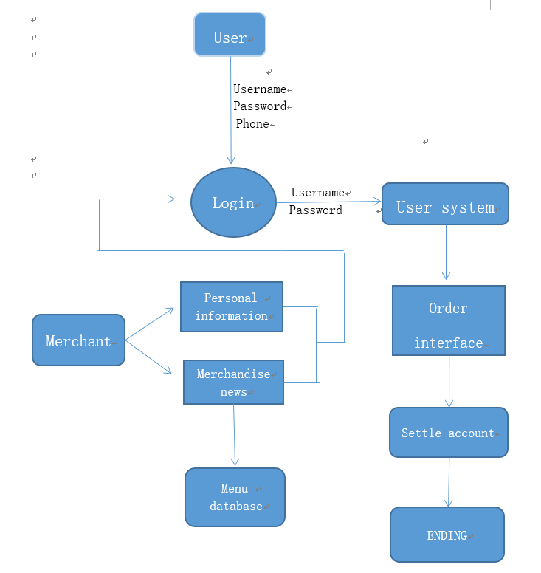

# 三、A Login Module

The designed login module is being developing to allow users and merchants to access the available interface and links to add, update and search the important data.

The development of this module includes writing code for following files:

1.NewCustomer.java 2.NewMenu.java

3.NewMerchant.java 4.Login.java

5.Welcome.java 6.Order.java

# 四、A Menu And Buy Module

The designed menu module is for users to choose the merchants and the food to order something. The designed buy module is for user to buy something and pay for it.

The development of menu module includes writing code for following files:

1. BiaoXinxi.java 2.BiaoXinxi1.java

3.Biaomodel.java 4.Bishengke.java

5.Coco.java 6.DBConnection.java

7.Dashang.java 8.Gongcha.java

9.Maili.java 10.NewMarchanttable.java

11.Ordertable.java 12.Sanshi.java

13.Xiaozhuizi.java 14.Youchu.java

The development of buy module includes writing code for following files:

1. BuyBishengke.java 2.BuymenuBishengke.java

3.BuyCoco.java 4.BuymenuCoco.java

5.BuyDashang.java 6.BuymenuDashang.java

7.BuyGongcha.java 8.BuymenuGongcha.java

9.BuyMaili.java 10.BuymenuMaili.java

11.BuySanshi.java 12.BuymenuSanshi.java

13.BuyYouchu.java 14.BuymenuYouchu.java

# 五、Cost Estimation

For cost estimation of this project (RBRS), I carry out the different tasks in this project according to the time period gives below. First we estimate the

Cost in working hours.

* Analysis carried out 1 days

from 5 May 2019 to 6 May 2019.

* Design carried out 2 days

from 6 May 2019 to 8 May 2019.

* Coding carried out 6 days

from 8 May 2019 to 15 May 2019.

* Integration & Testing carried out 3 days

from 16 May 2019 to 18 May 2019.

* Report Writing(Documentation of the project) carried out 3 days

from 19 May 2019 to 22 May 2019

# 六、Project basic Information

Project theme: Food Delivery System

Project name : Fat

1.The composition of the project: 1 user login interface: the user needs to enter the user name and password. If the user name and password are entered correctly, you can log in successfully after clicking "begin". In addition, on the login page, There are two buttons, "New user" and "New Merchants". After clicking on the two buttons, you can jump to their respective registration pages.

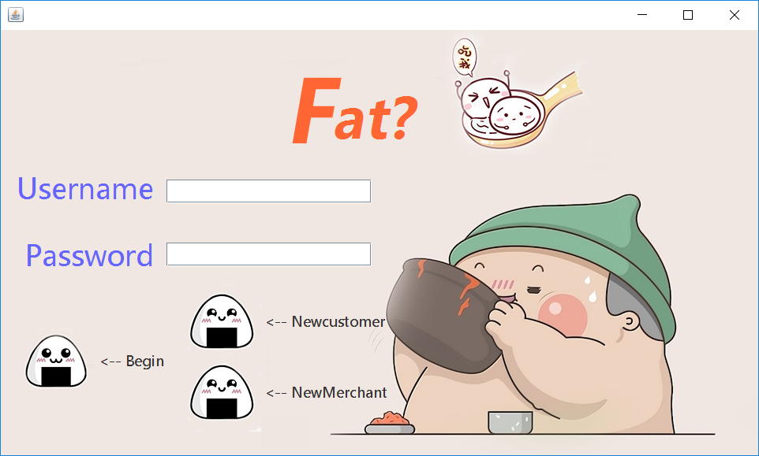

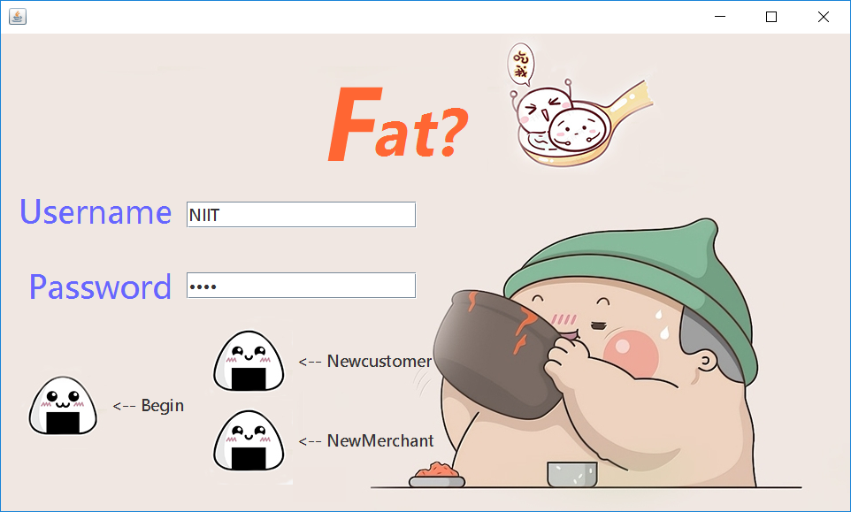

2.New user and new business registration interface: new users only need to enter according to the requirements to register successfully;

The merchant registration page has two pages, one is the merchant information page, the other is the information of the items managed by the merchant.

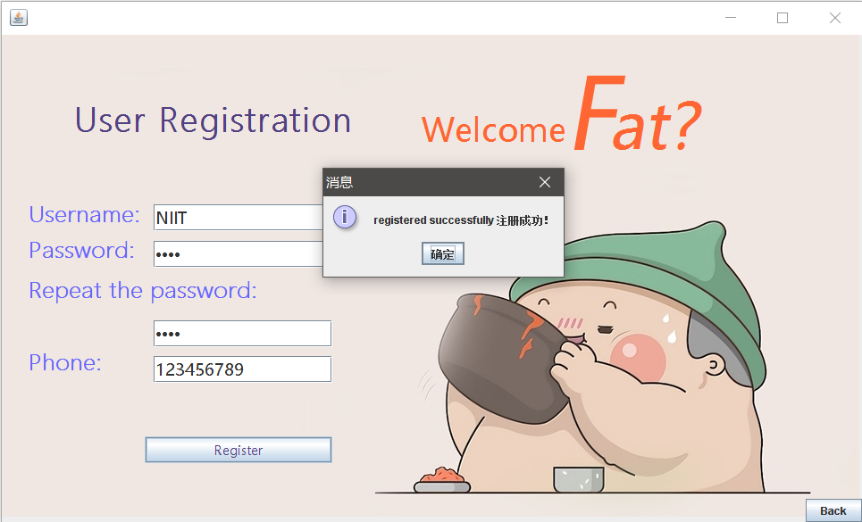

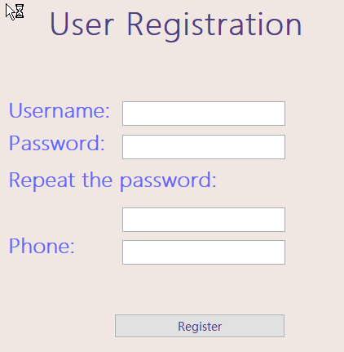

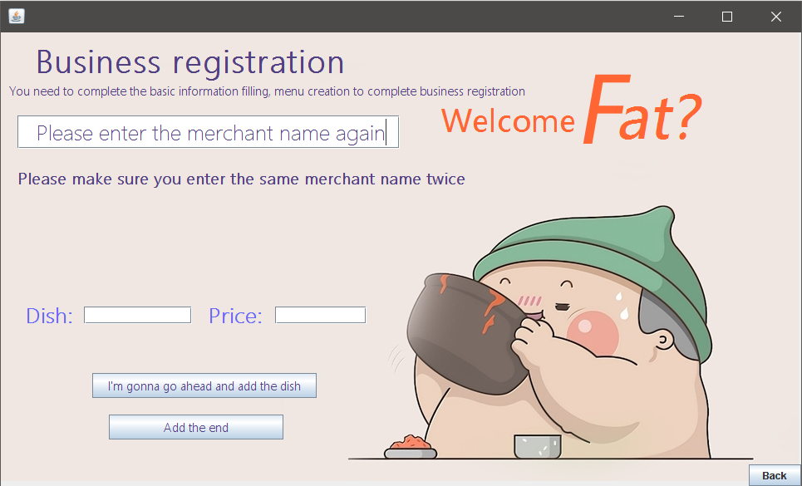

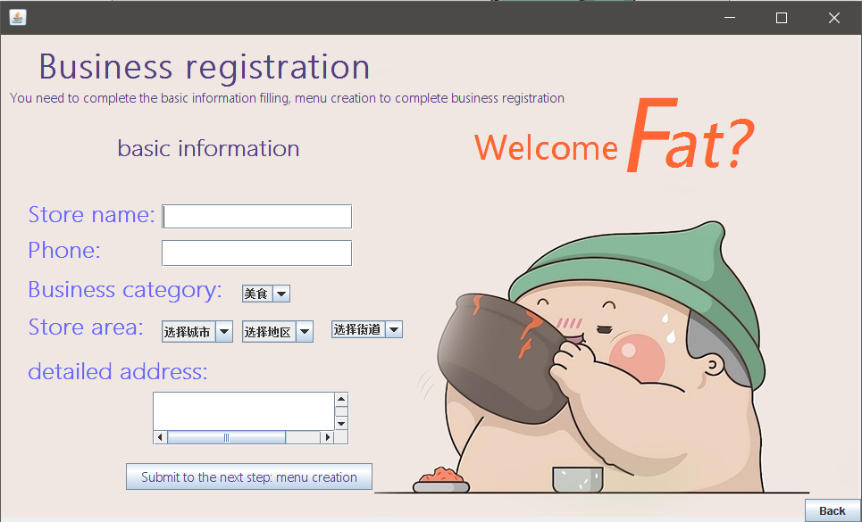

3.User point single interface:

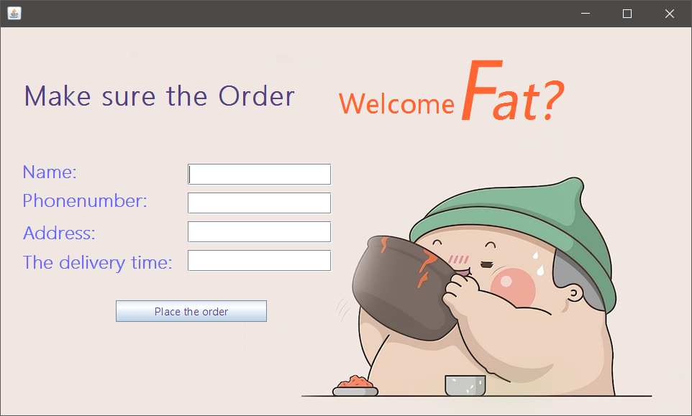

4.Menu, consisting of four parts: food, drinks, supermarkets, fresh.

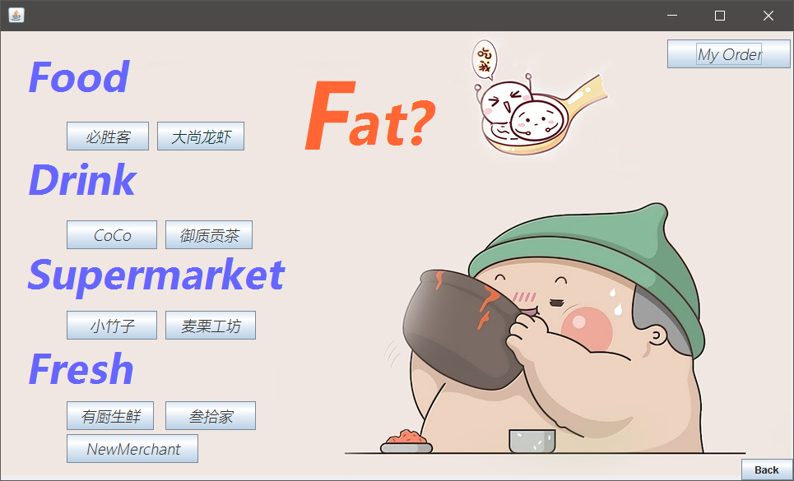

Click on each of the four categories and the corresponding menu bar appears

The illustration shows the contents of the CoCo column:

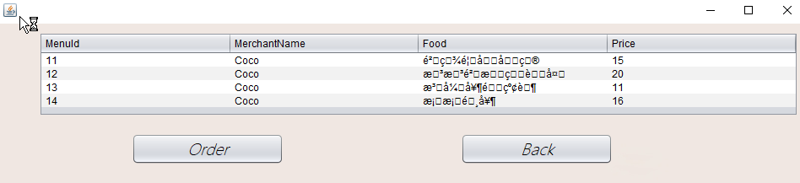

When you click "Order", the shopping cart interface appears, and the total cost is calculated after you enter the information:

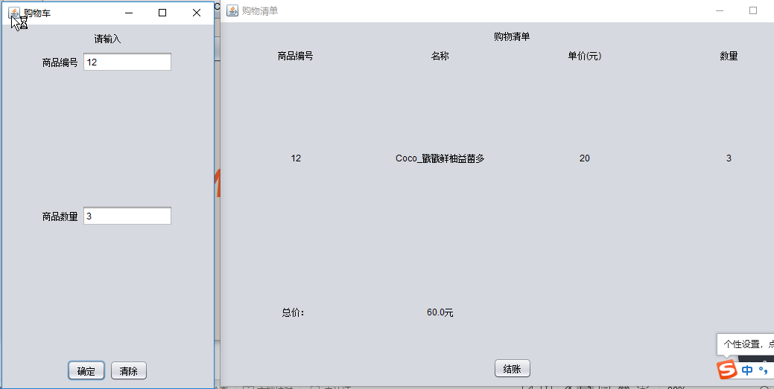

5.Realization of Shopping cart

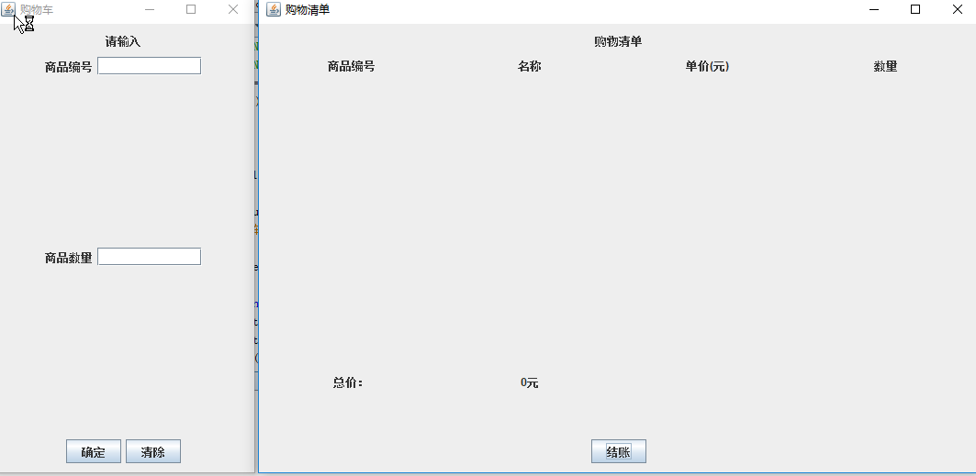

# 七、Database design

|  |  |  |  |  |
| --- | --- | --- | --- | --- |
| Table Name | Field Name | Size | Primary Key | Null |
| Customer | ID | 10 | Y | Y |
| UserName | 30 | N | Y |
| Password | 20 | N | Y |
| UserPhone Number | 20 | N | Y |
| Merchant | Name | 50 | N | Y |
| Sort | 20 | N | Y |
| Phone | 20 | N | Y |
| Area | 50 | N | Y |
| Street | 50 | N | Y |
| City | 50 | N | Y |
| Address | 100 | N | Y |
| Menu | MenuID | 20 | N | Y |
| Merchant Name | 50 | N | Y |
| Food | 50 | N | Y |
| Price | 10 | N | Y |

# 八、Project code

## （一）Project source code

**Code of BuyCoCO.java**

package fooddelivery.Buy;

import fooddelivery.Buymenu.BuymenuCoco;

import java.awt.BorderLayout;

import javax.swing.JFrame;

import javax.swing.JPanel;

import javax.swing.border.EmptyBorder;

import javax.swing.JButton;

import javax.swing.JLabel;

import java.awt.GridLayout;

import javax.swing.JTextField;

import java.awt.event.ActionListener;

import java.awt.event.ActionEvent;

public class BuyCoco extends JFrame {

private JFrame jf=new JFrame();

private BuymenuCoco li ;

private JPanel contentPane=new JPanel();

private JTextField textField;

private JTextField textField\_1;

private JLabel lblNewLabel;

private JButton btnNewButton;

private JButton btnNewButton\_1;

private JLabel lblNewLabel\_1;

private JLabel lblNewLabel\_2;

String str="",str1="";

public BuyCoco() {

}

public void list\_11() {

li = new BuymenuCoco();

setTitle("购物车");

setDefaultCloseOperation(JFrame.EXIT\_ON\_CLOSE);

setBounds(435, 500, 300, 528);

contentPane = new JPanel();

contentPane.setBorder(new EmptyBorder(5, 5, 5, 5));

contentPane.setLayout(new BorderLayout(0, 0));

setContentPane(contentPane);

JPanel panel = new JPanel();

contentPane.add(panel, BorderLayout.NORTH);

lblNewLabel = new JLabel("请输入");

panel.add(lblNewLabel);

JPanel panel\_1 = new JPanel();

contentPane.add(panel\_1, BorderLayout.SOUTH);

btnNewButton = new JButton("确定");

btnNewButton.addActionListener(new ActionListener() {

public void actionPerformed(ActionEvent e) {

}

});

panel\_1.add(btnNewButton);

btnNewButton\_1 = new JButton("清除");

btnNewButton\_1.addActionListener(new ActionListener() {

public void actionPerformed(ActionEvent e) {

}

});

panel\_1.add(btnNewButton\_1);

JPanel panel\_2 = new JPanel();

contentPane.add(panel\_2, BorderLayout.CENTER);

panel\_2.setLayout(new GridLayout(0, 1, 2, 0));

JPanel panel\_3 = new JPanel();

panel\_2.add(panel\_3);

lblNewLabel\_1 = new JLabel("商品编号");

panel\_3.add(lblNewLabel\_1);

textField = new JTextField();

panel\_3.add(textField);

textField.setColumns(10);

JPanel panel\_4 = new JPanel();

panel\_2.add(panel\_4);

lblNewLabel\_2 = new JLabel("商品数量");

panel\_4.add(lblNewLabel\_2);

textField\_1 = new JTextField();

panel\_4.add(textField\_1);

textField\_1.setColumns(10);

setVisible(true);

btnNewButton.addActionListener(new ActionListener() {

@Override

public void actionPerformed(ActionEvent e) {

li.list\_1(textField.getText(),textField\_1.getText());

}

});

btnNewButton\_1.addActionListener(new ActionListener() {

@Override

public void actionPerformed(ActionEvent e) {

textField.setText("");

textField\_1.setText("");

}

});

}

public static void main(String[] args) {

new BuyCoco().list\_11();

}

public String S1(){

return str;

}

public String S2(){

return str1;

}

}

**Code of BuyDaShang.java**

package fooddelivery.Buy;

import fooddelivery.Buymenu.BuymenuCoco;

import java.awt.BorderLayout;

import javax.swing.JFrame;

import javax.swing.JPanel;

import javax.swing.border.EmptyBorder;

import javax.swing.JButton;

import javax.swing.JLabel;

import java.awt.GridLayout;

import javax.swing.JTextField;

import java.awt.event.ActionListener;

import java.awt.event.ActionEvent;

public class BuyCoco extends JFrame {

private JFrame jf=new JFrame();

private BuymenuCoco li ;

private JPanel contentPane=new JPanel();

private JTextField textField;

private JTextField textField\_1;

private JLabel lblNewLabel;

private JButton btnNewButton;

private JButton btnNewButton\_1;

private JLabel lblNewLabel\_1;

private JLabel lblNewLabel\_2;

String str="",str1="";

public BuyCoco() {

}

public void list\_11() {

li = new BuymenuCoco();

setTitle("购物车");

setDefaultCloseOperation(JFrame.EXIT\_ON\_CLOSE);

setBounds(435, 500, 300, 528);

contentPane = new JPanel();

contentPane.setBorder(new EmptyBorder(5, 5, 5, 5));

contentPane.setLayout(new BorderLayout(0, 0));

setContentPane(contentPane);

JPanel panel = new JPanel();

contentPane.add(panel, BorderLayout.NORTH);

lblNewLabel = new JLabel("请输入");

panel.add(lblNewLabel);

JPanel panel\_1 = new JPanel();

contentPane.add(panel\_1, BorderLayout.SOUTH);

btnNewButton = new JButton("确定");

btnNewButton.addActionListener(new ActionListener() {

public void actionPerformed(ActionEvent e) {

}

});

panel\_1.add(btnNewButton);

btnNewButton\_1 = new JButton("清除");

btnNewButton\_1.addActionListener(new ActionListener() {

public void actionPerformed(ActionEvent e) {

}

});

panel\_1.add(btnNewButton\_1);

JPanel panel\_2 = new JPanel();

contentPane.add(panel\_2, BorderLayout.CENTER);

panel\_2.setLayout(new GridLayout(0, 1, 2, 0));

JPanel panel\_3 = new JPanel();

panel\_2.add(panel\_3);

lblNewLabel\_1 = new JLabel("商品编号");

panel\_3.add(lblNewLabel\_1);

textField = new JTextField();

panel\_3.add(textField);

textField.setColumns(10);

JPanel panel\_4 = new JPanel();

panel\_2.add(panel\_4);

lblNewLabel\_2 = new JLabel("商品数量");

panel\_4.add(lblNewLabel\_2);

textField\_1 = new JTextField();

panel\_4.add(textField\_1);

textField\_1.setColumns(10);

setVisible(true);

btnNewButton.addActionListener(new ActionListener() {

@Override

public void actionPerformed(ActionEvent e) {

li.list\_1(textField.getText(),textField\_1.getText());

}

});

btnNewButton\_1.addActionListener(new ActionListener() {

@Override

public void actionPerformed(ActionEvent e) {

textField.setText("");

textField\_1.setText("");

}

});

}

public static void main(String[] args) {

new BuyCoco().list\_11();

}

public String S1(){

return str;

}

public String S2(){

return str1;

}

}

**Code of BuyGongCha.java**

package fooddelivery.Buy;

import fooddelivery.Buymenu.BuymenuGongcha;

import java.awt.BorderLayout;

import javax.swing.JFrame;

import javax.swing.JPanel;

import javax.swing.border.EmptyBorder;

import javax.swing.JButton;

import javax.swing.JLabel;

import java.awt.GridLayout;

import javax.swing.JTextField;

import java.awt.event.ActionListener;

import java.awt.event.ActionEvent;

public class BuyGongcha extends JFrame {

private JFrame jf=new JFrame();

private BuymenuGongcha lii2 ;

private JPanel contentPane=new JPanel();

private JTextField textField;

private JTextField textField\_1;

private JLabel lblNewLabel;

private JButton btnNewButton;

private JButton btnNewButton\_1;

private JLabel lblNewLabel\_1;

private JLabel lblNewLabel\_2;

String str="",str1="";

public BuyGongcha() {

}

public void list\_11() {

lii2 = new BuymenuGongcha();

setTitle("购物车");

setDefaultCloseOperation(JFrame.EXIT\_ON\_CLOSE);

setBounds(435, 500, 300, 528);

contentPane = new JPanel();

contentPane.setBorder(new EmptyBorder(5, 5, 5, 5));

contentPane.setLayout(new BorderLayout(0, 0));

setContentPane(contentPane);

JPanel panel = new JPanel();

contentPane.add(panel, BorderLayout.NORTH);

lblNewLabel = new JLabel("请输入");

panel.add(lblNewLabel);

JPanel panel\_1 = new JPanel();

contentPane.add(panel\_1, BorderLayout.SOUTH);

btnNewButton = new JButton("确定");

btnNewButton.addActionListener(new ActionListener() {

public void actionPerformed(ActionEvent e) {

}

});

panel\_1.add(btnNewButton);

btnNewButton\_1 = new JButton("清除");

btnNewButton\_1.addActionListener(new ActionListener() {

public void actionPerformed(ActionEvent e) {

}

});

panel\_1.add(btnNewButton\_1);

JPanel panel\_2 = new JPanel();

contentPane.add(panel\_2, BorderLayout.CENTER);

panel\_2.setLayout(new GridLayout(0, 1, 2, 0));

JPanel panel\_3 = new JPanel();

panel\_2.add(panel\_3);

lblNewLabel\_1 = new JLabel("商品编号");

panel\_3.add(lblNewLabel\_1);

textField = new JTextField();

panel\_3.add(textField);

textField.setColumns(10);

JPanel panel\_4 = new JPanel();

panel\_2.add(panel\_4);

lblNewLabel\_2 = new JLabel("商品数量");

panel\_4.add(lblNewLabel\_2);

textField\_1 = new JTextField();

panel\_4.add(textField\_1);

textField\_1.setColumns(10);

setVisible(true);

btnNewButton.addActionListener(new ActionListener() {

@Override

public void actionPerformed(ActionEvent e) {

lii2.list\_1(textField.getText(),textField\_1.getText());

}

});

btnNewButton\_1.addActionListener(new ActionListener() {

@Override

public void actionPerformed(ActionEvent e) {

textField.setText("");

textField\_1.setText("");

}

});

}

public static void main(String[] args) {

new BuyGongcha().list\_11();

}

public String S1(){

return str;

}

public String S2(){

return str1;

}

}

**Code of BuyMaiLi.java**

package fooddelivery.Buy;

import fooddelivery.Buymenu.BuymenuMaili;

import java.awt.BorderLayout;

import javax.swing.JFrame;

import javax.swing.JPanel;

import javax.swing.border.EmptyBorder;

import javax.swing.JButton;

import javax.swing.JLabel;

import java.awt.GridLayout;

import javax.swing.JTextField;

import java.awt.event.ActionListener;

import java.awt.event.ActionEvent;

public class BuyMaili extends JFrame {

private JFrame jf=new JFrame();

private BuymenuMaili li ;

private JPanel contentPane=new JPanel();

private JTextField textField;

private JTextField textField\_1;

private JLabel lblNewLabel;

private JButton btnNewButton;

private JButton btnNewButton\_1;

private JLabel lblNewLabel\_1;

private JLabel lblNewLabel\_2;

String str="",str1="";

public BuyMaili() {

}

public void list\_11() {

li = new BuymenuMaili();

setTitle("购物车");

setDefaultCloseOperation(JFrame.EXIT\_ON\_CLOSE);

setBounds(435, 500, 300, 528);

contentPane = new JPanel();

contentPane.setBorder(new EmptyBorder(5, 5, 5, 5));

contentPane.setLayout(new BorderLayout(0, 0));

setContentPane(contentPane);

JPanel panel = new JPanel();

contentPane.add(panel, BorderLayout.NORTH);

lblNewLabel = new JLabel("请输入");

panel.add(lblNewLabel);

JPanel panel\_1 = new JPanel();

contentPane.add(panel\_1, BorderLayout.SOUTH);

btnNewButton = new JButton("确定");

btnNewButton.addActionListener(new ActionListener() {

public void actionPerformed(ActionEvent e) {

}

});

panel\_1.add(btnNewButton);

btnNewButton\_1 = new JButton("清除");

btnNewButton\_1.addActionListener(new ActionListener() {

public void actionPerformed(ActionEvent e) {

}

});

panel\_1.add(btnNewButton\_1);

JPanel panel\_2 = new JPanel();

contentPane.add(panel\_2, BorderLayout.CENTER);

panel\_2.setLayout(new GridLayout(0, 1, 2, 0));

JPanel panel\_3 = new JPanel();

panel\_2.add(panel\_3);

lblNewLabel\_1 = new JLabel("商品编号");

panel\_3.add(lblNewLabel\_1);

textField = new JTextField();

panel\_3.add(textField);

textField.setColumns(10);

JPanel panel\_4 = new JPanel();

panel\_2.add(panel\_4);

lblNewLabel\_2 = new JLabel("商品数量");

panel\_4.add(lblNewLabel\_2);

textField\_1 = new JTextField();

panel\_4.add(textField\_1);

textField\_1.setColumns(10);

setVisible(true);

btnNewButton.addActionListener(new ActionListener() {

@Override

public void actionPerformed(ActionEvent e) {

li.list\_1(textField.getText(),textField\_1.getText());

}

});

btnNewButton\_1.addActionListener(new ActionListener() {

@Override

public void actionPerformed(ActionEvent e) {

textField.setText("");

textField\_1.setText("");

}

});

}

public static void main(String[] args) {

new BuyMaili().list\_11();

}

public String S1(){

return str;

}

public String S2(){

return str1;

}

}

**Code of BuySanshi.java**

package fooddelivery.Buy;

import fooddelivery.Buymenu.BuymenuSanshi;

import java.awt.BorderLayout;

import javax.swing.JFrame;

import javax.swing.JPanel;

import javax.swing.border.EmptyBorder;

import javax.swing.JButton;

import javax.swing.JLabel;

import java.awt.GridLayout;

import javax.swing.JTextField;

import java.awt.event.ActionListener;

import java.awt.event.ActionEvent;

public class BuySanshi extends JFrame {

private JFrame jf=new JFrame();

private BuymenuSanshi li ;

private JPanel contentPane=new JPanel();

private JTextField textField;

private JTextField textField\_1;

private JLabel lblNewLabel;

private JButton btnNewButton;

private JButton btnNewButton\_1;

private JLabel lblNewLabel\_1;

private JLabel lblNewLabel\_2;

String str="",str1="";

public BuySanshi() {

}

public void list\_11() {

li = new BuymenuSanshi();

setTitle("购物车");

setDefaultCloseOperation(JFrame.EXIT\_ON\_CLOSE);

setBounds(435, 500, 300, 528);

contentPane = new JPanel();

contentPane.setBorder(new EmptyBorder(5, 5, 5, 5));

contentPane.setLayout(new BorderLayout(0, 0));

setContentPane(contentPane);

JPanel panel = new JPanel();

contentPane.add(panel, BorderLayout.NORTH);

lblNewLabel = new JLabel("请输入");

panel.add(lblNewLabel);

JPanel panel\_1 = new JPanel();

contentPane.add(panel\_1, BorderLayout.SOUTH);

btnNewButton = new JButton("确定");

btnNewButton.addActionListener(new ActionListener() {

public void actionPerformed(ActionEvent e) {

}

});

panel\_1.add(btnNewButton);

btnNewButton\_1 = new JButton("清除");

btnNewButton\_1.addActionListener(new ActionListener() {

public void actionPerformed(ActionEvent e) {

}

});

panel\_1.add(btnNewButton\_1);

JPanel panel\_2 = new JPanel();

contentPane.add(panel\_2, BorderLayout.CENTER);

panel\_2.setLayout(new GridLayout(0, 1, 2, 0));

JPanel panel\_3 = new JPanel();

panel\_2.add(panel\_3);

lblNewLabel\_1 = new JLabel("商品编号");

panel\_3.add(lblNewLabel\_1);

textField = new JTextField();

panel\_3.add(textField);

textField.setColumns(10);

JPanel panel\_4 = new JPanel();

panel\_2.add(panel\_4);

lblNewLabel\_2 = new JLabel("商品数量");

panel\_4.add(lblNewLabel\_2);

textField\_1 = new JTextField();

panel\_4.add(textField\_1);

textField\_1.setColumns(10);

setVisible(true);

btnNewButton.addActionListener(new ActionListener() {

@Override

public void actionPerformed(ActionEvent e) {

li.list\_1(textField.getText(),textField\_1.getText());

}

});

btnNewButton\_1.addActionListener(new ActionListener() {

@Override

public void actionPerformed(ActionEvent e) {

textField.setText("");

textField\_1.setText("");

}

});

}

public static void main(String[] args) {

new BuySanshi().list\_11();

}

public String S1(){

return str;

}

public String S2(){

return str1;

}

}

**Code of BuyXiaoZhuZi.java**

package fooddelivery.Buy;

import fooddelivery.Buymenu.BuymenuXiaozhuzi;

import java.awt.BorderLayout;

import javax.swing.JFrame;

import javax.swing.JPanel;

import javax.swing.border.EmptyBorder;

import javax.swing.JButton;

import javax.swing.JLabel;

import java.awt.GridLayout;

import javax.swing.JTextField;

import java.awt.event.ActionListener;

import java.awt.event.ActionEvent;

public class BuyXiaozhuzi extends JFrame {

private JFrame jf=new JFrame();

private BuymenuXiaozhuzi li ;

private JPanel contentPane=new JPanel();

private JTextField textField;

private JTextField textField\_1;

private JLabel lblNewLabel;

private JButton btnNewButton;

private JButton btnNewButton\_1;

private JLabel lblNewLabel\_1;

private JLabel lblNewLabel\_2;

String str="",str1="";

public BuyXiaozhuzi() {

}

public void list\_11() {

li = new BuymenuXiaozhuzi();

setTitle("购物车");

setDefaultCloseOperation(JFrame.EXIT\_ON\_CLOSE);

setBounds(435, 500, 300, 528);

contentPane = new JPanel();

contentPane.setBorder(new EmptyBorder(5, 5, 5, 5));

contentPane.setLayout(new BorderLayout(0, 0));

setContentPane(contentPane);

JPanel panel = new JPanel();

contentPane.add(panel, BorderLayout.NORTH);

lblNewLabel = new JLabel("请输入");

panel.add(lblNewLabel);

JPanel panel\_1 = new JPanel();

contentPane.add(panel\_1, BorderLayout.SOUTH);

btnNewButton = new JButton("确定");

btnNewButton.addActionListener(new ActionListener() {

public void actionPerformed(ActionEvent e) {

}

});

panel\_1.add(btnNewButton);

btnNewButton\_1 = new JButton("清除");

btnNewButton\_1.addActionListener(new ActionListener() {

public void actionPerformed(ActionEvent e) {

}

});

panel\_1.add(btnNewButton\_1);

JPanel panel\_2 = new JPanel();

contentPane.add(panel\_2, BorderLayout.CENTER);

panel\_2.setLayout(new GridLayout(0, 1, 2, 0));

JPanel panel\_3 = new JPanel();

panel\_2.add(panel\_3);

lblNewLabel\_1 = new JLabel("商品编号");

panel\_3.add(lblNewLabel\_1);

textField = new JTextField();

panel\_3.add(textField);

textField.setColumns(10);

JPanel panel\_4 = new JPanel();

panel\_2.add(panel\_4);

lblNewLabel\_2 = new JLabel("商品数量");

panel\_4.add(lblNewLabel\_2);

textField\_1 = new JTextField();

panel\_4.add(textField\_1);

textField\_1.setColumns(10);

setVisible(true);

btnNewButton.addActionListener(new ActionListener() {

@Override

public void actionPerformed(ActionEvent e) {

li.list\_1(textField.getText(),textField\_1.getText());

}

});

btnNewButton\_1.addActionListener(new ActionListener() {

@Override

public void actionPerformed(ActionEvent e) {

textField.setText("");

textField\_1.setText("");

}

});

}

public static void main(String[] args) {

new BuyXiaozhuzi().list\_11();

}

public String S1(){

return str;

}

public String S2(){

return str1;

}

}

**Code of BuyYouChu.java**

package fooddelivery.Buy;

import fooddelivery.Buymenu.BuymenuYouchu;

import java.awt.BorderLayout;

import javax.swing.JFrame;

import javax.swing.JPanel;

import javax.swing.border.EmptyBorder;

import javax.swing.JButton;

import javax.swing.JLabel;

import java.awt.GridLayout;

import javax.swing.JTextField;

import java.awt.event.ActionListener;

import java.awt.event.ActionEvent;

public class BuyYouchu extends JFrame {

private JFrame jf=new JFrame();

private BuymenuYouchu li ;

private JPanel contentPane=new JPanel();

private JTextField textField;

private JTextField textField\_1;

private JLabel lblNewLabel;

private JButton btnNewButton;

private JButton btnNewButton\_1;

private JLabel lblNewLabel\_1;

private JLabel lblNewLabel\_2;

String str="",str1="";

public BuyYouchu() {

}

public void list\_11() {

li = new BuymenuYouchu();

setTitle("购物车");

setDefaultCloseOperation(JFrame.EXIT\_ON\_CLOSE);

setBounds(435, 500, 300, 528);

contentPane = new JPanel();

contentPane.setBorder(new EmptyBorder(5, 5, 5, 5));

contentPane.setLayout(new BorderLayout(0, 0));

setContentPane(contentPane);

JPanel panel = new JPanel();

contentPane.add(panel, BorderLayout.NORTH);

lblNewLabel = new JLabel("请输入");

panel.add(lblNewLabel);

JPanel panel\_1 = new JPanel();

contentPane.add(panel\_1, BorderLayout.SOUTH);

btnNewButton = new JButton("确定");

btnNewButton.addActionListener(new ActionListener() {

public void actionPerformed(ActionEvent e) {

}

});

panel\_1.add(btnNewButton);

btnNewButton\_1 = new JButton("清除");

btnNewButton\_1.addActionListener(new ActionListener() {

public void actionPerformed(ActionEvent e) {

}

});

panel\_1.add(btnNewButton\_1);

JPanel panel\_2 = new JPanel();

contentPane.add(panel\_2, BorderLayout.CENTER);

panel\_2.setLayout(new GridLayout(0, 1, 2, 0));

JPanel panel\_3 = new JPanel();

panel\_2.add(panel\_3);

lblNewLabel\_1 = new JLabel("商品编号");

panel\_3.add(lblNewLabel\_1);

textField = new JTextField();

panel\_3.add(textField);

textField.setColumns(10);

JPanel panel\_4 = new JPanel();

panel\_2.add(panel\_4);

lblNewLabel\_2 = new JLabel("商品数量");

panel\_4.add(lblNewLabel\_2);

textField\_1 = new JTextField();

panel\_4.add(textField\_1);

textField\_1.setColumns(10);

setVisible(true);

btnNewButton.addActionListener(new ActionListener() {

@Override

public void actionPerformed(ActionEvent e) {

li.list\_1(textField.getText(),textField\_1.getText());

}

});

btnNewButton\_1.addActionListener(new ActionListener() {

@Override

public void actionPerformed(ActionEvent e) {

textField.setText("");

textField\_1.setText("");

}

});

}

public static void main(String[] args) {

new BuyYouchu().list\_11();

}

public String S1(){

return str;

}

public String S2(){

return str1;

}

}

**Code of BuyBiShengKe.java**

package fooddelivery.Buy;

import fooddelivery.Buymenu.Buymenubishengke;

import java.awt.BorderLayout;

import javax.swing.JFrame;

import javax.swing.JPanel;

import javax.swing.border.EmptyBorder;

import javax.swing.JButton;

import javax.swing.JLabel;

import java.awt.GridLayout;

import javax.swing.JTextField;

import java.awt.event.ActionListener;

import java.awt.event.ActionEvent;

public class Buybishengke extends JFrame {

private JFrame jf=new JFrame();

private Buymenubishengke li ;

private JPanel contentPane=new JPanel();

private JTextField textField;

private JTextField textField\_1;

private JLabel lblNewLabel;

private JButton btnNewButton;

private JButton btnNewButton\_1;

private JLabel lblNewLabel\_1;

private JLabel lblNewLabel\_2;

String str="",str1="";

public Buybishengke() {

}

public void list\_11() {

li = new Buymenubishengke();

setTitle("购物车");

setDefaultCloseOperation(JFrame.EXIT\_ON\_CLOSE);

setBounds(435, 500, 300, 528);

contentPane = new JPanel();

contentPane.setBorder(new EmptyBorder(5, 5, 5, 5));

contentPane.setLayout(new BorderLayout(0, 0));

setContentPane(contentPane);

JPanel panel = new JPanel();

contentPane.add(panel, BorderLayout.NORTH);

lblNewLabel = new JLabel("请输入");

panel.add(lblNewLabel);

JPanel panel\_1 = new JPanel();

contentPane.add(panel\_1, BorderLayout.SOUTH);

btnNewButton = new JButton("确定");

btnNewButton.addActionListener(new ActionListener() {

public void actionPerformed(ActionEvent e) {

}

});

panel\_1.add(btnNewButton);

btnNewButton\_1 = new JButton("清除");

btnNewButton\_1.addActionListener(new ActionListener() {

public void actionPerformed(ActionEvent e) {

}

});

panel\_1.add(btnNewButton\_1);

JPanel panel\_2 = new JPanel();

contentPane.add(panel\_2, BorderLayout.CENTER);

panel\_2.setLayout(new GridLayout(0, 1, 2, 0));

JPanel panel\_3 = new JPanel();

panel\_2.add(panel\_3);

lblNewLabel\_1 = new JLabel("商品编号");

panel\_3.add(lblNewLabel\_1);

textField = new JTextField();

panel\_3.add(textField);

textField.setColumns(10);

JPanel panel\_4 = new JPanel();

panel\_2.add(panel\_4);

lblNewLabel\_2 = new JLabel("商品数量");

panel\_4.add(lblNewLabel\_2);

textField\_1 = new JTextField();

panel\_4.add(textField\_1);

textField\_1.setColumns(10);

setVisible(true);

btnNewButton.addActionListener(new ActionListener() {

@Override

public void actionPerformed(ActionEvent e) {

li.list\_1(textField.getText(),textField\_1.getText());

}

});

btnNewButton\_1.addActionListener(new ActionListener() {

@Override

public void actionPerformed(ActionEvent e) {

textField.setText("");

textField\_1.setText("");

}

});

}

public static void main(String[] args) {

new Buybishengke().list\_11();

}

public String S1(){

return str;

}

public String S2(){

return str1;

}

}

## （二）Page design code

**Code of BuyCoCoMenu.java**

package fooddelivery.Buymenu;

import fooddelivery.Buy.BuyCoco;

import fooddelivery.Order.Order;

;

import java.awt.BorderLayout;

import javax.swing.JFrame;

import javax.swing.JPanel;

import javax.swing.border.EmptyBorder;

import javax.swing.JLabel;

import javax.swing.JOptionPane;

import javax.swing.JButton;

import java.awt.GridLayout;

import java.awt.event.ActionEvent;

import java.awt.event.ActionListener;

import javax.swing.JTextField;

public class BuymenuCoco extends JFrame {

String[] list1 = {"11", "Coco\_鲜百香双响炮", "15", "0"};

String[] list2 = {"12", "Coco\_戳戳鲜柚益菌多", "20", "0"};

String[] list3 = {"13", "Coco\_法式奶霜红茶", "11", "0"};

String[] list4 = {"14", "Coco\_桃桃酸奶", "16", "0"};

int flag = 0;

double sum = 0;

BuyCoco lii1;

private JPanel contentPane;

private JLabel lblNewLabel;

private JPanel panel;

private JPanel panel\_1;

private JButton btnNewButton;

private JButton btnNewButton\_1;

private JPanel panel\_2;

private JPanel panel\_3;

private JLabel lblNewLabel\_1;

private JLabel lblNewLabel\_2;

private JLabel lblNewLabel\_3;

private JLabel lblNewLabel\_4;

private JLabel lblNewLabel\_5;

private JLabel lblNewLabel\_6;

private JLabel lblNewLabel\_7;

private JLabel lblNewLabel\_8;

private JLabel lblNewLabel\_9;

private JLabel lblNewLabel\_10;

private JLabel lblNewLabel\_11;

private JLabel lblNewLabel\_12;

private JLabel lblNewLabel\_13;

private JLabel lblNewLabel\_14;

private JLabel lblNewLabel\_15;

private JLabel lblNewLabel\_16;

private JLabel lblNewLabel\_17;

private JLabel lblNewLabel\_18;

private JLabel lblNewLabel\_19;

private JLabel lblNewLabel\_20;

private JLabel lblNewLabel\_21;

private JLabel lblNewLabel\_22;

private JButton btnNewButton\_2;

public BuymenuCoco() {

lii1 = new BuyCoco();

setDefaultCloseOperation(JFrame.EXIT\_ON\_CLOSE);

setTitle("购物清单");

setBounds(730, 500, 800, 528);

contentPane = new JPanel();

contentPane.setBorder(new EmptyBorder(5, 5, 5, 5));

contentPane.setLayout(new BorderLayout(0, 0));

setContentPane(contentPane);

panel = new JPanel();

contentPane.add(panel, BorderLayout.NORTH);

lblNewLabel = new JLabel("购物清单");

panel.add(lblNewLabel);

panel\_1 = new JPanel();

contentPane.add(panel\_1, BorderLayout.SOUTH);

btnNewButton = new JButton("结账");

panel\_1.add(btnNewButton);

panel\_2 = new JPanel();

contentPane.add(panel\_2, BorderLayout.CENTER);

panel\_2.setLayout(new GridLayout(0, 4, 4, 0));

panel\_3 = new JPanel();

panel\_2.add(panel\_3);

lblNewLabel\_1 = new JLabel("商品编号");

panel\_3.add(lblNewLabel\_1);

JPanel panel\_4 = new JPanel();

panel\_2.add(panel\_4);

lblNewLabel\_2 = new JLabel("名称");

panel\_4.add(lblNewLabel\_2);

JPanel panel\_5 = new JPanel();

panel\_2.add(panel\_5);

lblNewLabel\_3 = new JLabel("单价(元)");

panel\_5.add(lblNewLabel\_3);

JPanel panel\_6 = new JPanel();

panel\_2.add(panel\_6);

lblNewLabel\_4 = new JLabel("数量");

panel\_6.add(lblNewLabel\_4);

JPanel panel\_7 = new JPanel();

panel\_2.add(panel\_7);

lblNewLabel\_5 = new JLabel();

panel\_7.add(lblNewLabel\_5);

JPanel panel\_8 = new JPanel();

panel\_2.add(panel\_8);

lblNewLabel\_6 = new JLabel();

panel\_8.add(lblNewLabel\_6);

JPanel panel\_9 = new JPanel();

panel\_2.add(panel\_9);

lblNewLabel\_7 = new JLabel();

panel\_9.add(lblNewLabel\_7);

JPanel panel\_10 = new JPanel();

panel\_2.add(panel\_10);

lblNewLabel\_8 = new JLabel();

panel\_10.add(lblNewLabel\_8);

JPanel panel\_11 = new JPanel();

panel\_2.add(panel\_11);

lblNewLabel\_9 = new JLabel();

panel\_11.add(lblNewLabel\_9);

JPanel panel\_12 = new JPanel();

panel\_2.add(panel\_12);

lblNewLabel\_10 = new JLabel();

panel\_12.add(lblNewLabel\_10);

JPanel panel\_13 = new JPanel();

panel\_2.add(panel\_13);

lblNewLabel\_11 = new JLabel();

panel\_13.add(lblNewLabel\_11);

JPanel panel\_14 = new JPanel();

panel\_2.add(panel\_14);

lblNewLabel\_12 = new JLabel();

panel\_14.add(lblNewLabel\_12);

JPanel panel\_15 = new JPanel();

panel\_2.add(panel\_15);

lblNewLabel\_13 = new JLabel();

panel\_15.add(lblNewLabel\_13);

JPanel panel\_16 = new JPanel();

panel\_2.add(panel\_16);

lblNewLabel\_14 = new JLabel();

panel\_16.add(lblNewLabel\_14);

JPanel panel\_17 = new JPanel();

panel\_2.add(panel\_17);

lblNewLabel\_15 = new JLabel();

panel\_17.add(lblNewLabel\_15);

JPanel panel\_18 = new JPanel();

panel\_2.add(panel\_18);

lblNewLabel\_16 = new JLabel();

panel\_18.add(lblNewLabel\_16);

JPanel panel\_19 = new JPanel();

panel\_2.add(panel\_19);

lblNewLabel\_17 = new JLabel();

panel\_19.add(lblNewLabel\_17);

JPanel panel\_20 = new JPanel();

panel\_2.add(panel\_20);

lblNewLabel\_18 = new JLabel("");

panel\_20.add(lblNewLabel\_18);

JPanel panel\_21 = new JPanel();

panel\_2.add(panel\_21);

lblNewLabel\_19 = new JLabel("");

panel\_21.add(lblNewLabel\_19);

JPanel panel\_22 = new JPanel();

panel\_2.add(panel\_22);

lblNewLabel\_20 = new JLabel("");

panel\_22.add(lblNewLabel\_20);

JPanel panel\_23 = new JPanel();

panel\_2.add(panel\_23);

lblNewLabel\_21 = new JLabel("总价：");

panel\_23.add(lblNewLabel\_21);

JPanel panel\_24 = new JPanel();

panel\_2.add(panel\_24);

lblNewLabel\_22 = new JLabel("0元");

panel\_24.add(lblNewLabel\_22);

setVisible(true);

btnNewButton.addActionListener(new ActionListener() {

@Override

public void actionPerformed(ActionEvent e) {

JOptionPane.showConfirmDialog(null, "您的消费总额为" + sum + "元");

Order order = new Order();

order.pack();

order.setLocationRelativeTo(null);

order.setVisible(true);

}

});

}

public void list\_1(String str1, String str2) {

if (str1.equals(list1[0])) {

lblNewLabel\_5.setText(list1[0]);

lblNewLabel\_6.setText(list1[1]);

lblNewLabel\_7.setText(list1[2]);

list1[3] = str2;

lblNewLabel\_8.setText(list1[3]);

Double d1 = new Double(list1[2]);

Double d2 = new Double(list1[3]);

sum = sum + d1 \* d2;

}

if (str1.equals(list2[0])) {

lblNewLabel\_9.setText(list2[0]);

lblNewLabel\_10.setText(list2[1]);

lblNewLabel\_11.setText(list2[2]);

list2[3] = str2;

lblNewLabel\_12.setText(list2[3]);

Double d3 = new Double(list2[2]);

Double d4 = new Double(list2[3]);

sum = sum + d3 \* d4;

}

if (str1.equals(list3[0])) {

lblNewLabel\_13.setText(list3[0]);

lblNewLabel\_14.setText(list3[1]);

lblNewLabel\_15.setText(list3[2]);

list3[3] = str2;

lblNewLabel\_16.setText(list3[3]);

Double d5 = new Double(list3[2]);

Double d6 = new Double(list3[3]);

sum = sum + d5 \* d6;

}

if (str1.equals(list4[0])) {

lblNewLabel\_17.setText(list4[0]);

lblNewLabel\_18.setText(list4[1]);

lblNewLabel\_19.setText(list4[2]);

list4[3] = str2;

lblNewLabel\_20.setText(list4[3]);

Double d7 = new Double(list4[2]);

Double d8 = new Double(list4[3]);

sum = sum + d7 \* d8;

}

lblNewLabel\_22.setText(sum + "元");

}

}

**Code ofBuyMenuDaShang.java**

package fooddelivery.Buymenu;

import fooddelivery.Buy.BuyDashang;

import fooddelivery.Order.Order;

import java.awt.BorderLayout;

import javax.swing.JFrame;

import javax.swing.JPanel;

import javax.swing.border.EmptyBorder;

import javax.swing.JLabel;

import javax.swing.JOptionPane;

import javax.swing.JButton;

import java.awt.GridLayout;

import java.awt.event.ActionEvent;

import java.awt.event.ActionListener;

import javax.swing.JTextField;

public class BuymenuDashang extends JFrame {

String[] list1 = {"6", "大尚龙虾海鲜烧烤\_大尚招牌虾", "62.8", "0"};

String[] list2 = {"7", "大尚龙虾海鲜烧烤\_辣炒花甲", "19.9", "0"};

String[] list3 = {"8", "大尚龙虾海鲜烧烤\_馋嘴牛蛙仔", "23.8", "0"};

String[] list4 = {"9", "大尚龙虾海鲜烧烤\_秘制蒜香虾尾", "98", "0"};

int flag = 0;

double sum = 0;

BuyDashang lii;

private JPanel contentPane;

private JLabel lblNewLabel;

private JPanel panel;

private JPanel panel\_1;

private JButton btnNewButton;

private JButton btnNewButton\_1;

private JPanel panel\_2;

private JPanel panel\_3;

private JLabel lblNewLabel\_1;

private JLabel lblNewLabel\_2;

private JLabel lblNewLabel\_3;

private JLabel lblNewLabel\_4;

private JLabel lblNewLabel\_5;

private JLabel lblNewLabel\_6;

private JLabel lblNewLabel\_7;

private JLabel lblNewLabel\_8;

private JLabel lblNewLabel\_9;

private JLabel lblNewLabel\_10;

private JLabel lblNewLabel\_11;

private JLabel lblNewLabel\_12;

private JLabel lblNewLabel\_13;

private JLabel lblNewLabel\_14;

private JLabel lblNewLabel\_15;

private JLabel lblNewLabel\_16;

private JLabel lblNewLabel\_17;

private JLabel lblNewLabel\_18;

private JLabel lblNewLabel\_19;

private JLabel lblNewLabel\_20;

private JLabel lblNewLabel\_21;

private JLabel lblNewLabel\_22;

private JButton btnNewButton\_2;

public BuymenuDashang() {

lii = new BuyDashang();

setDefaultCloseOperation(JFrame.EXIT\_ON\_CLOSE);

setTitle("购物清单");

setBounds(730, 500, 800, 528);

contentPane = new JPanel();

contentPane.setBorder(new EmptyBorder(5, 5, 5, 5));

contentPane.setLayout(new BorderLayout(0, 0));

setContentPane(contentPane);

panel = new JPanel();

contentPane.add(panel, BorderLayout.NORTH);

lblNewLabel = new JLabel("购物清单");

panel.add(lblNewLabel);

panel\_1 = new JPanel();

contentPane.add(panel\_1, BorderLayout.SOUTH);

btnNewButton = new JButton("结账");

panel\_1.add(btnNewButton);

panel\_2 = new JPanel();

contentPane.add(panel\_2, BorderLayout.CENTER);

panel\_2.setLayout(new GridLayout(0, 4, 4, 0));

panel\_3 = new JPanel();

panel\_2.add(panel\_3);

lblNewLabel\_1 = new JLabel("商品编号");

panel\_3.add(lblNewLabel\_1);

JPanel panel\_4 = new JPanel();

panel\_2.add(panel\_4);

lblNewLabel\_2 = new JLabel("名称");

panel\_4.add(lblNewLabel\_2);

JPanel panel\_5 = new JPanel();

panel\_2.add(panel\_5);

lblNewLabel\_3 = new JLabel("单价(元)");

panel\_5.add(lblNewLabel\_3);

JPanel panel\_6 = new JPanel();

panel\_2.add(panel\_6);

lblNewLabel\_4 = new JLabel("数量");

panel\_6.add(lblNewLabel\_4);

JPanel panel\_7 = new JPanel();

panel\_2.add(panel\_7);

lblNewLabel\_5 = new JLabel();

panel\_7.add(lblNewLabel\_5);

JPanel panel\_8 = new JPanel();

panel\_2.add(panel\_8);

lblNewLabel\_6 = new JLabel();

panel\_8.add(lblNewLabel\_6);

JPanel panel\_9 = new JPanel();

panel\_2.add(panel\_9);

lblNewLabel\_7 = new JLabel();

panel\_9.add(lblNewLabel\_7);

JPanel panel\_10 = new JPanel();

panel\_2.add(panel\_10);

lblNewLabel\_8 = new JLabel();

panel\_10.add(lblNewLabel\_8);

JPanel panel\_11 = new JPanel();

panel\_2.add(panel\_11);

lblNewLabel\_9 = new JLabel();

panel\_11.add(lblNewLabel\_9);

JPanel panel\_12 = new JPanel();

panel\_2.add(panel\_12);

lblNewLabel\_10 = new JLabel();

panel\_12.add(lblNewLabel\_10);

JPanel panel\_13 = new JPanel();

panel\_2.add(panel\_13);

lblNewLabel\_11 = new JLabel();

panel\_13.add(lblNewLabel\_11);

JPanel panel\_14 = new JPanel();

panel\_2.add(panel\_14);

lblNewLabel\_12 = new JLabel();

panel\_14.add(lblNewLabel\_12);

JPanel panel\_15 = new JPanel();

panel\_2.add(panel\_15);

lblNewLabel\_13 = new JLabel();

panel\_15.add(lblNewLabel\_13);

JPanel panel\_16 = new JPanel();

panel\_2.add(panel\_16);

lblNewLabel\_14 = new JLabel();

panel\_16.add(lblNewLabel\_14);

JPanel panel\_17 = new JPanel();

panel\_2.add(panel\_17);

lblNewLabel\_15 = new JLabel();

panel\_17.add(lblNewLabel\_15);

JPanel panel\_18 = new JPanel();

panel\_2.add(panel\_18);

lblNewLabel\_16 = new JLabel();

panel\_18.add(lblNewLabel\_16);

JPanel panel\_19 = new JPanel();

panel\_2.add(panel\_19);

lblNewLabel\_17 = new JLabel();

panel\_19.add(lblNewLabel\_17);

JPanel panel\_20 = new JPanel();

panel\_2.add(panel\_20);

lblNewLabel\_18 = new JLabel("");

panel\_20.add(lblNewLabel\_18);

JPanel panel\_21 = new JPanel();

panel\_2.add(panel\_21);

lblNewLabel\_19 = new JLabel("");

panel\_21.add(lblNewLabel\_19);

JPanel panel\_22 = new JPanel();

panel\_2.add(panel\_22);

lblNewLabel\_20 = new JLabel("");

panel\_22.add(lblNewLabel\_20);

JPanel panel\_23 = new JPanel();

panel\_2.add(panel\_23);

lblNewLabel\_21 = new JLabel("总价：");

panel\_23.add(lblNewLabel\_21);

JPanel panel\_24 = new JPanel();

panel\_2.add(panel\_24);

lblNewLabel\_22 = new JLabel("0元");

panel\_24.add(lblNewLabel\_22);

setVisible(true);

btnNewButton.addActionListener(new ActionListener() {

@Override

public void actionPerformed(ActionEvent e) {

JOptionPane.showConfirmDialog(null, "您的消费总额为" + sum + "元");

Order order = new Order();

order.pack();

order.setLocationRelativeTo(null);

order.setVisible(true);

}

});

}

public void list\_1(String str1, String str2) {

if (str1.equals(list1[0])) {

lblNewLabel\_5.setText(list1[0]);

lblNewLabel\_6.setText(list1[1]);

lblNewLabel\_7.setText(list1[2]);

list1[3] = str2;

lblNewLabel\_8.setText(list1[3]);

Double d1 = new Double(list1[2]);

Double d2 = new Double(list1[3]);

sum = sum + d1 \* d2;

}

if (str1.equals(list2[0])) {

lblNewLabel\_9.setText(list2[0]);

lblNewLabel\_10.setText(list2[1]);

lblNewLabel\_11.setText(list2[2]);

list2[3] = str2;

lblNewLabel\_12.setText(list2[3]);

Double d3 = new Double(list2[2]);

Double d4 = new Double(list2[3]);

sum = sum + d3 \* d4;

}

if (str1.equals(list3[0])) {

lblNewLabel\_13.setText(list3[0]);

lblNewLabel\_14.setText(list3[1]);

lblNewLabel\_15.setText(list3[2]);

list3[3] = str2;

lblNewLabel\_16.setText(list3[3]);

Double d5 = new Double(list3[2]);

Double d6 = new Double(list3[3]);

sum = sum + d5 \* d6;

}

if (str1.equals(list4[0])) {

lblNewLabel\_17.setText(list4[0]);

lblNewLabel\_18.setText(list4[1]);

lblNewLabel\_19.setText(list4[2]);

list4[3] = str2;

lblNewLabel\_20.setText(list4[3]);

Double d7 = new Double(list4[2]);

Double d8 = new Double(list4[3]);

sum = sum + d7 \* d8;

}

lblNewLabel\_22.setText(sum + "元");

}

}

**Code ofBuyMenuGongCha.java**

package fooddelivery.Buymenu;

import fooddelivery.Buy.BuyDashang;

import fooddelivery.Order.Order;

import java.awt.BorderLayout;

import javax.swing.JFrame;

import javax.swing.JPanel;

import javax.swing.border.EmptyBorder;

import javax.swing.JLabel;

import javax.swing.JOptionPane;

import javax.swing.JButton;

import java.awt.GridLayout;

import java.awt.event.ActionEvent;

import java.awt.event.ActionListener;

import javax.swing.JTextField;

public class BuymenuDashang extends JFrame {

String[] list1 = {"6", "大尚龙虾海鲜烧烤\_大尚招牌虾", "62.8", "0"};

String[] list2 = {"7", "大尚龙虾海鲜烧烤\_辣炒花甲", "19.9", "0"};

String[] list3 = {"8", "大尚龙虾海鲜烧烤\_馋嘴牛蛙仔", "23.8", "0"};

String[] list4 = {"9", "大尚龙虾海鲜烧烤\_秘制蒜香虾尾", "98", "0"};

int flag = 0;

double sum = 0;

BuyDashang lii;

private JPanel contentPane;

private JLabel lblNewLabel;

private JPanel panel;

private JPanel panel\_1;

private JButton btnNewButton;

private JButton btnNewButton\_1;

private JPanel panel\_2;

private JPanel panel\_3;

private JLabel lblNewLabel\_1;

private JLabel lblNewLabel\_2;

private JLabel lblNewLabel\_3;

private JLabel lblNewLabel\_4;

private JLabel lblNewLabel\_5;

private JLabel lblNewLabel\_6;

private JLabel lblNewLabel\_7;

private JLabel lblNewLabel\_8;

private JLabel lblNewLabel\_9;

private JLabel lblNewLabel\_10;

private JLabel lblNewLabel\_11;

private JLabel lblNewLabel\_12;

private JLabel lblNewLabel\_13;

private JLabel lblNewLabel\_14;

private JLabel lblNewLabel\_15;

private JLabel lblNewLabel\_16;

private JLabel lblNewLabel\_17;

private JLabel lblNewLabel\_18;

private JLabel lblNewLabel\_19;

private JLabel lblNewLabel\_20;

private JLabel lblNewLabel\_21;

private JLabel lblNewLabel\_22;

private JButton btnNewButton\_2;

public BuymenuDashang() {

lii = new BuyDashang();

setDefaultCloseOperation(JFrame.EXIT\_ON\_CLOSE);

setTitle("购物清单");

setBounds(730, 500, 800, 528);

contentPane = new JPanel();

contentPane.setBorder(new EmptyBorder(5, 5, 5, 5));

contentPane.setLayout(new BorderLayout(0, 0));

setContentPane(contentPane);

panel = new JPanel();

contentPane.add(panel, BorderLayout.NORTH);

lblNewLabel = new JLabel("购物清单");

panel.add(lblNewLabel);

panel\_1 = new JPanel();

contentPane.add(panel\_1, BorderLayout.SOUTH);

btnNewButton = new JButton("结账");

panel\_1.add(btnNewButton);

panel\_2 = new JPanel();

contentPane.add(panel\_2, BorderLayout.CENTER);

panel\_2.setLayout(new GridLayout(0, 4, 4, 0));

panel\_3 = new JPanel();

panel\_2.add(panel\_3);

lblNewLabel\_1 = new JLabel("商品编号");

panel\_3.add(lblNewLabel\_1);

JPanel panel\_4 = new JPanel();

panel\_2.add(panel\_4);

lblNewLabel\_2 = new JLabel("名称");

panel\_4.add(lblNewLabel\_2);

JPanel panel\_5 = new JPanel();

panel\_2.add(panel\_5);

lblNewLabel\_3 = new JLabel("单价(元)");

panel\_5.add(lblNewLabel\_3);

JPanel panel\_6 = new JPanel();

panel\_2.add(panel\_6);

lblNewLabel\_4 = new JLabel("数量");

panel\_6.add(lblNewLabel\_4);

JPanel panel\_7 = new JPanel();

panel\_2.add(panel\_7);

lblNewLabel\_5 = new JLabel();

panel\_7.add(lblNewLabel\_5);

JPanel panel\_8 = new JPanel();

panel\_2.add(panel\_8);

lblNewLabel\_6 = new JLabel();

panel\_8.add(lblNewLabel\_6);

JPanel panel\_9 = new JPanel();

panel\_2.add(panel\_9);

lblNewLabel\_7 = new JLabel();

panel\_9.add(lblNewLabel\_7);

JPanel panel\_10 = new JPanel();

panel\_2.add(panel\_10);

lblNewLabel\_8 = new JLabel();

panel\_10.add(lblNewLabel\_8);

JPanel panel\_11 = new JPanel();

panel\_2.add(panel\_11);

lblNewLabel\_9 = new JLabel();

panel\_11.add(lblNewLabel\_9);

JPanel panel\_12 = new JPanel();

panel\_2.add(panel\_12);

lblNewLabel\_10 = new JLabel();

panel\_12.add(lblNewLabel\_10);

JPanel panel\_13 = new JPanel();

panel\_2.add(panel\_13);

lblNewLabel\_11 = new JLabel();

panel\_13.add(lblNewLabel\_11);

JPanel panel\_14 = new JPanel();

panel\_2.add(panel\_14);

lblNewLabel\_12 = new JLabel();

panel\_14.add(lblNewLabel\_12);

JPanel panel\_15 = new JPanel();

panel\_2.add(panel\_15);

lblNewLabel\_13 = new JLabel();

panel\_15.add(lblNewLabel\_13);

JPanel panel\_16 = new JPanel();

panel\_2.add(panel\_16);

lblNewLabel\_14 = new JLabel();

panel\_16.add(lblNewLabel\_14);

JPanel panel\_17 = new JPanel();

panel\_2.add(panel\_17);

lblNewLabel\_15 = new JLabel();

panel\_17.add(lblNewLabel\_15);

JPanel panel\_18 = new JPanel();

panel\_2.add(panel\_18);

lblNewLabel\_16 = new JLabel();

panel\_18.add(lblNewLabel\_16);

JPanel panel\_19 = new JPanel();

panel\_2.add(panel\_19);

lblNewLabel\_17 = new JLabel();

panel\_19.add(lblNewLabel\_17);

JPanel panel\_20 = new JPanel();

panel\_2.add(panel\_20);

lblNewLabel\_18 = new JLabel("");

panel\_20.add(lblNewLabel\_18);

JPanel panel\_21 = new JPanel();

panel\_2.add(panel\_21);

lblNewLabel\_19 = new JLabel("");

panel\_21.add(lblNewLabel\_19);

JPanel panel\_22 = new JPanel();

panel\_2.add(panel\_22);

lblNewLabel\_20 = new JLabel("");

panel\_22.add(lblNewLabel\_20);

JPanel panel\_23 = new JPanel();

panel\_2.add(panel\_23);

lblNewLabel\_21 = new JLabel("总价：");

panel\_23.add(lblNewLabel\_21);

JPanel panel\_24 = new JPanel();

panel\_2.add(panel\_24);

lblNewLabel\_22 = new JLabel("0元");

panel\_24.add(lblNewLabel\_22);

setVisible(true);

btnNewButton.addActionListener(new ActionListener() {

@Override

public void actionPerformed(ActionEvent e) {

JOptionPane.showConfirmDialog(null, "您的消费总额为" + sum + "元");

Order order = new Order();

order.pack();

order.setLocationRelativeTo(null);

order.setVisible(true);

}

});

}

public void list\_1(String str1, String str2) {

if (str1.equals(list1[0])) {

lblNewLabel\_5.setText(list1[0]);

lblNewLabel\_6.setText(list1[1]);

lblNewLabel\_7.setText(list1[2]);

list1[3] = str2;

lblNewLabel\_8.setText(list1[3]);

Double d1 = new Double(list1[2]);

Double d2 = new Double(list1[3]);

sum = sum + d1 \* d2;

}

if (str1.equals(list2[0])) {

lblNewLabel\_9.setText(list2[0]);

lblNewLabel\_10.setText(list2[1]);

lblNewLabel\_11.setText(list2[2]);

list2[3] = str2;

lblNewLabel\_12.setText(list2[3]);

Double d3 = new Double(list2[2]);

Double d4 = new Double(list2[3]);

sum = sum + d3 \* d4;

}

if (str1.equals(list3[0])) {

lblNewLabel\_13.setText(list3[0]);

lblNewLabel\_14.setText(list3[1]);

lblNewLabel\_15.setText(list3[2]);

list3[3] = str2;

lblNewLabel\_16.setText(list3[3]);

Double d5 = new Double(list3[2]);

Double d6 = new Double(list3[3]);

sum = sum + d5 \* d6;

}

if (str1.equals(list4[0])) {

lblNewLabel\_17.setText(list4[0]);

lblNewLabel\_18.setText(list4[1]);

lblNewLabel\_19.setText(list4[2]);

list4[3] = str2;

lblNewLabel\_20.setText(list4[3]);

Double d7 = new Double(list4[2]);

Double d8 = new Double(list4[3]);

sum = sum + d7 \* d8;

}

lblNewLabel\_22.setText(sum + "元");

}

}

**Code ofBuyMenuMaiLi.java**

package fooddelivery.Buymenu;

import fooddelivery.Buy.BuyDashang;

import fooddelivery.Order.Order;

import java.awt.BorderLayout;

import javax.swing.JFrame;

import javax.swing.JPanel;

import javax.swing.border.EmptyBorder;

import javax.swing.JLabel;

import javax.swing.JOptionPane;

import javax.swing.JButton;

import java.awt.GridLayout;

import java.awt.event.ActionEvent;

import java.awt.event.ActionListener;

import javax.swing.JTextField;

public class BuymenuDashang extends JFrame {

String[] list1 = {"6", "大尚龙虾海鲜烧烤\_大尚招牌虾", "62.8", "0"};

String[] list2 = {"7", "大尚龙虾海鲜烧烤\_辣炒花甲", "19.9", "0"};

String[] list3 = {"8", "大尚龙虾海鲜烧烤\_馋嘴牛蛙仔", "23.8", "0"};

String[] list4 = {"9", "大尚龙虾海鲜烧烤\_秘制蒜香虾尾", "98", "0"};

int flag = 0;

double sum = 0;

BuyDashang lii;

private JPanel contentPane;

private JLabel lblNewLabel;

private JPanel panel;

private JPanel panel\_1;

private JButton btnNewButton;

private JButton btnNewButton\_1;

private JPanel panel\_2;

private JPanel panel\_3;

private JLabel lblNewLabel\_1;

private JLabel lblNewLabel\_2;

private JLabel lblNewLabel\_3;

private JLabel lblNewLabel\_4;

private JLabel lblNewLabel\_5;

private JLabel lblNewLabel\_6;

private JLabel lblNewLabel\_7;

private JLabel lblNewLabel\_8;

private JLabel lblNewLabel\_9;

private JLabel lblNewLabel\_10;

private JLabel lblNewLabel\_11;

private JLabel lblNewLabel\_12;

private JLabel lblNewLabel\_13;

private JLabel lblNewLabel\_14;

private JLabel lblNewLabel\_15;

private JLabel lblNewLabel\_16;

private JLabel lblNewLabel\_17;

private JLabel lblNewLabel\_18;

private JLabel lblNewLabel\_19;

private JLabel lblNewLabel\_20;

private JLabel lblNewLabel\_21;

private JLabel lblNewLabel\_22;

private JButton btnNewButton\_2;

public BuymenuDashang() {

lii = new BuyDashang();

setDefaultCloseOperation(JFrame.EXIT\_ON\_CLOSE);

setTitle("购物清单");

setBounds(730, 500, 800, 528);

contentPane = new JPanel();

contentPane.setBorder(new EmptyBorder(5, 5, 5, 5));

contentPane.setLayout(new BorderLayout(0, 0));

setContentPane(contentPane);

panel = new JPanel();

contentPane.add(panel, BorderLayout.NORTH);

lblNewLabel = new JLabel("购物清单");

panel.add(lblNewLabel);

panel\_1 = new JPanel();

contentPane.add(panel\_1, BorderLayout.SOUTH);

btnNewButton = new JButton("结账");

panel\_1.add(btnNewButton);

panel\_2 = new JPanel();

contentPane.add(panel\_2, BorderLayout.CENTER);

panel\_2.setLayout(new GridLayout(0, 4, 4, 0));

panel\_3 = new JPanel();

panel\_2.add(panel\_3);

lblNewLabel\_1 = new JLabel("商品编号");

panel\_3.add(lblNewLabel\_1);

JPanel panel\_4 = new JPanel();

panel\_2.add(panel\_4);

lblNewLabel\_2 = new JLabel("名称");

panel\_4.add(lblNewLabel\_2);

JPanel panel\_5 = new JPanel();

panel\_2.add(panel\_5);

lblNewLabel\_3 = new JLabel("单价(元)");

panel\_5.add(lblNewLabel\_3);

JPanel panel\_6 = new JPanel();

panel\_2.add(panel\_6);

lblNewLabel\_4 = new JLabel("数量");

panel\_6.add(lblNewLabel\_4);

JPanel panel\_7 = new JPanel();

panel\_2.add(panel\_7);

lblNewLabel\_5 = new JLabel();

panel\_7.add(lblNewLabel\_5);

JPanel panel\_8 = new JPanel();

panel\_2.add(panel\_8);

lblNewLabel\_6 = new JLabel();

panel\_8.add(lblNewLabel\_6);

JPanel panel\_9 = new JPanel();

panel\_2.add(panel\_9);

lblNewLabel\_7 = new JLabel();

panel\_9.add(lblNewLabel\_7);

JPanel panel\_10 = new JPanel();

panel\_2.add(panel\_10);

lblNewLabel\_8 = new JLabel();

panel\_10.add(lblNewLabel\_8);

JPanel panel\_11 = new JPanel();

panel\_2.add(panel\_11);

lblNewLabel\_9 = new JLabel();

panel\_11.add(lblNewLabel\_9);

JPanel panel\_12 = new JPanel();

panel\_2.add(panel\_12);

lblNewLabel\_10 = new JLabel();

panel\_12.add(lblNewLabel\_10);

JPanel panel\_13 = new JPanel();

panel\_2.add(panel\_13);

lblNewLabel\_11 = new JLabel();

panel\_13.add(lblNewLabel\_11);

JPanel panel\_14 = new JPanel();

panel\_2.add(panel\_14);

lblNewLabel\_12 = new JLabel();

panel\_14.add(lblNewLabel\_12);

JPanel panel\_15 = new JPanel();

panel\_2.add(panel\_15);

lblNewLabel\_13 = new JLabel();

panel\_15.add(lblNewLabel\_13);

JPanel panel\_16 = new JPanel();

panel\_2.add(panel\_16);

lblNewLabel\_14 = new JLabel();

panel\_16.add(lblNewLabel\_14);

JPanel panel\_17 = new JPanel();

panel\_2.add(panel\_17);

lblNewLabel\_15 = new JLabel();

panel\_17.add(lblNewLabel\_15);

JPanel panel\_18 = new JPanel();

panel\_2.add(panel\_18);

lblNewLabel\_16 = new JLabel();

panel\_18.add(lblNewLabel\_16);

JPanel panel\_19 = new JPanel();

panel\_2.add(panel\_19);

lblNewLabel\_17 = new JLabel();

panel\_19.add(lblNewLabel\_17);

JPanel panel\_20 = new JPanel();

panel\_2.add(panel\_20);

lblNewLabel\_18 = new JLabel("");

panel\_20.add(lblNewLabel\_18);

JPanel panel\_21 = new JPanel();

panel\_2.add(panel\_21);

lblNewLabel\_19 = new JLabel("");

panel\_21.add(lblNewLabel\_19);

JPanel panel\_22 = new JPanel();

panel\_2.add(panel\_22);

lblNewLabel\_20 = new JLabel("");

panel\_22.add(lblNewLabel\_20);

JPanel panel\_23 = new JPanel();

panel\_2.add(panel\_23);

lblNewLabel\_21 = new JLabel("总价：");

panel\_23.add(lblNewLabel\_21);

JPanel panel\_24 = new JPanel();

panel\_2.add(panel\_24);

lblNewLabel\_22 = new JLabel("0元");

panel\_24.add(lblNewLabel\_22);

setVisible(true);

btnNewButton.addActionListener(new ActionListener() {

@Override

public void actionPerformed(ActionEvent e) {

JOptionPane.showConfirmDialog(null, "您的消费总额为" + sum + "元");

Order order = new Order();

order.pack();

order.setLocationRelativeTo(null);

order.setVisible(true);

}

});

}

public void list\_1(String str1, String str2) {

if (str1.equals(list1[0])) {

lblNewLabel\_5.setText(list1[0]);

lblNewLabel\_6.setText(list1[1]);

lblNewLabel\_7.setText(list1[2]);

list1[3] = str2;

lblNewLabel\_8.setText(list1[3]);

Double d1 = new Double(list1[2]);

Double d2 = new Double(list1[3]);

sum = sum + d1 \* d2;

}

if (str1.equals(list2[0])) {

lblNewLabel\_9.setText(list2[0]);

lblNewLabel\_10.setText(list2[1]);

lblNewLabel\_11.setText(list2[2]);

list2[3] = str2;

lblNewLabel\_12.setText(list2[3]);

Double d3 = new Double(list2[2]);

Double d4 = new Double(list2[3]);

sum = sum + d3 \* d4;

}

if (str1.equals(list3[0])) {

lblNewLabel\_13.setText(list3[0]);

lblNewLabel\_14.setText(list3[1]);

lblNewLabel\_15.setText(list3[2]);

list3[3] = str2;

lblNewLabel\_16.setText(list3[3]);

Double d5 = new Double(list3[2]);

Double d6 = new Double(list3[3]);

sum = sum + d5 \* d6;

}

if (str1.equals(list4[0])) {

lblNewLabel\_17.setText(list4[0]);

lblNewLabel\_18.setText(list4[1]);

lblNewLabel\_19.setText(list4[2]);

list4[3] = str2;

lblNewLabel\_20.setText(list4[3]);

Double d7 = new Double(list4[2]);

Double d8 = new Double(list4[3]);

sum = sum + d7 \* d8;

}

lblNewLabel\_22.setText(sum + "元");

}

}

**Code ofBuyMenuSanShi.java**

package fooddelivery.Buymenu;

import fooddelivery.Buy.BuySanshi;

import fooddelivery.Buy.Buybishengke;

import fooddelivery.Order.Order;

import java.awt.BorderLayout;

import javax.swing.JFrame;

import javax.swing.JPanel;

import javax.swing.border.EmptyBorder;

import javax.swing.JLabel;

import javax.swing.JOptionPane;

import javax.swing.JButton;

import java.awt.GridLayout;

import java.awt.event.ActionEvent;

import java.awt.event.ActionListener;

import javax.swing.JTextField;

public class BuymenuSanshi extends JFrame {

String[] list1 = {"36", "叁拾加水果专家\_妃子笑荔枝250g", "13.9", "0"};

String[] list2 = {"37", "叁拾加水果专家\_大樱桃250g", "16.9", "0"};

String[] list3 = {"38", "叁拾加水果专家\_进口加力果500g", "11.9", "0"};

String[] list4 = {"39", "叁拾加水果专家\_麒麟瓜(切)400g", "9.9", "0"};

int flag = 0;

double sum = 0;

BuySanshi li;

private JPanel contentPane;

private JLabel lblNewLabel;

private JPanel panel;

private JPanel panel\_1;

private JButton btnNewButton;

private JButton btnNewButton\_1;

private JPanel panel\_2;

private JPanel panel\_3;

private JLabel lblNewLabel\_1;

private JLabel lblNewLabel\_2;

private JLabel lblNewLabel\_3;

private JLabel lblNewLabel\_4;

private JLabel lblNewLabel\_5;

private JLabel lblNewLabel\_6;

private JLabel lblNewLabel\_7;

private JLabel lblNewLabel\_8;

private JLabel lblNewLabel\_9;

private JLabel lblNewLabel\_10;

private JLabel lblNewLabel\_11;

private JLabel lblNewLabel\_12;

private JLabel lblNewLabel\_13;

private JLabel lblNewLabel\_14;

private JLabel lblNewLabel\_15;

private JLabel lblNewLabel\_16;

private JLabel lblNewLabel\_17;

private JLabel lblNewLabel\_18;

private JLabel lblNewLabel\_19;

private JLabel lblNewLabel\_20;

private JLabel lblNewLabel\_21;

private JLabel lblNewLabel\_22;

private JButton btnNewButton\_2;

public BuymenuSanshi() {

li = new BuySanshi();

setDefaultCloseOperation(JFrame.EXIT\_ON\_CLOSE);

setTitle("购物清单");

setBounds(730, 500, 800, 528);

contentPane = new JPanel();

contentPane.setBorder(new EmptyBorder(5, 5, 5, 5));

contentPane.setLayout(new BorderLayout(0, 0));

setContentPane(contentPane);

panel = new JPanel();

contentPane.add(panel, BorderLayout.NORTH);

lblNewLabel = new JLabel("购物清单");

panel.add(lblNewLabel);

panel\_1 = new JPanel();

contentPane.add(panel\_1, BorderLayout.SOUTH);

btnNewButton = new JButton("结账");

panel\_1.add(btnNewButton);

panel\_2 = new JPanel();

contentPane.add(panel\_2, BorderLayout.CENTER);

panel\_2.setLayout(new GridLayout(0, 4, 4, 0));

panel\_3 = new JPanel();

panel\_2.add(panel\_3);

lblNewLabel\_1 = new JLabel("商品编号");

panel\_3.add(lblNewLabel\_1);

JPanel panel\_4 = new JPanel();

panel\_2.add(panel\_4);

lblNewLabel\_2 = new JLabel("名称");

panel\_4.add(lblNewLabel\_2);

JPanel panel\_5 = new JPanel();

panel\_2.add(panel\_5);

lblNewLabel\_3 = new JLabel("单价(元)");

panel\_5.add(lblNewLabel\_3);

JPanel panel\_6 = new JPanel();

panel\_2.add(panel\_6);

lblNewLabel\_4 = new JLabel("数量");

panel\_6.add(lblNewLabel\_4);

JPanel panel\_7 = new JPanel();

panel\_2.add(panel\_7);

lblNewLabel\_5 = new JLabel();

panel\_7.add(lblNewLabel\_5);

JPanel panel\_8 = new JPanel();

panel\_2.add(panel\_8);

lblNewLabel\_6 = new JLabel();

panel\_8.add(lblNewLabel\_6);

JPanel panel\_9 = new JPanel();

panel\_2.add(panel\_9);

lblNewLabel\_7 = new JLabel();

panel\_9.add(lblNewLabel\_7);

JPanel panel\_10 = new JPanel();

panel\_2.add(panel\_10);

lblNewLabel\_8 = new JLabel();

panel\_10.add(lblNewLabel\_8);

JPanel panel\_11 = new JPanel();

panel\_2.add(panel\_11);

lblNewLabel\_9 = new JLabel();

panel\_11.add(lblNewLabel\_9);

JPanel panel\_12 = new JPanel();

panel\_2.add(panel\_12);

lblNewLabel\_10 = new JLabel();

panel\_12.add(lblNewLabel\_10);

JPanel panel\_13 = new JPanel();

panel\_2.add(panel\_13);

lblNewLabel\_11 = new JLabel();

panel\_13.add(lblNewLabel\_11);

JPanel panel\_14 = new JPanel();

panel\_2.add(panel\_14);

lblNewLabel\_12 = new JLabel();

panel\_14.add(lblNewLabel\_12);

JPanel panel\_15 = new JPanel();

panel\_2.add(panel\_15);

lblNewLabel\_13 = new JLabel();

panel\_15.add(lblNewLabel\_13);

JPanel panel\_16 = new JPanel();

panel\_2.add(panel\_16);

lblNewLabel\_14 = new JLabel();

panel\_16.add(lblNewLabel\_14);

JPanel panel\_17 = new JPanel();

panel\_2.add(panel\_17);

lblNewLabel\_15 = new JLabel();

panel\_17.add(lblNewLabel\_15);

JPanel panel\_18 = new JPanel();

panel\_2.add(panel\_18);

lblNewLabel\_16 = new JLabel();

panel\_18.add(lblNewLabel\_16);

JPanel panel\_19 = new JPanel();

panel\_2.add(panel\_19);

lblNewLabel\_17 = new JLabel();

panel\_19.add(lblNewLabel\_17);

JPanel panel\_20 = new JPanel();

panel\_2.add(panel\_20);

lblNewLabel\_18 = new JLabel("");

panel\_20.add(lblNewLabel\_18);

JPanel panel\_21 = new JPanel();

panel\_2.add(panel\_21);

lblNewLabel\_19 = new JLabel("");

panel\_21.add(lblNewLabel\_19);

JPanel panel\_22 = new JPanel();

panel\_2.add(panel\_22);

lblNewLabel\_20 = new JLabel("");

panel\_22.add(lblNewLabel\_20);

JPanel panel\_23 = new JPanel();

panel\_2.add(panel\_23);

lblNewLabel\_21 = new JLabel("总价：");

panel\_23.add(lblNewLabel\_21);

JPanel panel\_24 = new JPanel();

panel\_2.add(panel\_24);

lblNewLabel\_22 = new JLabel("0元");

panel\_24.add(lblNewLabel\_22);

setVisible(true);

btnNewButton.addActionListener(new ActionListener() {

@Override

public void actionPerformed(ActionEvent e) {

JOptionPane.showConfirmDialog(null, "您的消费总额为" + sum + "元");

Order order = new Order();

order.pack();

order.setLocationRelativeTo(null);

order.setVisible(true);

}

});

}

public void list\_1(String str1, String str2) {

if (str1.equals(list1[0])) {

lblNewLabel\_5.setText(list1[0]);

lblNewLabel\_6.setText(list1[1]);

lblNewLabel\_7.setText(list1[2]);

list1[3] = str2;

lblNewLabel\_8.setText(list1[3]);

Double d1 = new Double(list1[2]);

Double d2 = new Double(list1[3]);

sum = sum + d1 \* d2;

}

if (str1.equals(list2[0])) {

lblNewLabel\_9.setText(list2[0]);

lblNewLabel\_10.setText(list2[1]);

lblNewLabel\_11.setText(list2[2]);

list2[3] = str2;

lblNewLabel\_12.setText(list2[3]);

Double d3 = new Double(list2[2]);

Double d4 = new Double(list2[3]);

sum = sum + d3 \* d4;

}

if (str1.equals(list3[0])) {

lblNewLabel\_13.setText(list3[0]);

lblNewLabel\_14.setText(list3[1]);

lblNewLabel\_15.setText(list3[2]);

list3[3] = str2;

lblNewLabel\_16.setText(list3[3]);

Double d5 = new Double(list3[2]);

Double d6 = new Double(list3[3]);

sum = sum + d5 \* d6;

}

if (str1.equals(list4[0])) {

lblNewLabel\_17.setText(list4[0]);

lblNewLabel\_18.setText(list4[1]);

lblNewLabel\_19.setText(list4[2]);

list4[3] = str2;

lblNewLabel\_20.setText(list4[3]);

Double d7 = new Double(list4[2]);

Double d8 = new Double(list4[3]);

sum = sum + d7 \* d8;

}

lblNewLabel\_22.setText(sum + "元");

}

}

**Code ofByMenuxiaozhuzi.java**

package fooddelivery.Buymenu;

import fooddelivery.Buy.BuyCoco;

import fooddelivery.Order.Order;

import java.awt.BorderLayout;

import javax.swing.JFrame;

import javax.swing.JPanel;

import javax.swing.border.EmptyBorder;

import javax.swing.JLabel;

import javax.swing.JOptionPane;

import javax.swing.JButton;

import java.awt.GridLayout;

import java.awt.event.ActionEvent;

import java.awt.event.ActionListener;

import javax.swing.JTextField;

public class BuymenuXiaozhuzi extends JFrame {

String[] list1 = {"21", "小竹子零食窝\_天润爆款酸奶", "6.5", "0"};

String[] list2 = {"22", "小竹子零食窝\_七饼师傅椰丝球", "7.5", "0"};

String[] list3 = {"23", "小竹子零食窝\_蜂蜜杨梅", "3", "0"};

String[] list4 = {"24", "小竹子零食窝\_鼎源麻辣味苏打饼干", "6.8", "0"};

int flag = 0;

double sum = 0;

BuyCoco lii1;

private JPanel contentPane;

private JLabel lblNewLabel;

private JPanel panel;

private JPanel panel\_1;

private JButton btnNewButton;

private JButton btnNewButton\_1;

private JPanel panel\_2;

private JPanel panel\_3;

private JLabel lblNewLabel\_1;

private JLabel lblNewLabel\_2;

private JLabel lblNewLabel\_3;

private JLabel lblNewLabel\_4;

private JLabel lblNewLabel\_5;

private JLabel lblNewLabel\_6;

private JLabel lblNewLabel\_7;

private JLabel lblNewLabel\_8;

private JLabel lblNewLabel\_9;

private JLabel lblNewLabel\_10;

private JLabel lblNewLabel\_11;

private JLabel lblNewLabel\_12;

private JLabel lblNewLabel\_13;

private JLabel lblNewLabel\_14;

private JLabel lblNewLabel\_15;

private JLabel lblNewLabel\_16;

private JLabel lblNewLabel\_17;

private JLabel lblNewLabel\_18;

private JLabel lblNewLabel\_19;

private JLabel lblNewLabel\_20;

private JLabel lblNewLabel\_21;

private JLabel lblNewLabel\_22;

private JButton btnNewButton\_2;

public BuymenuXiaozhuzi() {

lii1 = new BuyCoco();

setDefaultCloseOperation(JFrame.EXIT\_ON\_CLOSE);

setTitle("购物清单");

setBounds(730, 500, 800, 528);

contentPane = new JPanel();

contentPane.setBorder(new EmptyBorder(5, 5, 5, 5));

contentPane.setLayout(new BorderLayout(0, 0));

setContentPane(contentPane);

panel = new JPanel();

contentPane.add(panel, BorderLayout.NORTH);

lblNewLabel = new JLabel("购物清单");

panel.add(lblNewLabel);

panel\_1 = new JPanel();

contentPane.add(panel\_1, BorderLayout.SOUTH);

btnNewButton = new JButton("结账");

panel\_1.add(btnNewButton);

panel\_2 = new JPanel();

contentPane.add(panel\_2, BorderLayout.CENTER);

panel\_2.setLayout(new GridLayout(0, 4, 4, 0));

panel\_3 = new JPanel();

panel\_2.add(panel\_3);

lblNewLabel\_1 = new JLabel("商品编号");

panel\_3.add(lblNewLabel\_1);

JPanel panel\_4 = new JPanel();

panel\_2.add(panel\_4);

lblNewLabel\_2 = new JLabel("名称");

panel\_4.add(lblNewLabel\_2);

JPanel panel\_5 = new JPanel();

panel\_2.add(panel\_5);

lblNewLabel\_3 = new JLabel("单价(元)");

panel\_5.add(lblNewLabel\_3);

JPanel panel\_6 = new JPanel();

panel\_2.add(panel\_6);

lblNewLabel\_4 = new JLabel("数量");

panel\_6.add(lblNewLabel\_4);

JPanel panel\_7 = new JPanel();

panel\_2.add(panel\_7);

lblNewLabel\_5 = new JLabel();

panel\_7.add(lblNewLabel\_5);

JPanel panel\_8 = new JPanel();

panel\_2.add(panel\_8);

lblNewLabel\_6 = new JLabel();

panel\_8.add(lblNewLabel\_6);

JPanel panel\_9 = new JPanel();

panel\_2.add(panel\_9);

lblNewLabel\_7 = new JLabel();

panel\_9.add(lblNewLabel\_7);

JPanel panel\_10 = new JPanel();

panel\_2.add(panel\_10);

lblNewLabel\_8 = new JLabel();

panel\_10.add(lblNewLabel\_8);

JPanel panel\_11 = new JPanel();

panel\_2.add(panel\_11);

lblNewLabel\_9 = new JLabel();

panel\_11.add(lblNewLabel\_9);

JPanel panel\_12 = new JPanel();

panel\_2.add(panel\_12);

lblNewLabel\_10 = new JLabel();

panel\_12.add(lblNewLabel\_10);

JPanel panel\_13 = new JPanel();

panel\_2.add(panel\_13);

lblNewLabel\_11 = new JLabel();

panel\_13.add(lblNewLabel\_11);

JPanel panel\_14 = new JPanel();

panel\_2.add(panel\_14);

lblNewLabel\_12 = new JLabel();

panel\_14.add(lblNewLabel\_12);

JPanel panel\_15 = new JPanel();

panel\_2.add(panel\_15);

lblNewLabel\_13 = new JLabel();

panel\_15.add(lblNewLabel\_13);

JPanel panel\_16 = new JPanel();

panel\_2.add(panel\_16);

lblNewLabel\_14 = new JLabel();

panel\_16.add(lblNewLabel\_14);

JPanel panel\_17 = new JPanel();

panel\_2.add(panel\_17);

lblNewLabel\_15 = new JLabel();

panel\_17.add(lblNewLabel\_15);

JPanel panel\_18 = new JPanel();

panel\_2.add(panel\_18);

lblNewLabel\_16 = new JLabel();

panel\_18.add(lblNewLabel\_16);

JPanel panel\_19 = new JPanel();

panel\_2.add(panel\_19);

lblNewLabel\_17 = new JLabel();

panel\_19.add(lblNewLabel\_17);

JPanel panel\_20 = new JPanel();

panel\_2.add(panel\_20);

lblNewLabel\_18 = new JLabel("");

panel\_20.add(lblNewLabel\_18);

JPanel panel\_21 = new JPanel();

panel\_2.add(panel\_21);

lblNewLabel\_19 = new JLabel("");

panel\_21.add(lblNewLabel\_19);

JPanel panel\_22 = new JPanel();

panel\_2.add(panel\_22);

lblNewLabel\_20 = new JLabel("");

panel\_22.add(lblNewLabel\_20);

JPanel panel\_23 = new JPanel();

panel\_2.add(panel\_23);

lblNewLabel\_21 = new JLabel("总价：");

panel\_23.add(lblNewLabel\_21);

JPanel panel\_24 = new JPanel();

panel\_2.add(panel\_24);

lblNewLabel\_22 = new JLabel("0元");

panel\_24.add(lblNewLabel\_22);

setVisible(true);

btnNewButton.addActionListener(new ActionListener() {

@Override

public void actionPerformed(ActionEvent e) {

JOptionPane.showConfirmDialog(null, "您的消费总额为" + sum + "元");

Order order = new Order();

order.pack();

order.setLocationRelativeTo(null);

order.setVisible(true);

}

});

}

public void list\_1(String str1, String str2) {

if (str1.equals(list1[0])) {

lblNewLabel\_5.setText(list1[0]);

lblNewLabel\_6.setText(list1[1]);

lblNewLabel\_7.setText(list1[2]);

list1[3] = str2;

lblNewLabel\_8.setText(list1[3]);

Double d1 = new Double(list1[2]);

Double d2 = new Double(list1[3]);

sum = sum + d1 \* d2;

}

if (str1.equals(list2[0])) {

lblNewLabel\_9.setText(list2[0]);

lblNewLabel\_10.setText(list2[1]);

lblNewLabel\_11.setText(list2[2]);

list2[3] = str2;

lblNewLabel\_12.setText(list2[3]);

Double d3 = new Double(list2[2]);

Double d4 = new Double(list2[3]);

sum = sum + d3 \* d4;

}

if (str1.equals(list3[0])) {

lblNewLabel\_13.setText(list3[0]);

lblNewLabel\_14.setText(list3[1]);

lblNewLabel\_15.setText(list3[2]);

list3[3] = str2;

lblNewLabel\_16.setText(list3[3]);

Double d5 = new Double(list3[2]);

Double d6 = new Double(list3[3]);

sum = sum + d5 \* d6;

}

if (str1.equals(list4[0])) {

lblNewLabel\_17.setText(list4[0]);

lblNewLabel\_18.setText(list4[1]);

lblNewLabel\_19.setText(list4[2]);

list4[3] = str2;

lblNewLabel\_20.setText(list4[3]);

Double d7 = new Double(list4[2]);

Double d8 = new Double(list4[3]);

sum = sum + d7 \* d8;

}

lblNewLabel\_22.setText(sum + "元");

}

}

**Code ofByMenuYouChu.java**

package fooddelivery.Buymenu;

import fooddelivery.Buy.Buybishengke;

import fooddelivery.Order.Order;

import java.awt.BorderLayout;

import javax.swing.JFrame;

import javax.swing.JPanel;

import javax.swing.border.EmptyBorder;

import javax.swing.JLabel;

import javax.swing.JOptionPane;

import javax.swing.JButton;

import java.awt.GridLayout;

import java.awt.event.ActionEvent;

import java.awt.event.ActionListener;

import javax.swing.JTextField;

public class BuymenuYouchu extends JFrame {

String[] list1 = {"31", "有厨生鲜\_五花肉300g", "7.9", "0"};

String[] list2 = {"32", "有厨生鲜\_青椒250g", "3.5", "0"};

String[] list3 = {"33", "有厨生鲜\_大土豆500g", "3.8", "0"};

String[] list4 = {"34", "有厨生鲜\_胡萝卜250g", "2.8", "0"};

int flag = 0;

double sum = 0;

Buybishengke li;

private JPanel contentPane;

private JLabel lblNewLabel;

private JPanel panel;

private JPanel panel\_1;

private JButton btnNewButton;

private JButton btnNewButton\_1;

private JPanel panel\_2;

private JPanel panel\_3;

private JLabel lblNewLabel\_1;

private JLabel lblNewLabel\_2;

private JLabel lblNewLabel\_3;

private JLabel lblNewLabel\_4;

private JLabel lblNewLabel\_5;

private JLabel lblNewLabel\_6;

private JLabel lblNewLabel\_7;

private JLabel lblNewLabel\_8;

private JLabel lblNewLabel\_9;

private JLabel lblNewLabel\_10;

private JLabel lblNewLabel\_11;

private JLabel lblNewLabel\_12;

private JLabel lblNewLabel\_13;

private JLabel lblNewLabel\_14;

private JLabel lblNewLabel\_15;

private JLabel lblNewLabel\_16;

private JLabel lblNewLabel\_17;

private JLabel lblNewLabel\_18;

private JLabel lblNewLabel\_19;

private JLabel lblNewLabel\_20;

private JLabel lblNewLabel\_21;

private JLabel lblNewLabel\_22;

private JButton btnNewButton\_2;

public BuymenuYouchu() {

li = new Buybishengke();

setDefaultCloseOperation(JFrame.EXIT\_ON\_CLOSE);

setTitle("购物清单");

setBounds(730, 500, 800, 528);

contentPane = new JPanel();

contentPane.setBorder(new EmptyBorder(5, 5, 5, 5));

contentPane.setLayout(new BorderLayout(0, 0));

setContentPane(contentPane);

panel = new JPanel();

contentPane.add(panel, BorderLayout.NORTH);

lblNewLabel = new JLabel("购物清单");

panel.add(lblNewLabel);

panel\_1 = new JPanel();

contentPane.add(panel\_1, BorderLayout.SOUTH);

btnNewButton = new JButton("结账");

panel\_1.add(btnNewButton);

panel\_2 = new JPanel();

contentPane.add(panel\_2, BorderLayout.CENTER);

panel\_2.setLayout(new GridLayout(0, 4, 4, 0));

panel\_3 = new JPanel();

panel\_2.add(panel\_3);

lblNewLabel\_1 = new JLabel("商品编号");

panel\_3.add(lblNewLabel\_1);

JPanel panel\_4 = new JPanel();

panel\_2.add(panel\_4);

lblNewLabel\_2 = new JLabel("名称");

panel\_4.add(lblNewLabel\_2);

JPanel panel\_5 = new JPanel();

panel\_2.add(panel\_5);

lblNewLabel\_3 = new JLabel("单价(元)");

panel\_5.add(lblNewLabel\_3);

JPanel panel\_6 = new JPanel();

panel\_2.add(panel\_6);

lblNewLabel\_4 = new JLabel("数量");

panel\_6.add(lblNewLabel\_4);

JPanel panel\_7 = new JPanel();

panel\_2.add(panel\_7);

lblNewLabel\_5 = new JLabel();

panel\_7.add(lblNewLabel\_5);

JPanel panel\_8 = new JPanel();

panel\_2.add(panel\_8);

lblNewLabel\_6 = new JLabel();

panel\_8.add(lblNewLabel\_6);

JPanel panel\_9 = new JPanel();

panel\_2.add(panel\_9);

lblNewLabel\_7 = new JLabel();

panel\_9.add(lblNewLabel\_7);

JPanel panel\_10 = new JPanel();

panel\_2.add(panel\_10);

lblNewLabel\_8 = new JLabel();

panel\_10.add(lblNewLabel\_8);

JPanel panel\_11 = new JPanel();

panel\_2.add(panel\_11);

lblNewLabel\_9 = new JLabel();

panel\_11.add(lblNewLabel\_9);

JPanel panel\_12 = new JPanel();

panel\_2.add(panel\_12);

lblNewLabel\_10 = new JLabel();

panel\_12.add(lblNewLabel\_10);

JPanel panel\_13 = new JPanel();

panel\_2.add(panel\_13);

lblNewLabel\_11 = new JLabel();

panel\_13.add(lblNewLabel\_11);

JPanel panel\_14 = new JPanel();

panel\_2.add(panel\_14);

lblNewLabel\_12 = new JLabel();

panel\_14.add(lblNewLabel\_12);

JPanel panel\_15 = new JPanel();

panel\_2.add(panel\_15);

lblNewLabel\_13 = new JLabel();

panel\_15.add(lblNewLabel\_13);

JPanel panel\_16 = new JPanel();

panel\_2.add(panel\_16);

lblNewLabel\_14 = new JLabel();

panel\_16.add(lblNewLabel\_14);

JPanel panel\_17 = new JPanel();

panel\_2.add(panel\_17);

lblNewLabel\_15 = new JLabel();

panel\_17.add(lblNewLabel\_15);

JPanel panel\_18 = new JPanel();

panel\_2.add(panel\_18);

lblNewLabel\_16 = new JLabel();

panel\_18.add(lblNewLabel\_16);

JPanel panel\_19 = new JPanel();

panel\_2.add(panel\_19);

lblNewLabel\_17 = new JLabel();

panel\_19.add(lblNewLabel\_17);

JPanel panel\_20 = new JPanel();

panel\_2.add(panel\_20);

lblNewLabel\_18 = new JLabel("");

panel\_20.add(lblNewLabel\_18);

JPanel panel\_21 = new JPanel();

panel\_2.add(panel\_21);

lblNewLabel\_19 = new JLabel("");

panel\_21.add(lblNewLabel\_19);

JPanel panel\_22 = new JPanel();

panel\_2.add(panel\_22);

lblNewLabel\_20 = new JLabel("");

panel\_22.add(lblNewLabel\_20);

JPanel panel\_23 = new JPanel();

panel\_2.add(panel\_23);

lblNewLabel\_21 = new JLabel("总价：");

panel\_23.add(lblNewLabel\_21);

JPanel panel\_24 = new JPanel();

panel\_2.add(panel\_24);

lblNewLabel\_22 = new JLabel("0元");

panel\_24.add(lblNewLabel\_22);

setVisible(true);

btnNewButton.addActionListener(new ActionListener() {

@Override

public void actionPerformed(ActionEvent e) {

JOptionPane.showConfirmDialog(null, "您的消费总额为" + sum + "元");

Order order = new Order();

order.pack();

order.setLocationRelativeTo(null);

order.setVisible(true);

}

});

}

public void list\_1(String str1, String str2) {

if (str1.equals(list1[0])) {

lblNewLabel\_5.setText(list1[0]);

lblNewLabel\_6.setText(list1[1]);

lblNewLabel\_7.setText(list1[2]);

list1[3] = str2;

lblNewLabel\_8.setText(list1[3]);

Double d1 = new Double(list1[2]);

Double d2 = new Double(list1[3]);

sum = sum + d1 \* d2;

}

if (str1.equals(list2[0])) {

lblNewLabel\_9.setText(list2[0]);

lblNewLabel\_10.setText(list2[1]);

lblNewLabel\_11.setText(list2[2]);

list2[3] = str2;

lblNewLabel\_12.setText(list2[3]);

Double d3 = new Double(list2[2]);

Double d4 = new Double(list2[3]);

sum = sum + d3 \* d4;

}

if (str1.equals(list3[0])) {

lblNewLabel\_13.setText(list3[0]);

lblNewLabel\_14.setText(list3[1]);

lblNewLabel\_15.setText(list3[2]);

list3[3] = str2;

lblNewLabel\_16.setText(list3[3]);

Double d5 = new Double(list3[2]);

Double d6 = new Double(list3[3]);

sum = sum + d5 \* d6;

}

if (str1.equals(list4[0])) {

lblNewLabel\_17.setText(list4[0]);

lblNewLabel\_18.setText(list4[1]);

lblNewLabel\_19.setText(list4[2]);

list4[3] = str2;

lblNewLabel\_20.setText(list4[3]);

Double d7 = new Double(list4[2]);

Double d8 = new Double(list4[3]);

sum = sum + d7 \* d8;

}

lblNewLabel\_22.setText(sum + "元");

}

}

**Code ofByMenuBiShengKe.java**

package fooddelivery.Buymenu;

import fooddelivery.Buy.Buybishengke;

import fooddelivery.Order.Order;

import java.awt.BorderLayout;

import javax.swing.JFrame;

import javax.swing.JPanel;

import javax.swing.border.EmptyBorder;

import javax.swing.JLabel;

import javax.swing.JOptionPane;

import javax.swing.JButton;

import java.awt.GridLayout;

import java.awt.event.ActionEvent;

import java.awt.event.ActionListener;

import javax.swing.JTextField;

public class Buymenubishengke extends JFrame {

String[] list1 = {"1", "必胜客\_超级至尊披萨套餐", "49.9", "0"};

String[] list2 = {"2", "必胜客\_超级大方披萨套餐", "139", "0"};

String[] list3 = {"3", "必胜客\_下午茶解馋双人餐", "49.9", "0"};

String[] list4 = {"4", "必胜客\_人气满满超值小吃套餐", "69", "0"};

int flag = 0;

double sum = 0;

Buybishengke li;

private JPanel contentPane;

private JLabel lblNewLabel;

private JPanel panel;

private JPanel panel\_1;

private JButton btnNewButton;

private JButton btnNewButton\_1;

private JPanel panel\_2;

private JPanel panel\_3;

private JLabel lblNewLabel\_1;

private JLabel lblNewLabel\_2;

private JLabel lblNewLabel\_3;

private JLabel lblNewLabel\_4;

private JLabel lblNewLabel\_5;

private JLabel lblNewLabel\_6;

private JLabel lblNewLabel\_7;

private JLabel lblNewLabel\_8;

private JLabel lblNewLabel\_9;

private JLabel lblNewLabel\_10;

private JLabel lblNewLabel\_11;

private JLabel lblNewLabel\_12;

private JLabel lblNewLabel\_13;

private JLabel lblNewLabel\_14;

private JLabel lblNewLabel\_15;

private JLabel lblNewLabel\_16;

private JLabel lblNewLabel\_17;

private JLabel lblNewLabel\_18;

private JLabel lblNewLabel\_19;

private JLabel lblNewLabel\_20;

private JLabel lblNewLabel\_21;

private JLabel lblNewLabel\_22;

private JButton btnNewButton\_2;

public Buymenubishengke() {

li = new Buybishengke();

setDefaultCloseOperation(JFrame.EXIT\_ON\_CLOSE);

setTitle("购物清单");

setBounds(730, 500, 800, 528);

contentPane = new JPanel();

contentPane.setBorder(new EmptyBorder(5, 5, 5, 5));

contentPane.setLayout(new BorderLayout(0, 0));

setContentPane(contentPane);

panel = new JPanel();

contentPane.add(panel, BorderLayout.NORTH);

lblNewLabel = new JLabel("购物清单");

panel.add(lblNewLabel);

panel\_1 = new JPanel();

contentPane.add(panel\_1, BorderLayout.SOUTH);

btnNewButton = new JButton("结账");

panel\_1.add(btnNewButton);

panel\_2 = new JPanel();

contentPane.add(panel\_2, BorderLayout.CENTER);

panel\_2.setLayout(new GridLayout(0, 4, 4, 0));

panel\_3 = new JPanel();

panel\_2.add(panel\_3);

lblNewLabel\_1 = new JLabel("商品编号");

panel\_3.add(lblNewLabel\_1);

JPanel panel\_4 = new JPanel();

panel\_2.add(panel\_4);

lblNewLabel\_2 = new JLabel("名称");

panel\_4.add(lblNewLabel\_2);

JPanel panel\_5 = new JPanel();

panel\_2.add(panel\_5);

lblNewLabel\_3 = new JLabel("单价(元)");

panel\_5.add(lblNewLabel\_3);

JPanel panel\_6 = new JPanel();

panel\_2.add(panel\_6);

lblNewLabel\_4 = new JLabel("数量");

panel\_6.add(lblNewLabel\_4);

JPanel panel\_7 = new JPanel();

panel\_2.add(panel\_7);

lblNewLabel\_5 = new JLabel();

panel\_7.add(lblNewLabel\_5);

JPanel panel\_8 = new JPanel();

panel\_2.add(panel\_8);

lblNewLabel\_6 = new JLabel();

panel\_8.add(lblNewLabel\_6);

JPanel panel\_9 = new JPanel();

panel\_2.add(panel\_9);

lblNewLabel\_7 = new JLabel();

panel\_9.add(lblNewLabel\_7);

JPanel panel\_10 = new JPanel();

panel\_2.add(panel\_10);

lblNewLabel\_8 = new JLabel();

panel\_10.add(lblNewLabel\_8);

JPanel panel\_11 = new JPanel();

panel\_2.add(panel\_11);

lblNewLabel\_9 = new JLabel();

panel\_11.add(lblNewLabel\_9);

JPanel panel\_12 = new JPanel();

panel\_2.add(panel\_12);

lblNewLabel\_10 = new JLabel();

panel\_12.add(lblNewLabel\_10);

JPanel panel\_13 = new JPanel();

panel\_2.add(panel\_13);

lblNewLabel\_11 = new JLabel();

panel\_13.add(lblNewLabel\_11);

JPanel panel\_14 = new JPanel();

panel\_2.add(panel\_14);

lblNewLabel\_12 = new JLabel();

panel\_14.add(lblNewLabel\_12);

JPanel panel\_15 = new JPanel();

panel\_2.add(panel\_15);

lblNewLabel\_13 = new JLabel();

panel\_15.add(lblNewLabel\_13);

JPanel panel\_16 = new JPanel();

panel\_2.add(panel\_16);

lblNewLabel\_14 = new JLabel();

panel\_16.add(lblNewLabel\_14);

JPanel panel\_17 = new JPanel();

panel\_2.add(panel\_17);

lblNewLabel\_15 = new JLabel();

panel\_17.add(lblNewLabel\_15);

JPanel panel\_18 = new JPanel();

panel\_2.add(panel\_18);

lblNewLabel\_16 = new JLabel();

panel\_18.add(lblNewLabel\_16);

JPanel panel\_19 = new JPanel();

panel\_2.add(panel\_19);

lblNewLabel\_17 = new JLabel();

panel\_19.add(lblNewLabel\_17);

JPanel panel\_20 = new JPanel();

panel\_2.add(panel\_20);

lblNewLabel\_18 = new JLabel("");

panel\_20.add(lblNewLabel\_18);

JPanel panel\_21 = new JPanel();

panel\_2.add(panel\_21);

lblNewLabel\_19 = new JLabel("");

panel\_21.add(lblNewLabel\_19);

JPanel panel\_22 = new JPanel();

panel\_2.add(panel\_22);

lblNewLabel\_20 = new JLabel("");

panel\_22.add(lblNewLabel\_20);

JPanel panel\_23 = new JPanel();

panel\_2.add(panel\_23);

lblNewLabel\_21 = new JLabel("总价：");

panel\_23.add(lblNewLabel\_21);

JPanel panel\_24 = new JPanel();

panel\_2.add(panel\_24);

lblNewLabel\_22 = new JLabel("0元");

panel\_24.add(lblNewLabel\_22);

setVisible(true);

btnNewButton.addActionListener(new ActionListener() {

@Override

public void actionPerformed(ActionEvent e) {

JOptionPane.showConfirmDialog(null, "您的消费总额为" + sum + "元");

Order order = new Order();

order.pack();

order.setLocationRelativeTo(null);

order.setVisible(true);

}

});

}

public void list\_1(String str1, String str2) {

if (str1.equals(list1[0])) {

lblNewLabel\_5.setText(list1[0]);

lblNewLabel\_6.setText(list1[1]);

lblNewLabel\_7.setText(list1[2]);

list1[3] = str2;

lblNewLabel\_8.setText(list1[3]);

Double d1 = new Double(list1[2]);

Double d2 = new Double(list1[3]);

sum = sum + d1 \* d2;

}

if (str1.equals(list2[0])) {

lblNewLabel\_9.setText(list2[0]);

lblNewLabel\_10.setText(list2[1]);

lblNewLabel\_11.setText(list2[2]);

list2[3] = str2;

lblNewLabel\_12.setText(list2[3]);

Double d3 = new Double(list2[2]);

Double d4 = new Double(list2[3]);

sum = sum + d3 \* d4;

}

if (str1.equals(list3[0])) {

lblNewLabel\_13.setText(list3[0]);

lblNewLabel\_14.setText(list3[1]);

lblNewLabel\_15.setText(list3[2]);

list3[3] = str2;

lblNewLabel\_16.setText(list3[3]);

Double d5 = new Double(list3[2]);

Double d6 = new Double(list3[3]);

sum = sum + d5 \* d6;

}

if (str1.equals(list4[0])) {

lblNewLabel\_17.setText(list4[0]);

lblNewLabel\_18.setText(list4[1]);

lblNewLabel\_19.setText(list4[2]);

list4[3] = str2;

lblNewLabel\_20.setText(list4[3]);

Double d7 = new Double(list4[2]);

Double d8 = new Double(list4[3]);

sum = sum + d7 \* d8;

}

lblNewLabel\_22.setText(sum + "元");

}

}

**Code of购物车代码.java**

package fooddelivery.table;

Code of

\* To change this template, choose Tools | Templates

\* and open the template in the editor.

.java

//

import java.io.Serializable;

import java.sql.Connection;

import java.sql.PreparedStatement;

import java.sql.ResultSet;

import java.sql.SQLException;

import java.util.Vector;

import java.util.logging.Level;

import java.util.logging.Logger;

import javax.swing.table.AbstractTableModel;

public class BiaoXinxi extends AbstractTableModel {

Connection con=null;

PreparedStatement ps=null;

ResultSet rs=null;

Vector<Serializable> rowData,columnName;

public BiaoXinxi(String sql){

init( sql) ;

}

public BiaoXinxi(){

}

public void init(String sql){

//columnName保存表头信息

columnName=new Vector<Serializable>();

columnName.add("MenuId");

columnName.add("MerchantName");

columnName.add("Food");

columnName.add("Price");

//rowData向量保存每一行的信息

rowData=new Vector<Serializable>();

try {

con = DBConnection.getConnection();

ps=(PreparedStatement) con.prepareStatement( sql);

rs=ps.executeQuery();

while(rs.next()){

Vector bang=new Vector();

bang.add(rs.getString(1) );

bang.add(rs.getString(2) );

bang.add(rs.getString(3) );

bang.add(rs.getString(4) );

//将读取的每一行数据添加到bang中，然后再把bang添加到rowData向量中

rowData.add(bang);

}

} catch (ClassNotFoundException e) {

// TODO Auto-generated catch block

e.printStackTrace();

} catch (SQLException e) {

// TODO Auto-generated catch block

e.printStackTrace();

}finally {

if(con!=null&&ps!=null&rs!=null){

try {

con.close();

ps.close();

rs.close();

} catch (SQLException e) {

e.printStackTrace();

}

}

}

}

public void SQL(String sql){

Connection con=null;

PreparedStatement ps=null;

int rs;

try {

con = DBConnection.getConnection();

ps=(PreparedStatement) con.prepareStatement( sql);

rs=ps.executeUpdate();

} catch (ClassNotFoundException e) {

// TODO Auto-generated catch block

e.printStackTrace();

} catch (SQLException e) {

// TODO Auto-generated catch block

e.printStackTrace();

}

}

///////////////////////////////////////////////////////////////////////////////////////////////////////////////////////////////////////////////////////////

public void delete(String sql){

SQL( sql);

}

public void Add(String sql){

SQL( sql);

}

public void Update(String sql){

SQL( sql);

}

//////////////////////////////////////////////////////////////////////////////////////////////////////////////////////////////////////////////////////////////

@Override

public int getRowCount() {

return this.rowData.size();

}

@Override

public int getColumnCount() {

return this.columnName.size();

}

@Override

public Object getValueAt(int row, int column) {

return ((Vector ) this.rowData.get(row)).get(column);

}

public String getColumnName(int column) {

return (String) this.columnName.get(column);

}

}

# 九、Database code

create database if not exists FoodDelivery;

use FoodDelivery;

create table Customer

(

User\_ID int not null primary key AUTO\_increment,

UserName varchar(30) not null,

Password varchar(20) not null,

Password\_2 varchar(20) not null,

UserPhone\_num varchar(20)

);

insert into Customer values(1,"云佳薇","1234","1234","15708927103"),

(2,"杨子嘉","1234","1234","18789103820"),

(3,"李子成","1234","1234","18876093142"),

(4,"张贺","1234","1234","17645140054");

create table Merchant

(

Name varchar(50) not null primary key,

sort varchar(20) not null,

Phone\_num varchar(20) not null,

City varchar(50) not null,

Area varchar(50) not null,

Street varchar(50) not null,

Address varchar(100) not null

);

insert into Merchant values("必胜客","美食","4009208809","海口","美兰区","人民大道", "海甸岛人民大道56-1号"),

("大尚龙虾海鲜烧烤","美食","17886771103","海口","美兰区","蓝田街道","海甸蓝田街道杭州大厦C座"),

("Coco","饮品","18889625243","海口","美兰区","三西路","海甸三西路2号"),

("御质贡茶","饮品","0898-66255728","海口","美兰区","和平大道","海甸和平大道鹏晖商业广场L1-030-1"),

("小竹子零食窝","超市","18489966306","海口","美兰区","人民大道","海甸人民大道58号紫荆办公楼西侧6号"),

("麦栗工坊","超市","089866270703","海口","美兰区","安民路","海甸安民路安置便民疏导点4号"),

("有厨生鲜","生鲜","18389288458","海口","美兰区","三西路","海甸三西路集贸市场蔬菜摊125号"),

("叁拾加水果专家","生鲜","0898-66273620","海口","美兰区","安民路","海甸安民路1号");

create table Menu

(

MenuID int not null primary key auto\_increment,

MerchantName varchar(50) not null ,

Food varchar(50) not null,

price int(10) not null,

foreign key (MerchantName) references Merchant(Name)

);

insert into Menu values("1","必胜客","超级至尊披萨套餐","49.9"),

("2","必胜客","超级大方披萨套餐","139"),

("3","必胜客","下午茶解馋双人餐","49.9"),

("4","必胜客","人气满满超值小吃套餐","69"),

("5","必胜客","美式精选披萨S[纯珍]","65"),

("6","大尚龙虾海鲜烧烤","大尚招牌虾","62.8"),

("7","大尚龙虾海鲜烧烤","辣炒花甲","19.9"),

("8","大尚龙虾海鲜烧烤","馋嘴牛蛙仔","23.8"),

("9","大尚龙虾海鲜烧烤","秘制蒜香虾尾","98"),

("10","大尚龙虾海鲜烧烤","香辣馋嘴蛙","88"),

("11","Coco","鲜百香双响炮","15"),

("12","Coco","戳戳鲜柚益菌多","20"),

("13","Coco","法式奶霜红茶","11"),

("14","Coco","桃桃酸奶","16"),

("15","Coco","森林莓莓","16"),

("16","御质贡茶","熊猫奶盖茶","18"),

("17","御质贡茶","金钻奶茶","16"),

("18","御质贡茶","港式鸡蛋仔","12"),

("19","御质贡茶","黑糖脏脏鲜奶","15"),

("20","御质贡茶","海盐拿铁","16"),

("21","小竹子零食窝","天润爆款酸奶","6.5"),

("22","小竹子零食窝","七饼师傅椰丝球","7.5"),

("23","小竹子零食窝","蜂蜜杨梅","3"),

("24","小竹子零食窝","鼎源麻辣味苏打饼干","6.8"),

("25","小竹子零食窝","可口可乐碳酸饮料","3"),

("26","麦栗工坊","500g庆佳味糖炒麦栗","24.51"),

("27","麦栗工坊","266g麦栗工坊原味葵花籽","10"),

("28","麦栗工坊","100g麦栗工坊腰果","17.2"),

("29","麦栗工坊","200g麦栗工坊奇异果干","11.2"),

("30","麦栗工坊","500g散装原味开心果","79.8"),

("31","有厨生鲜","五花肉300g","7.9"),

("32","有厨生鲜","青椒250g","3.5"),

("33","有厨生鲜","大土豆500g","3.8"),

("34","有厨生鲜","胡萝卜250g","2.8"),

("35","有厨生鲜","空心菜350g","4.8"),

("36","叁拾加水果专家","妃子笑荔枝250g","13.9"),

("37","叁拾加水果专家","大樱桃250g","16.9"),

("38","叁拾加水果专家","进口加力果500g","11.9"),

("39","叁拾加水果专家","麒麟瓜(切)400g","9.9"),

("40","叁拾加水果专家","进口红提250g","9.9");

create table OrderInformation

(

User\_Name varchar(50) not null,

Phone\_num varchar(20) not null,

Address varchar(100) not null,

Preasure\_time varchar(30) not null

);