1 install ch340 driver
You need to connect the panda touch to your computer before doing this.

1.1 Double click the file
“CH34xVCPDriver.pkg”
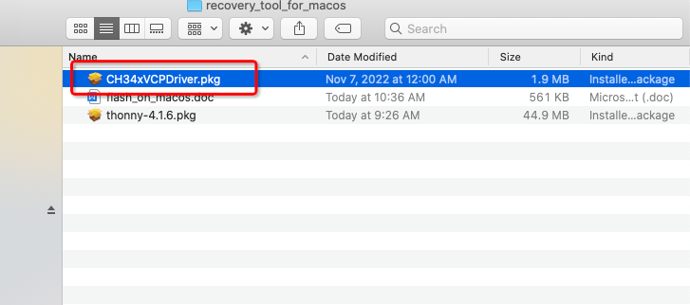
1.2 And you can install it follow these steps
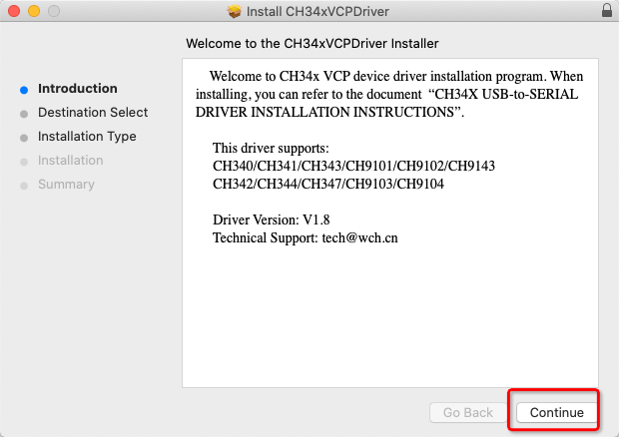
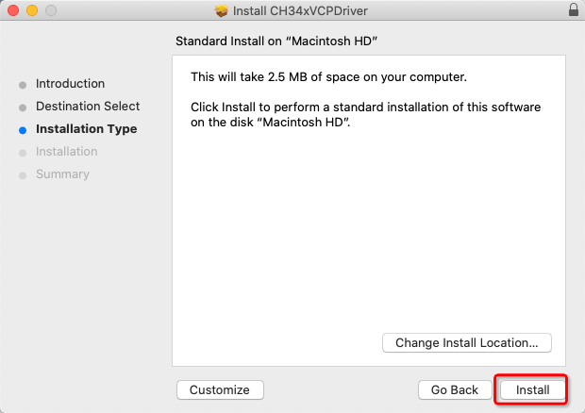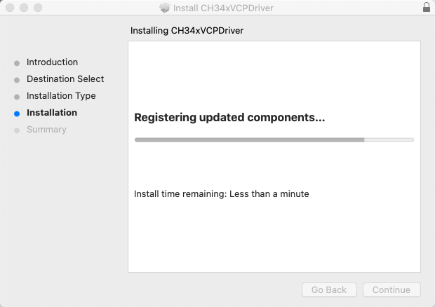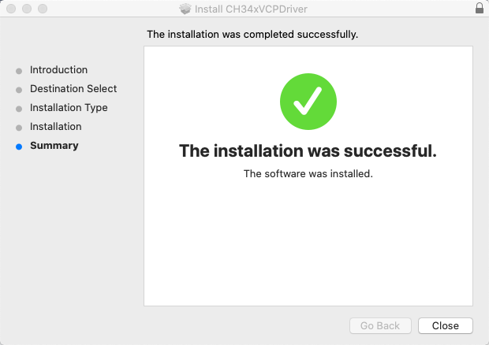
1.3 allow the use driver by following this step(important):
- go to system Preferences page and click “Security& Privacy”
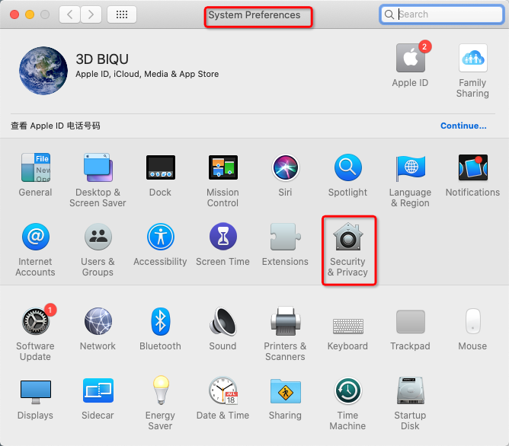

- mark sure the this driver will not be stopped by this setting
if it has been stopped it will show something like “jiangsu...”
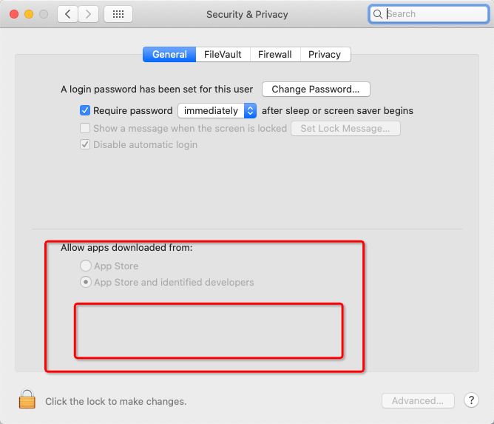

2 reboot you computer(we have to do this step before go to step3)
3 check out the use driver
3.1 Click about this mac on the left corner
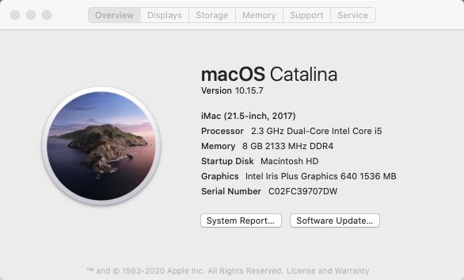

3.2 go to system report page and make sure that the vendor id is 0x1a86
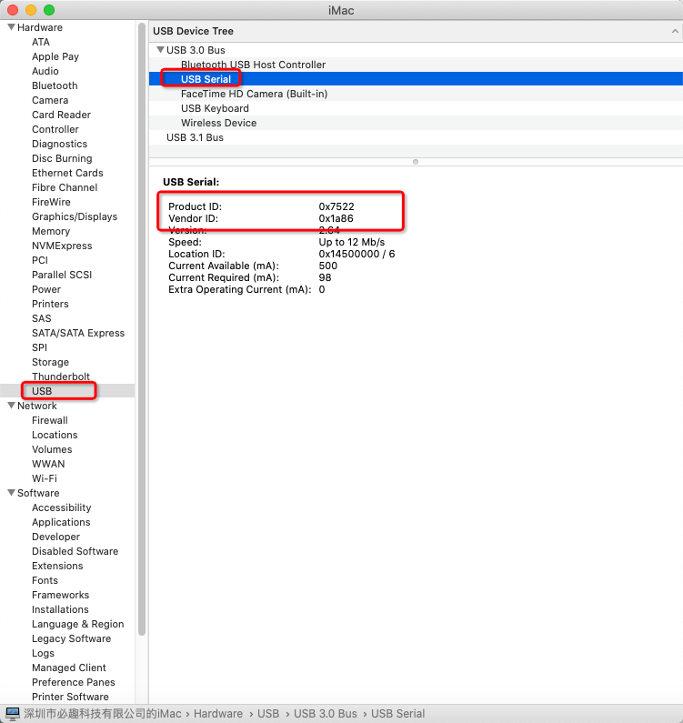

3.3 open your terminal
input this command
”ls /dev/tty.wch**”
you will find the name of device
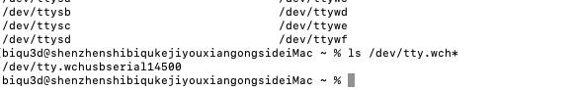
3.4 install thonny
- double click the file named “thonny-4.1.6.pkg”
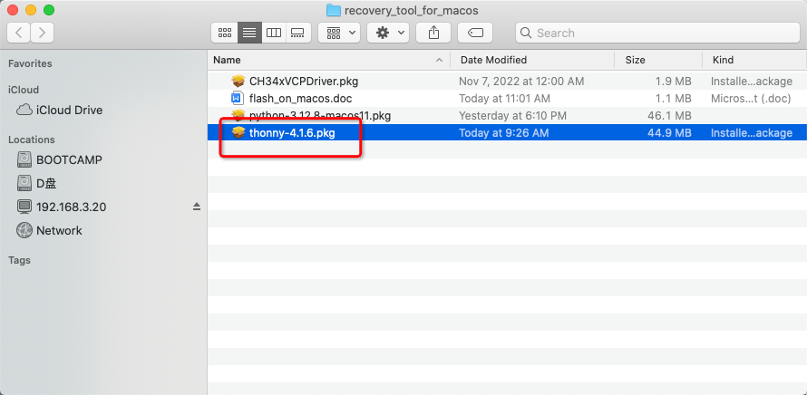
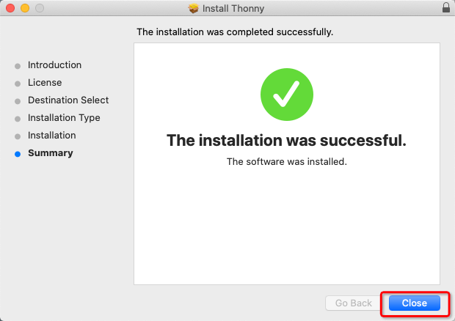
3.5 configure
-go to configure page
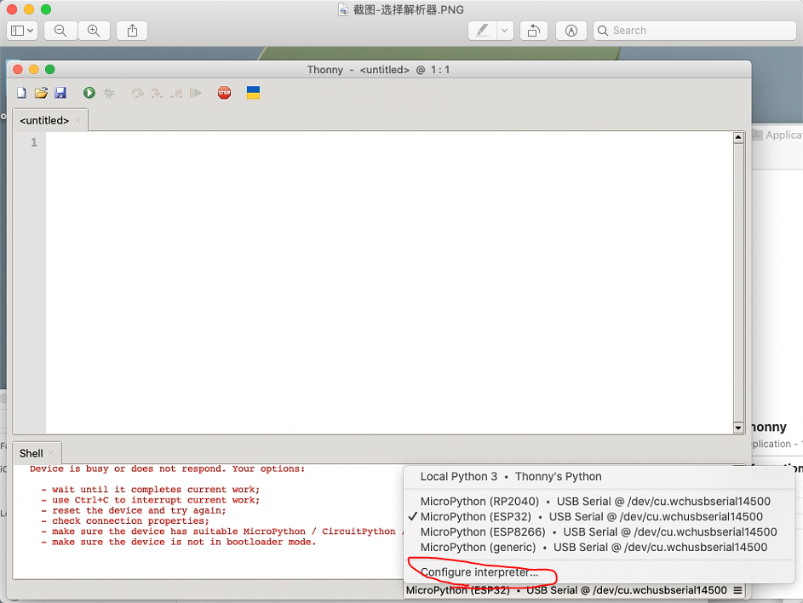
-choose esp32
-click “install or update MicroPython(esptool)”

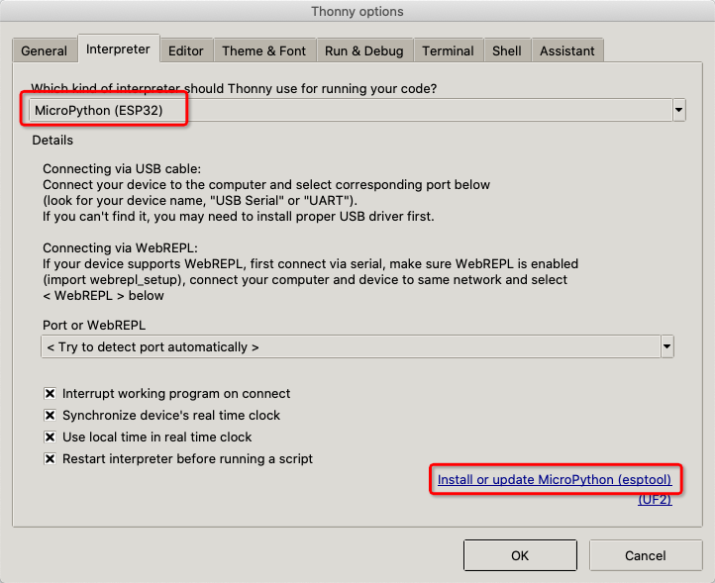
- select the bin file
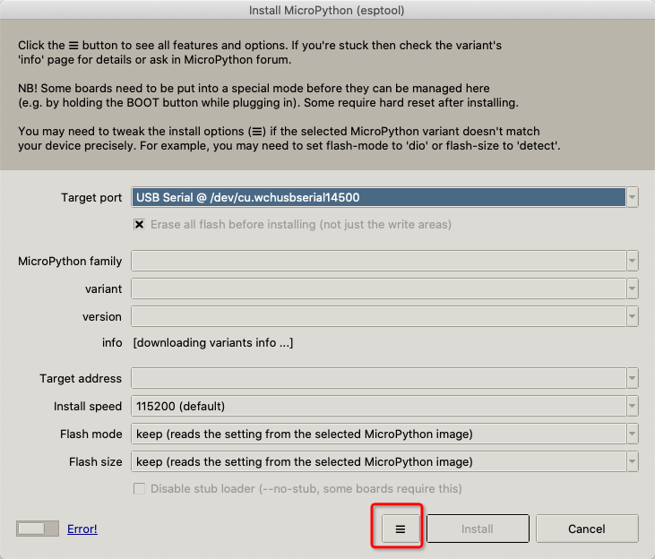
- select local Micropython image ...
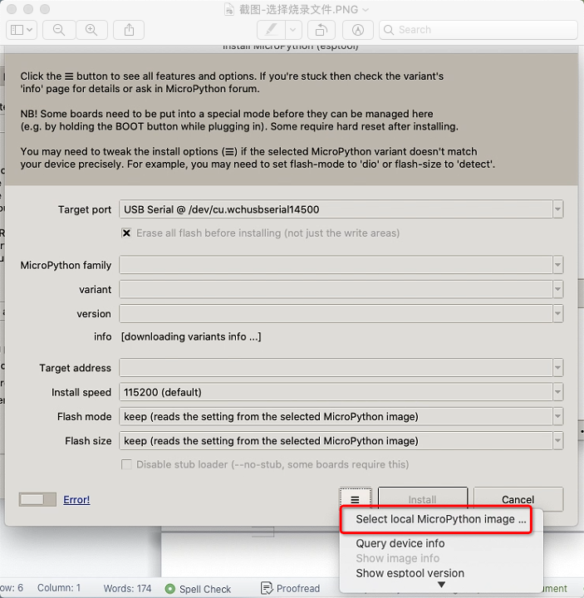

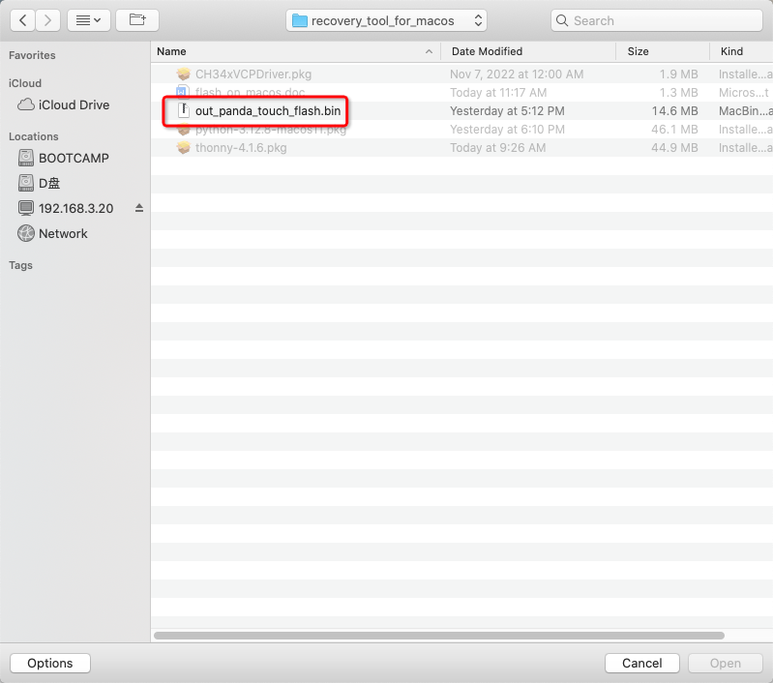

4 start flash
Make sure that the configure is same as this picture:
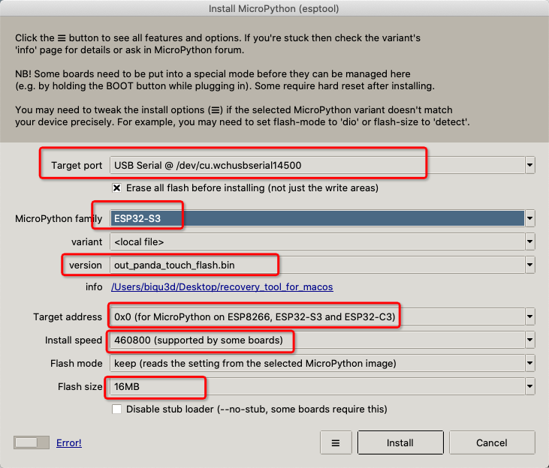

-click ”install” to start flash
- you need to wait for a while


- please wait for a while don’t click “cancel”
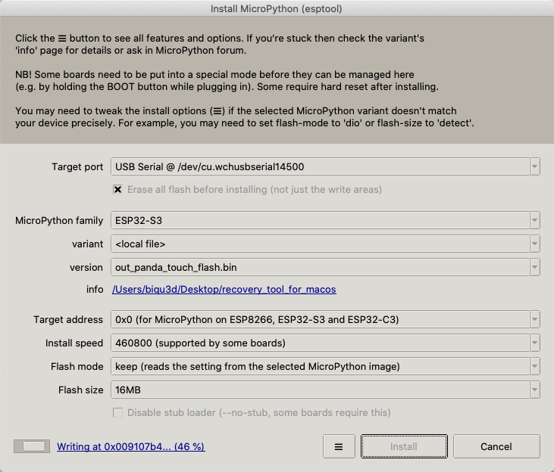
- The panda touch will reboot once it is finished.
