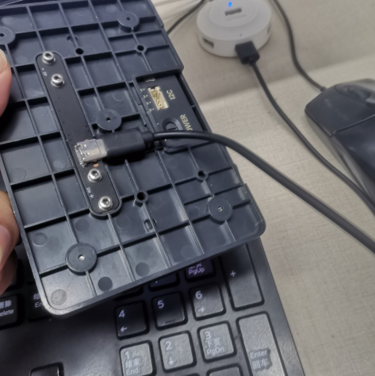
Please make sure that Panda Touch is connecting with PC by usb cable (type-c charger cable) before you do this.
1 open a browser from computer type-in this address:
https://espressif.github.io/esptool-js/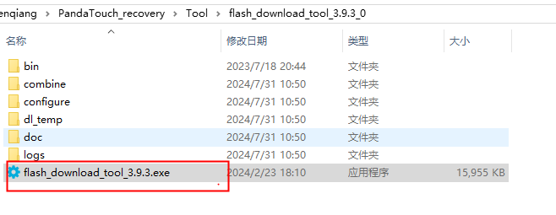

2 click “connect”
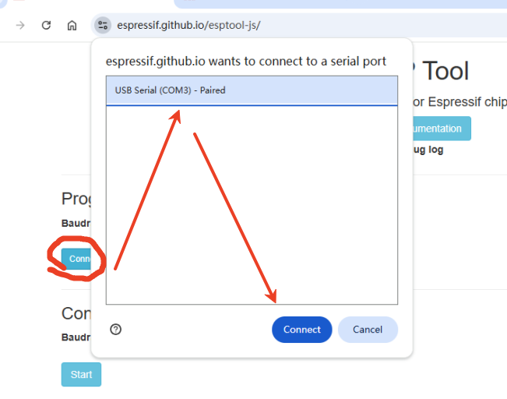
3 Click the ERASE and Waiting for completion
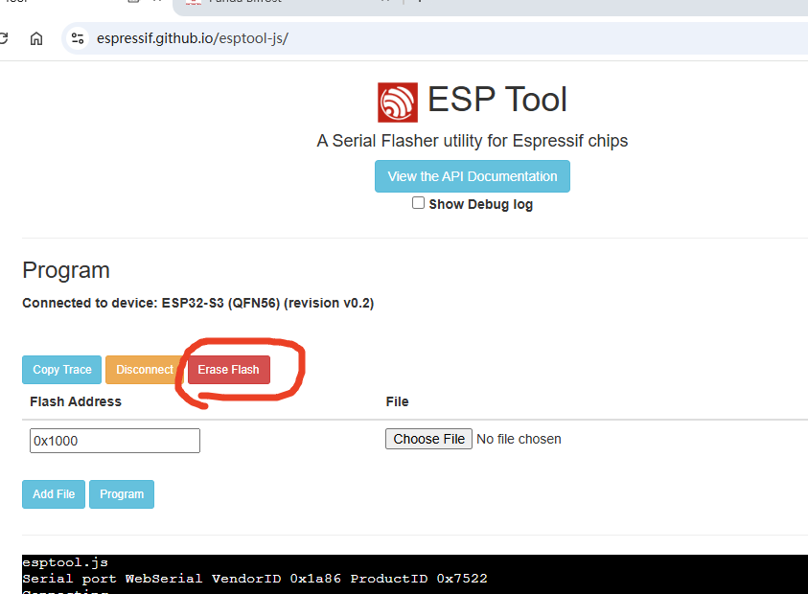
4 choose files and type-in the address of flash
