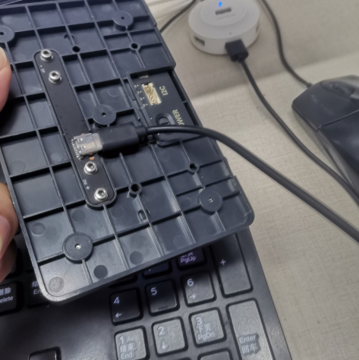
Please make sure that Panda Touch is connecting with PC by usb cable (type-c charger cable) before you do this.
1 click this exe file 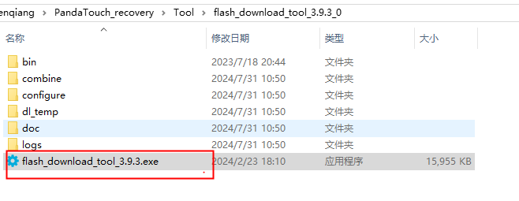
2 select ESP32-S3
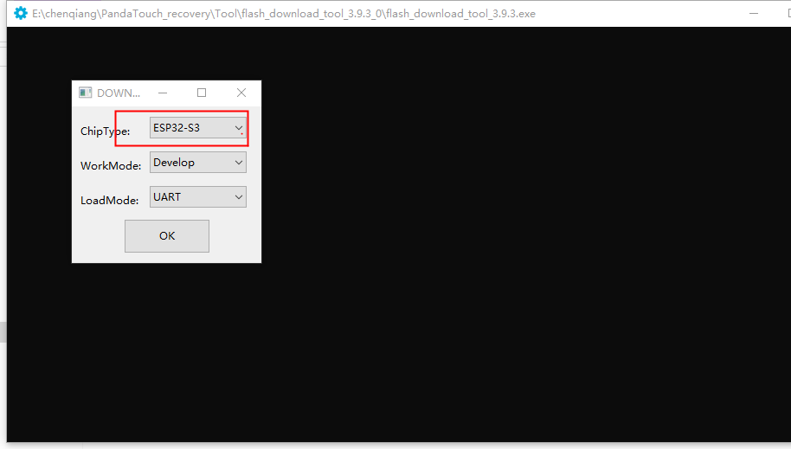
3 Click“flash_dowmload_tool_3.9.3.exe ”
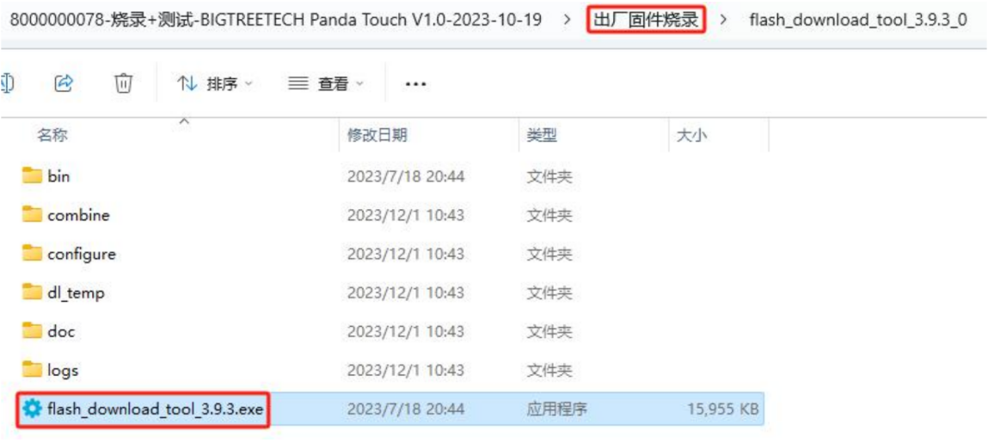
4 Click the ERASE and Waiting for completion
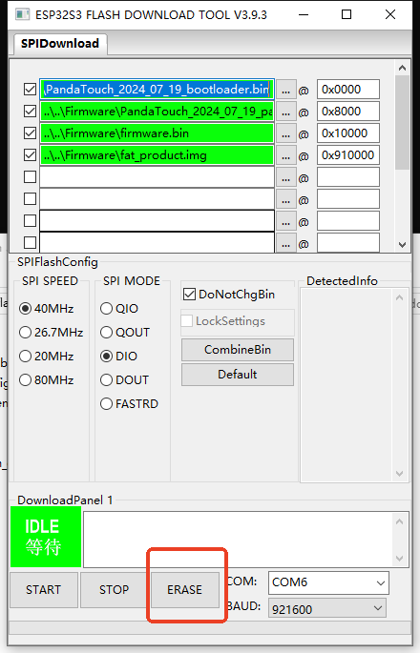
5 Click the START and Waiting for completion
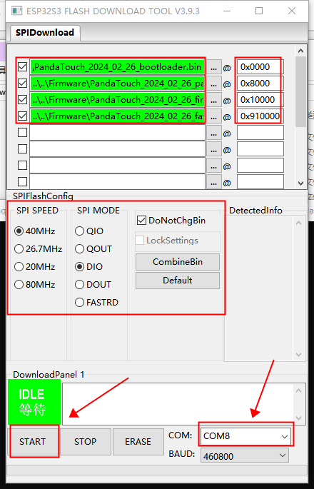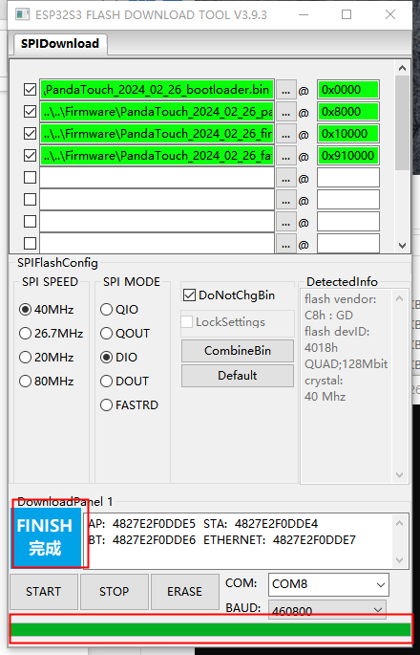

6 Change the power supply mode waiting for rebooting

