1 download the mqttx tool from this link
https://www.emqx.com/en/downloads/MQTTX/v1.11.1/MQTTX-Setup-1.11.1-ia32.exe
2 connect to printer by mqtt
2.1 create connection
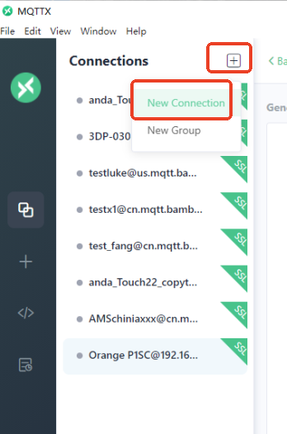
2.2 edit parameters
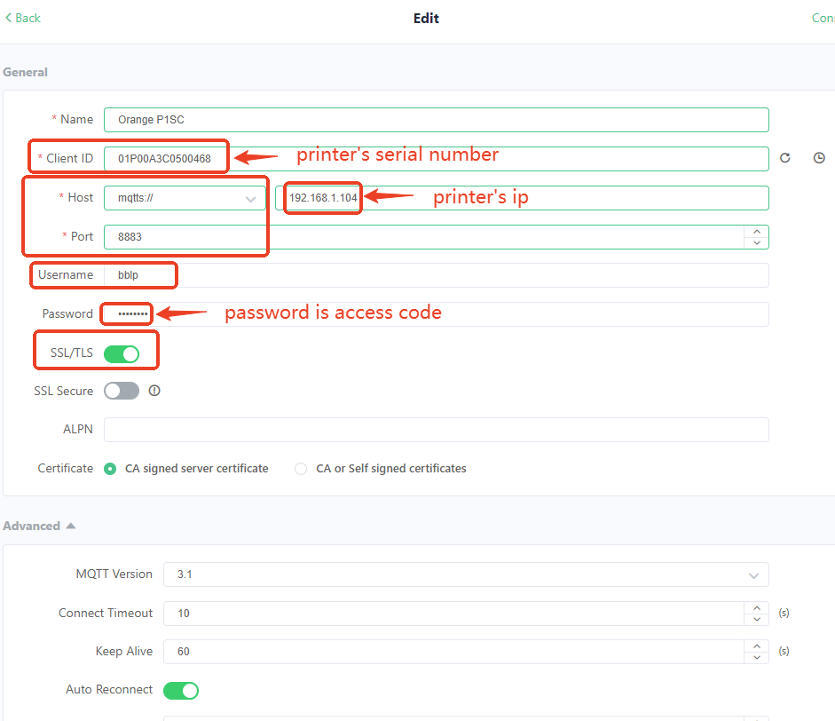
2.3 click connect
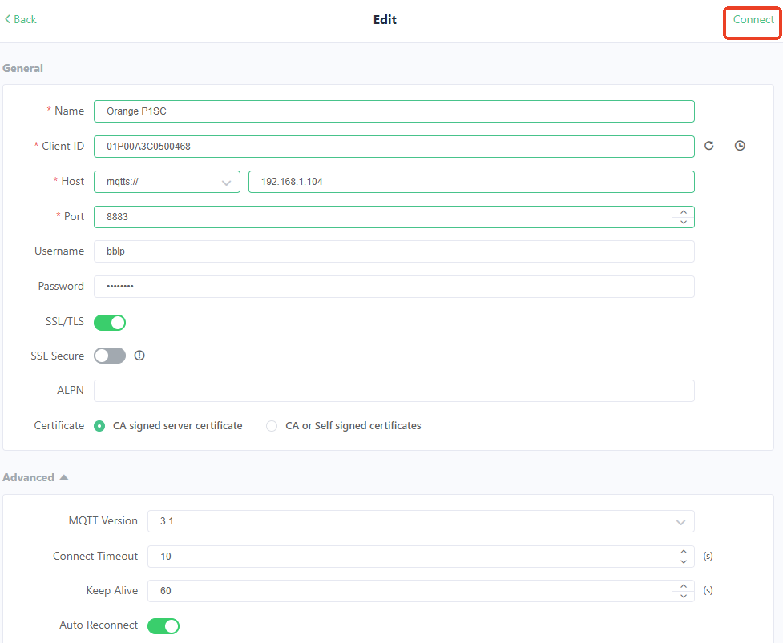
3 subscription
set Topic to device/01P00A3C0500468/report and click confirm
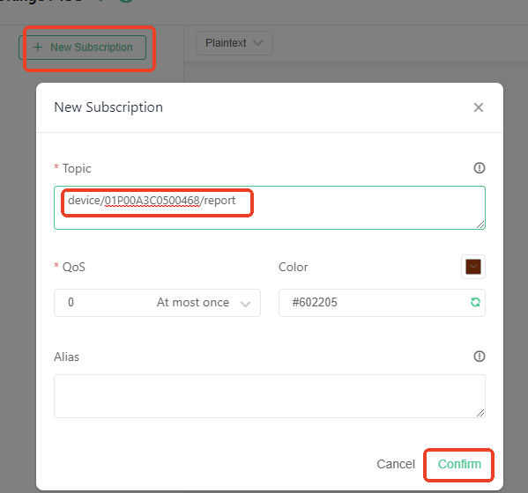
4 start a new print task from the original screen of printer
you can select the a3 before printing
you can send me the logs after you start a new printing task.
