Please make sure that Panda Bamboo feeder is connecting with PC by usb cable (type-c charger cable) before you do this.
1 open a browser from computer and type-in this address:
https://espressif.github.io/esptool-js/
2 click “connect”
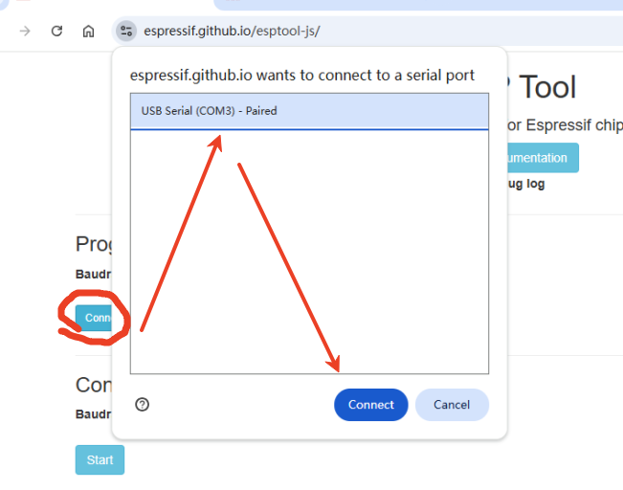
3 Click the ERASE and Waiting for completion
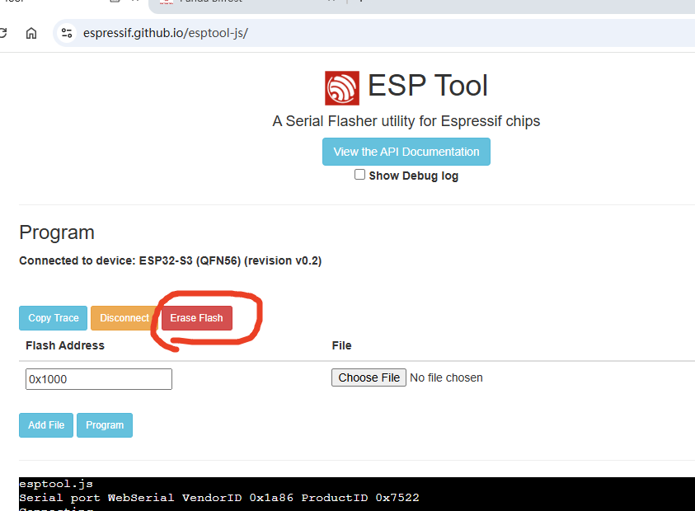

4 choose files and type-in the address of flash


