Zachary Bigwood
30326688
Michael Nelson
Using Models 1
Q1. 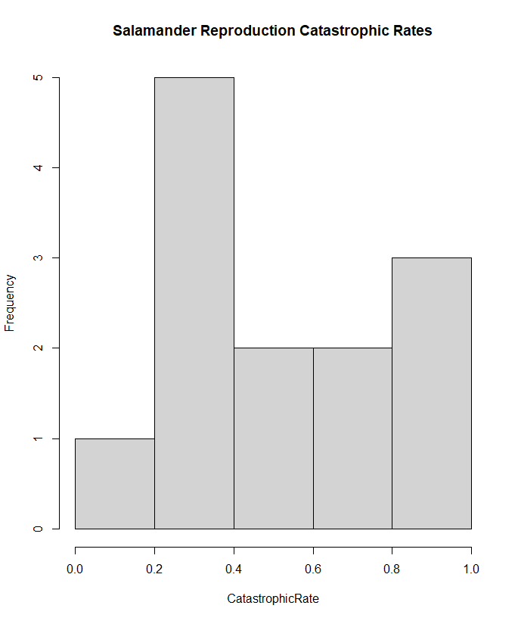

Q2. Code to check for normality in cat.rate of marbled salamanders:
shapiro.test(catrate$cat.rate)

Q3.
Pt 1: The typical null hypothesis for the Shapiro test is to see if the data were sampled from a normally distributed population.
Pt 2: Since the P value is so low at 0.04097 this suggests that there is good evidence against the null hypothesis so the data is not sampled from a normally distributed population.

Q4.
Pt 1: The null hypothesis of the test is that we assume the difference between the actual mean and the value we use for comparison are both equal to zero.
Pt 2:
t.test(catrate$cat.rate, mu = 0)

Q5.
Pt 1: The p value is 3.99 x 10^-5
Pt 2: The confidence interval between the null hypothesis and alternative hypothesis is that the true mean is not equal to 0.
Pt 3: Since the P-value is so close to zero I think that there is enough evidence to reject the null hypothesis in this case.

Q6.
wilcox.test(catrate$cat.rate, mu = 2 / 7)

Q7.
Pt 1: The p-value is 0.006275.
Pt 2: Since the p-value is again lower than the threshold of 0.05 we should reject the null hypothesis.

Q8.
Pt 1: I think when you consider both tests the t.test might have been more appropriate for this data set.
Pt 2: With the t.test we get a useful sample estimate of the mean whereas with the wilcox test we only get a value that the mean is not. I think that even though you can reject the null using both methods the extra information you get using the t.test is more beneficial.

Q9.
Pt 1:
dat_adelie = subset(penguin_dat, species == "Adelie")
shapiro.test(dat_adelie$flipper_length_mm)
dat_chinstrap = subset(penguin_dat, species == "Chinstrap")
shapiro.test(dat_chinstrap$flipper_length_mm)
Pt 2:
Knowing that p-values larger than 0.05 mean a normal distribution I would conclude that both penguins’ flipper lengths are normally distributed.

Q 10.
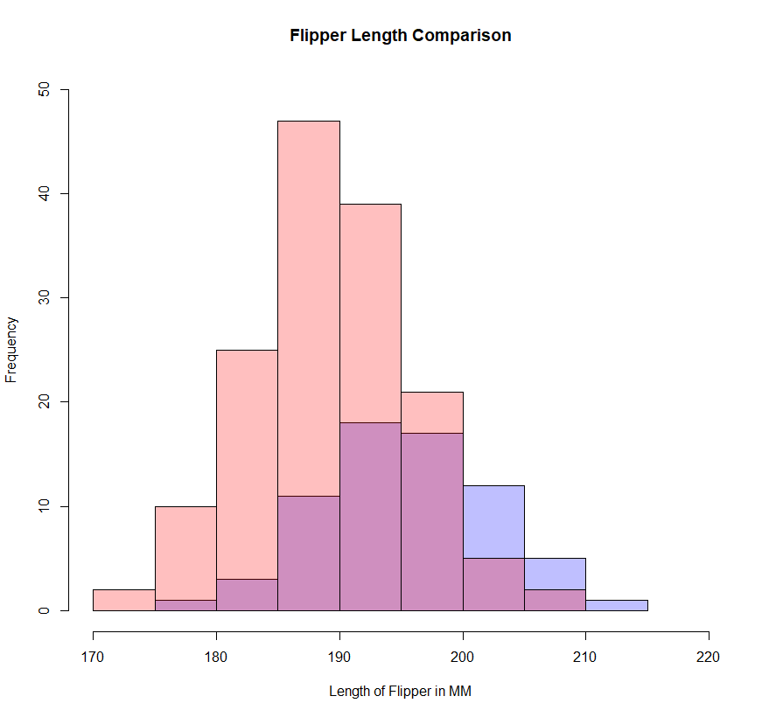
I realized after I did this that you wanted them next to each other not stacked but as I had already done this, I figured I might as well leave it up.
Here is the actual one:
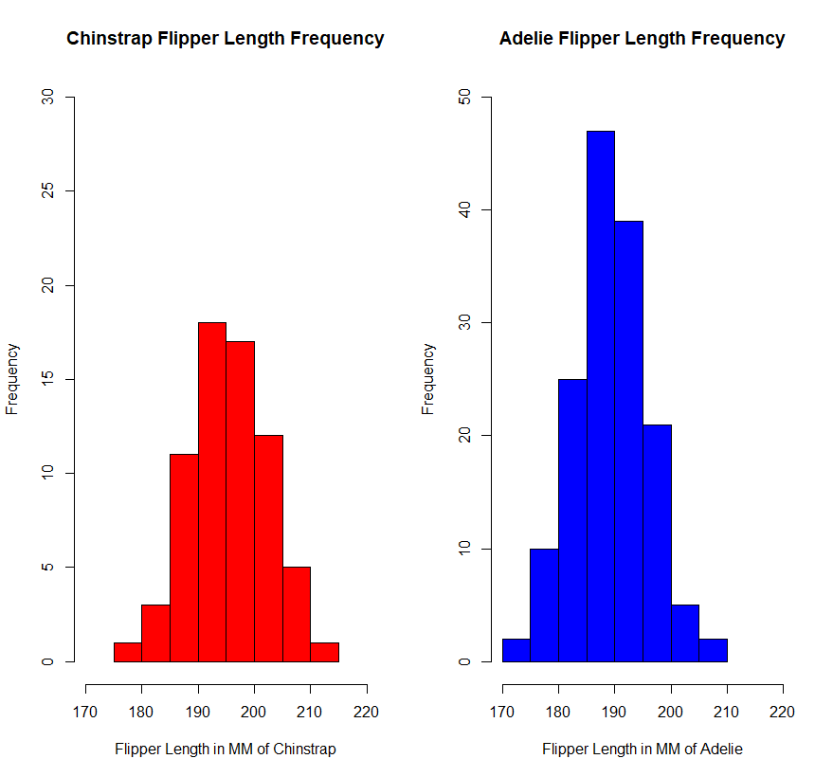

Q11.
Pt 1: The p-value is below our threshold of 0.05 so I would reject the null hypothesis in this case. I think we are still doing a one tailed test so we are looking again at the lower 5% of values so rejecting makes sense.
Pt 2:
t.test(flipper_length_mm ~ species, data = penguin_dat)

