**UNIT- 1**

Q. **Define Human resource management.**

A. Organizations are nothing but people. They utilize—physical, financial and human – to produce result. When people work to the best of their abilities and work with zeal, enthusiasm and commitment, organisation grow to gigantic proportions.

HRM is the process of acquiring, training, appraising, and compensating employees, and attending to their labour relations, health and safety and fairness concerns.

The “People” or personnel aspects of a manager’s job include:

* Conducting job analyses.
* Planning labour needs and recruiting job candidates
* Selecting job candidates
* Orienting and training new employees.
* Compensating employees
* Providing incentives and benefits.
* Appraising performance
* Communicating (interviewing, counseling, discipline)
* Training and developing managers
* Building employee commitment.

And what a manager should know about:

* Equal opportunity and affirmative action.
* Employee health and safety
* Handling grievances and labour relations.

Definitions:

**According to Terry**, HRM is not a one shot deal. It cannot be practiced only one hour each day or one day a week. It requires a constant alertness and awareness of human relations and their importance In every day operations.

HRM tries to build and maintain cordial relation between people working at various levels in the organisation. In short, it tries to integrate human assets in the best possible manner in the service of an organisation.

**Q. Discuss the objectives of Human Resource Management :**

**A. Primary objectives are:**

Human resource managers need to get the right people into the right place at the right time and then help tem maximize their performance and future potential. The principal objectives of HRM may be listed thus:

1. **To help organisation reach its goals:** HR department, like other department in an organisation, exits to achieve the goals of the organisation first and if it does not meet this purpose, HR department will wither and die.
2. **To employ the skills and abilities of the workforce efficiently:** the primary purpose of HRM is to make people’s strength productive and to benefit customers, stockholders and employees. Keep your employees happy and encourage them to do everything possible to keep customers happy. The results would b truly outstanding-like take the case of Southwest airline- delivering outstandingresults for over three decades- based on its” employees first and customer next” policy.
3. **To provide the organisation with well- trained and well-motivated employees:** HRM requires that employees be motivated to exert their maximum efforts, that their performance be evaluated properly for results and that hey be remunerated on the basis of their contributions to the organisation.
4. **To increase the fullest the employee’s job satisfaction and self-actualization**: it tries to promote and stimulate every employee to realize his potential. To this end programmes have to be designed aimed at improving the quality of work life.
5. **To develop and maintain a quality of work lif**e: it makes employment in the organisation a desirable, personal and social, situation. Without improvement in the quality of work life, it is difficult to improve organizational performance.
6. **To communicate HR policies to all employees**: it is the responsibility of HRM to communicate in the fullest possible sense; tapping ideas, opinions and feelings of customers, non- customers, regulator and other external public a s well as understanding the views of internal human resources.
7. **To be ethically and socially responsive to the needs of society**: HRM must ensure that organisation manage, human resources in an ethical and socially responsible manner trough ensuring compliance with legal and ethical standards.

**Other Objectives of HRM**

**SOCIETAL OBJECTIVES:**

* To be ethical and socially responsible to the needs and challenges of the society while minimizing the negative impact of such demands upon the organization.
* The failure of organizations to use their resources for the society’s benefit in ethical ways may lead to restrictions. E.G.- Society may limit HR decisions through law that enforce reservation in hiring and laws that address discrimination, safety or other such areas of societal concern.

**FUNCTIONAL OBJECTIVES:**

* To maintain the department’s contribution at a level appropriate to the organization’s needs.
* Resources are wasted when HRM is either more or less sophisticated to suit the organizations needs.
* The departments level of service must be tailored to fit the organization it serves.

**ORGANISATIONAL OBJECTIVES:**

* To assist employees in achieving their personal goals, at least in so far as these goals enhance the individual’s contribution to the organization.
* Personal objectives of the employees must be met if workers are to be maintained, retained and motivated otherwise, employee performance and satisfaction may decline and employee may leave the organization.

**Q Discuss the nature of HRM.**

**A.**

* HRM is a Management function that helps managers recruit, select, train and develop members for on organization.
* Organizations comprise of people. It is the people who staff and manage organizations.
* HRM involves the application of management function and principles. The functions and principles are applied to acquisitioning, developing, maintaining, and remunerating employees in organizations.
* Decisions relating to employees must be integrated.

**Q. Define the term HRM. Discuss its Functions of HRM.**

Organizations are nothing but people. They utilize—physical, financial and human – to produce result. When people work to the best of their abilities and work with zeal, enthusiasm and commitment, organisation grow to gigantic proportions.

**Major functions of human resource management are as follows:**

1. **Managerial Functions :**

* Planning: this function deals with the determination of the future course of action to achieve desired results. Planning of personnel today prevents crises tomorrow. The personnel manager is expected to determine the personnel programme regarding recruiting, selection and training of employees.
* Organizing; this function is primarily concerned with proper grouping of personnel activities. Assigning of different groups of activities to different individuals and delegation of authority. Creation of a proper structural framework is his primary task. Organizing, in fact is considered to be the wool of the entire management fabric and hence cannot afford to be ignored.
* Directing: this involves supervising an guiding the personnel. To execute plans, direction is essential for without direction there is no destination. Many a time, the success of the organization depends on the direction of things rather then their design. Direction then consist of motivation and leadership.
* Controlling : controlling function of personnel management comprise measuring the employee’s performance, correcting negative deviations and industrial assuring an efficient accomplishment of plans. It makes individuals aware of their performance through review reports, records and personnel audit pogrammes.

1. **Operative Functions**

**Procurement:**

* **Job analysis**: it is the process of collecting information relating to a specific job.
* **HRP:**it is a process of determining and assuring that the organization will have an adequate number of qualified persons, available at proper times, perform jobs which would meet their needs and provides satisfaction for the individuals involved.
* **Recruitment:**it is the process of searching and stimulating prospective candidate for an job.
* **Selection:**it is the process of ascertaining qualifications, experiences, skill and knowledge of an applicant with a view to appraising his / her suitability to the job in questions.
* **Placement: it is the** processes that ensure the 360 degree fir, matching the employee’s qualifications, experiences, skills and interest with the job on offer.
* **Induction and orientation:**induction and orientation are the techniques by which a new employee is rehabilitated in his new surroundings and introduced to the practices, policies and people**.**
* **Internal mobility:** movement of employees from one job to another through transfers and promotion.

**Development:**it is the process of improving, moulding, changing and developing b the skills, knowledge, creative ability, aptitude, attitude, values and commitment based on present and future requirements both at the individuals and organisation’s level. This function includes:

**Training**: training is a continuous process by which employees learn skills, knowledge, abilities and attitudes to further organizational and personnel goals.

**Executive development**: it is a systematic process of developing managerial skills and capabilities through appropriate programme.

**Career planning and development**: it is the planning o one’s career and implementation of career plans by means of education, training, job search and acquisition of work experience.

**Human resource development**: HRD aims at developing the total organisation. It creates a climate that enables every employee to develop and use his capabilities in order to further both individual and organizational goals.

**Motivation and compensation**

It is the process which inspires people to give their best to the organisation though the use of intrinsic rewards( achievement, recognition, responsibility) and extrinsic rewards ( job design , work scheduling, appraisal based incentives).

Job design: organising tasks, and responsibilities towards having a productive unit of work is called job design. The main purpose of the job design is to integrate the needs of the employees to suit the requirement of an organisation.

Work scheduling: organisations must realise the importance of schedule at work to motive employees trough job enrichment, shorter work weeks, flexi-time, work haring and home work assignments.

Motivation: combing forces that allow people to behave in certain ways is an integral aspect of motivation.

Jo evaluation: organisation formally determine the value of jobs through the process of job evaluation. Job evaluation is the systematic process of determine the relative worth of jobs in order to establish which jobs should be paid more than others within the organisation.

Performance appraisal: after an employee has been selected for a job, has been trained to do it and has worked on it for a period of time, his performance should be evaluated. Performance evaluation or appraisal is the process of deciding how employees do their jobs.

Compensation administration: compensation administration is the process of dividing how much an employee should be paid.

Incentives and benefits: in addition to a basic wage structure, most organisation now a days offer incentive compensation based on actual performance.

**Maintenance: it aims at protecting and preserving the physical and psychological health of employees through various welfare measures.**

**Health and safety:** managers at all levels are expected to know and enforce safety and health standards throughout the organisation. They must ensure the work environment that protects employees from physical hazards**.**

**Employee welfare:** employee welfare includes the service, amenities and facilities offered to employees within or outside the establishment for their physical, psychological and social well being.

**Social security measures: management provide social security to their employees in addition to fringe benefits. These measures include:**

1. Workmen’s compensation to those workers who are involved in accidents
2. Maternity benefits to women employees.
3. Sickness benefits and medical benefits.
4. Disablement benefits/ allowance

**Integration function:**this tries to integrate the goals of an organisation with employee aspiration though various employee- oriented programme, like redressing grievances promptly, instating proper disciplinary**.**

**Emerging Issues:** effective management of human resources depends on refining HRM practices to changing conditions. Hence the need to look at other important issues that can motivate people to give their best in a dynamic and ever-changing environment.

**Q. Elaborate the Process of HRM**

**A.**

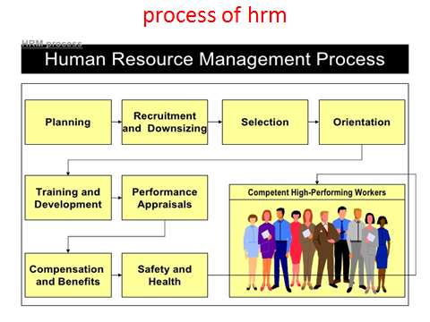

* **HRP:** it is process that identifies current and future human resource needs for an organisation.
* **Recruitment**: Attracting, selecting & appointing suitable candidates for jobs ( either permanent or temporary) within an organisation.
* **Downsizing:**It is reducing the number of employees on the operating payroll.

**Rightsized**: it reduce the size of a company by shedding staff.

* **Employee orientation** is an assimilation process in which new hires are introduced to the company and co-workers.
* **Training:** the action of teaching a person
* **Performance appraisal**: A **performance appraisal** is a systematic and periodic process that assesses an individual employee's **job performance and productivity** in relation to certain pre-established criteria and organizational objectives
* **Compensation:** what a person is paid".
* **Safety :** Each year, we organize a safety week and in 2013 they focused on raising awareness about manual handling and ergonomics ( **interaction between human being)**
* High performing team: High performance teams is a concept within organisation, where team are highly focused on their goal .

**Q. Discuss the evolution of HRM.**

**A**

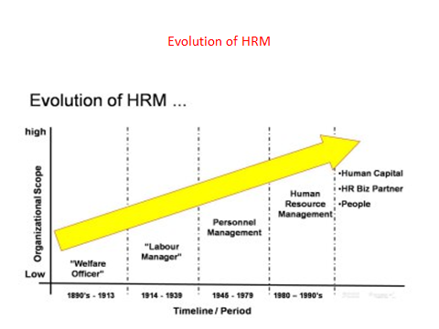

* **Welfare officer:**
* It is anyone whose job is to ensure the wellbeing or survival of any distinct group of people.( under privilege individuals)
* ( food, shelter, employment)
* **Labour manager**: Labour relations managers and officers, also known as industrial relations specialists, implement industrial labour relations programmes.
* **Personnel manager**: a ​person who is in ​charge of the ​department that ​deals with the ​employment, ​training, ​support, ​records, etc. of a company's ​employees: The ​function of a ​personnel ​manager usually begins with the ​staffing ​process.
* **Human capital:** the skills, knowledge, and experience possessed by an individual or population, viewed in terms of their value or cost to an organization or country.
* **HR biz partner**: HR business partners are HR professionals who work closely with an organization's senior leaders in order to develop an HR agenda that closely supports the overall aims of the organisation. (David Ulrich)

**Q.What do you mean by Strategic HRM? Discuss its role in the organization.**

**A.**

**INTRODUCTION:**

Strategic management is drafting, implementing and evaluating cross-functional decisions that will enable an organization to achieve its long-term objectives (David, 1989). It is the process of specifying the organization’s mission, vision and objectives, and developing policies and plans, often in terms of projects and programs. A balance scorecard is often used to evaluate the overall performance of the business and its progress towards objectives.

There are two ways of looking at strategy. First is the mainstream view which sees strategy as a plan; and second is the processual view that sees strategy as a pattern.

***Mainstream view:*** It describes strategy as a plan.

(i) Strategy is plans made up top managers and their corporate strategy advisors.

(ii) Strategy is a matter of policy and it precedes action.

(iii) Strategy and implementation are separate.

***Processual view:*** It describes strategy as a pattern.

(i) Strategies are more usefully seen as the outcome of both planned and unplanned activities.

(ii) Policies often emerge out of actions that have already been taken.

(iii) Strategy and implementation tend to happen simultaneously.

Strategic Human Resource Management (SHRM) is concerned with the contribution that human resource strategies make to organization effectiveness and the ways in which these contributions are achieved. Strategy is the critical factor that affects an organization percolates. It contributes to competitive advantage in markets with a long-term focus. It involves the top executives and percolates down the hierarchy. It provides a general framework for selecting specific policies and procedures. SHRM can be conceptualized as the broad pattern to be observed in the various practices undertaken to ensure that human efforts, skills and commitments are obtained, developed and sometimes discarded to help bring about the long-term survival of an organization.

**Q. state the difference between HR and SHRM.**

|  |  |
| --- | --- |
| Human Resources | Strategic Human Resource Management |
| The efforts, skills or capabilities that people contribute to an employing to enable it to continue its existence. | The general direction followed by an organization in how it secures, develops and from time to time dispenses with human resources to help it continue in the long-term. |

**Q. Briefly explain the scope of SHRM.**

The scope of a SHRM ranges from what would readily be recognized as 'big' or obviously strategic matters, like the choice of a particular organizational structure or the favoring of a specific cultural style, down to very particular and detailed matters such as how people are expected to dress at work .

Over time there has been a shift from 'show what' to 'show how', shifting to the domain of fit or alignment (Dyel and Shafer, 1979). The fit can be either vertical or horizontal. Vertical fit represents the degree of alignment between: a) components of an organization's human resource strategy, and b) core features of its business strategies. Horizontal fit represents the degree of alignment, among the components of organizations business strategy (typical activities or programs such as selection, training and compensation).

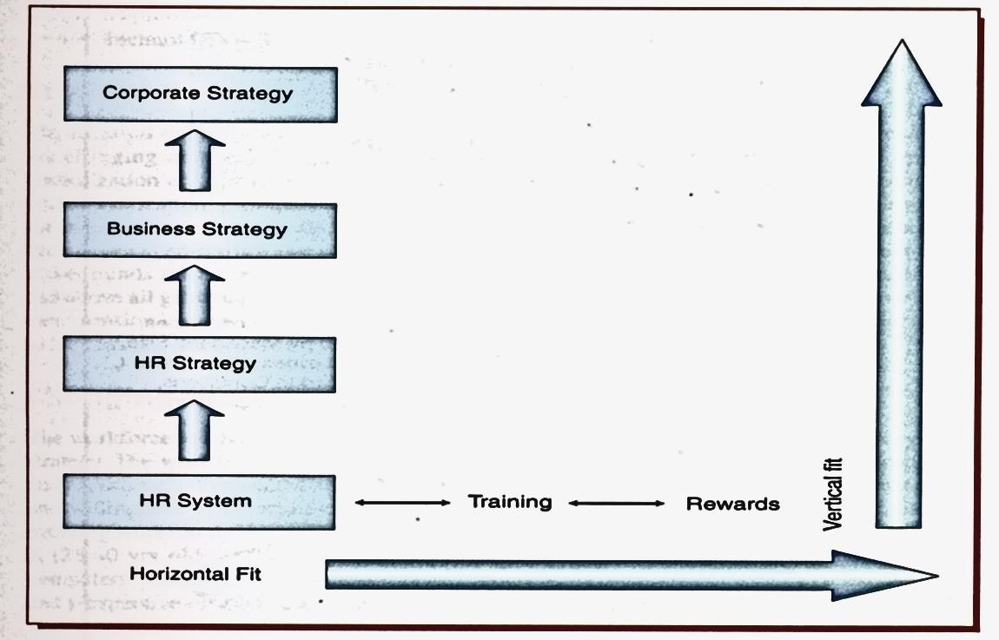

***(Figure: HR Strategy: Strategic Fit)***

Each organization's SHRM would be a unique mixture of different practices and styles. But this would be to deny any kind of notion to 'fit' or integration, whether this is *vertical integration* between the SHRM and the organizational context or *horizontal integration* between different elements of human resourcing principles and practices.

The two alternative key principles that give analytical starting point for comparing SHRM (and hence, informing the strategic choices that might be made) are those of *direct control/low commitment* and *indirect control/high commitment*.

*Two Key and Alternative Human Resourcing Principles*

|  |  |
| --- | --- |
| Direct control/low commitment | Indirect control/high commitment |
| * Employees given little discretion, closely supervised. * Limited ‘psychological’ commitment sought from employees. | * Employees ‘empowered’- encouraged to use discretion and monitored. * High ‘psychological’ commitment sought from employees. |

Recruitment, selection, employee development and deployment policies and practices all follow from this basic choice. It might lead to practices that combine aspects of the two principles. The pattern of 'lean production' seen in some car-assembly plants would be an example of this (Womack, Jones and Roos, 1990). The term 'human resource management' is often used to refer to human resourcing practices based on *indirect control* and *high commitment principles.*

**Q. state and discuss the factors influencing HR strategy**

Five key factors influence the HR system

1. External environment
2. Changing workforce
3. Organization culture
4. Organization structure
5. Technology

The external environment broadly comprises of social, political, legal and economic trends. The social values are changing and so are the roles. The definition of a family has changed and now the work culture is 24/7. Globalization and internationalization have broadened the diversity of values and culture. Political trends in India with liberalization, globalization and opening of FM, reflect the issues that are most important in workplaces across the nation. These include focus on security, health care, tough competition, and global effect on business as has been experienced during the recession of 2008-2009. How recession in the west affected the Asian countries. The newer trends raise concern job security, exports and imports, expanding global market place, regional differences and above all growing economic interdependency among the countries of the world. Economic trends include health care, pension cost, and demand for corporate governance resulting from scandals, from Enron, Leyhman in the US to Satyam and 2G spectrums in India.

**Changing Workforce**

The workforce is becoming diverse and global. With global village and boundary-less arena, diversity is a business strategy. The workforce, hence, will further become more diverse and also complex because of the different needs and experiences. Organization will have a variety of problems and make a variety of decisions, but it needs tolerance and willingness to embrace change. HR has to manage the demographic and psychographic characteristics of an evolving workforce. The workforce comprises of Traditionalist (60-70 yrs. old), Boomers (41-59 yrs. old), Generation X (28-40 yrs. old) and Generation Y or millennials (27 and below). Generation Y are those who are born with computers. They are comfortable in a multicultural environment and have excess to internet information. Experience and perspective of workforce is one of the major factors influencing SHRM.

**Organization Culture**

Increasingly, the organizations around the world have adopted formal statements of corporate values, and honesty, integrity and corporate social responsibilities are the top issues on corporate agenda. Organizational culture is being recognized as essential for long-term success. Organizations are taking steps to align corporate culture to business strategy and to HR strategy. HR is playing a strategic role in shaping the values of the organizations right from hiring to developing. Impact of culture is becoming deeper as more organizations are becoming global, and the challenge is more when there is integration of cultures because of mergers and acquisitions. Culture is gradually getting translated into 'employer branding' and 'employer engagement'.

**Organization Structure**

New forms of organization structures have emerged making them more receptive and adaptive. New forms of structure have:

* Strong employee involvement, staying highly attentive and adaptive to the needs of stakeholders.
* Organic in structure with fewer rules and regulations, sometimes no clear boundaries and always changing forms.
* Authority based on capability, ensuring that the organization remains a means to an end and not an end in itself.
* Alliances, taking advantage of economies of scale, e.g. collaborations, networks, strategic alliance/mergers, etc.
* Teams sharing activities to take advantage of economies of scale with involvement of employees at the lowest levels.
* Comparatively flat, decentralized organizations have less middle management and lesser levels of hierarchy, resulting in top management exchanging more feedback and less overhead costs, Mindful of environments, changing patterns and themes, prioritizing on reflection and inquiry to learn from experience, developing learning organizations — the new structures, network structures, virtual organizations. Self-managed teams, self-organizing systems and learning organizations are also influencing the human resource management strategies. Also with changing structures, HR is the change agent, advocate and business partner in the organizational effectiveness.

**Technology**

Technology with all its self-service, anytime, anywhere communication capabilities are impacting SHRM. It is impacting both our personal lives and life at workplace and is still evolving; Cell phones, email, messaging, device like Blackberry and the like have blurred the lives between work life and home life. One is on call virtually everywhere and all the time. Gradually technology is giving way to Employee Relationship Management (ERM). Employee self-service is becoming important. Technology advances have raised issues on protection of privacy and security of HR data. Organization is becoming virtual because of technology. The arrangement of virtual workers and flexi work arrangements are a result of technology. Technology is enabling the **HR** strategies to look for HR solution framework and enable the management of employees from hire to retire.

**Q. Explain the link between business strategy and HR policies and practices with some model.**

There are various models that attempt to explore the link between business strategy and HR policies and practices.

1. Life cycle Model
2. Competitive Advantage Model

**Life cycle Model**

This model was developed by Kochan and Borocci. According to this model, the policies and practices of the organization should fit the relevant stage of an organization development or life cycle.

* **Introductory stage**

At this startup phase of the business, there is an emphasis on 'flexibility' in HR to enable the growth of business and faster entrepreneurialism.

* **Growth stage**

At this stage, when the business grows beyond a certain size, emphasis moves to the development of formal **HR** policies and procedures.

* **Maturity stage**

At this stage, as the market matures, margins decrease the performance of certain products or the organization plateaus, and then the focus of HR strategy is on cost control.

* **Decline stage**

At this stage, the emphasis shifts to rationalization, downsizing and redundancy implications for the HR function. (see figure below)

|  |  |
| --- | --- |
| **Life Cycle Stages** | **HR Practices** |
| **Start-up** | * **Flexible patterns of work** * **Recruitment of highly motivated and committed employees** * **Competitive pay** * **Little formality** * **No unions** |
| **Growth** | * **More sophisticated recruitment and selection** * **Training and development** * **Performance management processes** * **Reward systems** * **Focus on high commitment** * **Developing stable employee relations** |
| **Maturity** | * **Attention to the control of labour costs** * **Focus on increasing productivity** * **Strained employee relations** * **Control compensation** |
| **Decline** | * **Emphasis on rationalization of workforce and downsizing** * **Abandoning some longstanding practices to cut costs** * **Trade unions have a marginalized role** * **Retraining and career consulting services** |

There are various issues emerging for the SHRM. How can the SHRM secure and retain the type of human resources that are necessary for the organization's continued viability as industries and sectors develope?

Which FIR policies and practices are more likely to contribute to sustainable competitive advantage as organizations go through their life cycle?

Two kinds of mature organizations manage to survive industry development:

1. The firm that succeeds in dominating the direction of industry change
2. The firm that manages to adopt the direction of change

The route to the advantage of SHRM lies in the preparation for retaining viability and competitive advantage in the mature phase.

The model also keeps the organization agile by building the internal capacity to flex and adapt to changes in the external context and by enabling the business to change as a matter of course.

**Competitive Advantage Model**

This model was developed by Porter in 1985. It has three major parameters:

*(i) Cost leadership, (ii) Differentiation, and (iii) Focus.*

(i) *Cost leadership* focuses on the delivery of efficiency mainly through 'hard' HR techniques

(ii) *Differentiation* is focus on the delivery of added values through 'softer' HR techniques and policies

(iii) *Focus* is on softer HR techniques/policies for the delivery of added value

According to the model, the business performance will improve when HR practices mutually reinforce the organization's choice of competitive strategy. Herein, the mission and values are expressed through their desired competitive strategy.

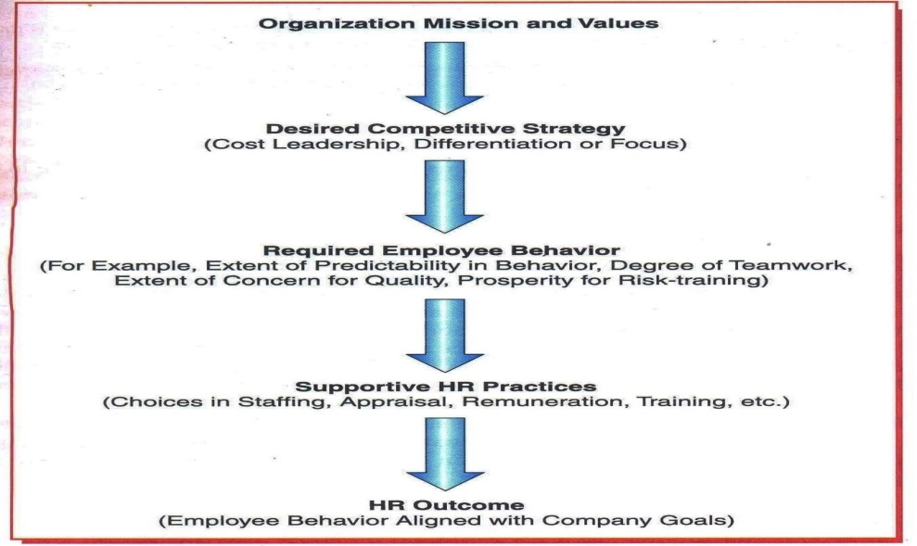

(Figure 2.3: Competitive Advantage Model and HR)

The best fit model is the one in which SHRM becomes more effective when it is designed to fit certain critical contingencies in the organization's specific context. A major criticism on both the models is that they tend to ignore the employees' interest in pursuit of enhanced economic performance and they endanger diversity rather than uniformity in SHRM. When SHRM advocates universalism, the organizations are better off identifying and adopting the 'best practices' for managing people.

SHRM has to be aligned with the corporate strategy and various functions of HRM. The process has to be in the context of internal and external factors that influence the organization.

**Q. Discuss the role of SHRM in HRM functions.**

**SHRM and Human Resource Planning**

Strategic Human Resource Planning considers both internal and external environmental influences on an organization, its objectives, culture and structure. The planning must reflect the environmental trend and that may affect its human resources. Globalization, for example, has promoted the workforce to behave like capital flowing across the world to centers that offer the best return and the best future (Macken, 1999). Also an increasing number of women at work and dual careers depends on how good the child care facilities are, availability of part-time jobs, job security, flexi timing, maternity leave, etc. The HR has to forecast future human resource requirements and determine where they will come from. The success ultimately depends on how well its human resources are managed. However, there is a danger that it may become a fad, failing because it cannot satisfy unrealistic expectations of the management (Stone, 2002).

For such planning to be successful, the HR requires top management support. The HR needs to ensure that the organization does not start with an overly complex system, the communication between the HR and line managers is healthy, the HR plan is integrated with the organizations strategic plan and there is a balanced qualitative and quantitative approach to HR planning (Walker, 1972).

**SHRM and Recruitment Selection**

The pressures of competition, cost saving, downsizing and global skill shortages have made recruitment a top priority. Strategic recruitment avoids the risks and costly wastage of time by locating and attracting the rightpotential candidates to the right job openings within the organization. Strategic selection on the other hand links the selection activities to the organization strategic business objectives and culture, while selecting the long-term and short-term objectives are to be kept in mind. Strategically workforce can be developed to fulfill future needs. The business objectives and culture are the determining factors for selection and by employing like-minded people, organizations are able to increase the strength of their culture and reduce the possibility and consequences of undesired behavior *(Ogbonna, 1992)*. Hiring and retention is critical to the success of the HR and the organization. Poor selection decisions result in increased training time, labor turnover, absenteeism, accidents, industrial unrest, job dissatisfaction, and poor performance. A systematic selection process is essential to ensure that the person and the job match.

**SHRM and Performance Appraisal and Management**

The evaluation of organizational and employee performance permits the HR to check whether strategic business objectives are valid, are being successfully communicated throughout the organization and being achieved. Strategic performance management ensures that jobs are properly designed, qualified personnel are hired, trained, rewarded, and motivated to achieve the organizational strategic objectives (Stone, 2002). Companies that manage performance, outperform companies that do not with higher profits, better cash flows, stronger stock market performance, productivity gains, higher sales growth per employee, and an overall better financial performance (Mc Donald and Smith, 1995).

Strategic performance appraisal provides a dynamic link to all HR functions. Performance appraisal signals to managers and employees what is really important; it provides a way to measure what is important; it fixes accountability for behavior and result; and it helps to improve performance. Appraising and managing performance strategically are critical management responsibilities that are a vital part of the organization's strategic management process.

**SHRM and Training & Development**

Training and development have an important role in generating improved organizational performance and individual growth, but these should be aligned with corporate objectives if an organization is to gain any real benefit from expenditure. Developmental activities emphasizing key behaviors and competencies must be similarly highlighted in the organization's performance appraisal and reward systems (Pfeffer, 1998). Failure to link developmental activities to business objectives means that the organization's competitive strategy will not be supported, and training and development will take place for their own sake and will be determined by the popularity with management and employees. However, a strategic approach aims to meet an organization's specific business development to help the organization and individuals to compete more effectively, now and in the future.

**SHRM and Compensation:**

Compensation can help to reinforce the organization culture and key values and facilitate the achievement of its strategic business objectives. A study suggested that organizations that are seeking to gain a competitive advantage through high innovative strategy utilize remuneration practices that encourage, facilitate and reward strategy relevant behavior (Schuler and Jackson, 1988). Strategic compensation is a formidable communicator and can be a powerful instrument for change and also a major determinant of the culture of an organization. Reward systems by themselves will not change a culture, but they can help reinforce a designed culture (Mc Laughlin, 1991). In addition, compensation policies and practices should reinforce employee behavior that helps to achieve the organization's strategic business objectives and reinforce its desired culture.

**Q. Briefly explain the role of Strategic Human Resource Management in an organization.**

With the human resource management becoming more business-oriented and strategically focused, various new roles of HRM have emerged.

**Strategic Partner**

Human resource manager is becoming an essential part of the management team, running an organization and contributing to the achievement of the organization's objectives by translating business strategy into action.

With the changing role, the HR manager must develop business acumen, customer orientation and awareness of the competition, to be able to link business strategy to human resource policies and practices. The HR plays the role of strategic partner when they have the ability to translate business strategies into action.

**Administrative Expert** Efficiency of the HR lies in effective management of HR activities. To create value with the changed role, HR must be able to reengineer HR activities through the use of technology, rethinking and redesigning work processes and continuous improvement of organizational processes.

**Employee Champion** The HR needs to be the employee voice in management decisions and emerge as an employee champion. HR must be able to relate and meet the needs of the employees, helping employees for example in learning how to set priorities, eliminate non-value added work, clarify goals, simplify a complex process, become involved in decision making, increased commitments, share in economic games, enabling them to successfully perform their jobs*.*

**Company Champion** The HR needs to be the company's voice in management decisions, thereby becoming a part of the business team. Nevertheless, the dual responsibility of employee champion and company champion can create tensions as the human resource manager learns to balance the demand of both *(Ellig, 1996).*

**Change Agent** A change agent is one who acts as a catalyst for change. The change agent's role is not about bringing about changes, it is about a proper change management and helping the employees to overcome the changes. HR as a change agent needs to have a deep knowledge of the change management process and be able to make proper plans for employees and minimize the negative impact on employees and the whole organization. The role is challenging, but SHRM function has to invest its courage.

**Q. what is human resource planning?**

**Meaning and Definition of Human Resource Planning**

Human resource planning or manpower planning is essentially the process of getting the right number of qualified people into right job at the right time. It is a system of matching the supply of people (existing employees and those to be hired or searched for) with openings the organization expects over a given time frame.

**According to Edwin B. Geisler,** "Manpower Planning is the process (including forecasting, developing, implementing and controlling) by which a firm ensures that it has the right number of people and the right kind of people', at the right places, at the right time, doing things for which they are economically most useful".

**According to Leon C. Megginson**, "Human resource planning is an integrated approach to performing the planning aspects of the personnel function in order to have a sufficient supply of adequately developed and motivated people to perform the duties and tasks required to meet organizational objectives and satisfy the individual needs goals of organizational members".

Often we express that the most important asset in organization is our people. Without the right people, it is unlikely that even the most comprehensive and business plans/strategies will deliver negative performances. The vast majority of organization comes when the right people with right knowledge, skills and behaviour are deployed throughout an organization.HR planning is how to achieve that match of skills, knowledge and behaviours. It is about:

* Developing an understanding of everything possible about the internal and external environment and how these will affect our current and future workforce. It is about understanding the make up of our current workforce and the necessary skills, capabilities and aptitudes that will be required to achieve business outcomes in our current and changing environment.
* It is about assuring that we link our human resources strategies with business outcomes and that our workforce plans reflect those initiative/strategies and provide our managers with a framework for making informed decisions in line with our managers with a framework for making informed decisions in the line with our mission, strategies plan and financial resources.
* Also, it provides the opportunity for longer term thinking about future service pressures and needs, and what you need to do now to get workable strategies in place not only for the employees development, but for strategies financial and human capital management.

**Q. what is the Need for HRP in an organization?**

Major reasons for the present emphasis on manpower planning include:

**1) Employment-Unemployment Situation:** In general the number of educated unemployed is on the rise, there is acute shortage for a variety of skills. This emphasizes need for more effective recruitment and retaining people.

**2) Technological Changes:** The myriad changes in production technologies, marketing methods and management techniques have been extensive and rapid (e.g., introduction of HRIS). These changes cause problems relating to redundancies, retraining and redeployment. All these suggest the need to manpower needs intensively and systematically.

**3) Organizational Changes:** In the turbulent environment marked by cyclical fluctuations and discontinuities, the nature and pace of changes in organizational environment, activities, and structures affect manpower requirements and require strategic considerations.

**4) Demographic Changes:** The changing profile of the work terms of age; gender participation, literacy, technical inputs and social background; have implications for manpower planning. The workforce is more diverse than ever before. And the trend shows it is going to be on the rise even more.

**5) Skill Shortages:** Organizations have in general become complex and thus, in turn require more specialist skills that are rare and scarce. The result is more dependency on the professionals and further implications of what is most happening in the business world today.

**6) Governmental Influences:** Government control and changes in legislation with regard to affirmative action for disadvantaged groups, working conditions and hours of work, restrictions on women and child employment, casual and contract labor, etc. have stimulated the organizations to become involved in systematic manpower planning.

**7) Legislative Controls:** The days of 'hire and fire' policies are gone. It is easy to increase but difficult to shed the fat in terms of the numbers employed because of recent changes in labor laws relating to lay-offs and closures. Those responsible for managing manpower must look far ahead and thus attempt to foresee manpower problems.

**8) Impact of Pressure Groups:** Pressure groups such as unions, politicians and NGO's displaced, from land by location of giant enterprises have been raising contradictory pressures on enterprise management such as internal recruitment and promotions, preference to employees' children, displaced persons, sons of the soil, etc.

**9) Systems Concept:** The spread of systems thinking, the advent of the PC's and the upsurge of people management concept which all emphasize the planning and having common and transparent personnel records.

**10) Lead Time:** The long lead-time is necessary in the selection process and for training and development of the employee to handle new knowledge and skills successfully. .

**Q. State the Objectives/Importance of Human Resource Planning in an organization.**

**1) Forecasting Human Resource Requirements:** Human resource planning is essential to determine future human resource needs in an organization. In the absence of such a plan, it would be difficult to have the services of the right kind of people at the right time.

**2) Effective Management of Change:** Proper planning is required to cope with changes in market conditions¸ technology, products, and government regulations in an effective way. These changes call for continuous allocation or reallocation of skills and in the absence of planning there might be under-utilization of human resource.

**3) Realizing Organizational Goals:** In order to meet the needs of expansion programs and growth strategies of the organizations planning is essential.

**4) Promoting Employees:** The database available provides a comprehensive skill repertoire, which facilitates for decision making as to the promotional opportunities to be made available for the organization.

**5) Effective Utilization of Human Resource:** This database is also useful for identifying surplus and unutilized human resource and resources. In times of downsizing or in estimating the cost-benefit analysis of human resources would add value to the process.

**6} Facilitates Economic Development:** At the national level, manpower planning is essential for economic development. It is particularly helpful in the generation of employment in educational reforms and geographical mobility of talent.

**7) Helps Fill the Gap:** Manpower planning identifies the gaps in existing manpower so that suitable training programs may be developed for building specific skills, required in future.

**Q. Discuss the need of HRP at Different Levels .**

**1) National Level:** Generally government at the center plan for human resources at the national level. It forecasts the demand for and supply of human resource, for the entire nation.

**2)Sectoral Level:** Manpower requirements for a particular sector like agricultural sector, industrial sector or tertiary sector are projected based on the government policy, projected output/operations etc.

**3) Industry Level:** Manpower needs of a particular industry like cement, textile, chemical is predicted taking into account the output/operational level of that particular industry.

**4) Unit Level:** This covers the estimation of human resource needs of an organization or company based on its corporate business plan.

**5) Departmental Level:** This covers the manpower needs of a particular department in a company.

**6) Job Level:** Manpower needs of a particular job family within department like Mechanical Engineer, are forecasted at this level.

**Q. As we know that there are several Factors affecting to Human Resource Planning. Discuss the factors with suitable example.**

Several factors affect HRP. These factors can be classified into external factors and internal factors:

**External Factors Internal Factors**

Government Policies Company Policies and Strategies

Level of Economic Development Human Resource Policies

Business Environment Job Analysis

Level of Technology Time Horizons

International Factors Type and Quality of Information

Company's Production Operations Policy

Trade Unions

**External Factors:**

1) Government Policies: Policies of the government like labor policy, industrial relations policy, policy towards reserving certain jobs for different communities and sons-of-the-soil etc. affect the HRP.

2) Level of economic development: Level of economic development determines the level of HRD in the country and thereby the supply of human resources in the future in the country.

3) Business Environment: External business environmental factors influence the volume and mix of production and thereby the future demand for human resources.

4) Level of Technology: Level of technology determines the kind of human resources required.

5) International Factors: International factors like the demand for the resources and supply of human resources in various countries.

**Internal Factors:**

1) Company Policies and Strategies: Company's policies and strategies relating to expansion, diversification, alliances, etc. determines the human resource demand in terms of quality and quality.

2) Human Resource Policies: Human resources policies of the company regarding quality of human resource, compensation level, quality of work life etc. influences human resource plan.

3) Job Analysis: Fundamentally, human resource plan is based on job analysis. Job description and job specification determines the kind of employees required.

4) Time Horizons: Companies with stable competitive environment can plan for the long run whereas the firms with unstable competitive environment can plan for only short term range.

5) Type and Quality of Information: Any planning process needs qualitative and accurate information. This is more important in human resource plan, strategic, organizational and specific information affecting HRP.

6) Company's Production Operations Policy: Company's policy regarding how much to produce and how much to buy from outside to prepare a final product influence the number and kind of people required.

7) Trade Unions: Influence of trade unions regarding number of working hours per week, recruitment sources, etc. also affects the HRP.

**Q. What is human resource planning? Briefly explain Human Resource Planning Process**

HRP essentially involves forecasting personnel needs, assessing personnel supply and matching demand-supply factors through personnel-related programs. The planning process is influenced by overall organizational objectives and the environment of business.

**I) Environmental Scanning:**

Environmental scanning refers to the systematic monitoring of the external forces influencing the organization. Managers monitor several forces such as economic factors including general and regional conditions, technological such as IT and automation, demographic changes including age, sex composition and literacy and political, legislative and social concerns including child care, and educational facilities and priorities. By scanning the environment for changes that will affect an organization, managers can anticipate their impact and make adjustments early.

**Environment**

**Organizational**

**Objectives & Policies**

**HR Needs Forecast**

**HR Supply Forecast**

**HR Programming**

**HRP Implementation**

**Control and Evaluation**

**of programme**

**Surplus**

**Restricted Hiring**

**Reduced Hours**

**VRS, lay off etc.**

**Shortage**

**Recruitment**

**Selection, etc.**

**THE HRP PROCESS**

**II) Organizational Objectives and Policies:**

HR plans need to be based on organizational objectives. In practice, this implies that objectives of the HR plan must be derived from organizational objectives. Specific requirements in terms of number and characteristics of employees should be derived from the organizational objectives.

**III) HR Demand Forecast:** Demand forecasting is the process of estimating the future quantity and quality of people required. The basis of the forecast must be the annual budget and long term corporate plan, translated into activity levels for each function and department.

**Factors Determining Forecasting Demand**

**i) Anticipated Growth of the Organization:** This growth rate can be· calculated from the past trends on the assumption that all variables affecting this growth will remain constant.

**Q. Every HR personnel faces problem while doing human resource planning. Discuss the barriers of Human Resource Planning.**

**1) Dependency on Accuracy of Forecasts: T**he effectiveness of planning depends upon the accuracy of forecasts. If the forecasts are not cent per cent accurate, planning will not be, hundred per cent accurate.

**2) Identity Crisis:** Many human resource specialists and the managers do not understand the whole manpower planning process. Because of this, there is generally an identity crisis, Till the specialists develop a strong sense of purpose, planning cannot be effective.·

**3) Support of Top Management:** Manpower planning requires full and wholehearted support from the top management. In the absence of this support and commitment, it would not be possible to ensure the necessary resources, cooperation and support for the success of the manpower planning.

**4) Resistance from Employees:** Employees and trade unions resist manpower planning. They feel that this planning increases their overall workload and regulates them through productivity bargaining. They also feel that it would lead to widespread unemployment, especially of unskilled labor.

**5) Insufficient Initial Efforts:** Successful human resource planning flourishes slowly and gradually. Sometimes sophisticated technologies are forcefully introduced, just because competitors have adopted them. These may not be successful unless matched with the needs and environment of the particular enterprise.

**6) Management Information System:** Effectiveness of planning depends upon the reliability of the information system. In most of the Indian industries, human resource information system has not fully developed. In the absence of reliable data, it would not be possible to have effective planning.

**7) Uncertainties:** It is risky, to depend upon general estimates of manpower, in the face of rapid changes in the environment. Absenteeism, turnover, seasonal employment, technological changes and market fluctuations are the uncertainties which serve as constraints to manpower planning.

**8) Expensive and Time Consuming:** Manpower planning is an expensive and time consuming process.

**9) Coordination with Other Managerial Functions:** There is generally a tendency on the part of the manpower planners to remain aloof from other operating managers and to become totally absorbed in their own world. To be effective, manpower planning must be integrated with other management functions.

**10) Unbalanced Approach:** Many human resource experts give more importance on the quantitative aspect of manpower to ensure that there is adequate flow of people in and out of the organization. They overlook the qualitative aspects like career development and planning, skill levels, morale, etc. which affects the effectiveness of manpower planning.

**Demand and supply forecasting techniques:**

**Demand forecasting techniques**

* **Judgmental method:**Managerial judgement technique is very common technique of demand forecasting. This approach is applied by small as well as large scale organisations. This technique involves two types of approaches i.e. 'bottom-up approach' and 'top-down approach'. Under the 'bottom-up approach', line mangers send their departmental requirement of human resources to top management. Top management ultimately forecasts the human resource requirement for the overall organisation on the basis of proposals of departmental heads. Under the Top-down approach', top management forecasts the human resource requirement for the entire organisation and various departments. This information is supplied to various departmental heads for their review and approval. However, a combination of both the approaches i.e. 'Participative Approach' should be applied for demand forecasting. Under this approach, top management and departmental heads meet and decide about the future human resource requirement. So, demand of human resources can be forecasted with unanimity under this approach.
* **Trend analysis:**

HR needs can be estimated by examining past trends.Past rates of change can be projected into the future or employment growth can be estimated by its relationship with a particular index**.**

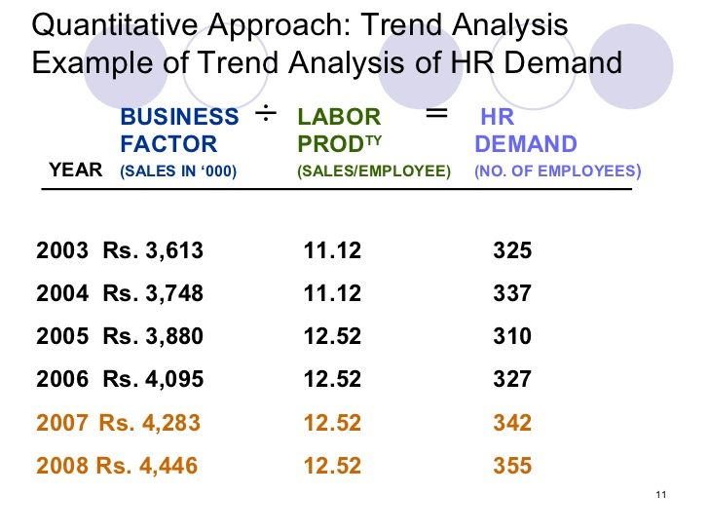

* **Workforce analysis:**
* Workforce analysis is the foundation of any good workforce plan. It involves three distinct phases including Supply Analysis, Demand (or Needs) Analysis and Gap Analysis.The purpose of workforce planning is to ensure that the organisation has an adequate supply of people with the skills, knowledge and experience required to achieve its strategic objectives efficiently and effectively, both in the short and long term.
* **Workload analysis:**

This technique is also known as 'work-load analysis'. This technique is suitable where the estimated work-load is easily measureable. Under this method, estimated total production and activities for a specific future period are predicted. This information is translated into number of man-hours required to produce per units taking into consideration the capability of the workforce. Past-experience of the management can help in translating the work-loads into number of man-hours required. Thus, demand of human resources is forecasted on the basis of estimated total production and contribution of each employee in producing each unit items. The following example gives clear idea about this technique. Let us assume that the estimated production of an organisation is 3.00.000 units. The standard man-hours required to produce each unit are 2 hours. The past experiences show that the work ability of each employee in man-hours is 1500 hours per annum. The work-load and demand of human resources can be calculated as under:

* Estimated total annual production = 300000 units
* Standard man-hours needed to produce each unit = 2 hrs
* Estimated man-hours needed to meet estimated annual production (i x ii) = 600000 hrs
* Work ability/contribution per employee in terms of man-hour = 1500 units
* Estimated no. of workers needed (iii / iv) = 600000/1500 = 400 units
* The above example clearly shows that 400 workers are needed for the year. Further, absenteeism rate, rate of labour turnover, resignations, deaths, machine break-down, strikes, power-failure etc. should also be taken into consideration while estimating future demand of human resources/ manpower.

**HR Supply Forecast**

The next step for the management is to determine whether it will be able to procure the required number of personnel and the sources for such procurement.

**Factors affecting HR supply forecasting**

* Promotions of Employees from within the Organization.
* Availability of Required Talent in the External Labor Market.
* Competition for Talent within the Industry
* Population Movement Trends

**Determining Internal and External Supply of Employees**

Not only must the demand for employees be determined, but workforce planning must include an analysis of the potential supply. Forecasts must be made of the supply of candidates for jobs within the organization and the supply external to the organization in the relevant labour market. Methods of forecasting supply, internally and externally, are discussed in the following section.

**Internal Supply**

The internal supply of candidates can be determined using a number of methods, such as replacement charts, succession plans, human resource management information systems, and departmental estimates. A brief discussion of each of these methods follows.

**Sources of Supply**

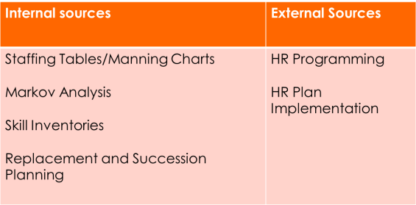

**Staffing / Manning Table**

These are pictorial representations of all organizational jobs, along with the numbers of employees currently occupying those jobs and future employment requirements.

The figures in the table are usually based on casual observation about how many people are needed at various levels of sales, production, or service delivery.

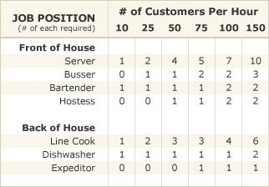

**Markov Analysis**

* It shows the percentage (and actual number) of employees who remain in each job from one year to the next, as also the proportion of those who are promoted or transferred or who exit the organization.
* This movement of employees (internal mobility) among different job classifications can be forecasted based upon past movement patterns.
* Past patterns of employee movements (transitions) are used to project future patterns. Markov analysis can also be used to forecast employee movement pattern that may occur among organizational units, between organizational levels.

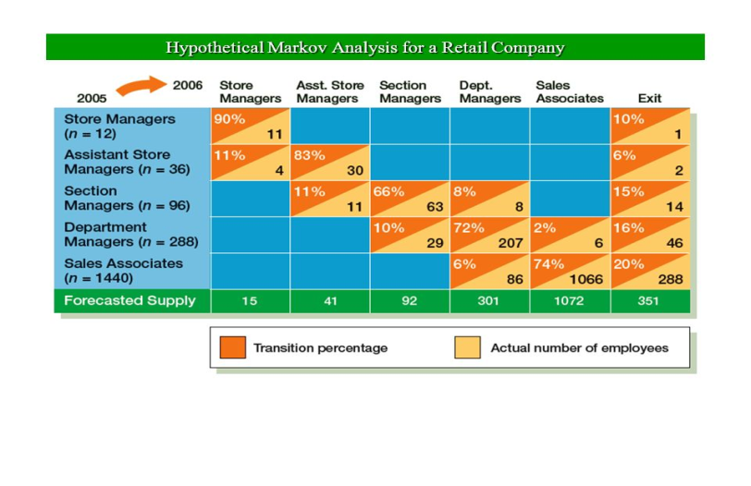

**Skill Inventories**

* One of oldest supply forecasting methods is the skills inventory which is a file of information containing each employee's skills, abilities, knowledge, and experience.
* This method can be useful in revealing situations where there is an inadequate supply of skilled candidates inside the organization to fill the forecasted future demand.

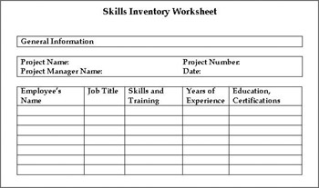

**Replacement Charts**

* Replacement charts are manual or automated records indicating which employees are currently ready for promotion to a specific position. If needs are forecasted for a particular job, replacement charts provide data with which to determine the supply of internal candidates to fill the openings. Against each vacant position, the competencies required for the position are mapped and then the employees in the organization with the requisite competencies are tagged and thus the potential replacements are found.
* The details of the potential candidates along with their age, skills, their experience and the competencies they need to satisfy the required position are listed.
* Then a comparative analysis of the experience and skillsets of the potential candidates with those required for the position is done.
* It is in this way that the company can organize its succession planning and can identify internal KSAs (Knowledge, Skills and Abilities).

**Replacement charts classify employees into four groups**

* i) Employees ready for promotion
* ii) Employees who would be ready for future promotions if given additional training
* iii) Employees performing satisfactorily but needs motivation and further improvements
* iv) Employees who are not fit to be on employment & need to be replaced.

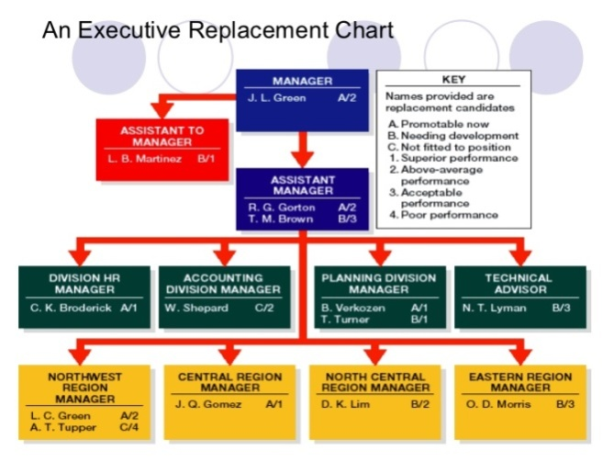

**Succession Planning**

The concept of succession planning is similar to replacement charting except the time perspective is different. *Succession planning* is the process of identifying candidates for future openings. It is a longer-term plan for developing candidates to fill positions. Traditionally, succession planning has been reserved for only high-level positions. However, because of the increased importance of human capital in many organizations, succession plans are being developed for the orderly replacement of lower-level employees.

**Q. Define Job Analysis.**

Job-analysis is a detailed and systematic study of jobs to know the nature and characteristics of the people to be employed on various jobs. It involves collection of necessary facts regarding jobs and their analysis.

According to Dale Yoder, "Job analysis is the procedure by which the facts with respect to each job are systematically, discovered and noted. It is sometimes called 'Job study' suggesting the care with which tasks, processes, responsibilities and personnel requirements are investigated".

According to Edwin B. Flippo, "Job analysis is the process of studying and collecting information relating to the operations and responsibilities of specific job".

**Q. State the nature of Job Analysis .**

**1) Systematic Way of Gathering and Analyzing Information about a Job:** The most basic building block of HR management is job analysis which is a systematic way of gathering and analyzing information about the content, context, and human requirement of jobs.

**2) Develop Jobs:** Job design attempts to develop jobs that fit effectively into the flow of the organizational work that needs to be done. The narrow focus of job analysis centers on using a formal system to gather data about what people do in their jobs. This data is used to generate job descriptions and job specifications:

**3) Identifies Job Factors and Duties:** Various methods and sources of data can be used to conduct job analyses. The real value of job analysis begins as the information is compiled into job descriptions and job specifications for use in virtually all HR activities. To be effective, HR planning, recruiting, and selection all must be based on job requirements and the capabilities of individuals. Compensation, training, and employee performance appraisals all should be based on the specific needs of the job. Job analysis is also useful in identifying job factors and duties that may contribute to workplace health and safety issues. Finally, job analysis plays a key role in employee/labor relations issues. .

**4) Redesigns Jobs:** Job analysis involves collecting information on the characteristics of a job that differentiate it from other jobs. The information generated by job analysis may be useful in redesigning jobs.

**Q. Briefly explain the importance of Job Analysis .**

The use of job analysis is given below:

**I) Human Resource Planning:** Job analysis helps in forecasting human resource requirements in terms of knowledge and skills. By showing lateral and vertical relationships between jobs, it facilitates the formulation of a systematic promotion and transfer policy. It also helps in determining quality of human resources needed in an organization.

**2) Recruitment:** Job analysis is used to find out how and when to hire people for future job openings. An understanding of the skills needed and the positions that will be vacant in future helps managers to plan and hire people in a systematic way.

**3) Selection:** it is not possible to select a right person without a proper understanding of what is to be done on a job.

**4) Placement and Orientation:** After selecting people, they are placed on jobs best suited to their interests, activities and aptitude. This is not possible without proper job analysis. Similarly, effective job orientation cannot be achieved without a proper understanding of the needs of each job.

**5) Training:** Whether or not a current or potential job holder requires additional training can be determined only after the specific needs of the jobs have been identified through a job analysis.

**6) Counseling:** Managers can properly counsel employees about their careers when they understand the different jobs in the organization. Job analysis can point out areas that an employee might need to develop to further a career.

**7) Employee Safety:** A thorough job analysis reveals unsafe conditions associated with a job. By studying how the various operations are taken up in a job, managers can find unsafe practices and thereby rectify easily.

**8) Performance Appraisal:** By comparing what an employee is supposed to be doing (based on job analysis) to what the individual has actually done, the worth of the person can be assessed. Ultimately, every organization has to pay a fair remuneration to people based on their performance.

**9) Job Design and Redesign:** Once the jobs are understood properly, it is easy to locate weak spots and undertake remedial steps. We can eliminate unnecessary movements, simplify certain steps and improve the existing ones through continuous monitoring.

**10) Job Evaluation:** Job analysis helps in finding the relative worth of a job, based on criteria such as degree of difficulty, type of work done, skills and knowledge needed, etc. This, in turn, assists in designing proper wage policies with internal pay equity between jobs.

**11) Discipline:** Job analysis studies the failure of the workers to meet the required standard of performance. Corrective measures may be taken in time to avoid untoward situations. In this way, it helps in maintaining discipline in the organization.

**12) Labor Relations:** Job analysis will be helpful in improving labor management relations. It can also be used to resolve disputes and grievances relating to work load, work procedures, etc.

**13) Compensation and Benefits:** In the area of compensation, it is helpful to know the relative value of a particular job to the company before a monetary value is placed on it. From an internal perspective, the more significant its duties and responsibilities, the more the job is worth.

**14) Legal Considerations:** A proper prepared job analysis is particularly important for supporting the legality of employment practices. Job analysis data are needed to defend decisions involving promotion, transfers, and demotions, e.g., job analysis provides the basis for tying the functional areas together and the foundation for developing a sound human resource program.

**15) Job Analysis for Teams:** Historically, companies have established permanent jobs and filled these jobs with people who best fit the job description. The jobs then continued in effect for years to come.

**Q. Define job analysis. Discuss various methods of Data Collection for Job Analysis**

**1) Questionnaire:** This method is usually used to obtain information about jobs through a mail survey. The job incumbents who can easily express themselves in writing are asked to provide data about their jobs in their own words. This method is, therefore, best suited to clerical workers. But it is often a very time consuming and laborious process to analyze the data obtained in this manner.

**2) Checklist:** This method requires the worker to check the task he performs from a long list of possible task statements. However, in order to prepare the checklist, extensive preliminary work is required in collecting appropriate task statements. While checklists are easy for the incumbent to 'respond to, they do not provide an integrated picture of the job in question. They are easily administered to large groups and are easy to tabulate.

**3) Interview:** In this method a group of representative job incumbents are selected for extensive interview - usually outside of the actual job situation. The interview may be carried out either individually or in a group to save time. The replies obtained from the interviewees are then combined into a single job description. This method though very costly and time consuming helps in getting a complete picture of the job.

**4) Observation:** This method can be followed right on the job. The analyst observes the incumbent as he performs his work and questions him to get the required data. Besides being slow and costly, this method also interferes with normal work operations. However, it generally produces a good and complete job description. This method is particularly desirable where manual operations are prominent and where the work cycle is short. Working conditions and hazards can also be better described when observed personally by the analyst.

**5) Participation:** In this method the job analyst actually performs the job himself. In this way he is able to obtain first-hand information about what characteristics comprise the job under investigation. This method is fairly good for simple jobs but in case of complex jobs advance training of the analyst becomes necessary. The method is also time-consuming and expensive.

**6) Technical Conference:** In this method information about the characteristics of the job is collected from the expert - usually the supervisors and not from the actual job incumbents. One important drawback of this method is that the experts may at times show poor knowledge about the job which they are not actually performing themselves and may give answers based upon their past experience.

**7) Self-recording of Diary:** In this method the job incumbent is asked to record his daily activities each day using some type of logbook or diary. This method is good in the sense that it systematically collects a great deal of information about the nature of and the time spent on various activities during the day by each incumbent.

But it is very time-consuming and the incumbent may start complaining that he spends more time in writing his diary than in doing his job. This method is particularly useful for high-level managerial jobs.

**8) Critical Incident:** In this method the supervisor is asked to provide instances of on-the -job behaviors of people which he considers to be noteworthy. Such instances can be both of good and bad on-the-job behavior. The number of such instances can be as many as the supervisor can recall. These instances can provide information about critical aspects of the job, but the method does not provide an integrated picture of the entire task.

**Q. Discuss the process of Job Analysis.**

**1) Determination of Uses of Job Analysis:** Initially, job analysis was used primarily for recruitment and selection. As the complexity of managing human resources increased, the scope of the use of job analysis also increased covering many more areas. Therefore, before undertaking the actual procedure of job analysis, the organization should define the uses of job analysis.

**2) Strategic Choices in Job Analysis:** With regard to job analysis, an organization is required to make at least five choices:

**i) Employee Involvement: -** Job analysis involves collecting job-related information-duties, responsibilities, skills and knowledge required to perform the jobs. Employees are often asked to supply vital information about the contents of job; given their familiarity with it.

**ii) Level of Details:** The level of analysis may vary from detailed, as in time and motion studies, to broad as in analyzing jobs based on general duties. The level of analysis affects the nature of the data collected.

**iii) When and How Often:** Another strategic choice relates to the timing and frequency of conducting job analysis. Job-analysis is generally conducted when:

* Any organization is newly established and the job analysis is initiated for the first time;
* A new job is created in an established company;
* A job is changed significantly due to change in technology, methods, procedures or systems;
* The organization is contemplating a new remuneration plan; or
* The employees or managers feel that there exist certain inequities between job demands and the remuneration it carries.

**iv)Past-Oriented versus Future-Oriented:** If an organization is changing rapidly due to fast growth or technological change, a more future oriented approach to job-analysis may be desired. Traditional job analysis information describes how the job has been done in the past and the manner in which it is being currently done. If necessary, a future orientation can be given to the job-analysis and predictions may be made as to how the job will be done in future and the way it should be done. This will allow firms to begin hiring and training people for these jobs prior to the actual change.

**v) Source of Job Data:** Although the most direct source of information about a job is the job holder, a number of other human and non-human sources are available. These sources may provide information which an average job holder cannot, thereby enabling the job analyst to question the job holder more effectively.

**Q. Explain the Sources of Job Data .**

**Non-Human Sources Human Sources**

Existing job descriptions and specifications Job analysts

Equipment maintenance records Job incumbents

Equipment design blueprints Supervisors

Architectural blueprints of work area Job experts

Films of employees working

Training manuals and other job training materials

Popular literature such as magazines and newspapers

**3) Information Collection:** This step involves collection of three types of information.

**i) Types of Job Analysis Information:** Considerable information. is needed for the successful accomplishment of job analysis. The job analyst identifies the job's actual duties and responsibilities and gathers the other types of data shown below:

**Types of Data Collected in Job Analysis**

* Work Activities,
* Worker-Oriented Activities,
* Machines, Tools, Equipment, and Work Aids Used,
* Job-Related Tangibles and Intangibles,
* Work Performance,

f) Job Context,

g) Personal Requirements for the Job.

**ii) Persons Involved in Information Collection:** There are three categories of persons who may be involved in information collection:

* Trained job analysts,
* Superiors,
* Job holders.

**iii) Methods of Data Collection:** Following methods may be used to collect information for job analysis:

* Questionnaire,
* Checklist,
* Interview,
* Observation,
* Participation,
* Technical Conference,
* Self-Recording of Diary,

h) Critical Incident.

**4) Information Processing:** Once the job information has been collected, it needs to be processed, so that it would be useful in various personnel functions. Specifically, job-related data would be useful to prepare job description and job specification.

**5) Outputs of Job Analysis:** Job analysis is the process of obtaining information about requirements of tasks and human attributes needed to meet those requirements. The immediate outputs of job analysis are job description and job specification. Job analysis is central to .human resource management system and the data generated through this process can be utilized for all personnel functions. Job analysis needs to be supplemented with the more dynamic concept of role analysis which takes into consideration changing requirements of jobs and provides a realistic picture of the way employees carry out their jobs.

**Q. State the difference between job description and job specification.**

Process of obtaining all pertinent job facts

|  |  |
| --- | --- |
| **Job Description** | **Job Specification** |
| ***A statement containing items such as:*** | ***A statement of human qualifications necessary to do the job usually contains such items as:*** |
| **1) Job title** | **1 ) Education** |
| **2) Location** | **2) Experience** |
| **3) Job summary** | **3) Training** |
| **4) Duties** | **4) Judgment** |
| **5) Machines, tools, and equipment** | **5) Initiative** |
| **6) Materials and tools used** | **6) Physical effort** |
| **7) Supervision given or received.** | **7) Physical skills** |
| **8) Working conditions** | **8) Responsibilities** |
| **9) Hazards** | **9) Communication skills** |
|  | **10) Emotional characteristics** |
|  | **11) Unusual sensory demands such as sight, smell, hearing** |

Figure showing Job Description and Job Specification in Job Analysis

**Q. What are the various problems in Job Analysis?**

**1) Lack of Support from Top Management:** In most cases the support from top management is missing. They refuse to appropriately describe what an employee is supposed to do in the company creating confusion in the minds of employees. The top management should make it clear to all employees that their full and honest participation is extremely important for the process.

**2) Single Method:** All too often, job analyst relies on only one of the methods when a combination of two or more methods might provide a better idea.

**3) Lack of Training and Motivation:** Job holders are a great source of information about the job, but they are not trained or motivated to generate quality data for job analysis. Further, job holders are rarely made aware of the importance of the data and are never rewarded for providing accurate data.

**4) Distortion of Activities:** When training or preparedness does not exist, job holders tend to submit distorted data, either intentionally or inadvertently.

**Q. Define the term recruitment.**

Recruitment is the discovering of potential applicants for actual or anticipated organizational vacancies. In simple terms, recruitment applies to the process of attracting potential employees to the organization or company. It is a systematic means of finding and inducing available candidates to apply to the company or enterprise for employment. Recruitment is said to be positive in its approach as it seeks to attract as many candidates as possible.

According to Flippo, "Recruitment is the process of searching for prospective employees and stimulating them to apply for jobs in the organization".

According to Dale Yoder, "Recruitment is a process to discover the sources of manpower to meet the requirements of the staffing schedule and to employ effective measures for attracting that manpower in adequate numbers to facilitate effective selection of an efficient working force".

Thus, recruitment is a linking activity bringing together those with jobs and those seeking jobs. Recruitment is therefore the process of searching prospective workers and stimulating them to apply for jobs in the organization.

**Q. Discuss the nature of Recruitment.**

**1) It is a process:** Recruitment is a continuous process or a series of activities rather than a single act or event. The basic purpose of recruitment is to locate the sources of people required to meet job requirements and attracting such people to offer for employment in the organization.

**2) Linking Activity:** Recruitment is a linking activity as it brings together those with jobs (employer) and those seeking jobs (prospective employees).

**3) Positive Function:** Recruitment is a positive function as it seeks to develop a pool of eligible persons from which most suitable ones can be selected. It is a positive process which stimulates the prospective employees to apply for the job.

**4) Important Function:** Recruitment is an important function as it makes it possible to acquire the number and type of persons necessary for the continued functioning of the organization.

**5) Pervasive Function:** Recruitment is a pervasive function as all organizations engage in recruiting activity. But the volume and nature of recruitment varies with the size, nature and environment of the particular organization. .

**6) Two-Way Process:** Recruitment is a two-way process as it takes a recruiter and a recruitee to be successful. Just as the recruiter has a choice whom to recruit or not, similarly the prospective employee can choose for which organization to apply for a job.

**7) It Identifies Human Resource:** Recruitment treats applicants as a precious resource in an organization. It is all about knowing the competition and recruiting needs. It is a process of identifying sources of human force, attracting and motivating them to apply for the job in organizations.

**8) Fulfillment of Manpower Needs:** As recruiting is the discovering of potential applicants for actual and anticipated organizational vacancies, it fulfills the present and future manpower needs.

**9) Dependency:** Recruitment which is the first step of appointment is based on job description, job analysis and job specification.

**10) Complex Job:** Recruitment is a complex job because too many factors affect it, e.g., image of the organization, nature of jobs offered, organizational policies, working conditions and compensation levels in the organization, rate of growth of the organization, past recruitment record, employment conditions in the community, trade union attitudes, labor laws, culture and environment, government policies, e.g., reservation for SC/ST. Most of these factors serve as constraints restricting the freedom of management in recruitment.

**Q. Writes down the objectives of Recruitment**

**1) Attract People:** To attract people with multi-dimensional skills and experiences that suits the present and future organizational strategies.

**2) Induct Outsiders:** To induct outsiders with a new perspective to lead the company and to infuse fresh blood at all levels of the organization.

**3) Development of Organizational Culture:** To develop an organizational culture that attracts competent people to the company.

**4) Search People:** To search or head hunt people whose skills fit the company's values.

**5) Devise Methodologies:** To devise methodologies for assessing psychological traits.

**6) Search Talent Globally:** To search for talent globally and not just within the company.

**7) Design Entry Pay:** To design entry pay that competes on quality but not on quantum.

**8) Anticipate People:** To anticipate and find people for positions that does not exist yet.

**Q. Point out the Factors Affectingin RecruitmentPolicy .**

Policies or directives provide continuous framework for executive actions on recurrent managerial problems. Such a policy asserts the objectives of the recruitment and provides a framework of implementation of the recruitment program in the form of procedures.

There are two factors that affect recruitment policy. They are external factors and internal factors.

**Factors affecting recruitment**

**External Factors**

* Supply and demand
* Unemployment rate
* Labour market
* Political-legal
* Sons of soil
* Image

**Factors affecting recruitment**

**Internal Factors**

* Recruitment policy
* HRP
* Size of organization
* Cost
* Growth and expansion

1. **External Factors:** There are various external factors which have their impact on recruitment and an organization does not have control over these factors. The major external factors are of the following types:
2. **Supply and Demand of Human Resources:** Nature of competition for human resources determines the organizational approach towards its recruitment program to a great extent. In India, there is abundant supply of unskilled workers which far exceeds their demand, but there is battle among organizations for certain other categories of personnel such as managerial talents - both fresh and experienced, computer software professionals, etc.
3. **Unemployment rate:** When the unemployment rate in a given area is high, the company’s recruitment process may be simpler. The number of unsolicited applicants is greater and the increased size of the labour pool provides better opportunities for attracting qualified applicants. On the other hand, as the unemployment rate drops, recruiting efforts must be increased and new sources explored.
4. **Labour market conditions:** In a local area, this is of primary importance for recruitments of non-managerial and supervisory positions. For executives and managerial positions, conditions of all India market are considered.
5. **Political and legal considerations:** Reservation of jobs for SCs, STs, minorities, and other backward classes is a political decision. There is a strong case for giving preference to people hailing from less-advantaged sections of the society. There are various legal provisions, which affect the recruitment policy of an organization. Various Acts which provide the restrictions to free recruitment are Child Labor (prohibition and Regulation) Act 1986, Employment Exchange (Compulsory Notification of Vacancies) Act 1959, The Apprentices Act 1961, the Factories Act 1948 and the Mines Act 1952. Besides, provisions regarding mandatory employment of certain categories of personnel such as scheduled castes/tribes. OBCs, etc. impinge upon recruitment policy of an organization, more particularly in public sector.
6. **Sons of the soil:** Political leadersclamor that preference must be given to the people of their respective states in matters of employment.
7. **Company’s image:** Thecompany’s image also matters in attracting large number of job seekers. Blue chip companies attract large number of applications. It is the perception of the job-seekers about the company that matters in attracting qualified prospective employees.

**II) Internal Factors:** Besides the various external factors, there are various internal factors in the organization which affect the recruitment program. These factors are as follows:

1. **Recruiting policy:** Most firms have a policy on recruiting internally or externally. Generally, the policy is to prefer internal sourcing as own employees know the company well and can recommend candidates who fit the organization’s culture.
2. **Human resource planning:** A company cannot attract prospective employees in sufficient numbers and with required skills overnight. It takes time to examine the alternatives regarding the appropriate sources of recruits and the most productive methods for obtaining them. Effective HRP greatly facilitates the recruiting efforts.
3. **Size of Organization:** Size of an organization is another factor which determines the degree of attractiveness to the prospective candidates. A small organization cannot have the same recruitment practices which a large organization may have; it may not be able to attract highly talented personnel.
4. **Cost:** Recruiting costs are calculated per new hire and the figure is considerable now a days. Recruiters must therefore operate within budgets. Careful HRP and forethought by recruiters can minimize recruitment costs.
5. **Growth and expansion:** An organization registering growth and expansion will have more recruiting on hand than the one which finds its fortunes declining.

**Q. Outline the recruitment procedure briefly.**

Recruitment is a process consisting of various activities, through which search of prospective personnel both in quantity and quality - as indicated by human resource planning and job description and job specification is made. This process includes recruitment planning, identification of recruitment sources, contacting those sources, and receiving applications from prospective employees.

**1) Recruitment Planning:** Recruitment process starts with its planning which involves the determination of number of applicants and type of applicants to be contacted.

**i) Number of Contacts:** Organizations, generally, plan to attract more applicants than what they intend to select as they wish to have option in selecting the right candidates. The option is required because some of the candidates may not be interested in joining the organization; some of them may not meet the criteria of selection. Therefore, each time a recruitment program is contemplated, the organization has to plan about the number of applications it should receive in order to fulfill all its vacancies with right personnel.

**ii) Type of Contacts:** This refers to the type of personnel to be informed about the job openings based on job description and job specification. This determines how the prospective personnel may be communicated about the job openings.

**2) Sources of Recruitment:** After the finalization of recruitment plan indicating the number and type of prospective candidates, they must be attracted to offer themselves for consideration to their employment. This necessitates the identification of sources from which these candidates can be attracted.

**3) Contacting Sources:** After the finalization of sources from where the prospective candidates will he selected, the process of contacting these sources starts. Recruitment involves both recruiter and recruitee. A recruiter has the choice of whom, to recruit based on the various information about the candidates. In the same way, a recruitee must have information about the organization to decide whether to join it or not. Therefore, before making the contact with the sources, particularly the external ones, the organization must decide the information which must be shared with the candidates.

**4) Application Pool:** Whatever the method of recruitment is adopted, the ultimate objective is to attract as many candidates as possible so as to have flexibility in selection. When the sources of recruitment are contacted, the organization receives applications from prospective candidates. The number of applications depends on the type of organization, the type of jobs, and the conditions in specific human resource market. An organization having better perceived image is able to attract more number of applications. Various applications received for a particular job are pooled together which become the basis for selection process.

**5) Selection:** Selection is the process of differentiating between applicants in order to identify (and hire) those with a greater likelihood of success in a job. In selection process, highly specialized techniques are required. Therefore in the selection process, only personnel with specific skills like expertise in using selection tests, conducting interviews etc. are involved.

Q**. What are the merit and demerits of different sources of recruitment?**

Normally for an ongoing organization, there are· two sources of supply of manpower: internal and external. Each of these sources has its own merits and demerits. Therefore, both sources are to be tapped in varying proportions.

**1) Internal Source:** They include those who are already on the payroll of the organization and those who served the organization in the past (but quit voluntary or due to retrenchment) and would like to return if the organization likes to reemploy. There is merit in looking for internal resources since they provide opportunities for better deployment and utilization of existing human resources through planned placements and transfers or to motivate people through planned promotions and career development where vacancies exist in higher grades. The law provides preference to retrenched employees when vacancies arise in future.

**Merits of Internal Source**

**i) Familiarity:** The organization and its employees are familiar to each other. The organization knows the ability and skills of the likely candidates since they are insiders. Similarly, employees also know about the working conditions and job requirements of the vacancies.

**ii) Better Utilization of Internal Talent:** Reliance on internal recruitment enables the enterprise to make the best use of the capabilities of its employees. For example; some employees may be so talented that they deserve promotion or some may do better on transfer to other jobs.

**iii) Economy:** The cost of recruiting internal employees is minimal. The enterprise need not incur any expenditure on informing and inducing its employees to apply.

**iv)Motivational Value:** Internal recruitment is a source of encouragement and motivation for employees. The employees can look for promotion and transfer with hope and thereby do their jobs well so as to earn the desired promotion/transfer.

**Demerits of Internal Source**

**i) Restricted Choice:** Internal recruitment restricts the options and freedom for the enterprise in hiring the most suitable candidates for the vacancies. It has a narrow base. The enterprise may have to compromise on quality of its choice of candidates.

**ii) Inbreeding:** If the enterprise depends too much on internal recruitment, it means that the enterprise denies itself fresh talent and 'new blood' available outside. Existing employees, even if promoted or transferred may continue to work and be behave in their old ways, without any dynamism.

**iii) Absence of Competition:** In the absence of competition from qualified candidates from outside employees are likely to expect automatic promotion on the basis of seniority and thus may lose the drive for proving their worth.

**iv) Conflict:** There may be chance of conflict and infighting among those employees who aspire for promotion to the available vacancies. Those who will not be promoted may beome demotivated and their efficiency may decline.

**2) External Source:** Organizations may look for people outside it. Entry level jobs are usually filled by new entrants from outside. Organizations may resort to outside sources in the following circumstances:

(a)when suitably qualified people are not available; (b) when the organization feels it is necessary to inject new blood into it for fresh ideas, initiatives, etc; (c) when it is diversifying into new avenues and (d) when it is merging with another organization.

**Merits of External Source**

**i)Wide Choice:** The organization has the freedom to select candidates from a large pool. Persons with requisite qualifications could be picked up.

**ii) Injection of Fresh Blood:** People with special skills and knowledge could be hired to stir up the existing employees and pave the way for innovative ways of working.

**iii) Motivational Force:** It helps in motivating internal employees to work hard and compete with external candidates while seeking career growth.

**iv) Long-term Benefits:** Talented people can join higher ranks, new ideas can find meaningful expression, a competitive atmosphere will compel people to. give out their best and earn rewards, etc.

**Demerits of External Source**

**i) Expensive:** Hiring costs could go up substantially. Tapping numerous sources of recruitment is not an easy task either.

**ii) Time Consuming:** It takes time to advertise, screen, to test and to select .suitable employees.

**iii) Demotivating:** Existing employees who have put in considerable service may resist the process of filling up vacancies from outside. The feeling that their services have not been recognized by the organization forces them to work with less enthusiasm and motivation.

i**v) Uncertainty:** There is no guarantee that the organization ultimately will be able to hire the services of suitable candidates. It may end up hiring someone who does not 'fit' arid who may not be able to adjust in the new set-up.

**Q. Discuss the different Sources of Recruitment used by an organization.**

**1) Internal Sources**: Internal method seeks applicants for positions from those who are currently employed. It includes transfers and promotions of present employees, job posting, and employee referrals.

**i) Promotions and Transfers:** This is a method of filling vacancies from within through transfers and promotions. A transfer is an internal movement within the same grade from one job to another. It may lead to changes in duties and responsibilities, working conditions, etc., but not necessarily salary. Promotion, on the other hand, involves movement of employee from a lower level position to a higher level position accompanied by (usually) changes in duties, responsibilities, status and value.

**ii) Job Posting:** Job posting is another way of hiring people from within. In this method, the organization publicizes job openings on bulletin boards, electronic media and similar outlets.

**iii) Employee Referrals:** Employee referral means using personal contacts to locate job opportunities. It is a recommendation from a current employee regarding a job applicant.

**2) External Sources:**

**i) Professional or Trade Associations:** Meetings, conferences, seminars, and other social functions, social professional associations/bodies of major professionals like doctors, Engineers, Auditors, Chartered Accountants, and managers also provide ample opportunity to locate potential candidates for technical, scientific and managerial cadre vacancies. Many associations provide placement services for their members.

**ii) Advertisements:** This method is appropriate when the organization intends to reach a large target group and wants a fairly good number of talented people who are geographically spread out. To apply for the advertised vacancies there are wide variety of alternatives available to a company such as:

**a) News Paper Ads:** Here it's easy to place job ads without much of a lead time. It has flexibility in terms of information and can conveniently target a specific geographic location.

**b) Television and Radio Ads:** These ads are more likely to reach individuals who are not actively seeking employment; they are more likely to stand out distinctly, they help the organization to target the audience more selectively and they offer considerable scope for designing ads creatively.

**iii) Employment Exchanges:** Employment Exchanges have been set all over the country in deference to the provisions of the Employment Exchanges (Compulsory Notification of Vacancies) Act 1959. The Act requires all the industrial establishments having 25 workers or more each to notify the vacancies before they are filled. These agencies provide a wide range of services - counseling, assistance in getting jobs, information about the labor market, labor and wage rates.

**iv)Campus Recruitment:** It is a method of recruiting by visiting and participating in college campuses and their placement centers. Here the recruiters visit reputed educational institutions such as IITs, IIMs, colleges and universities with a view to pick up job aspirants having requisite technical or professional skills.

**v) Walk-ins and write-ins:** The most common and least expensive approach for candidates is direct applications in which job seekers submit unsolicited application letters or resumes. From candidates’ viewpoint, walk-ins are preferable as they are free from the hassles associated with other methods of recruitment. Unsolicited applicants, casual callers and job seekers at the factory and unsolicited applicants are other sources of direct recruitment.

**vi) Consultants:** Private Employment Agencies are widely used for filling up of vacancies in the organizations. They charge fees ranging from 20 to 50 percent of the first year salaries of the individuals placed. They also keep prospective employer and the employee anonymous. The specialization to these agencies enhances their capacity to interpret the needs to their clients, to seek out particular types of persons and to develop proficiency in recognizing the merit of specialized personnel.

**v) Competitors:** Recruiting personnel from reputed firms is popular practice. Certain companies and firms have built-up good reputation on efficiency, productivity and industrial peace. Many firms attempt to locate suitable candidates from such firms for filling up vacancies. This is also known as employee poaching.

**vii) Casual Labor or Applicant at the Gate:** Most industrial units rely to some extent on the casual labor, which presents itself daily at the factory gate or employment office. Trade Unions also provide manual and skilled workers in sufficient numbers.

**viii) Voluntary organizations:** Organizations such as private clubs, social organizations may also provide candidates who are handicaps, widowed or married women, old persons, retired hands, etc. in response to advertisements.

**ix) E- recruiting or Computer Data Banks:** When a company desires a particular type of employee, job specifications and requirements are fed into a computer, where they are matched against the resume data stored in there.

Selection: Meaning:

**Q. Defines the term Selection**.

Selection is the process of examining the applicants with regard to their suitability for the given job or jobs, and choosing the best from the suitable candidates and rejecting the others. Thus, selection is negative its application in as much as it seeks to eliminate as many unqualified applicants as possible in order to identify the right candidates.'

According to Steven P. Robbins and Mary Coulter, "Selection is the process of screening job applications to ensure that the most appropriate candidates are hired".

**Q. State few purposes of Selection.**

The purposes of selection are as follows:

**1) Select Suitable Candidate:** The purpose of selection is to pick up the most suitable candidate who would meet the requirements of the job as the most suitable person is picked up after eliminating the unsuitable applicants through successive stages of selection process.

**2) Determines Applicant's Capabilities:** The purpose of selection is to determine whether the applicants have required capabilities or not. In other words, the needs of the job are matched with the profile of candidates.

**3) Place Right candidate at Right Job:** The primary purpose of selection is to place individuals who can make effective and worthwhile contributions to an organization into appropriate jobs or roles.

**4) Generate Information about Candidate:** The purpose of selection is to generate information about the candidate in order to enable candidate in order to enable comparisons with other candidates and thus assist in decision-making.

**5) To Save Cost:** How well an employee is matched to a job is very important because it directly affects the amount and quality of employees work. Any mismatch in this regard can cost an organization a great deal of money time and trouble especially, in terms of training and operating costs. In course of time the employee may find the job distasteful and leave in frustration. He may even circulate 'hot news' and juicy bits of negative information about the company, causing incalculable hann in the long run. Effective selection, therefore, demands constant monitoring of the 'fit' between person and the job.

**Q. State the difference between Recruitment and Selection**

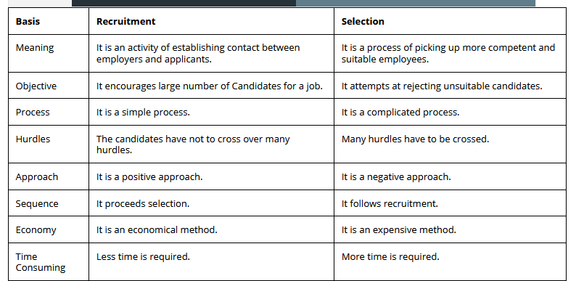

**Q. Is it essential to evaluate the effectiveness of selection process? If yes, justify.**

Clearly a great deal is involved in the process of establishing and maintaining a selection system. Once such a system is set-up, however, it is just as important to evaluate its effectiveness.

Once an organization has made a commitment to investigate what types of selection devices it will use, it must attempt to evaluate whether its efforts will be worthwhile. Ultimately, a large part of the answer to this question involves the utility of the selection process. Utility refers to the degree to which using a selection system improves the quality of the individuals being selected by the organization. Utility analysis is an attempt to determine the extent to which a selection system provides real benefit to the organization. This method assesses the practical pay-off for any selection system.

Utility has two related components, which are as follows:

**1) Statistical Utility:** It is the extent to which a selection technique allows an organization to better predict who will be successful.

**2) Organizational Utility:** It is dependent in part, on statistical utility and an organization’s costs and benefits. In other words, answering the question whether the selection system should be developed and used is ultimately an issue of whether it saves the organization more money than it costs.

Generally speaking, an analysis of the costs versus the benefits of selection requires estimates of the direct and indirect costs associated with the selection system. Direct costs include such things as the price of the tests, the salary paid to an interviewer, and the equipment used in a work sample test. Indirect costs include change in public image associated with implementing procedures such as drug testing.

The organization must also estimate how much money it will save by hiring more qualified employees using the selection system. These savings can come from improved outcomes such as higher levels of quality or quantity of output, reduced absenteeism, lower accident rates, and less turnover.

Sometimes, when an organization's managers see how costly systematic selection can be, they wonder whether it will ever have benefits. The answer to this basis question depends on many factors. But valid selection procedures can yield enormous benefits, especially in situations where the direct and indirect costs of hiring a poor performer are high. Imagine the costs associated with a single wrong hiring decision, when airlines are selecting pilots. Pilot errors can cost the company millions of dollars in destroyed or damaged equipment, and no amount of money can offset the potential loss of human life that may be involved.

One final thing about selection and cost-benefit analysis is that the way an organization hires employees is directly tied to other human resource programs. Perhaps the most important linkage is with training. Many trade off decisions must be made between selection and training. At the very least, the organization should realize that putting more money into selection can significantly reduce the amount of money it must spend on training, especially if the increased commitment to selection allows the organization to hire a more capable workforce.

**Q. Elaborate the Selection Procedure followed by an organization.**

Selection is usually a series of hurdles or steps. The basic idea is to solicit maximum possible information about the candidates to ascertain their suitability for employment. Since the type of information required for various positions may vary, it is possible that selection process may have different steps for various positions. But, a standard selection process has the following steps:

|  |  |  |  |  |  |  |  |  |
| --- | --- | --- | --- | --- | --- | --- | --- | --- |
|  |  |  |  |  |  |  | **Hiring Decision** | **Step 8** |
|  |  |  |  |  |  | **Reference Checks** | | **Step 7** |
|  |  |  |  |  | **Medical examination** | | | **Step 6** |
|  |  |  |  | **Selection Interview** | | | | **Step 5** |
|  |  |  | **Selection Tests** | | | | | **Step 4** |
|  |  | **Application Blank** | | | | | | **Step 3** |
|  | **Screening Interview** | | | | | | | **Step 2** |
| **Reception** | | | | | | | | **Step 1** |

**1) Screening of Applicants (Application Blank):** Prospective employees have to fill up some sort of applications forms. These forms have variety of information about the applicants like their personal biodata, achievements, experience, etc. Such information is used to screen the applicants who are found to be qualified for the consideration of employment. The information may also be used to keep permanent records of those persons who are selected. Based on the screening of applications, only those candidates are called for further process of selection that are found to be meeting the job standards of the organization.

**2) Selection Method/Tests:** Many organizations hold different kinds of selection tests to know more about the candidates or to reject the candidates who cannot be called for interview etc. Selection tests normally supplement the information provided in the application forms. These tests are designed to give information about the candidate’s intelligence, aptitude, attitude, interests, personality etc.

**3) Interview:** Selection tests are normally followed by personal interview of the candidates. The basis idea here is to find out overall suitability of candidates for the jobs. It also provides opportunity to give relevant information about the organization to the candidates. In many cases, interview of preliminary nature can be conducted before the selection tests.

**4) Medical Examination:** Certain jobs require unusual stamina, strength or tolerance of hard working conditions. A physical examination reveals whether or not a candidate possesses these qualities. It brings out deficiencies, not as a basis of rejection but as a positive aid to selective placement and as indicating restrictions on his transfer to other positions.

**5) Reference and Background Verification:** Many organizations ask the candidates to provide the name of referees from whom more information .about the candidates can be solicited. Such information may be related to character, working, etc. The usual referees may be previous employers, persons associated with the educational institutions from where the candidates have received education or other persons of prominence who may be aware of the candidate's behaviors and abilities.

**6) Approval by Appropriate Authority or Hiring Decisions:** On the basis of the above steps, suitable candidates are recommended for selection by the selection committee or personnel department. Though such a committee or personnel department may have authority to select the candidates finally, often it has staff authority to recommend the candidates for selection to the appropriate authority. Organization may designate the various authorities for approval of final selection of candidates for different categories of candidates. When the approval is received, the candidates are informed about their selection and asked to report for duty to specified persons.

**7) Placement:** After all the formalities are completed, the candidates are placed on their jobs initially on probation basis. The probation period may range from 3 months to 2 years. During this period, they are observed keenly and when they complete this period successfully, they become the permanent employees of the organization.

**Q. What is the Significance of Selection Procedure?**

The selection procedure adopted by an organization is mainly tailor made to meet its particular needs. The thoroughness of the procedure depends on three factors:

**1) Nature of the Selection:** Whether faulty or safe, because a faulty selection affects not only the training period that may be needed, but also results in heavy expenditure on the new employee and the loss that may be incurred by the organization in case the job occupant fails in their job.

**2) Policy of Company and the Attitude Management:** As a practice, some companies usually hire more the actual number needed with a view to remove the unfit persons from the jobs.

**3) Length of the Probation or the Trial Period:** The longer the period, the greater the uncertainty in the minds of the selected candidates about their future.

**Q. What are the Outcomes of the effective Selection Decision?**

|  |  |  |  |
| --- | --- | --- | --- |
|  | | | |
| **Success** | **False Negative Error** | **True Positive (High Hit)** |  |
| **Failure** | **True Negative (Low Hit)** | **False Positive Error** |
|  | **Failure Predicted** | **Success Predicted** |

The figure above shows four probable outcomes of selection decision. Two of these "true positive" (high hit) and "true negative"(low hit) are right selection decisions. The other two outcomes represent selection errors. In the "false positive", a decision is made to hire an applicant based on predicted success, but failure results. In "false negative error", applicant who would have succeeded on actual job is rejected based on prediction of failure. In either case, selectors will have erred. An organization where selectors make a false positive error incurs three types of costs:

i)This cost is incurred while the person is employed. This can be the result of production or profit losses, damaged company reputation, accidents due to negligence, absenteeism etc.

ii)This type of cost is associated with the training, transfer or terminating the services of the employee.

iii) The third type is cost of replacing an employee with a fresher, the cost of hiring, training and replacement. Generally, the most important the job, the greater is the cost of the selection error.

In the case of “false negative error”, an applicant who would have succeeded is rejected because of predicted failure. Most of the false negative errors go unnoticed except when the applicant belongs to a reserve category and files a discrimination charge. Costs associated with this type error are generally opportunity costs which are difficult to estimate.

**Tests**

* **Intelligence test:**

These are mental ability. They measure the incumbent’s learning ability and also the ability to understand instructions and make judgment. The basic objective of intelligence tests is to pick up employees who are alert and quick at learning things so that they can be offered adequate training to improve their skills for the benefit of the organization.

* **Aptitude test:**

**Aptitude test** measured an individual’s potential to learn certain skills- clerical, mechanical, mathematical etc. these tests indicate whether or not an individual has the ability to learn a given job quickly and efficiently. In order to recruit efficient office staff, aptitude tests are necessary. Ex- clerical test, for example, may measure the incumbent’s ability to take notes, perceive things correctly and quickly locate things, ensure proper movement of files.

* **Personality test:**

Of all the tests required for selection, personality tests have generated lot of heat and controversy. The definition of personality, methods of measuring personality factors and the relationship between personality factors and actual job criteria have been the subject of much discussion. There are three types of personality test

**Projective test**: interpret the picture or situation based on your own attitude, motives and values. These test expect the candidates to interpret problems or situation based on their own motives, attitudes, value etc. many personality tests are projective in nature.

* **Thematic appreciation test (TAT):** The testee is shown a picture and is asked to make up a story based on the picture. The responses are analyzed and a profile of personality is developed.These are design to measure what the applicant can do on the job currently. whether the testee actually knows what he or she claims to know. Ex- typing proficiency, a shorthand test measures It is also known as work sampling test. Two type. 1. motor . Involving physical manipulation of things, 2. verbal , involving problem, situations that are primarily language oriented.
* **Interest test: these**  are meant to find how a person in tests compare with the interest of successful people in a specific job. These tests show the areas of work in which a peson is most interested. The basic idea behind the use of interests tests is that people are most likely to be successful in jobs they like.
* **Preference test:** these tests try to compare employee preferences with the job and organizational requirements. The job diagnostic survey developed by Hackman and Oldham, is an example of a preference test.
* **Achievement test:** these are designed to measure what the applicant can do on the job currently. i.e whether the testee actually knows what he or she claims to know. Typing test shows typing proficiency, a shorthand test measures the testee; ability to take dictation and transcribe etc.
* **Simulation tests:**it is a test which duplicate many of the activities and problems an employee faces while at work. Such exercise are commonly used for hiring managers at various level.
* **Assessment center:** it is an extended work sample. It uses procedures that incorporate group and individual exercise. These exercises are designed to stimulate the type of work which the candidate will be expected to do.

1. **In basket- exercise:**here the candidate is faced with an accumulation of reports, memos, letters and other materials collected in the in-basket of the simulated jobs he is supposed to take over. He is asked to take necessary action within a limited amount of time on each of these materials , say, by writing letter, notes, agenda for meeting within a limited time. Measure oral, written, skills, planning, Decisiveness., initiative and organizing skills.
2. **Business games:** here participants try to solve the problems, usually as members of two or more simulated companies that are competing in the market place. Decision might include how to advertise and produce, how to penetrate the market, how much to keep in stock. Participants thereby exhibit planning and organizational abilities, interpersonal skills and leadership abilities.
3. **Individual presentation:** participants are given a limited amount of time to plan, organize and prepare a presentation on an assigned topic. This exercise is meant to assess the participants’ oral communication skill, self-confidence, persuasive abilities.

* **Graphology tests:** It involves using a trained evaluator to examine the lines, loops, curves and flourish in handwriting to asses the personality and emotional make-up.
* **Polygraph test:** consists of a rubber tube around the chest, a cuff round the arm, and sensors attached to ginger that record the physiological changes in the examine as the examiner puts questions that call for an answer of yes or no.
* **Integrity test: these are designed to** measure employee honesty to predict those who are more likely to steal from an employer)
* have you ever told a lie?
* do you report to your boss if you know of another employee stealing from the store?
* Do you carry office stationary back to your home for occasional use?
* Do you mark attendance for your college also?

**Q. What do you mean by Selection interview? Discuss the selection interview briefly.**

**Interview is the oral** examination of candidates for employment. This is the most essential steps in the selection process. In this step , the interviewers tries to obtain and synthesize information about the abilities of the interviewee and the requirement of the job.

**Types of interviews:**

* **Non- directive interview:** These **interview questions** are open-ended and give you the opportunity to decide what direction you will take in answering them.

1. Tell me about yourself?
2. What are your long-term goals?
3. How do you define success?
4. What is your philosophy of life?
5. What are your strengths and weaknesses? Please give examples.
6. Why do you want this job?

* **Directive or structural interview:**These **interview questions** are usually based on your resume.

1. What kinds of work have you done which would prepare you for the duties of this position?
2. What kinds of machines/equipment can you operate?
3. How does your education equip you for the job at hand?

* **Situational interview:**During a nondirective interview, you could be asked to render your expert advice on a challenge the organization is facing. For example, "Our company's technology solutions are fast becoming obsolete and we'd like to integrate cloud computing into our network to expand our capabilities and capacity for information. Tell me about organizations you've dealt with that are having the same issues and the advice you've provided. This is a situational, nondirective interview question because it requires the candidate to demonstrate an area of functional expertise, but doesn't set parameters for how the candidate should respond.
* **Behavioural interview:** Focuses on actual work incidents in the applicant’s past. Ex- how he disciplined an employee who was smoking inside the factory premises.
* **Stress interview: in the stress interviewer**  attempts to find how applicants would respond to aggressive, embarrassing, rude and insulting questions. The whole exercise meant to see whether the applicant can cope with highly stress- producing, anxious and demanding situations while ate work, in a calm and composed manner.
* **Panel interview:** in a typical panel interview, the applicants meets with three to five interviewers who take turns asking questions. After the interview, the interviewers pool their observations to arrive at a consensus about the suitability of the applicant. The panel members can ask new and incisive questions based on their expertise and experience and elicit deeper and more meaningful responses from candidates.

**Q. Define the term Induction.**

**Induction:** An induction programme is the process used within many businesses to welcome new employees to the company and prepare them for their new role. Induction serves the following objectives:

* **Removes fears:** a newcomer steps into an organization as a stranger. He is new to the people, workplace and work environment. He is not very sure about what he is supposed to do. Induction helps a new employee overcome such fear and perform better on the job. It assists him in knowing more about:
* The job, its content, policies, rules and regulations.
* The people with whom he is supposed to interact.
* The terms and conditions of employment.
* **Creates and good impression:** another purpose of induction is to make the newcomer feel at home and develop a sense of pride in the organization. Induction helps him to :
* Adjust and adapt to new demands of the job.
* Get along with people.
* Get off to a good start.
* **Acts as a valuable source of information:** induction serves as valuable source of information to new recruits. It classifies many things through employee manuals. Informal discussion with colleagues may also clear the fog surrounding certain issues.

**Q. Discuss the Induction programme steps followed by every organization.**

The HR department may initiate the following steps while organizing the induction programme:

1. Welcome to the organization
2. Explain about the company
3. Show the location/ department where the new recruit will work
4. Give the company’s manual to the new recruit.
5. Provide details about various work group and the extent of uniform within the company.
6. Give details about pay, benefits, holiday, leave etc. emphasize the importance of attendance or punctuality.
7. Explain about future training opportunities and career prospect.
8. Clarify doubts, by encouraging the employee to come out with questions.
9. Take the employee on a guided tour of building, facilities.

**Induction programme topics:**

**Organizational issues:**

* History
* Nam and titles of key executives
* Employees' title
* Layout of physical
* Probationary period
* Product and service offered
* Overview of production process
* Company policies and rules
* Disciplinary procedures
* Employees 'handbook
* Safety steps

**Employee benefit:**

* Pay scales, pay days
* Vacations, holidays
* Leave
* Training avenues
* Counselling
* Insurance, medical, recreation, retirement benefits.

**Job duties:**

* Location
* Job tasks
* Job safety needs
* Job objectives
* Relationship with other jobs

**Introductions :**

* To supervisors
* To co- workers
* To trainers
* To employee counselor

**Q. What do you mean by Socialization?**

Socializationsis a process through which a new recruit begins to understand and accept the values, norms, and beliefs held by others in the organization. HR department representatives help new recruits to “internalize the way things are done in the organization.”.Orientation helps the newcomers to interact freely with employees working at various levels and learn behaviors that are acceptable. Through such formal and informal interaction and discussion, newcomers begin to understand how the department is run, who holds power and who does not, who is politically active within the department.

******************************************************************************