The output of langrange interpolation is :

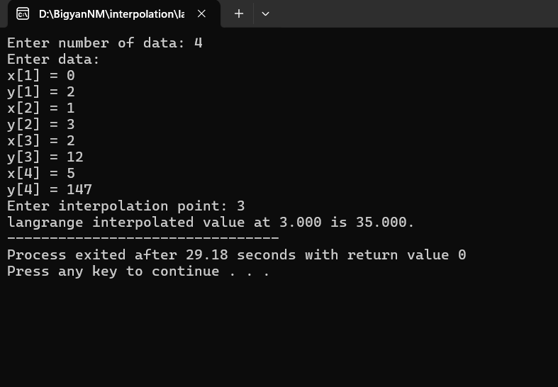

The output of Newton's forward interpolation is :

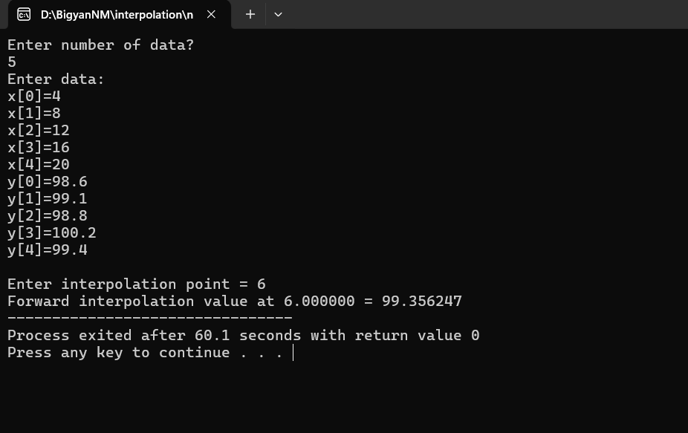

The output of Newton's backward interpolation is :

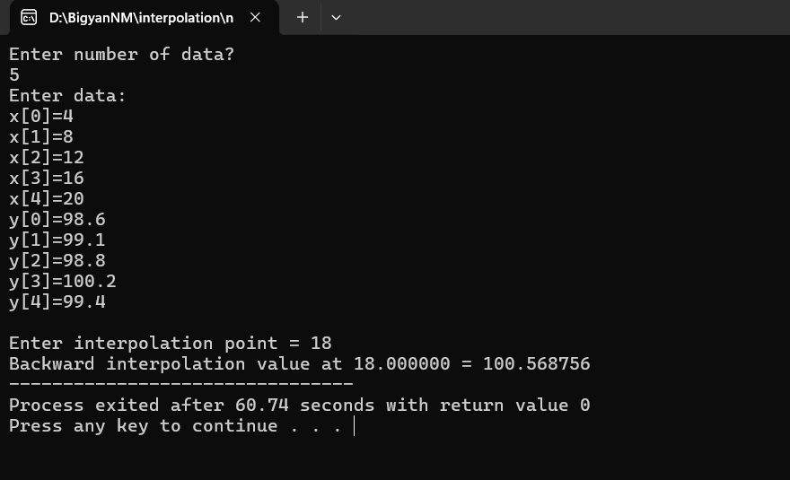

The output of LSM(linear regression) is :

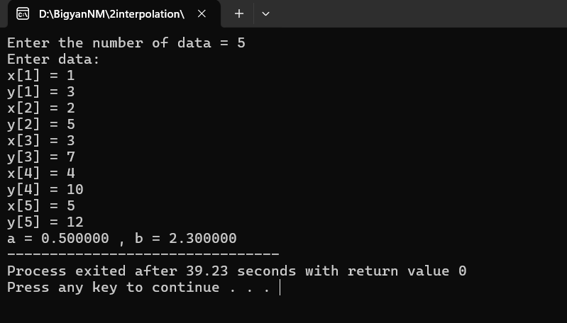

The output of LSM(exponential equation) is :

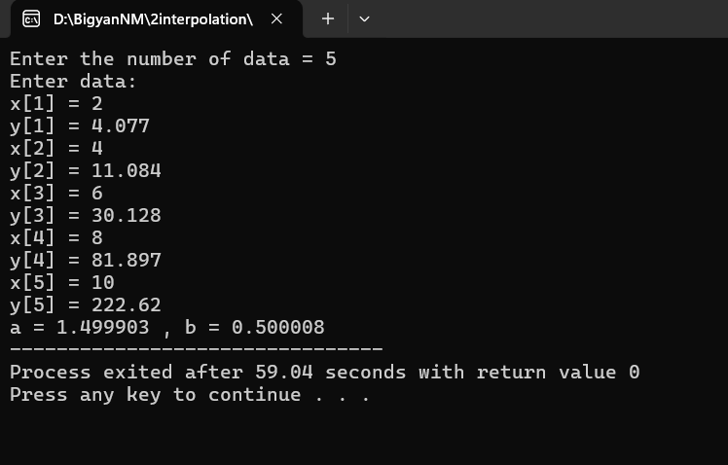

The output of LSM(power function) is :

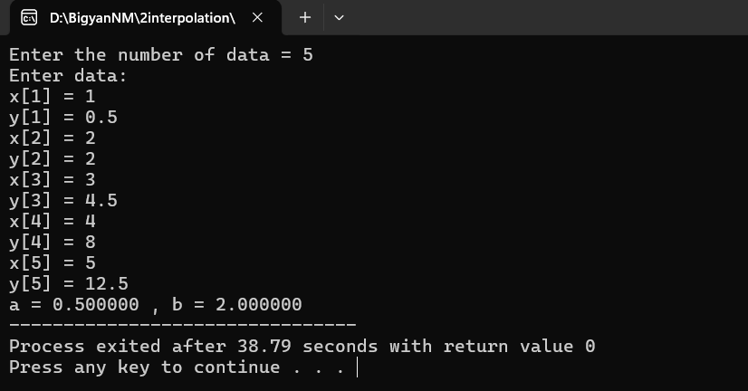

The output of LSM(quadratic equation) is:

