

**Tribhuvan University**

**Faculty of Humanities and Social Sciences**

**Gym & Fitness Club: Membership**

**and Product Hub**

**A PROJECT REPORT**

**Submitted to**

**Department of Computer Application**

**Jaya Multiple Campus**

**Gokharneshwor, Kathmandu**

***In partial fulfillment of the requirements for the Bachelors in Computer Application***

**Submitted by**

Utsab Dulal

BCA 4th Semester

TU Reg. No.: 6-2-721-31-2021

Symbol No.:72102106

Under the Supervision of

**Mukti Thapa**



**Tribhuvan University**

**Faculty of Humanities and Social Sciences**

**Jaya Multiple Campus**

Gokharneshwor, Kathmandu

Bachelor in Computer Applications (BCA)

**SUPERVISOR’S RECOMMENDATION**

I hereby recommend that this project prepared under my supervision by **UTSAB DULAL** entitled **“Gym & Fitness Club: Membership and Product Hub”** in the Partial Fulfillment of requirement for the degree of Bachelor of Computer Application is recommended for that final evaluation.

Mukti Thapa

Project Supervisor

BCA Department

Jaya Muliple Campus



**Tribhuvan University**

**Faculty of Humanities and Social Sciences**

**Jaya Multiple Campus**

Gokharneshwor, Kathmandu

Bachelor in Computer Applications (BCA)

**LETTER OF APPROVAL**

This is certifying that this project prepared by **UTSAB DULAL** entitled **“Gym & Fitness Club: Membership and Product Hub”** in the Partial Fulfillment of requirement for thedegree of Bachelor in Computer Application has been evaluated. In our opinion it is satisfactory in the scope and quality as a project for the required degree.

|  |  |
| --- | --- |
| Mukti Thapa | Subash Bista |
| Project Supervisor | H.O.D |
| BCA Department | Jaya Multiple Campus |
| Jaya Multiple Campus | Gokharneshwor, Kathmandu |

|  |  |  |
| --- | --- | --- |
| **External Examiner** | **Mukti Thapa** |  |
|  |  |
|  | **Internal Examiner** |  |

**ABSTRACT**

This document outlines the development of an integrated e-commerce platform for a fitness and gym center, facilitating the seamless buying and selling of both services and products online. With the increasing reliance on digital solutions for various needs, including fitness services and equipment, the demand for accessible and convenient online platforms has surged. Our e-commerce website caters to this demand by providing a user-friendly interface accessible through computers, tablets, smartphones, and other smart devices. Users can browse and purchase a wide range of offerings, including gym memberships, personal training sessions, group classes, and fitness products such as equipment, apparel, and supplements. The integration of physical delivery services ensures that customers receive their purchased products promptly at their specified address. This innovative approach combines the convenience of online shopping with the tangible experience of using fitness products and services, thereby enhancing customer satisfaction and accessibility. Users can enjoy the flexibility of browsing and purchasing fitness-related items and services from the comfort of their homes, further contributing to their overall well-being and fitness journey. By bridging the gap between digital accessibility and physical fulfillment, our e-commerce platform aims to enhance customer satisfaction and engagement in their fitness journey. Users benefit from the flexibility of accessing and acquiring fitness essentials from the comfort of their homes, empowering them to pursue their health and wellness goals with convenience and ease.

i

**ACKNOWLEDGEMENT**

We would like to express our special thanks of gratitude to our supervisor **Mukti Thapa** and BCA Coordinator **Subash Bista** who gave us the golden opportunityand also for his support and help for our personnel development and mainly for the completion of this wonderful project on the topic of **“Gym & Fitness Club: Membership and Product Hub”**, which also helped us in doing a lot of researchand we came to know about so many new tools and technologies.

We would like to express our special thanks of gratitude to our Campus Chief **Mr.**

**Bhawani Prasad Paudel** who gave us permission to do this Project.

I am highly indebted to Jaya Multiple Campus for their guidance and constant supervision as well as for providing necessary information regarding the Project and support in the completion.

We would also like to express my gratitude to the library and member of Jaya Multiple Campus for their kind co-operation and encouragement which help me in completion of this Project.

We would also like to thank our parents and friends who helped us a lot in finalizing this project within the limited time frame.

In the end, we would also like to thank Tribhuvan University for giving us this opportunity via the course of Computer Application to help us understand the project ethics at this early stage and helped us to evaluate my knowledge and expand it a little more.

Yours sincerely,

Utsab Dulal

ii

**TABLE OF CONTENTS**

|  |  |  |  |
| --- | --- | --- | --- |
| **SUPERVISOR’S RECOMMENDATION** | | |  |
| **LETTER OF APPROVAL** | | |  |
| **ABSTRACT -----------------------------------------------------------------------------------------** | | | **i** |
| **ACKNOWLEDGEMENT-----------------------------------------------------------------------** | | | **ii** |
| **LIST OF ABBERVATIONS --------------------------------------------------------------------** | | | **v** |
| **LIST OF FIGURES-------------------------------------------------------------------------------** | | | **vi** |
| **LIST OF TABLES** | | **-------------------------------------------------------------------------------** | **vii** |
| **CHAPTER 1: INTRODUCTION--------------------------------------------------------------** | | | **1** |
| 1.1 | Introduction ..................................................................................................... | | 1 |
| 1.2 | Problem Statement… ...................................................................................... | | 1 |
| 1.3 | Objectives ....................................................................................................... | | 2 |
| 1.4 | Scope and Limitation ...................................................................................... | | 2 |
| **CHAPTER 2: BACKGROUND STUDY AND LITERATURE REVIEW ................** | | | **3** |
| 2.1 | Background Study ............................................................................................ | | 3 |
| 2.2 | Literature Review ............................................................................................. | | 4 |
| **CHAPTER 3: SYSTEM ANALYSIS AND DESIGN ...................................................** | | | **6** |
| 3.1 | System Analysis ............................................................................................... | | 6 |
|  | 3.1.1 | Requirement Analysis ....................................................................... | 7 |
|  | 3.1.2 | Feasibility Analysis ........................................................................... | 9 |
|  | 3.1.3 | Data Modeling (ER-Diagram) … ................................................... | 11 |
|  | 3.1.4 | Process Modeling (DFD) ................................................................ | 12 |
| 3.2 | System Design ............................................................................................... | | 15 |
|  | 3.2.1 | Architectural Design ....................................................................... | 16 |
|  | 3.2.2 | System Flowchart............................................................................ | 16 |
|  | 3.2.3 | Database Schema Design ................................................................ | 18 |
|  | 3.2.4 | Interface Design .............................................................................. | 19 |
| **CHAPTER 4: IMPLEMENTATION AND TESTING ..............................................** | | | **22** |
| 4.1 | Implementation .............................................................................................. | | 22 |
|  | 4.1.1 | Tools Used ...................................................................................... | 22 |
|  | 4.1.2 | Implementation Details of Modules................................................ | 25 |
| 4.2 TESTING ....................................................................................................... | | | 25 |

iii

4.2.1 Purpose of Testing 25

4.2.2 Test Case for Unit Testing 26

A) Test case 1: Admin 26

A.1 Admin Login Page 26

A.2 Insert or Adding 26

A.3 Delete or Removing 26

B) Test Case 2: User 27

B.1 User Page 27

B.2 Cart Product Increment and Deletion 27

B.3 Categories 27

B.4 Order 28

B.5 Order Tracking 28

**CHAPTER 5: CONCLUSION AND FUTURE RECOMMENDATIONS** **29**

5.1 Lesson Learn 29

5.2 Conclusion 29

5.3 Future Recommendation 30

**REFERENCE** **31**

iv

|  |  |
| --- | --- |
|  | **LIST OF ABBREVIATIONS** |
|  |  |
| CRUD | Create, Read, Update and Delete |
|  |  |
| CSS | Cascading Style Sheet |
|  |  |
| DFD | Data Flow Diagram |
|  |  |
| ERD | Entity Relationship Diagram |
|  |  |
| HTML | Hyper Text Markup Language |
|  |  |
| JS | Java Script |
|  |  |
| MySQL | Microsoft Server Structured Query Language |
|  |  |
| PHP | Hypertext Preprocessor |
|  |  |
| UI | User Interface |
|  |  |

v

**LIST OF FIGURES**

Figure 3.1: Waterfall Model for Gym & Fitness Club: Membership and Product Hub 6

Figure 3.2: Use CASE Diagram of Gym & Fitness Club: Membership and Product Hub 8

Figure 3.3: Gantt chart for Gym & Fitness Club: Membership and Product Hub 11

Figure 3.4: ER-Diagram for Gym & Fitness Club: Membership and Product Hub 12

Figure 3.5: level 0 DFD for Gym & Fitness Club: Membership and Product Hub 13

Figure 3.6: Level 1 DFD for Gym & Fitness Club: Membership and Product Hub 13

Figure 3.7: Level 2 DFD for Gym & Fitness Club: Membership and Product Hub 14

Figure 3.8: Waterfall Model for Gym & Fitness Club: Membership and Product Hub 15

Figure 3.9: Architectural Design for Gym & Fitness Club: Membership and Product Hub . 16

Figure 3.10: Flowchart of Gym & Fitness Club: Membership and Product Hub for Admin 17

Figure 3.11: Flowchart of Gym & Fitness Club: Membership and Product Hub for User 18

Figure 3.12: Database Schema Diagram for Gym & Fitness Club: Membership and Product

Hub 19

Figure 3.13: Admin Signup Page for Gym & Fitness Club: Membership and Product Hub 19

Figure 3.14: Admin Login Page for Gym & Fitness Club: Membership and Product Hub . 20

Figure 3.15: Main Page for Gym & Fitness Club: Membership and Product Hub 21

vi

**LIST OF TABLES**

Table 3.1: Gantt chart Table for Gym & Fitness Club: Membership and Product Hub 11

Table 4.1: Admin Login Page of Gym & Fitness Club: Membership and Product Hub .. 26

Table 4.2: Insert or Adding of Gym & Fitness Club: Membership and Product Hub 26

Table 4.3: Deletion or Removing of Gym & Fitness Club: Membership and Product Hub

26

Table 4.4: User Page of Gym & Fitness Club: Membership and Product Hub 27

Table 4.5: Cart Product Increment and Deletion Gym & Fitness Club: Membership and

Product Hub 27

Table 4.6: Categories of Gym & Fitness Club: Membership and Product Hub 27

Table 4.7: Order Product of Gym & Fitness Club: Membership and Product Hub 28

Table 4.8: Track Order Product of Gym & Fitness Club: Membership and Product Hub 28

vii

**CHATER: 1**

**INTROUCTION**

**1.1 Introduction**

The Fitness Marketplace encompasses a platform where users can access a wide array of fitness-related products and services in electronic format, facilitating seamless browsing, purchasing, and physical delivery of items. This innovative approach integrates the convenience of online browsing and ordering with the traditional experience of receiving physical fitness products.

Customers can explore the marketplace's extensive collection, ranging from gym memberships and training sessions to fitness equipment, apparel, and supplements. Through the platform's interface, users can effortlessly browse and select their desired items, complete transactions, and specify delivery details.

Once orders are processed, the physical fitness products are promptly shipped or delivered through reliable postal services or designated carriers, ensuring prompt receipt at the customer's doorstep. This amalgamation of digital accessibility and physical delivery not only expands user accessibility to a diverse range of fitness offerings but also enhances the tangible experience of owning and utilizing fitness-related products.

**1.2 Problem Statement**

In today's digital age, the demand for online fitness solutions is surging, driven by the need for convenience, accessibility, and personalized experiences. However, existing platforms often fall short of providing comprehensive solutions. Issues like inadequate guidance, product authenticity concerns, delivery delays, and data security risks hinder users' experiences and confidence in online fitness shopping. To bridge this gap effectively, there's a pressing need for a user-centric fitness marketplace that not only offers a wide range of authentic products but also provides personalized guidance, ensures prompt and reliable delivery, and prioritizes robust data security measures. By addressing these challenges, the marketplace can revolutionize the way individuals approach fitness, empowering them to make informed choices and achieve their health and wellness goals with confidence and convenience.

1

**1.3 Objective**

Some of the objectives of system are as follow:

* Improve user experience with a user-friendly interface.
* Expand the collection of fitness products for accessibility.
* Provide personalized guidance for user's fitness goals.
* Ensure prompt delivery of fitness products.
* Implement efficient customer support mechanisms.

**1.4 Scope and limitations**

**1.4.1 Scope**

The scope of the project encompasses:

* Development of an e-commerce platform for fitness and gym products.
* Integration of user-friendly features for easy navigation and product selection.
* Inclusion of a diverse range of fitness products catering to various needs and

preferences.

* Implementation of secure payment gateways for seamless transactions.
* Incorporation of personalized fitness plans and guidance for users.
* Collaboration with reliable delivery services for timely product delivery.
* Provision of responsive customer support to address queries and concerns.
* Potential expansion to include additional services or product categories based on

user demand and market trends.

**1.4.2 Limitations**

1. **Limited physical interaction:** Users cannot physically inspect fitness products before purchase, potentially leading to dissatisfaction if products do not meet expectations.
2. **Technical challenges:** Possible issues like website downtime, server problems, or compatibility issues may disrupt user access and platform functionality.
3. **Security concerns:** The exchange of sensitive information during online transactions poses risks such as data breaches, hacking attempts, and identity theft, necessitating robust security measures.
4. **Limited physical interaction:** The absence of physical browsing in an online environment may pose challenges for users in assessing the quality and condition of products before purchase, potentially affecting their decision-making process and overall satisfaction.

2

**CHAPTER: 2**

**Background Study and Literature Review**

**2.1 Background Study**

Gym management systems have undergone significant transformations over the years, transitioning from manual processes to sophisticated digital platforms. This background study aims to explore the evolution of gym management systems by analyzing specific sources from the provided project.

**Historical Context:** The historical context of gym management systems can be traced through the project's database structure and tables. For example, referencing the database dump provided in the project, you can highlight the shift from manual record-keeping to database-driven systems. The "membership" table, with fields such as email, plan, created at, and expiry date, reflects the transition towards digitized membership management.

**Transition to Digital Platforms:** To illustrate the transition to digital platforms, you can cite the code snippets from the project that demonstrate the utilization of web-based technologies. For instance, the PHP code implementing session management, form submissions, and database interactions signifies the adoption of digital platforms for gym management tasks. Additionally, referencing the use of HTML and CSS in the project's frontend highlights the user interface enhancements made possible by web technologies.

**Rise of Web-Based Applications:** The rise of web-based applications in gym management can be explored through the project's architecture and functionalities. By examining the PHP scripts for membership registration, subscription management, and cancellation, you can discuss how web-based applications offer remote access, real-time updates, and scalability benefits. Furthermore, referencing the use of JavaScript libraries like Remix icon for iconography showcases the interactive and dynamic nature of modern gym management interfaces.

In conclusion, the evolution of gym management systems, as depicted in the provided project, underscores the industry's transition towards digitalization and innovation. By leveraging web-based technologies and database-driven architectures, modern gym management systems offer enhanced efficiency, accessibility, and user experience.

3

**2.2 Literature Review**

Gym management systems have undergone significant transformations over the years, influenced by past research findings and technological advancements. This literature review aims to synthesize past reviews and research on gym management systems, highlighting key themes such as system functionalities, user experiences, and business implications.

* In research by **GLOFOX** titled ***“The Fitness Industry Pre-Pandemic”.*** The global health club industry experienced remarkable growth before the COVID-19 pandemic, reaching record revenue of US$96.7 billion in 2019, with over 184 million members across nearly 210,000 facilities worldwide and more than one in five Americans being members of health clubs or studios. In response to this expansion, gym management systems emerged as indispensable tools for operators, offering functionalities like membership management, class scheduling, and payment processing. Research emphasized the importance of user-centric design principles to enhance member satisfaction and retention, while studies highlighted the positive impact of these systems on business performance through integrated analytics and data-driven decision-making. Technological innovations such as mobile integration and cloud computing have further shaped the evolution of gym management systems, catering to the dynamic needs of operators and members alike, thus underscoring their pivotal role in driving efficiency and enhancing experiences within the health club industry.[1]
* In research by **Dominick Duda** titled ***“Best Gym Management Software”.*** Gym and club management systems are essential tools for fitness businesses, offering a range of functionalities to streamline operations. These systems efficiently store member information, manage financial records, schedule classes, and reserve facilities, catering to various fitness-focused organizations such as athletic clubs, yoga studios, and swimming centers. Integration with other software enhances their capabilities, enabling tasks like billing management, transactional emails, and social media marketing. Overall, gym and club management systems play a vital role in optimizing administrative processes and fostering member engagement within the fitness industry. [2]

4

• In research by **Keep me** in **October 6th, 2023** titled ***“The Pain of Reporting -***

***Understanding your Gym’s Membership Engagement Data***. The fitness industry relies heavily on data to drive decisions, yet extracting meaningful insights from this data can be challenging. Existing gym management systems often lack the capability to provide actionable insights, leading to missed leads, decreased member retention, and declining engagement. The need for centralized data management and smarter analytics tools is evident to effectively track and utilize membership engagement data. Segmentation and personalization play crucial roles in creating relevant and engaging campaigns, leveraging a wealth of member data, including membership type, visit frequency, class attendance, and personal preferences. Measuring membership engagement involves holistic approaches, including surveys, Net Promoter Scores (NPS), and predictive analytics, which enable proactive member management and targeted outreach. Unified databases facilitate tracking and analyzing member interactions, paving the way for predictive analytics to anticipate member needs and tailor communications accordingly. Automation-powered engagement tools streamline processes, allowing for instant nurture sequences, personalized rewards, and targeted follow-ups, ultimately enhancing member experiences and driving business success. [3]

5

**CHAPTER: 3**

**SYSTEM ANALYSIS AND DESIGN**

**3.1 System Analysis**

System analysis is a methodical approach that involves collecting and interpreting facts, identifying problems, and decomposing a system into its component parts. For the development of our "Gym & Fitness Club: Membership and Product Hub," we employed the Waterfall Development Model. This model was chosen due to its simplicity and ease of comprehension. The Waterfall Model dictates that each phase of the development process must be completed before the next one begins, thereby eliminating phase overlap. This structured approach enabled us to systematically progress through the development stages of our system. In our case, the development cycle was meticulously divided into sequential phases: requirements analysis, system design, implementation, testing, deployment, and maintenance.

Through system analysis, we were able to identify and address potential issues early in the development process, ensuring that the final system is efficient and effective in managing gym memberships, scheduling classes, and handling various administrative tasks integral to the operation of a fitness club. [3]

The phases in waterfall model are shown as follows:

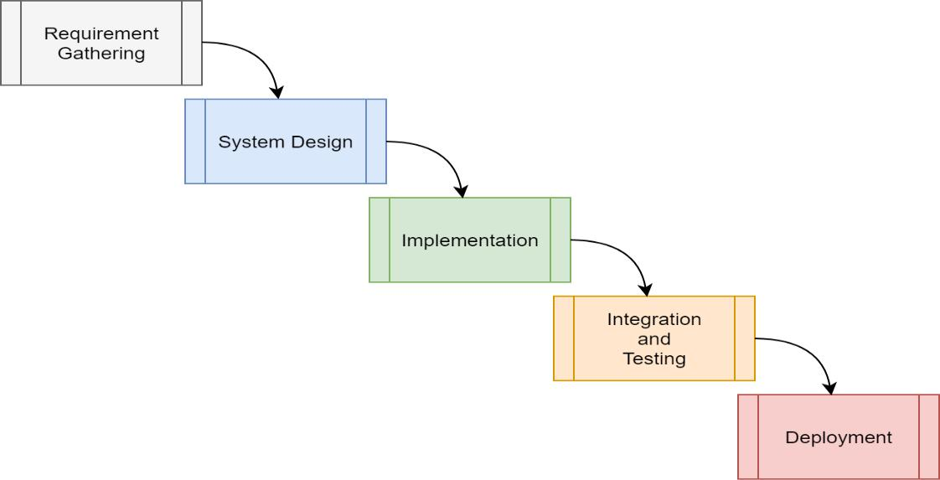

**Figure 3.1: Waterfall Model for Gym & Fitness Club: Membership and Product Hub**

6

* **Requirement gathering:** The system's services, contents, and goals are established through consultations with system users. These requirements are often defined in detail and serve as the system specification.
* **System design**: This phase establishes the overall system architecture. It involves identifying and describing the fundamental software system abstractions and their relationships.
* **Implementation:** This stage includes writing the source code and implementing it within the organization. The software design is realized as a set of programs and program units.
* **Integration and Testing:** Individual program units or programs are integrated and tested as a complete system to ensure that the software requirements are met. After integration, the entire system is tested for any faults and failures.
* **Deployment:** Once functional and non-functional testing is completed, the product is deployed in the customer environment or released into the market.

**3.1.1 Requirement Analysis**

Requirement analysis is a crucial phase in the system development lifecycle where the specific needs and objectives of the system are identified and documented. During this stage, consultations with system users and stakeholders are conducted to gather detailed information about the system's desired functionalities, performance expectations, and constraints. This information is meticulously analyzed to create a comprehensive system specification that serves as a blueprint for subsequent development phases.

* + 1. **Functional Requirements a. For Gym Members**
  + The system shall allow members to register and create a personal account.
  + The system shall record and manage member personal details (e.g., full name, email, mobile number, membership type).
  + The system shall enable members to book fitness classes and training sessions.
  + The system shall display available classes, personal training slots, and facility schedules.
  + The system shall allow users to purchase the products.

7

1. **For System Administrator**
   * The system shall allow administrators to add, update, or delete member record.
   * The system shall enable administrators to schedule and manage classes, personal training sessions, and facility availability.
   * The system shall provide administrators with access to member and booking information.
   * The system shall allow the system administrator to view the member’s information.
   * The system shall generate reports on membership statistics, attendance, and financial transactions.
2. **Use Case Diagram**

In **Gym & Fitness Club: Membership and Product Hub**, there are two actors such as member and admin, here members are allowed to create an account, login, get membership, purchase products and logout from the system. Whereas admin can login, manage data, view member details and delete from the admin panel.

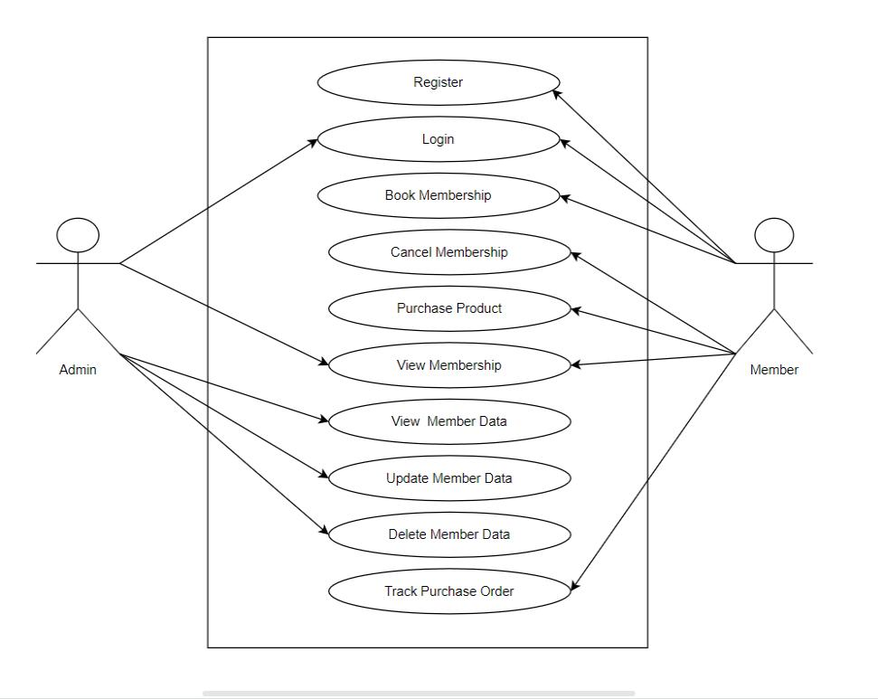

**Figure 3.2: Use Case Diagram of Gym & Fitness Club:**

**membership and Product Hub**

8

1. **Non-Functional Requirements**
   1. **Usability:** The system shall provide a user-friendly interface that is easy to navigate for both members and administrators**.**
   2. **Performance:** The system shall handle simultaneous access by multiple users without significant performance degradation.
   3. **Security:** The system shall ensure the security of user data through encryption and secure authentication mechanisms.
   4. **Reliability:** The system shall be highly reliable, with minimal downtime and robust error-handling procedures.
   5. **Scalability:** The system shall be scalable to accommodate a growing number of users and increased data volume.
   6. **Compatibility:** The system shall be compatible with various devices, including desktops, tablets, and smartphones.
   7. **Maintainability:** The system shall be designed for ease of maintenance, with clear documentation and modular components.
   8. **Compliance:** The system shall comply with relevant data protection and privacy regulations.

**3.1.2 Feasibility Analysis**

1. **Technical Feasibility**

Technical feasibility assesses whether the proposed Gym & Fitness Club: Membership and Product Hub can be implemented from a technological standpoint. It examines the availability of the required hardware, software, and technical resources. Key considerations for technical feasibility include:

* System Requirements: Evaluate whether the required technological infrastructure, including hardware and software, is available or can be acquired within budget constraints.
* Integration Capability: Assess the compatibility and feasibility of integrating the proposed system with existing gym management software, databases, and third-party services.
* Scalability: Determine if the system architecture can accommodate future growth in

membership and product offerings without significant performance degradation.

9

1. **Economic Feasibility:**

Economic feasibility assesses whether the Gym & Fitness Club: Membership and Product Hub project is financially viable and justifiable. It involves analyzing the costs and benefits associated with the project. Considerations for economic feasibility include:

* Cost-Benefit Analysis: Conduct a comprehensive analysis of the costs associated with system development, implementation, and maintenance, weighed against the anticipated benefits such as increased efficiency, revenue generation, and customer satisfaction.
* Return on Investment (ROI): Calculate the expected ROI based on projected revenue growth, cost savings, and other tangible and intangible benefits over a defined period.
* Budget Constraints: Determine if the project aligns with the available budget and financial resources of the gym or fitness club, considering both initial investment and ongoing expenses.
  1. **Operational Feasibility:**

Operational feasibility assesses whether the Gym & Fitness Club: Membership and Product Hub project can be effectively implemented and integrated into the existing operational environment. Considerations for operational feasibility include:

* User Acceptance: Conduct surveys or interviews with gym staff and potential users to gauge their willingness to adopt the new system and identify any potential resistance to change.
* Training Needs: Assess the training requirements for gym staff to effectively utilize the system and ensure smooth operations during the transition phase.
* Support and Maintenance: Evaluate the availability of technical support resources and the feasibility of maintaining and updating the system in the long term.
  1. **Schedule Feasibility:**

Schedule feasibility assesses whether the Gym & Fitness Club: Membership and Product Hub project can be complete within the specified time. Considerations for schedule feasibility include:

* Timeline: Evaluate the feasibility of completing the project within the desired time, considering factors such as development complexity and potential delays.
* Milestones: Define clear project milestones and deliverables to track progress and ensure that the project stays on schedule.
* Risk Management: Identify potential risks and develop contingency plans to mitigate

delays and minimize the impact on project timelines.

10

|  |  |
| --- | --- |
| **Task Name** | **Duration** |
|  |  |
| Getting Started | 2 weeks |
|  |  |
| System Design &Architecture | 2 weeks |
|  |  |
| Implementation | 7 weeks |
|  |  |
| Deployment | 4 weeks |
|  |  |
| Documentation | 12 weeks |
|  |  |

**Table 3.1: Gantt chart Table for Gym & Fitness Club: Membership**

**and Product Hub**

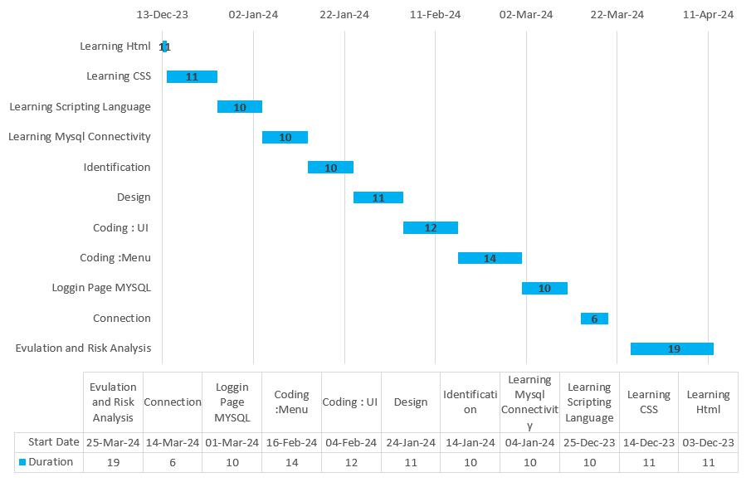

**Figure 3.3: Gantt chart for Gym & Fitness Club: Membership and**

**Product Hub**

**3.1.3 Data Modeling**

Data modeling is the process of creating a conceptual representation of the data requirements for a system or application. It involves identifying the entities, their attributes, and the relationships between them to create a structured and organized representation of the data. Data modeling is essential for designing and implementing databases, ensuring data integrity, and facilitating efficient data storage and retrieval.

11

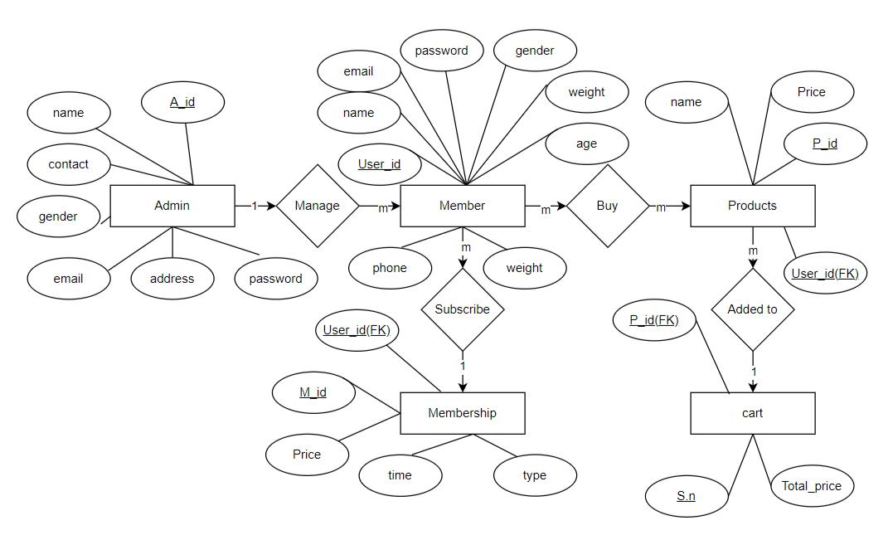

**Figure 3.4: ER-Diagram for Gym & Fitness Club: Membership and**

**Product Hub**

**3.1.4 Process Modeling**

Process modeling is a technique used to represent and analyze the flow of activities, data, and decisions within a system or organization. It aims to provide a visual representation of how a process works, enabling stakeholders to understand, analyze and improve the process. It helps in optimizing processes, reducing errors, improving communication, and facilitating process automation initiatives. So, the process modeling of our project is given below:

* **Zero Level DFD:** A Zero Level Data Flow Diagram (DFD), also known as a Context Diagram, is the highest-level view of a system's functional components and the interactions between them. It provides an overall picture of how data flows within a system without delving into the finer details. In a Zero Level DFD, you typically represent the entire system as a single process, or a bubble surrounded by external entities.

12

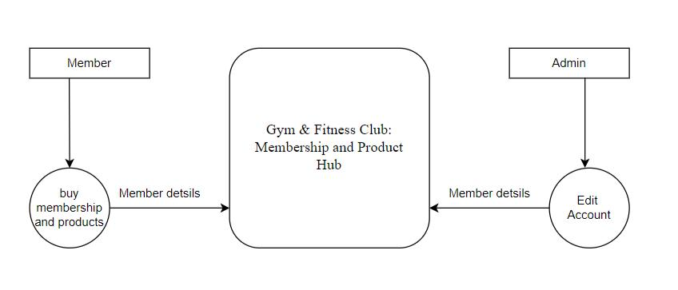

**Figure 3.5: Level 0 DFD For Gym & Fitness Club: Membership and**

**Product Hub**

* **First Level DFD:** A First Level Data Flow Diagram (DFD), also known as a Level 1 DFD, provides a more detailed view of a system's processes compared to the Zero Level DFD (Context Diagram). It breaks down the central process from the Zero Level DFD into more specific sub processes, showing how data flows between them.

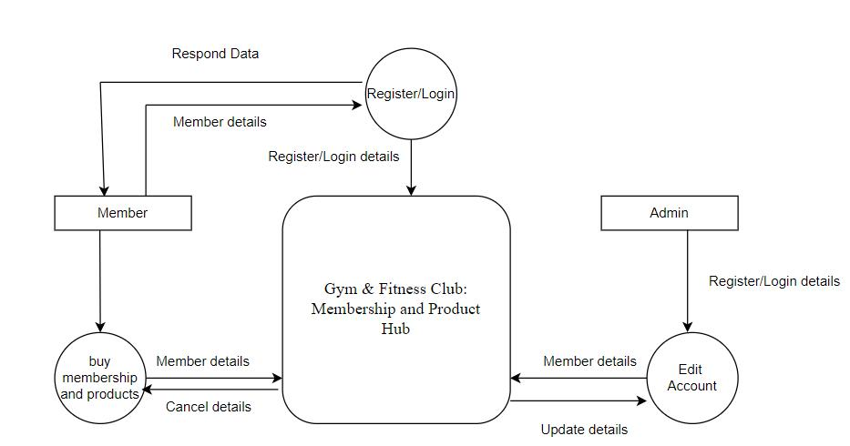

**Figure 3.6: Level 1 DFD for Gym & Fitness Club: Membership and**

**Product Hub**

13

**Second Level DFD:** A Second Level Data Flow Diagram (DFD) provides even more detailed information about a specific sub process or function within a system compared to the First Level DFD. It breaks down one of the processes from the First Level DFD into its constituent sub processes, data stores, and data flows. This Second Level DFD provides a more granular view of how the "By Keyword" sub process works within the system. Depending on the complexity of the system and the sub process, you can further break down each element into additional levels of DFDs if necessary to capture more detailed processes and data flows.

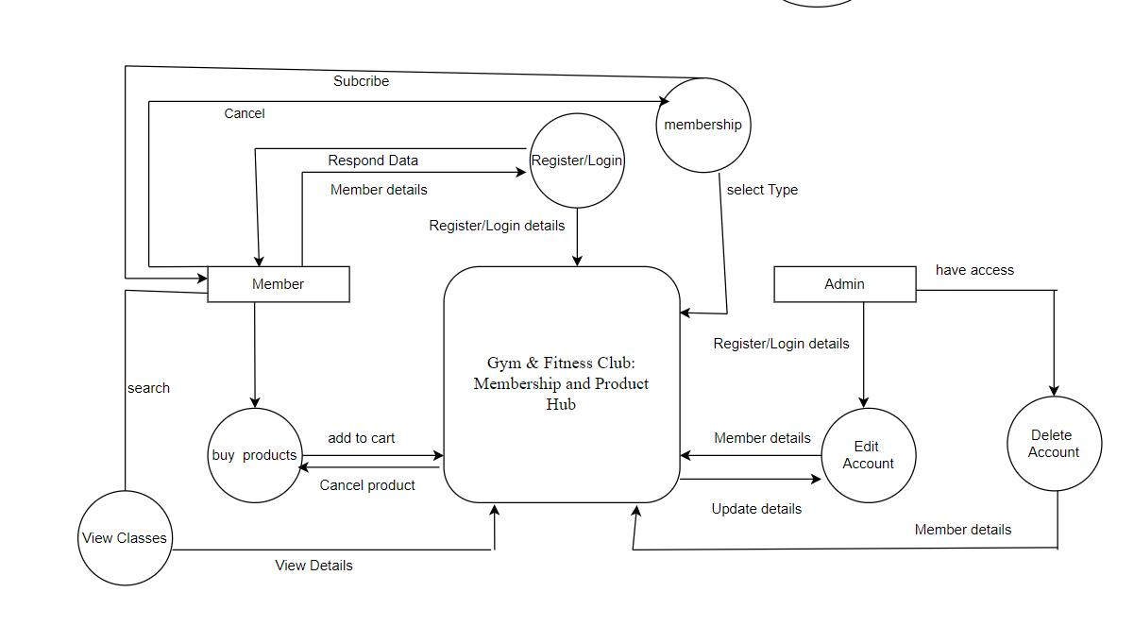

**Figure 3.7: Level 2 DFD for Gym & Fitness Club: Membership and**

**Product Hub**

14

**3.2 System Design:**

System design is the phase in software development where a detailed blueprint is created for a software system, encompassing architecture, component interactions, data structures, interfaces, and performance considerations. System Design is defined as a process of creating an architecture for different components, interfaces, and modules of the system and providing corresponding data helpful in implementing such elements in systems. It involves breaking down the system into manageable components, defining their relationships, and designing the database schema. User interface design, security measures, error handling, scalability, and testing strategies are also considered. The outcome of system design is a comprehensive plan that guides the development and deployment of a software system, ensuring it meets requirements, performs efficiently, and is secure and maintainable. It refers to the process of defining the architecture, modules, interfaces, and data for a system to satisfy specified requirements. It is a multi-disciplinary field that involves trade-off analysis, balancing conflicting requirements, and making decisions about design choices that will impact the overall system.

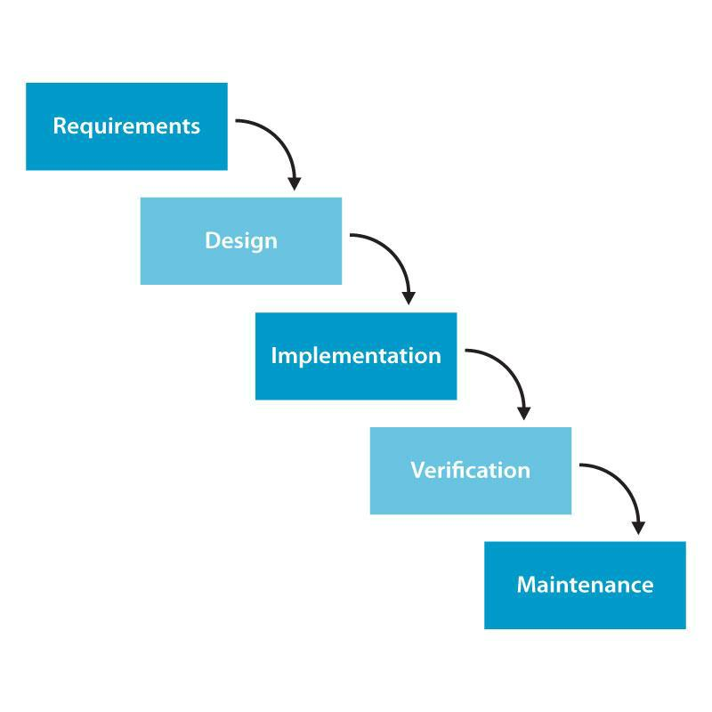

**Figure 3.8: Waterfall Model for** Gym **& Fitness Club: Membership**

**and Product Hub**

15

**3.2.1 Architectural Design**

Architectural design involves defining the overall structure, components, and interactions of the system. It determines how the different software and hardware elements will be organized and integrated to meet the functional and non-functional requirements of the system. The architectural design servers as a blueprint for the development and implementation of the system. The architectural design of a project provides a high-level overview of the system’s structure and guides the development and implementation process. It ensures that the system meets the functional and non-functional requirements while considering scalability, performance, security, and extensibility.

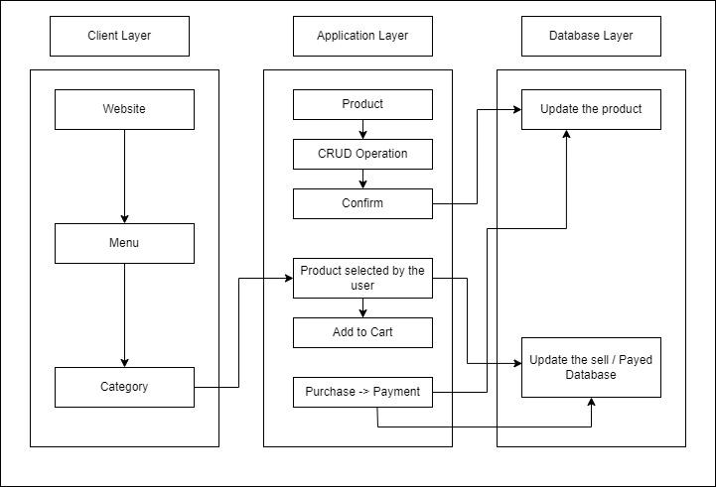

**Figure 3.9: Architectural Design for Gym & Fitness Club:**

**Membership and Product Hub**

**3.2.2 System Flowchart**

The figure below is the flowchart of Gym & Fitness Club: Membership and Product Hub system applicants and user login the system and if user is not register then they have to register first. After login success, it directs to dashboard of the system and user view the product category and add the product to the cart they want. The admin does not need to register they can directly login the system and after login success it redirects to dashboard of admin and admin can manage categories, and all the details of users. The admin approves the order from the users, and they go for place order and use different ways for payment method.

16

**For Admin**

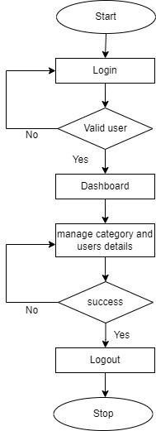

**Figure 3.10: Flowchart of Gym & Fitness Club: Membership and**

**Product Hub for Admin**

17

**For User**

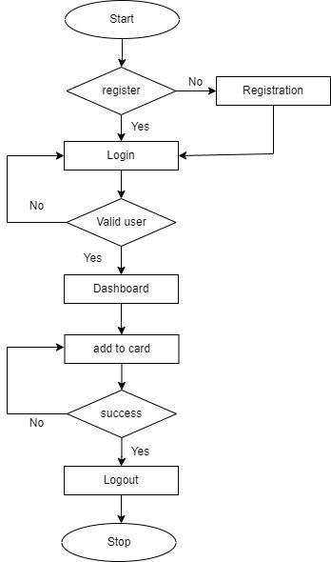

**Figure 3.11: Flowchart of Gym & Fitness Club: Membership and**

**Product Hub for User**

**3.2.3 Database Schema Design**

A database schema represents the logical configuration of all part of a relational database. It can exist both as a visual representation and a set of formulas known as integrity constraints that govern a database. Below here is the database schema of our project:

18

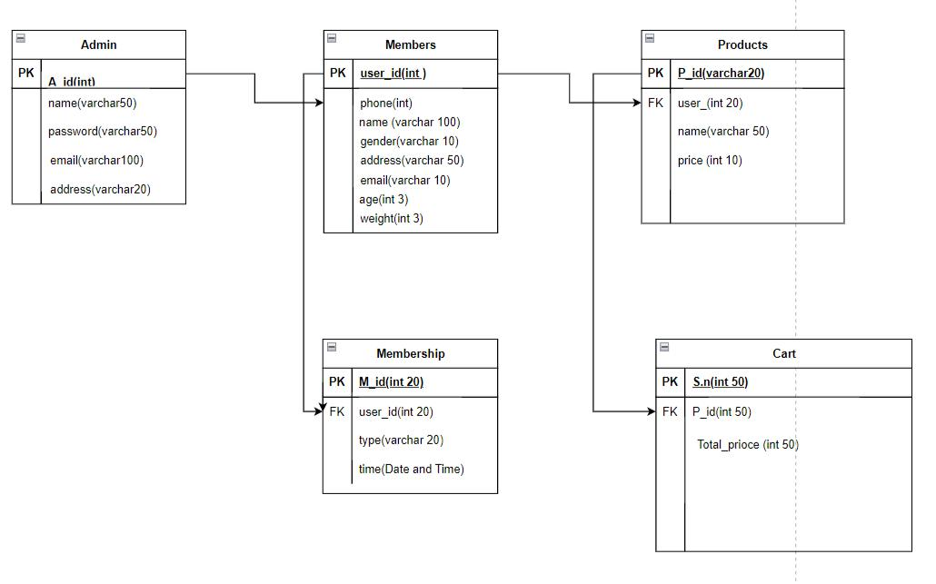

**Figure 3.12: Database Schema Design for Gym & Fitness Club:**

**Membership and Product Hub**

**3.2.3 Interface Design**

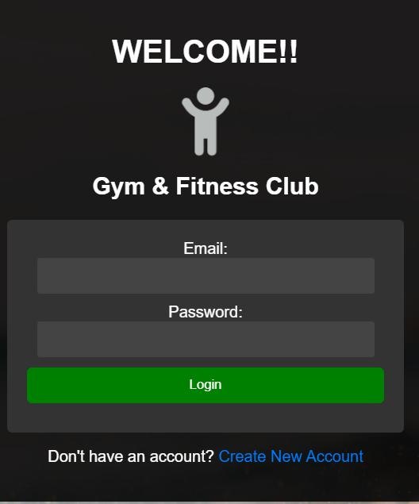

**Figure 3.13: Admin Login Page for Gym & Fitness Club: Membership**

**and Product Hub**

19

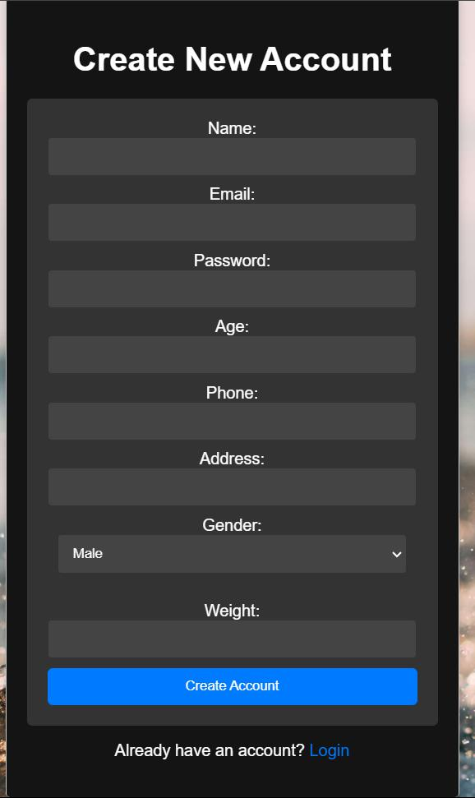

**Figure 3.14: Admin Sign Up Page for Gym & Fitness Club:**

**Membership and Product Hub**

20

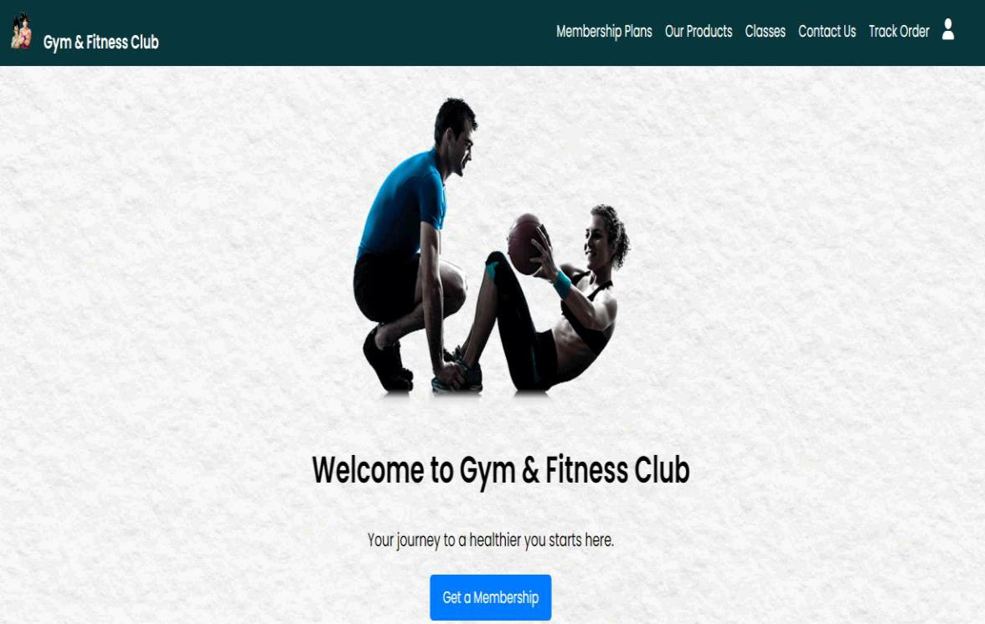

**Figure 3.15: Main Page for Gym & Fitness Club: Membership and**

**Product Hub**

21

**CHAPTER: 4**

**IMPLEMENTATION AND TESTING**

**4.1 IMPLEMENTATION**

**4.1.1 Tools Used**

Different tools, applications and technologies have been used in this project. And all of them are discussed below:

**i.** **Microsoft Visual Studio:**

Microsoft Visual Studio is an Integrated Development Environment (IDE) developed by Microsoft to develop GUI (Graphical user interface), console, web application, web apps, mobile apps, cloud, and wed server, etc. It uses the various platforms of Microsoft Software development software like windows store, Microsoft Silverlight, and Windows API, etc. It is not a language- specific IDE as you can use this to write code in c#, c++, VB (Visual Basic), Python, JavaScript, and many more languages. It provides support for 36 different programming languages.

**ii.** **XAMPP:**

XAMPP is one of the most widely used cross-platform web servers, which helps developers to create and test their programs on a local webserver. It was developed by the Apache Friends, and its native source code can be revised or modified by the audiences. It consists of Apache HTTP Serves, MariaDB, and interpreter for the different programming languages like PHP and Perl. XAMPP is used to symbolize the classification of solutions for different technologies. It provides a base for testing projects based on different technologies through a personal server. XAMPP is an abbreviation from each alphabet representing each of its major components.

**iii. Web Browser:**

A web browser, or simply “browser,” is an application used to access and view websites. Common web browsers include Microsoft Internet Explorer, Google Chromes, Mozilla

Firefox, and Apple Safari. Each time a browser loads a web page, it processes HTML, which may include text, links, and references to images and other items, such as CSS (Cascading Style Sheets) and JavaScript functions. The browser processes these items, then rendering them in the browser window. To build the Gym & Fitness Club: Membership and Product Hub web page various programming languages and tools are used which are described below:

22

**Front End Tools**

* **HTML:**

HTML stands for Hyper Text Markup Language in which it is the set of markup symbols or codes inserted into a file intended for displaying on the internet. The markup tells the web browser how to display a web page’s word and images. Each individual piece’s markup code (which would fall between “<” and “>”) is referred to as an element, though many people also refer to it as a tag. Some elements come in pairs that indicate when some display effect is to begin and when it is to end. Hyper Text Markup Language (HTML) is the basic scripting language used by web browsers to render pages on the World Wide Web. Hypertext allows a user to click a link and be redirected to a new page referencing be that link. HTML is a computer language that facilitates website creation. The language, which has code words and syntax just like any other language, is relatively easy to comprehend and, as time goes on, increasingly powerful in what it allows someone to create.

* **CSS:**

CSS stands for a Cascading Style Sheet. Cascading style sheets are used to format the layout of Web Pages. They can be used to define text style, table sizes, and other aspects of web pages that previously could only be defined in a page’s HTML. CSS helps Web developers create a uniform look across several pages of a Web site. Instead of defining the style of each table and each block of text within a page’s HTML, commonly used style needs to be defined only once in a CSS document. While CSS is great for creating text styles, it is helpful formatting other aspects of Web page layout as well. For example, CSS can be used to define the cell padding of the table cells, the style, thickness, and color of the table’s border, and the padding around images or other objects. CSS gives Wed developer more

exact control over how Web pages will look then HTML does. This is why most Web pages today incorporate cascading style sheets.

* **JavaScript:**

JavaScript is a programming language commonly used in web development, it was originally developed by NetScape as a means to add dynamic and interactive elements to websites. While JavaScript is influenced by java, the syntax is more similar to C and is based on ECMAScript, a scripting language developed by Sun Micro systems. JavaScript is a Client-Side Scripting language, which means the source code is processed by the

23

client’s web browser rather than on the web server. This means JavaScript functions can run after a web page has loaded without Communicating with the server. JavaScript function can be called within <script> tags or when specification events take places. Examples include onClick, onMouseDown, onMouseUp, onKeyDown, onKeyUp, onFocus, onBlur, onSubmit and many others. While standard JavaScript is still used for performing basic Client-Side functions, many web developers now prefer to use JavaScript libraries like Jquery to add more advanced dynamic elements to websites.

**Back End Tools**

* **PHP:**

PHP stands for Hyper Pre-Processor (it is a recursive acronym, if you can understand what that means.) PHP is an HTML-embedded Web Scripting language. This means PHP code can be inserted into the HTML of a Web pages. When a PHP page is accessed, the PHP code is read or “parsed” by the server the page resides on. The output forms the PHP functions on the page resides on. The output forms of the PHP functions on the page are typically returned as HTML code, which can be read by the browser. Because the PHP code is transformed into HTML before the page is loaded, user cannot view the PHP code on a page. This makes PHP pages secure enough to access databases and other secure information.

**Database**

**MySQL:**

MySQL is a relational database management system based on SQL (Structured Query Language). This application is used for a wide range of purposes, including data warehousing, e-commerce, and logging applications. The most commonly used for MySQL, however, is for the purpose of a web database. It can be used to store anything for a single record of information to an entire inventory of available product for an online store. MySQL provides an implementation of a SQL database very well suited for small to medium web pages. The database is free and open sources with the commercial license available. MySQL had one major advantage, since it is free, it is usually available on shearing hosting packages and can be easily set up in a Linux, UNIX, and Windows environment. In association with a scripting language such as PHP or Perl it is possible to create websites which will interact in real-time with a MySQL database to rapidly display categorized and searchable information to a website user.

24

**4.1.2 Implementation Details of Modules**

The "Gym & Fitness Club: Membership and Product Hub" system is designed to streamline and enhance the management of fitness facilities and their services. It begins with robust modules for membership management, class scheduling, product management, and facility reservation. These modules handle the secure storage of member information, real-time class and facility bookings, and inventory management for fitness products. User authentication and access control are critical components, ensuring data privacy and security. A user-friendly interface with customizable options and accessibility features caters to diverse user needs, providing a seamless and intuitive experience.

To ensure the system's effectiveness and reliability, comprehensive security measures, rigorous testing, and quality assurance are implemented. Analytics and reporting tools offer insights into user engagement and system performance, aiding in continuous improvement. The deployment strategy focuses on scalability and efficient hosting, with regular updates and maintenance planned. Additionally, user training and support resources facilitate easy adoption, while strategic marketing efforts promote the system to potential users. The system also adheres to data protection laws and copyright agreements, ensuring compliance and regulatory standards are met.

**4.2 TESTING**

**4.2.1 Purpose of Testing**

The purpose of testing in the "Gym & Fitness Club: Membership and Product Hub" system is to ensure that the software application meets both business and user requirements effectively. Key objectives of software testing include:

* To verify that the software meets the requirements and functions as expected.
* To identify and document any defects in the software before the end-users encounter them.
* To ensure that identified defects are addressed and corrected by developers.
* To implement strategies that prevent defects from occurring in the first place.
* To build confidence in the software's quality and reliability, ensuring it is fit for

25

deployment and use by the intended audience.

**4.2.2 Test Case for Unit Testing**

1. **Test Case 1: Admin A.1 Admin Login Page**

**Table 4.1: Admin Login of Gym & Fitness Club: Membership & Product Hub**

|  |  |
| --- | --- |
| Objective | Login into the web pages. |
|  |  |
| Action | Entering login credentials i.e. email address and password. |
|  |  |
| Expected Results | To enter dashboard by signing in with user type Admin |
|  | credentials. |
|  |  |
| Actual Results | Entered admin panel by signing in to the application with |
|  | admin Credentials. |
|  |  |
| Conclusion | Test Successful |
|  |  |

**A.2 Insert or Adding**

**Table 4.2: Insert or Adding of Gym & Fitness Club: Membership and Product Hub**

|  |  |
| --- | --- |
| Objective | Modify the data of member. |
|  |  |
| Action | By entering the update button on admin panel. |
|  |  |
| Expected Results | Entering update button there should be update button in user |
|  | details. |
|  |  |
| Actual Results | The details are entered according to the user registration |
|  | with the update button . |
|  |  |
| Conclusion | Test Successful. |
|  |  |

**A.3 Delete or Removing**

**Table 4.3: Deletion, Removing of Gym & Fitness Club: Membership & Product Hub**

|  |  |
| --- | --- |
| Objective | Delete the account into database. |
|  |  |
| Action | Deleting the old data or existing data from database. |
|  |  |
| Expected Results | Clicking “Delete” button to delete all the record of similar unique |
|  | id from the database. |
|  |  |
| Actual Results | Clicking the “Delete” button to delete the records from the database. |
|  |  |
| Conclusion | Test Successful. |
|  |  |
|  | 26 |

1. **Test Case 1: User B.1 User Page**

**Table 4.4: User Page of Gym & Fitness Club: Membership and Product Hub**

|  |  |
| --- | --- |
| Objective | Just to see the home page of the club. |
|  |  |
| Action | Click the profile icon in the top right corner. |
|  |  |
| Expected Results | To see user login detail with logout option. |
|  |  |
| Actual Results | Clicking t h e p r o f i l e i c o n t h e r e i s u s e r e m a i l a n d l o g o u t |
|  | b u t t o n . |
| Conclusion | Test Successful |
|  |  |

**B.2 Cart Product Increment and Deletion**

**Table 4.5: Cart Product Increment and Deletion of Gym & Fitness Club:**

**Membership and Product Hub**

|  |  |
| --- | --- |
| Objective | To add product in cart and increase the number and delete the product from |
|  | cart and decrease the number. |
|  |  |
| Action | To click on “Add to cart” to increase and click on “Delete” to decrease. |
|  |  |
| Excepted Results | Clicking the “Add to cart” the number in the nav bar should increases by 1 |
|  | & by clicking the “Delete” the number in the nav bar should decrease by 1. |
|  |  |
| Actual Results | Clicking the “Add to cart” the number in the nav bar is being increases by 1 |
|  | & by clicking the “Delete” the number in the nav bar is being decrease by 1. |

Conclusion

Test Successful.

**B.3 Membership**

**Table 4.6: Membership of Gym & Fitness Club: Membership and Product Hub**

|  |  |
| --- | --- |
| Objective | To see membership page. |
|  |  |
| Action | By clicking the “Get the Membership” button. |
|  |  |
| Expected Results | To redirect/link to other page. |
|  |  |
| Actual Results | Clicking on subscribe now button the plan is subscribed. |
|  |  |
| Conclusion | Test Successful. |
|  |  |
|  | 27 |

**B.4 Order**

**Table 4.7: Order Product of Gym & Fitness Club: Membership and Product Hub**

|  |  |  |
| --- | --- | --- |
| Objective | To order the product. |  |
|  |  |  |
| Action | To click on Proceed Check out. |  |
|  |  |  |
| Expected | Clicking the proceed to check out the product selected by the user should be |  |
| Results | ordered and delivered. |  |
|  |  |
|  |  |  |
| Actual Results | Clicking on the checkout the conformation will pop up and the order is placed. |  |

Conclusion

Test Successful.

**B.5 Track Order**

**Table 4.8: Track Order Product of Gym & Fitness Club: Membership and Product Hub**

|  |  |  |
| --- | --- | --- |
| Objective | To track the order the product. |  |
|  |  |  |
| Action | To click on “Track order” button. |  |
|  |  |  |
| Expected | Clicking the button the product ordered by the user should be shown along with |  |
| Results | delivery details. |  |
|  |  |
|  |  |  |
| Actual Results | Clicking on the button the conformation will pop up and the order is shown. |  |
|  |  |  |
| Conclusion | Test Successful. |  |
|  |  |  |

28

**CHATER: 5**

**CONCLUSION AND FUTURE**

**RECOMMENDATIONS**

**5.1 Lesson Learn:**

While making this project we have learnt many things. And they are listed down below:

* Learn about PHP, HTML, JavaScript, Jason, and MySQL server.
* Learn how to connect all the things.
* Learn about how to do research in the current market.
* Learn how to solve problems related to codes.
* Learn to implement a crud operation in a system.
* Learn how to completely workable project**.**

**5.2 Conclusion**

In conclusion, the concept of a "Gym & Fitness Club: Membership and Product Hub" represents a transformative shift in how fitness services and products are accessed and utilized. This digital evolution has not only enhanced the convenience and accessibility of gym memberships and fitness products but also revolutionized the way fitness centers operate, interact with members, and manage their offerings. With robust management systems, user-friendly interfaces, and, the "Membership and Product Hub" has made achieving fitness goals more dynamic and inclusive.

Moreover, the advent of digital gym management systems has democratized access to fitness resources, breaking down geographical barriers and providing a wealth of services to users worldwide. The inclusion of accessibility features ensures that individuals with diverse needs can equally benefit from this digital transformation, fostering a more inclusive fitness environment.

However, it's important to recognize that the implementation and maintenance of such system comes with challenges, including data security, user privacy, and the need for continuous updates and improvements. Despite these challenges, the system concept remains a powerful tool for both fitness enthusiasts and gym operators seeking to enhance service delivery and foster a culture of health and wellness. As technology continues to advance, the role and impact of digital gym management systems are poised to evolve further, promising an exciting future for digital fitness and member engagement.

29

**5.3 Future Recommendation:**

The future of the "Gym & Fitness Club: Membership and Product Hub" holds significant potential for innovation and enhancement. Here are some recommendations for future developments in this field:

Enhanced Interactivity: Expand the interactive capabilities of the platform by incorporating multimedia elements, virtual fitness classes, interactive workout plans, and augmented reality (AR) to create engaging and immersive fitness experiences.Personalization Algorithms: Develop advanced recommendation algorithms that consider individual fitness goals, preferences, and activity levels, enabling the platform to suggest personalized workout routines, nutrition plans, and fitness products tailored to each user's unique needs and interests.

* **Collaborative Features**: Integrate collaborative tools within the platform to facilitate group workouts, virtual fitness challenges, and community discussions, promoting collaborative fitness experiences and peer motivation.
* **AI-Powered Assistants:** Implement AI-powered virtual assistants within the platform to assist users in tracking their progress, setting goals, providing workout suggestions, and offering context-aware recommendations for fitness products and services.
* **Blockchain for Membership and Payments**: Explore the use of blockchain technology to securely manage membership records, payments, and rewards, ensuring transparency and security in transactions and member data management.
* **Sustainability Practices:** Implement sustainable practices in the management of the platform, considering energy-efficient data storage, eco-friendly initiatives, and promoting sustainable fitness products to reduce the environmental footprint.
* **User Feedback Integration:** Actively seek and incorporate user feedback to drive ongoing improvements in the platform's functionality, usability, and content selection,

ensuring the platform continues to meet the evolving needs of its members.

By implementing these recommendations, the "Gym & Fitness Club: Membership and Product Hub" can further enhance its offerings, providing a more personalized, engaging, and sustainable fitness experience for its users.

30

**REFERENCES**

[1] “The Fitness Industry Pre-Pandemic” | [ONLINE] | Available:

[https://www.glofox.com/blog/10-gym-membership-statistics-you-need-to-know/ |](https://theculturetrip.com/)

1. “Best Gym Management Software” | [ONLINE] | Available: <https://www.g2.com/categories/gym-management>|
2. “The Pain of Reporting - Understanding your Gym’s Membership Engagement Data” | [ONLINE] | Available: [https://www.keepme.ai/blog/the-pain-of-reporting-understanding-your-gyms-membership-engagement-data/ |](https://www.keepme.ai/blog/the-pain-of-reporting-understanding-your-gyms-membership-engagement-data/) [Accessed 2023]
3. "ChatGPT by OpenAI" | [ONLINE] | Available: https://www.openai.com/chatgpt | [Accessed 2023]
4. "Fitness Club Management Software: A Comprehensive Guide" | [ONLINE] |

Available: https://www.softwareadvice.com/resources/fitness-club-management-software/ | [Accessed 2023]

1. "The Role of Technology in Modern Gym Management" | [ONLINE] | Available: https://www.clubindustry.com/technology/role-technology-modern-gym-management | [Accessed 2023]
2. "How to Choose the Right Gym Management Software" | [ONLINE] | Available: https://www.glofox.com/blog/choose-the-right-gym-management-software/ | [Accessed 2023]
3. "Enhancing Gym Member Experience through Technology" | [ONLINE] | Available: https://www.wellnessliving.com/blog/enhancing-gym-member-experience/ | [Accessed 2023]
4. "A Guide to Fitness Club Automation and Management" | [ONLINE] | Available: https://fitli.com/blog/a-guide-to-fitness-club-automation-and-management/ | [Accessed 2023]
5. "Impact of Digital Tools on Gym Membership Retention" | [ONLINE] |

Available: https://www.clubsolutionsmagazine.com/2021/03/impact-of-digital-tools-on-gym-membership-retention/ | [Accessed 2023]

31

**APPENDIX: SYSTEM SCREENSHOTS**

* **Database overview**

• **User database**

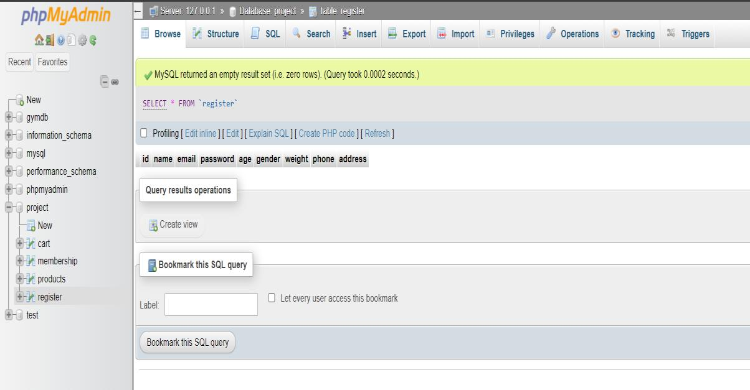

* **Products database**

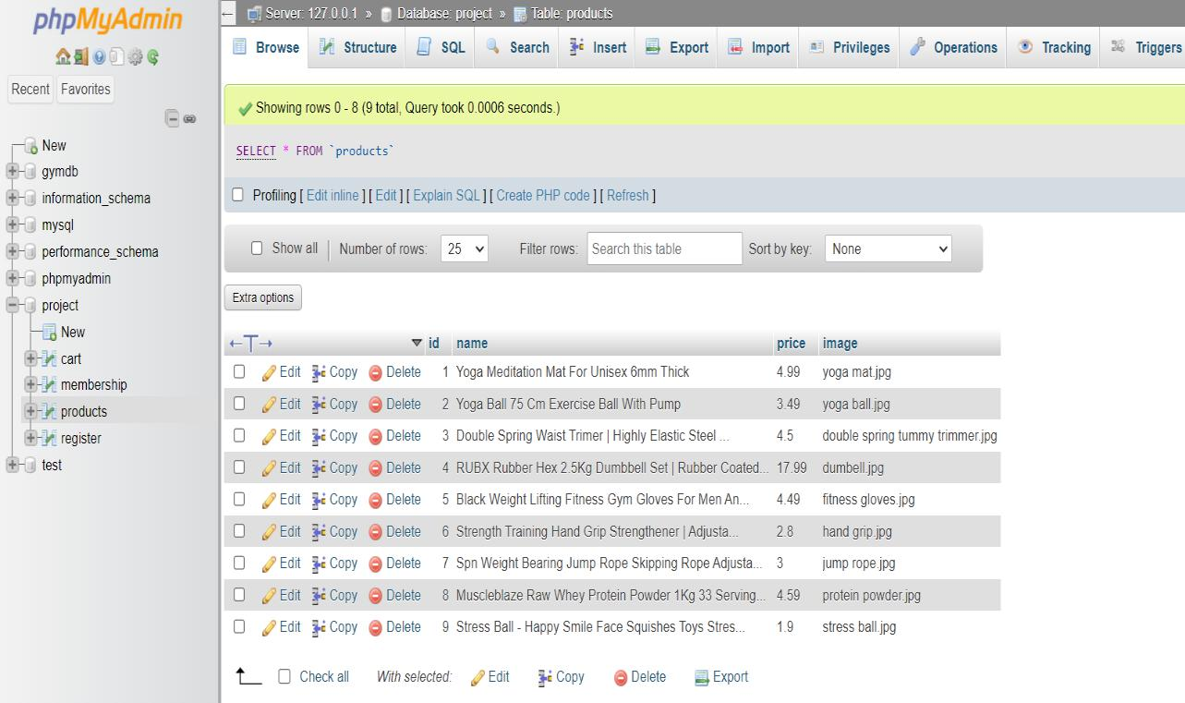

32

* **Cart database.**

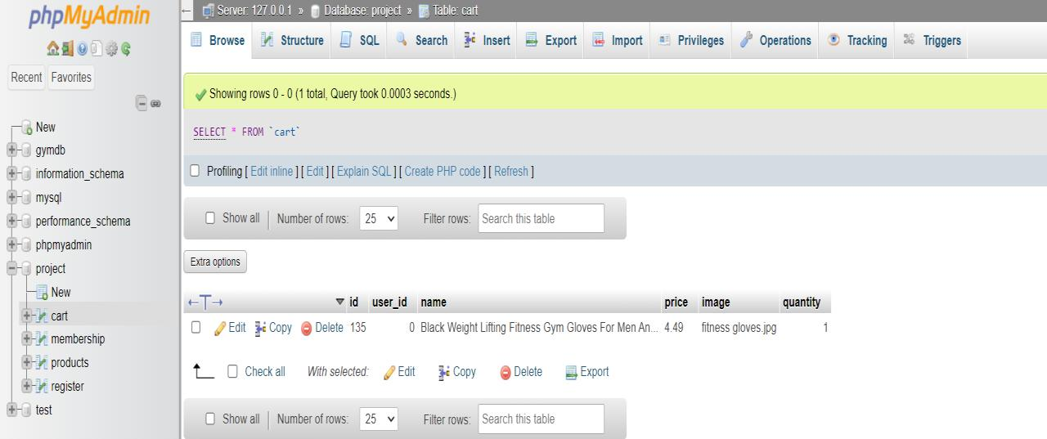

* **Membership database**

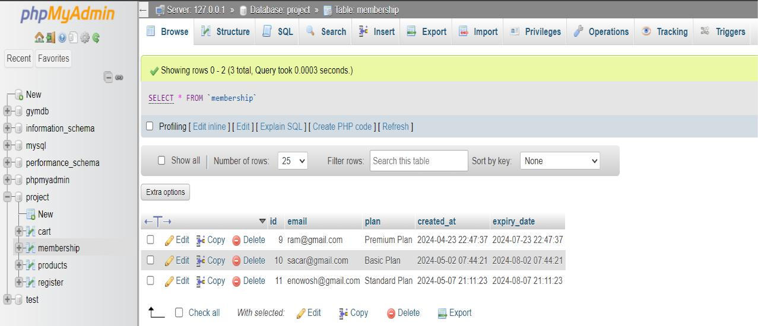

33

* **Frontend Overview**

• **Home Page**

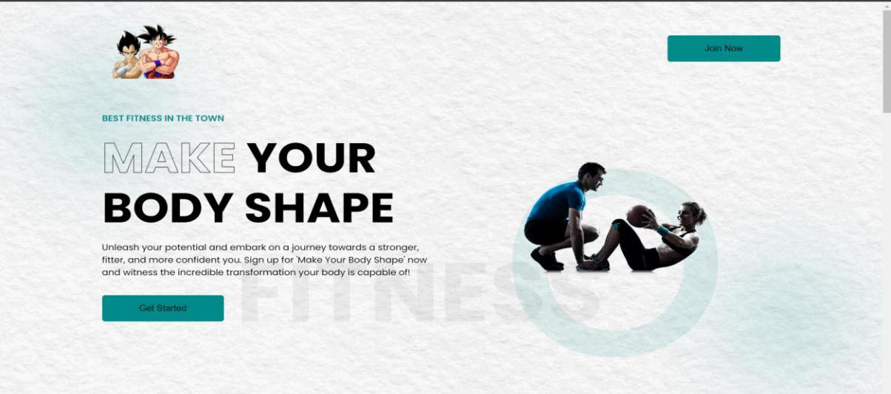

* **Login Page**



* **Register Page**

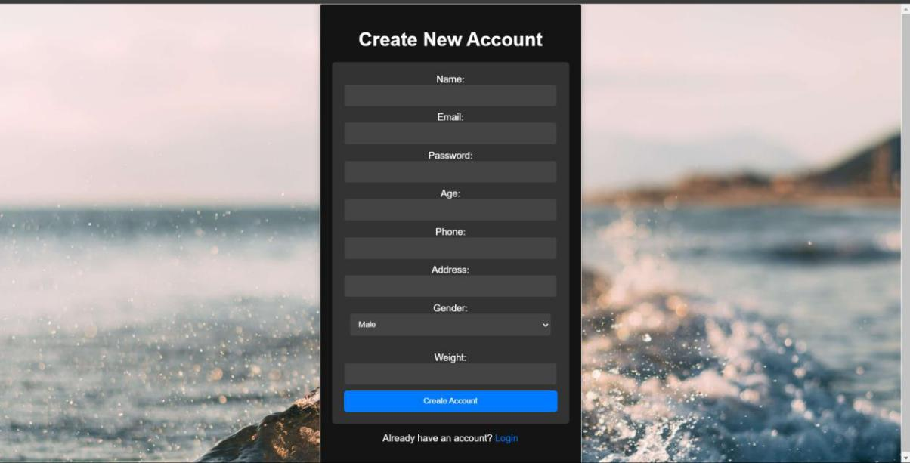

34

* **Products Page**

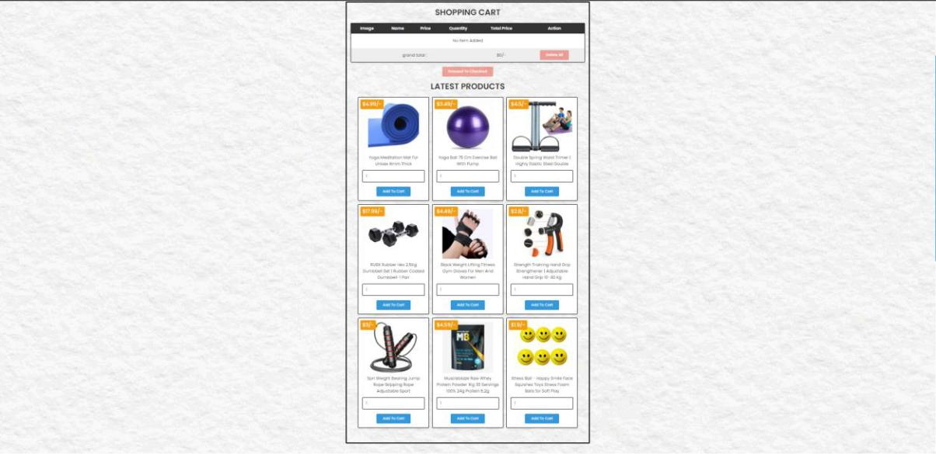

* **About Class**

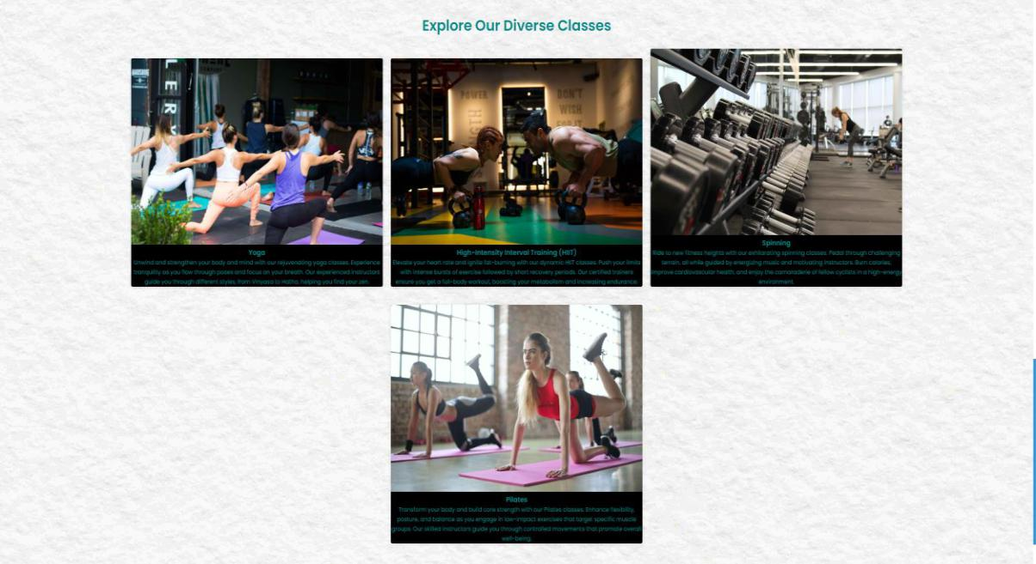

* **Contact Us page**



35

* **Membership plan**

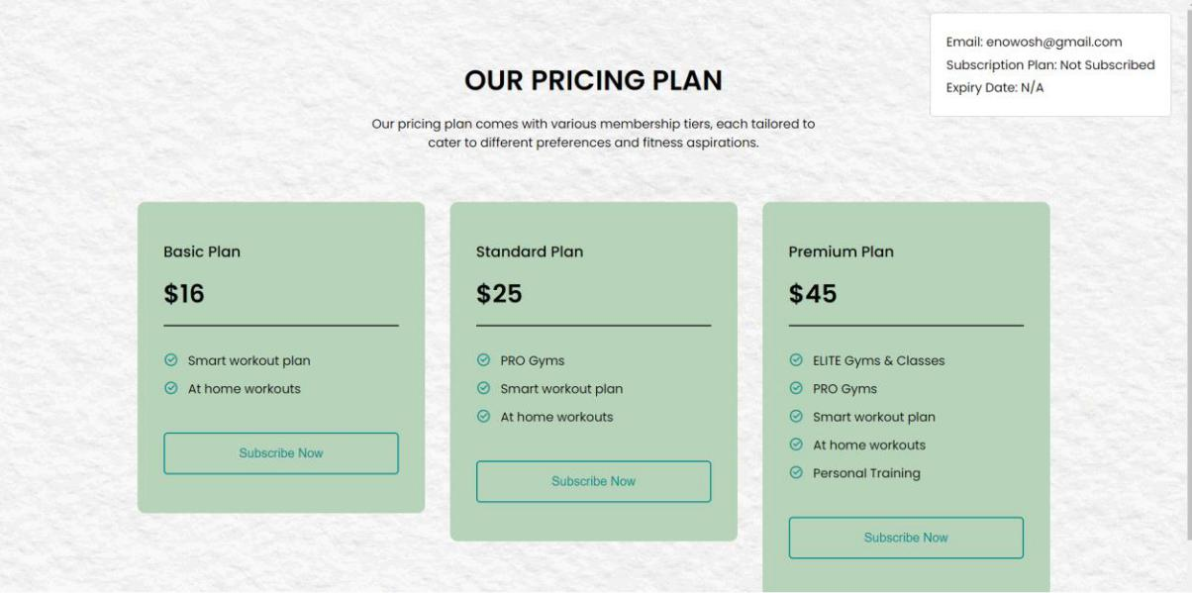

* **Shopping Cart**

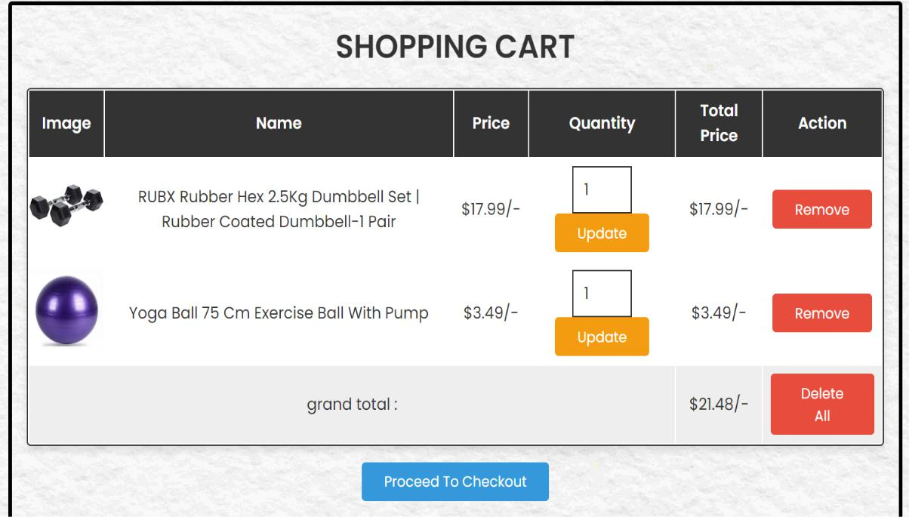

* **Track Order**

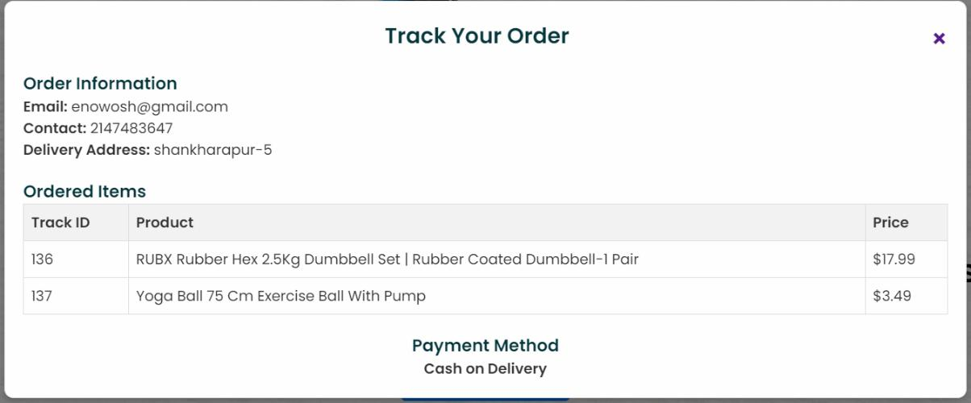

36

* **Admin Panel Overview**
  + **Dashboard**

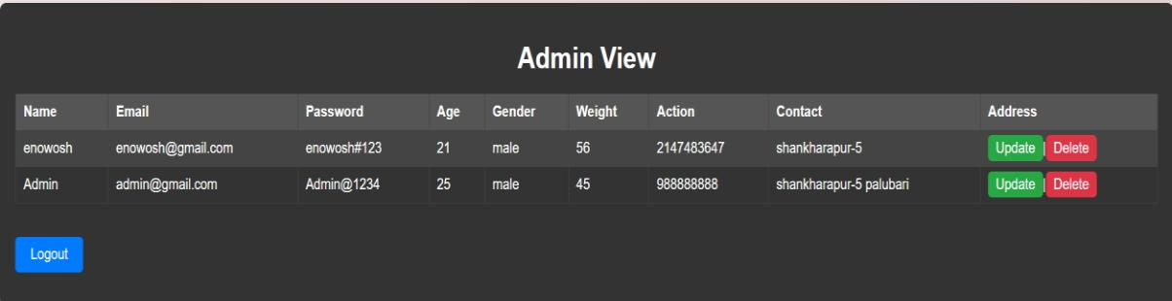

* **Update page.**

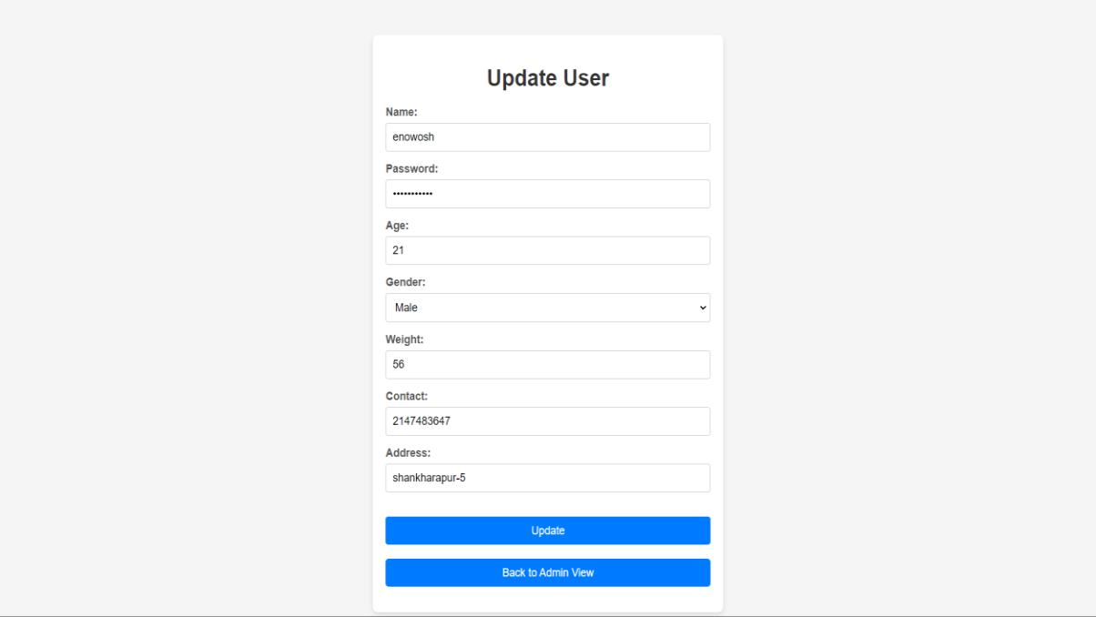

37