Screenshot showing BITS labs
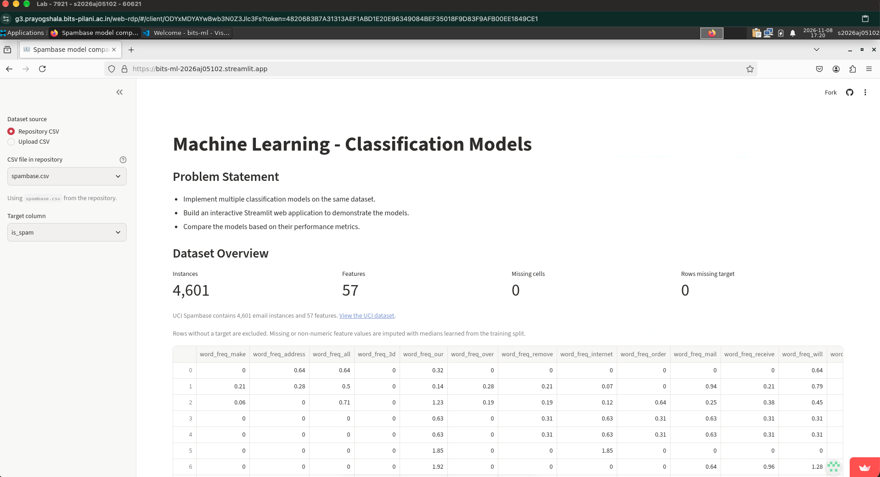
See issues below while using bits email id with streamlit. I also faced several issues connecting Labs vscode to github wherein I wasn’t able to create or link using github account using bits email id therefore I had to use my personal ID


